WALTHAMSTOW SCHOOL FOR GIRLS
“Neglect not the gift that is in me”

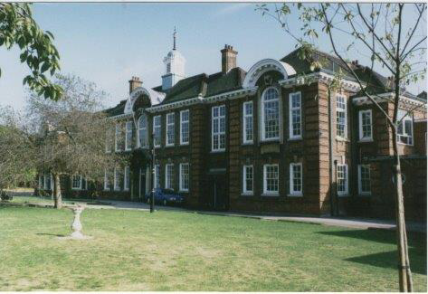

Information for applicants for the post of
Headteacher’s PA
(Fixed term)
Required for as soon as possible

November 2018

Dear Applicant
Thank you for requesting an application pack for the post of Headteacher’s PA.
Walthamstow School for Girls is a high achieving, oversubscribed, diverse school which is regularly in the top 5% nationally for progress and the top 10% nationally for attainment and is at the centre of the vibrant local community of Waltham Forest (the first London borough of culture). We have an ambition to become ‘world class’ and a commitment to work with other professionals both locally, nationally and internationally, through our Erasmus links. Three years ago we won the national High Aspiration Award for the progress made by disadvantaged students and have won SSAT Achievement and Progress awards annually since 2014. We have been awarded the SSAT Exceptional Education standard twice; in 2017, for Leadership through Moral Purpose, and, in 2018, for Systems: use of assessment, data, policies and monitoring to support teaching and learning. We were awarded Teaching School and National Support School Status in September 2017. In June 2018, following a Section 8 inspection, we were awarded an ‘outstanding’ judgement.
Our students are ambitious and hard-working; they embrace the range of opportunities offered to them both during and beyond the school day. This is highlighted not only by our exceptional examination results but also by the maturity of the girls, their sense of responsibility, community and fun. They are a delight to work with.
We offer excellent facilities to both staff and students. Our acclaimed architect designed site is an oasis of green and a pleasure to work in. It is well served by transport connections, being just ten minutes’ walk away from Walthamstow Central tube and overground station and five minutes’ walk from the popular Walthamstow ‘village’, and creative and restaurant quarter. We pride ourselves on working hard to retain our role as an important part of the local community. Examples of this commitment can be seen in our weekly Greensheets. Our staff are inclusive and friendly, with regular social and wellbeing events as well as charity fundraising.
We are committed to Safer Recruitment practices and procedures and shortlisted applicants will be questioned about their commitment to the safeguarding of young people. The successful candidate will be subject to an enhanced DBS clearance.
Thank you for taking an interest in this position. I do hope that having read more about the school you will decide to apply for the post. I look forward to receiving your application. Please note that it will not be possible to give feedback to unsuccessful applicants, other than those called for interview. Thank you for your understanding and good luck with your career in education.
Ms Meryl Davies
Headteacher, NPQH, NLE

The History of Walthamstow School for Girls
In January 1890, a circular stated that a “school for girls” was to be opened. Walthamstow was described as a pleasant suburb on the borders of Epping Forest. Hoe Street was almost a country road, with a few houses on either side and meadows in which were sheep, cattle, hawthorn and wild roses.
Miss Hewett was the first Headmistress, at the age of 27 until she retired in 1924. There were 49 girls, whose ages ranged from 7-16 years. At this time there were only five teachers, two of whom were graduates. The School’s original Staff Book gives details of the first one hundred teachers. Of them 30 remained at the school for ten years or more, 22 giving over twenty years’ service. Until 1944 all the teachers were women and not married.
The original building was in West Avenue Road and when the numbers grew the school moved to Church Hill House, where a church now stands. At this time there were also boys up to the age of 13 years at the school. It was in September 1913 that 243 girls came into the present building with the Greek Theatre being added in the 1920s. However in July 2008 the whole school moved off site for a period of four school terms to facilitate the building and refurbishment programme that has resulted in the unique blend of traditional and state of the art facilities found at the school today.
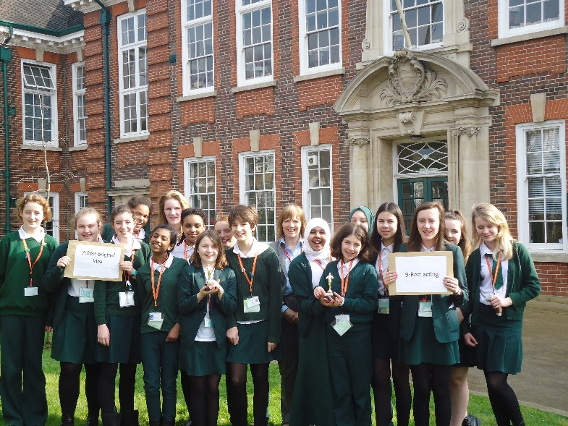
Walthamstow School for Girls is a place of high achievement. Effective teaching and learning are at the heart of our school. The school motto “Neglect not the gift that is in thee” underpins all the school’s work. Every girl is expected, encouraged and supported to achieve her very best academically and our pastoral system supports our students’ academic and social experiences.
Our role is to educate tomorrow’s women through a range of activities and opportunities to be confident, secure and happy individuals as they prepare for further education, careers and future lives.

Temporary Head Teacher’s PA
Scale: S01 (£28,356-£30,108)
Required as soon as possible until the end of the summer term 2019
36 hours per week / 52 weeks per year

Walthamstow School for Girls is an extremely successful multicultural school.
We are looking to appoint a well organised and innovative Headteacher’s PA to provide day to day secretarial and administrative support to the Headteacher. This is a temporary post to start as soon as possible until 31st July 2019.
You must have excellent secretarial and administrative skills together with extensive experience in the use of a wide range of computer software, e.g. spreadsheets, word processing and diary systems. You must have the ability to be self-motivated and flexible with a pleasant and positive attitude. You must possess a good telephone manner and be confident and skilled in liaising with parents, governors, staff and students. Previous experience of working in an educational environment would be an advantage.
An application form can be down loaded for this website. Completed application forms should be returned to the school by email to m.madhani@wsfg.waltham.sch.uk. Please note CV s will not be accepted.

Closing date: Tuesday 20th November 2018 (noon)
Interview date: To be confirmed
Please note: Applications will be considered as they are received and we reserve the right to close this position before the date specified above.

Walthamstow School for Girls is committed to safeguarding and protecting the welfare of children and young people. The successful candidate will be subject to an Enhanced DBS check.
Walthamstow School for Girls is committed to Safer Recruitment practices and procedures.

WALTHAMSTOW SCHOOL FOR GIRLS
Job Description

JOB TITLE: Head Teacher’s PA
(52 weeks p.a. - 36 hours per week)
GRADE: S01
REPORTING TO: Human Resources Manager
LINE MANAGEMENT: N/A

PURPOSE
To provide day to day administrative support to the Head Teacher. At all times to work to raise the public image of the school and provide a welcoming, courteous reception to all school visitors.
MAIN RESPONSIBILITIES
Administrative Support for the Head Teacher
- To provide personal, administrative and organisational support to the Headteacher.

- To undertake the typing and the complex IT based tasks required to produce correspondence and confidential reports.

- To be the first line of contact for the Headteacher and to use initiative to reply to matters arising from enquiries, memos or emails directly.

- To meet and greet all the Headteacher’s visitors, ensuring they are welcomed in a polite, friendly and efficient manner.

- To attend confidential staff meetings and take minutes, prepare documentation, meeting set deadlines, and distribute to relevant parties under the direction of the Head Teacher.

- To liaise/communicate on behalf of the Headteacher with Governors, staff, parents, pupils, LA, union and members of the extended community.

- To attend confidential student meetings, take notes, prepare documentation, and distribute to relevant parties under the direction of the Head Teacher.

- To understand the exclusions procedures and to process exclusions, ensuring records are kept up to date and providing data for external returns.

- Organise and maintain the diary for the Head Teacher, with a full understanding of the Headteacher’s priorities and deadlines. Arranging appointments as appropriate, and ensure that s/he is adequately briefed on matters to be discussed.

- To prioritise, assemble and prepare papers required by the Head Teacher to attend meetings, prepare reports, or reply to requests for information.

- To also ensure that matters arising from meetings are dealt with by the appropriate people within agreed timescales.

- To liaise with the Human Resources Manager to arrange termly absence meetings.

- To develop and maintain the Head Teacher’s filing system.

- To be responsible for setting up and maintaining an efficient review system of the school policies.

- To prepare agendas for meetings and to ensure all attendees receive the relevant correspondence.

- After discussion, to draft, as appropriate, outgoing correspondence and school documents that are the direct responsibility of the Headteacher.

- To carry out research for the Headteacher and SLT as required.

- Opening, sorting and prioritising the Headteacher’s correspondence.

- To arrange hospitality requests for any events/meetings involving the Head Teacher.

- To book and organise conferences on behalf of the HT.

- Make and plan travel arrangements as necessary.

Marketing and Communication

- To coordinate and produce key school publications including; SIP, SEF, School Prospectus and School Policy documents in liaison with the SLT and Middle Leaders, ensuring they are in the correct format and available within the set deadlines.

- To coordinate and manage the information to be uploaded onto the school’s website pages ensuring it meets statutory requirements.

- To plan and coordinate the production of key school marketing publications and to ensure the effective and timely distribution to the target audience.

- To prepare and issue press releases, under the direction of the Headteacher, in order to publicise school achievements to the wider community.

- To ensure that all school polices are available to all stakeholders.

Governing Body

- To be responsible for the preparation of agendas and paperwork for all Governors meetings, in liaison with the Headteacher, Chairs of Committee, Chair of Governors, Business Manager and the LA as appropriate.

- To liaise with the LA in respect of Governor related issues under the direction of the Head Teacher.

- To assist in the preparation of correspondence for Governors and ensuring Governors receive all relevant correspondence.

- To understand the process of recruiting a Parent Governor and to be responsible for the administration of the paperwork, in liaison with the LA.

- To support the Head Teacher and Chair of Governors in organising the programme of events for the annual Governors Day and other Governors events.

- To be aware of the information required by Governors and to co-ordinate records on behalf of Governors, e.g. Code of Practice, skills audit, declarations of interest.

- To prepare information packs for new Governor’s induction.

Other Administrative Duties

- To operate the telephone system, answering calls within the school’s agreed quality standards, filtering calls, directing calls, taking and communicating detailed messages (including electronic) as appropriate.

- To take minutes of staff meetings such as; Staff Briefings, Steering, HoFs/Pastoral and extra ordinary staff meetings.

- To receive visitors to the school, ensuring they are welcomed in a polite, friendly and efficient manner and providing hospitality as required.

- To liaise with the WFGTSA Administrator in the organisation of WFGTSA Courses and events.

- To coordinate the programme for events such as; end of term staff farewells, retirement events, etc…

- To provide other administrative support as directed by the line manager.

- Be aware of and comply with policies and procedures relating to Safeguarding, Equal Opportunities, Behaviour for Learning, Health and Safety, Data Protection and confidentiality, reporting all concerns to an appropriate person.

- There is an expectation to attend all key school events out of hours as detailed in the school calendar e.g. Open Evenings, all Faculty and Staff meetings and the relevant twilight inset sessions.

- Contribute to the overall ethos/work/aims of the school.

- To be flexible and work according to needs, which may involve assisting other areas which are commensurate with the grading of the post.

November 2018

WALTHAMSTOW SCHOOL FOR GIRLS
Person Specification
PA to the Headteacher

Experience
- Experience of delivering efficient and effective secretarial support for a senior manager, including word processing, minute taking and managing diary arrangements. | Essential
- Experience of working on own initiative with minimum supervision and meeting tight deadlines. | Essential
- Experience of devising, implementing and developing effective administrative systems and procedures. | Essential
- Experience of the use of computer software including word processing, database and spreadsheets. | Essential
- Special abilities / aptitudes
- Flexibility and ability to work as part of and contribute to the school administrative team. | Essential
- Interpersonal skills - dealing with parents, students, colleagues and outside agencies. | Essential
- Ability to deal sensitively and in confidence with a wide range of issues relating to working practices. | Essential
- Ability to communicate effectively at all levels both verbally and in writing and to produce high quality correspondence. | Essential
- Ability to work effectively under pressure, to manage own workload and conflicting priorities. | Essential
- Ability to take accurate minutes and produce reports of meetings. | Essential
- Ability to type fast and accurately. | Essential
- Ability to write shorthand. | Desirable
- Other job specific requirements
- Committed to the Authority’s Equal Opportunities Policy and acceptance of their responsibility for its practical application. | Essential
- To be available to attend meetings outside of normal working hours. | Desirable
- Knowledge/experience of Education sector and/or schools. | Desirable
- Education and Training
- Good General Standard of Education | Essential

Disqualifying Factors
Indication of sexist, racist or anti-disability attitudes or any other inconsistent with the Authority’s Equal Opportunities Policy.
November 2018

Staff Benefits

Outlined below are some of the additional benefits available to staff working at Walthamstow School for Girls.
Cycle 2 work scheme
This benefit offers staff the opportunity to make tax and national insurance savings whilst keeping fit at the same time.
Commitment to CPD
We actively encourage CPD to all staff. We regularly provide whole school CPD as part of the school calendar as well as supporting individual CPD requests.
Eye Tests
All staff using computer equipment should have eye and eyesight tests at regular intervals. Eyesight testing should also happen where staff experience visual difficulties, which may reasonably be considered to be caused by computer work.

Staff Wellbeing
As part of our CPD for staff we include sessions related to staff wellbeing. These include The Walthamstow School for Girls Running Club, Badminton, Box fit exercise sessions, yoga and the London Club (historical walks around London).

Workplace Options - Employee Assistance provider
A confidential counselling, help and information service is provided for all employees of LBWF and is available free of charge 24 hours a day, every day of the year. Counselling is offered on the telephone or in a face-to-face setting, in locations close to your work or your home. This service can help with a range of problems from practical everyday matters to sensitive and emotional issues. Please visit http://www.workplaceoptions.co.uk for further information.

It is welcoming, my daughter quickly settled into school life. It has high expectations of students but these are adapted for each individual so each is encouraged to do the best they can.

The diversity of all the students and accepting all religions, cultures and traditions.
The value placed on education for young women, standards of behaviour expected, opportunities for activities which extend my daughter's understanding and interests, diverse community.

That the school provides opportunities for each girl to feel confident to strive to push beyond their current capabilities to achieve through hard endeavour and a belief that anything is possible.

What do you value most
about our school?
A sample of responses from a recent
parent survey
The sense of community; the high standards and expectations set by the school; the holistic approach to learning for the girls; the extra curriculum activities which supports learning and the fact that the staff team is a good diverse one.

High-quality learning environment and culture: comprising motivated, well-behaved pupils, strong and inspiring teachers and good resources.

The professionalism and reputation over such a long number of years.

