Bramcote College
“Work Hard. Be Well. Do Well.”
SENCo and Inclusion Leader

WELCOME

Dear Applicant
I am delighted that you are interested in the position of SENCo and Inclusion Leader at Bramcote College, part of the White Hills Park Trust.
Bramcote College is a successful and inclusive school with a record of good progress, excellent student behaviour and a wide range of enrichment activities. In recent years, the school has gone from strength to strength and enjoys growing student numbers and an excellent reputation in the local community.
This is an exciting time for our Trust as we build on our successes and plan for the future.

We believe that the Trust will ensure all students can reach their potential, but also as a Trust we will be innovative and forward thinking in our delivery of education; in many respects the Trust itself is an example of innovative practice.

We can offer you a forward-looking and effective Board of Trustees and two Local Governing Bodies, supportive parents, talented and dedicated professional colleagues and positive, well-motivated students. We pride ourselves on the strong relationships that have been established across all members of our Multi Academy Trust, and the contribution this makes to our improving student outcomes.

We are also keen that all colleagues within the Trust have the opportunity to develop and also progress professionally by experiencing new responsibilities and ways of working. As the Executive Principal I am keen to appoint colleagues who will make the most of the opportunities which a Multi Academy Trust brings; the diversity of experience which can be gained and the benefits which can accrue from working closely with colleagues from two other schools.

I hope that after reading the information you are encouraged to apply for the post of SENCo and Inclusion Leader.

Yours sincerely

Heidi Gale
Headteacher

BACKGROUND INFORMATION
Bramcote College
Bramcote College is a small 11-18 school, with just under 700 students. We often describe ourselves as ‘family’, where there is genuine care for students and staff wellbeing as well as an unwavering ambition for all.
We want the best for all our students and have the highest expectations. Although we recognise how important academic performance is, Bramcote College is about much more than exam success. We ensure that our curriculum meets the needs of all our students. We recognise that one of the ingredients to personal and academic success is hard work.
At Bramcote College we talk about working hard, being well and doing well. Teaching across the school is good and we are privileged in having caring, talented and highly dedicated staff.
We develop our young people and place high value on enrichment and on providing learning opportunities that inspire our students both in and outside the classroom. There is an impressive programme of extra-curricular activities, visits and exchanges both in the UK and further afield. We recognise that every moment in school is a learning moment and that this contributes to the sense of belonging we foster.
Our sixth form welcomes students both from Bramcote College and other schools in the area. We are proud to continue the nurturing ethos that is part of the school experience and we compare both academic success with excellent post-18 destinations.
We work closely as a staff body and together with students, parents and governors, we ensure that our students make good progress. The strong partnerships forged with parents and carers is crucial to the success of our students. Our latest Ofsted report states that ‘Leaders are determined that only the best is good enough for pupils at the school. They have introduced an aspirational culture, which pupils and staff have embraced.’
Our strong pastoral care system, rooted in our INSPIRE values, means that we know our students well and recognise how to bring out the best in them.
We are proud of the school we are and excited about the school we are becoming.

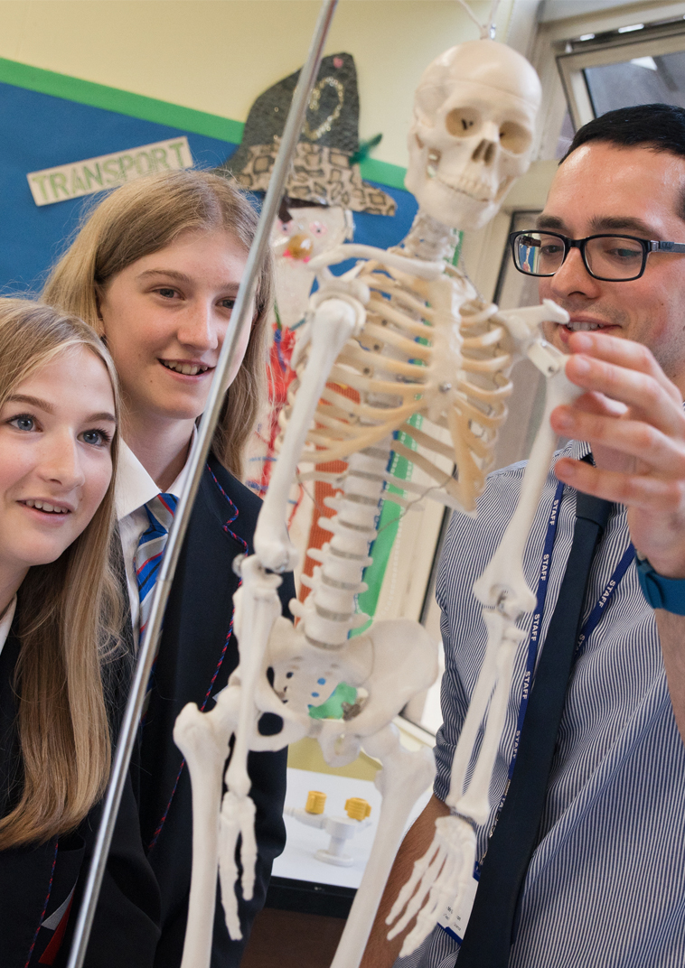
APPLICATION DETAILS
The Application Process

If you would like to discuss the role or arrange an informal visit, please contact Louise Jordan, School Administrator on 0115 9168900.

You must complete the application form fully and give details of all employment, training and gaps in employment since leaving secondary school to the present day. Any additional information, which you wish to bring to the notice of the selection panel should be included in your letter of application (supporting statement). Please ensure that you say why and how you meet the criteria from the person specification in your letter of application.
References must cover the previous five years employment. Please provide an email address for your referees so that we can contact them.

Closing date – 9.00 am on Monday, 20th May 2019
Interviews to be held w/c 20th May 2019

Please email your completed application form and letter of application (no longer than 2 sides of A4, Arial font size 11) to recruitment@whptrust.org. CV’s will not be accepted.

We look forward to receiving your application.

SAFEGUARDING

The White Hills Park Trust is an equal opportunities employer and is committed to safeguarding and protecting the welfare of children. The successful candidate will be required to undergo an enhanced Disclosure and Barring Service (DBS) clearance and checks will be made with past employers.

T
JOB DESCRIPTION

Post title: SENCo and Inclusion Leader
Salary: Leadership Scale 1-5
Responsible to: Headteacher
Job Purpose: To act as the SENCo and Inclusion Leader for Bramcote
College, including post-16 provision
Job Location: Bramcote College

Purpose of the post:

To act as the SENCo and Inclusion Leader for Bramcote College, including post-16 provision. To lead and manage any staff involved in the delivery of Learning Support and IMP (Individual Mentoring Programme – supporting some students who are at risk of permanent exclusion). In fulfilment of all responsibilities and duties, the SENCo and Inclusion Leader should show a commitment to the aims, policies, procedures and ethos of the Trust and strive to maintain these through personal conduct and effective relationships with colleagues and pupils. Be part of the SLT at Bramcote College.

Reporting to:

The Headteacher at Bramcote College.

Responsible for:

- All staff who work within Learning Support and the IMP.
- All pupils on courses for which the SENCo and Inclusion Leader has responsibility.

To co-operate with:

- The Governors of BC Local Governing Body, making such reports as required.
- The appointed Link Director for SEN and Inclusion.
- All colleagues, both teaching and support staff.
- LA, advisers.
- Outside agencies supporting students on the SEN register.
- Unions and other organisations representing teachers and other persons on the staff.

Disclosure:

- Enhanced DBS check.

Salary:

- Leadership Scale 1-5.

Main duties:

- To contribute to the Professional Vision, Leadership and Direction for the continuous improvement of Bramcote College.
- To develop, organise, manage and monitor the deployment of all Teaching Assistants and other staff in the IMP.
- To raise standards of student attainment and achievement for those students identified through the SEN register, to set targets, monitor and support their progress.
- To lead, develop and enhance the teaching practice of team members.
- To ensure the provision of an appropriately broad, balanced, relevant and differentiated curriculum, in accordance with school policies, for students identified on the SEN register.
- To integrate quality self-evaluation within Learning Support in order to support continuous improvement.
- To contribute to Bramcote College’s School Improvement Plan to ensure that the SEND are represented in whole school policies, procedures and strategic planning.
- To lead effective transition, induction and progression arrangements for students on the SEN register with reference to primary transition, KS3>4 and KS4>5, and new students.
- To create links with KS2 to develop opportunities, support progression and recruitment.

Duties and Responsibilities:

- To lead the development of appropriate courses, syllabuses, resources, schemes of work, marking policies, assessment, learning and teaching strategies within Learning Support and the IMP.
- To establish a clear and shared understanding of the importance of Learning Support within the context of Bramcote College’s provision, to support positive attitudes to education and achievement.
- Manage the day-to-day operations and IMP provision, including effective deployment of staff.
- To lead weekly inclusion/SEN team meetings.
- To implement effective strategies for absent staff to secure student entitlement in line with Trust policy.
- To use data effectively to identify students who are underachieving and, where necessary create and implement effective plans of action.
- To carry out effective QA of SEN provision and Inclusion, in line with school and Trust policy.
- To implement Trust policies, e.g. SEN, Equal Opportunities, Behaviour, Teaching and Learning, Assessment and marking.
- To maintain, implement and monitor Health and Safety policies in line with regulations and expectation.
- To work with colleagues to formulate aims, objectives and strategic plans for Learning Support which meet student needs and whole school strategic plans.
- To lead subject review and development planning activities in line with whole school cycles.
- To ensure planned and effective delivery and development of key skills, literacy, numeracy, ICT and cross curricular aspects such as moral, social, cultural, spiritual, citizenship education, physical and mental health within Learning Support.
- To oversee all Learning Support staff, working with the Assistant Heads of Key Stage to ensure their effectiveness.
- To establish clear and effective policies for assessment, marking, tracking and reporting of student progress within and across year groups.
- To advise on access to specialist equipment and resources and to be responsible for purchase orders for specialist equipment.
- To co-ordinate, plan and chair all SEND reviews and EHC annual reviews. To admission process for students with EHCP.
- To undertake other reasonable duties as requested, in accordance with the changing needs of the school.

Teaching and Learning:

- To teach small groups to GCSE level within Learning Support and the IMP.
- To lead learning through the modelling and development of good practice.
- To ensure curriculum coverage, continuity and progression for all students with particular reference to target groups e.g. SEN, EAL, EBD.
- To ensure individual education plans are in place and are matched to needs.
- To provide guidance as necessary on appropriate learning and teaching strategies/methodologies.
- To ensure that homework is set in accordance with policy and is used effectively to promote independent study and achievement.
- To ensure that teachers understand what comprises good and very good teaching for SEND.
- To develop different approaches for gathering feedback from students to support the development of effective learning strategies.
- To research, develop and share best practice with respect to national developments in the Learning Support and inclusive education.

Staff performance management and continuing professional development:

- To participate in the arrangements made for the performance management of own performance and that of other staff.
- To participate in the identification of areas for own professional development.
- To ensure that all staff receive effective and professional development and training in the management of SEN students, appropriate to their role and evaluate the effectiveness of this training.

Manage staff:

- To participate in selection and appointment of teaching and learning support staff.
- To oversee and organise the work of all TAs, ensuring that they are effectively deployed.

Monitor and evaluate:

Assist the Headteacher in the monitoring and evaluation of:

- The work and organisation of Learning Support and IMP.
- The standards of teaching and learning at Bramcote College, ensuring that proper standards of professional performance are established and maintained.
- Progress towards achievement of the school’s aims and objectives and the improvement of educational standards.

Develop personally and professionally through:

- Reflection on own practice and private study.
- Participation in the school’s teacher performance management programme.
- Participation in appropriate in-service education programmes.

Person Specification – SENCo and Inclusion Leader
CRITERIA | ESSENTIAL | DESIRABLE | TESTED BY
Experience
Experience of raising attainment in a challenging classroom environment |  |  | A / I / R
Have been either a family or school SENCo |  |  | A / R
Experience of working across phases – experience of transition for students with SEND |  |  | A / R
Experience of supporting pupils with SEND, demonstrating outstanding progress |  |  | A / I / R
Previous experience at Senior Leadership level |  |  | A / I / R
Qualifications
A recognised teacher qualification |  |  | A
The ability to teach a core subject (Maths, English or Science) to GCSE level |  |  | A
Qualified SENCo qualification or be willing to undertake this training |  |  | A
Qualified to degree level or above |  |  | A
Skills and knowledge
Exceptional communication, planning and organisational skills |  |  | A / I / R
Effective team worker |  |  | A / I / R
Inspirational leader |  |  | A / I / R
An understanding of the needs of children with SEND |  |  | A / I / R
A good knowledge of the SEND Code of Practice |  |  | A / I / R
Understanding of the principles of curriculum development |  |  | A / I / R
Commitment to and experience of the safeguarding and welfare of all students |  |  | A / I / R
In conjunction with the Family SENCo to determine eligibility for Access Arrangements, in GCSEs and post 16 qualifications |  |  | A / I
Personal qualities
Good attendance |  |  | R
Appreciative of the need to present a positive image |  |  | I
Positive approach to change |  |  | I
Disciplined time keeper |  |  | R
Work to tight deadlines and under pressure |  |  | R

