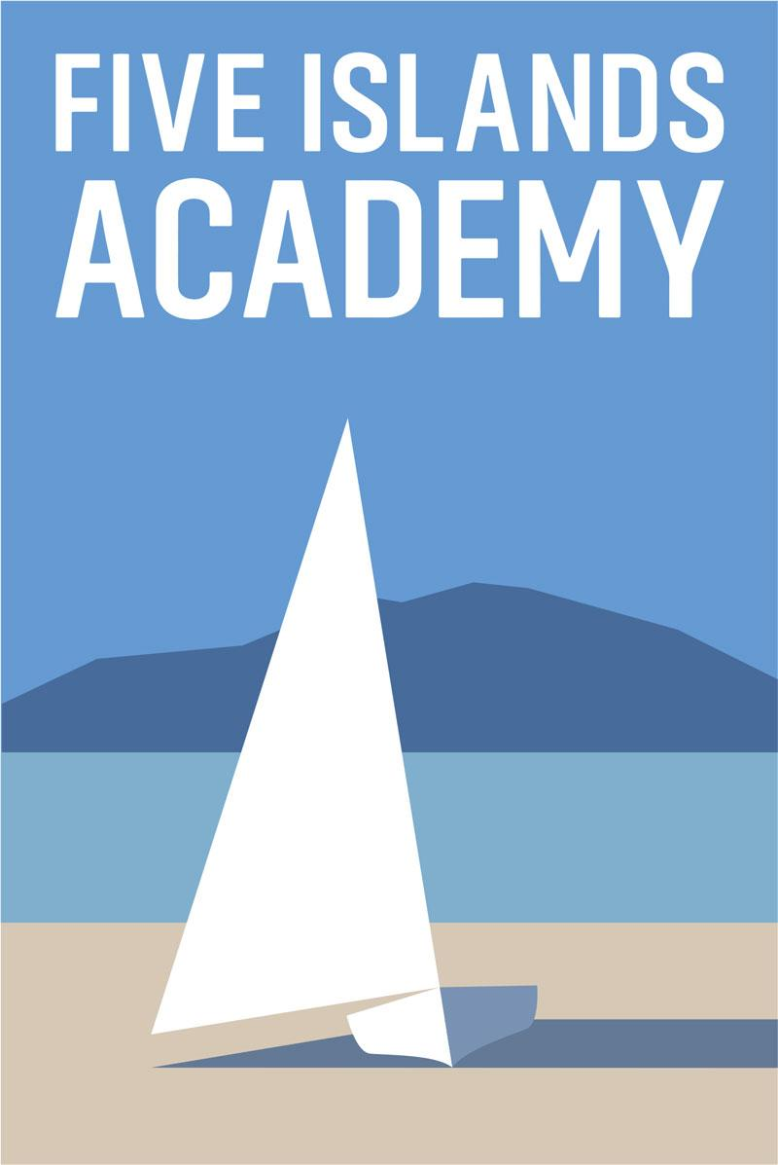

Dear Applicant
Thank you for considering applying for this vacancy. The Five Islands Academy is an all age, multi-site, Voluntary Controlled Church of England school serving the island communities of Bryher, St Agnes, St Martins, St Mary’s and Tresco. It is due to convert to an Academy on March 1st 2018, when it will join with the LEAP multi-academy trust. If successful, you will be joining the school at a very exciting and dynamic point in its development.
There are 270 students on roll across 4 school sites. Around 80 of these are of secondary age. Secondary students and the majority of primary students are based on the Carn Gwaval multi age site on St Mary’s. This new building was opened in 2011 and provides an excellent learning environment for the students.
There are bases on St Agnes, St Martin’s and Tresco, educating children from Reception to Year 6 in very small mixed-age classes. Secondary students from the off islands board at Mundesley House Monday to Thursday, returning home at the weekends.
At the Five Islands Academy we have high aspirations for our students and expect them to achieve great success. Following a section 5 Ofsted report in September 2016 the school was placed in special measures. Since that time leaders and staff have been working with a range of partners and the report from the section 8 monitoring visit in November 2017 recognised that: “Leaders and managers are taking effective action towards the removal of special measures.”

Applicants (their partner and family) need to be suited to living in a close island community. Most school employees live in rented accommodation and the successful candidate would be supported in finding suitable accommodation.

The school is committed to safeguarding and promoting the welfare of all our students and all posts are subject to DBS check.

I look forward to reading your application.

Jo Yeates
Head of School

The Application Process

The enclosed application form should be completed and returned by post to Rebecca Littlejohn, HR Assistant or emailed to rebeccalittlejohn@fiveislands.org

Closing date for applications: January 29th 2018
Skype pre-interviews to take place week commencing: February 5th 2018
Interviews to take place week commencing: February 19th 2018

The Head of School or another member of the School’s Leadership Team would be happy to be contacted to discuss the post. Please contact Rebecca Littlejohn on 01720 424872 to make a telephone appointment.

We are committed to equality of opportunities and actively encourage applications from all sectors of society.

The school is committed to safeguarding and promoting the welfare of all our students and all posts are subject to DBS check.

