Derbyshire County Council Church Lane
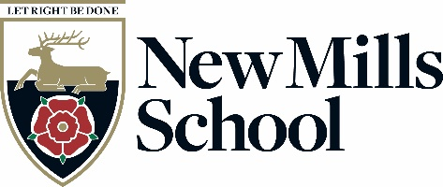
New Mills
High Peak
Derbyshire
SK22 4NR

Tel: 01663 743284
Fax: 01663 745134
Headteacher:
Mrs H Watts
email: head@newmillsschool.co.uk
web: www.newmillsschool.co.uk

Teaching and Learning Assistant (Maths)
G7 PP18-11 (£26,248-£28,161 pa, pro rata)
30 Hours and 50 Minutes, Term Time ONLY
Required From: Immediate Start

New Mills School is a rapidly improving 11-16 secondary school, set in the stunning High Peak close to the Peak District National Park, yet within easy reach of Stockport, Manchester and East Cheshire. Our recent strong results reflect the dedication of our team and our commitment to providing an ambitious and inclusive education.
You will find New Mills School a warm and welcoming place, where positive relationships underpin everything we do. Our core values—Think Big, Do the Right Thing, and Team Spirit—drive our relentless focus on student success.
This is an exciting opportunity for a dedicated Learning Support Assistant to join our committed team. The successful candidate will play a key role in supporting students with their learning, ensuring all learners are challenged and encouraged to achieve their full potential. You will be working alongside passionate staff who are determined to remove barriers and provide exceptional opportunities for every student.
If you share our values, have a passion for supporting young people, and want to be part of a forward-thinking and ambitious school, we would love to hear from you.
Application packs may be obtained from, and should be returned to Pete Eckersley, Office Manager, New Mills School, Church Lane, New Mills High Peak, SK22 4NR, or via email to jobs@newmillsschool.co.uk or from the school website www.newmillsschool.co.uk.

Informal visits to the School are welcomed; to make arrangements or for further details about this vacancy please contact Pete Eckersley, on 01663 423125, or via email jobs@newmillsschool.co.uk.

New Mills School is committed to safeguarding and promoting the welfare of children and young people and expects all staff and volunteers to share this commitment.

New Mills School is committed to creating a diverse workforce. We will consider all qualified applicants for employment without regard to sex, race, religion, belief, sexual orientation, gender reassignment, pregnancy, maternity, age, disability, marriage or civil partnership.

The successful applicant's appointment will be subject to satisfactory pre-employment clearances including references and a Disclosure and Barring check.

Closing date is 2nd March 2025 no later than 23:59

Interviews to take place as soon as possible thereafter

Kind Regards

Heather Watts
Headteacher

