

Careers at
SHARE Multi-
Academy Trust
Application Pack
Valuing People, Supporting Personal Best




Job Title – Wellbeing Mentor
Whitcliffe Mount, A SHARE Academy


John McNally
Chief Executive Officer
SHARE Multi-Academy Trust
Quality is our driving force

Welcome to SHARE Multi-Academy Trust, a supportive and close-knit family partnership of eight academies across West Yorkshire,
and a Teaching School Hub.

We are proud to be an employer of choice.
I believe our role as educators is to help children and young adults to instil a desire to learn, to overcome barriers to success, and to encourage an ambition to achieve. To reach this standard, we must first deliver for our people and ensure they feel valued, listened to and have a strong sense of belonging. In turn, our colleagues, pupils, and society all benefit enormously.

Two of our guiding principles are that ‘quality is our driving force’, and ‘teams drive success’. We know that recruiting and retaining an outstanding workforce is fundamental to achieving our aims. We therefore make it our mission to ensure every colleague within the trust has access to exceptional training and personal development opportunities, alongside a positive teaching environment, clear and ambitious progression pathways, and highly competitive packages.

We are also committed to sharing best practice across our trust, creating networks for colleagues to learn from one another, and fostering a learning environment and workplace where everyone feels supported and inspired, and can truly thrive. As a result, we are proud to be an employer of choice.

Thank you for your interest in our academies and trust. I hope you will consider joining us as we continue to deliver the very best education for our pupils. Whether you are an education practitioner looking to start your journey, or an established professional wanting to bolster your career – we look forward to working together soon.
We must
first deliver
for our people and ensure they feel valued.
At SHARE, we are committed to delivering strong educational standards within our
academies and providing our people with excellent careers. This is all underpinned by an unwavering commitment to our vision of Valuing People, and Supporting Personal Best.

Teams drive success






ABOUT US
TESTIMONIALS
JOB DETAILS


About
our Trust

SHARE Multi-Academy Trust was first established in
2014, and since then, we have built a solid reputation
for high standards and strong achievements.

We operate four successful primary academies and
four high-performing secondary academies across
the region. Our outstanding provision is supported
by our Calderdale and Kirklees Teaching School Hub
and national training accreditations, which enable us
to deliver exemplary training and development opportunities for education practitioners at every stage of their career, from initial training to executive leadership.

Our academies achieve excellent outcomes across the board. This includes academic attainment and school improvement, as well as maintaining exceptionally high standards in all aspects of school life including behaviour and attendance.

As a result of the trust’s supportive and inclusive approach, senior leaders invest significant time in supporting positive pupil behaviour and attendance. Our pupils attend well and are positive about learning. In turn, this creates a positive and respectful teaching and learning environment for staff, with teachers able to focus on delivering an excellent education to students without distraction, and with a manageable workload.

Behaviour is excellent, and there are high levels of mutual respect and tolerance amongst pupils and staff.

Ofsted, 2023*

Whilst being close-knit, we are ambitious for the future.


We are always looking for additional ways to expand our positive impact, be that by working with new schools
on exciting initiatives, or by collaborating with our
talented team of staff.

Our aim has long been to be the best trust, not
the biggest. Our priority for the future is to keep
improving standards, building on our successes,
and raising aspirations so we can support even
more pupils to achieve even better outcomes.


*2023 Ofsted report for Thornhill
Community Academy, A SHARE Academy
ABOUT US
TESTIMONIALS
JOB DETAILS


Jack Wyatt
Associate Principal
Shelley College
often exceed them. We continue to contribute to the generous Teachers and Local Government Pension

School Teachers’ Pay and Review Body. We use the flexibilities available to us as an academy to enhance our offers where we can.

Schemes and at least match pay awards agreed or recommended by the Local Government Association and

Your Career
at SHARE
Our vision of ‘Valuing People, Supporting Personal Best’ underpins everything we do. Central to our work and ability to deliver a transformational education, is our dedication to developing our greatest asset, our staff.
That is why we have an outstanding pledge to teachers and support staff to provide professional development and training opportunities, particularly through our Teaching School Hub. We are committed to investing in our staff, ensuring that they have fulfilling careers and enjoy their jobs every day. This is fundamental to our ability to turn academies around and
deliver the very best education to pupils.
We offer a competitive package
to all our colleagues.
We work as a collective group of professionals to achieve common goals. Watching new teachers and leaders become established in their roles gives me an immense sense of professional pride, as they help our pupils to achieve excellent outcomes.
As well as two generous pension schemes, we also offer

employee assistance and wellbeing packages; and flexible

and family-friendly policies, such as flexible working, shared parental leave and enhanced maternity,
paternity, and adoption entitlement, giving colleagues

the control and freedom to work in a way that suits their needs. We offer incremental progression and cost-of-living pay increases, subscribe to local
and national discount schemes, and provide exceptional onsite catering facilities.
We have committed to offering our colleagues pay and conditions that are at least as good as those available to colleagues in maintained schools. In practice, we
ABOUT US
TESTIMONIALS
JOB DETAILS
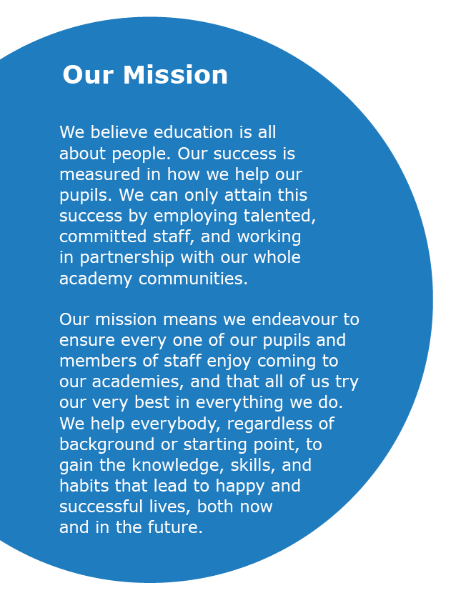


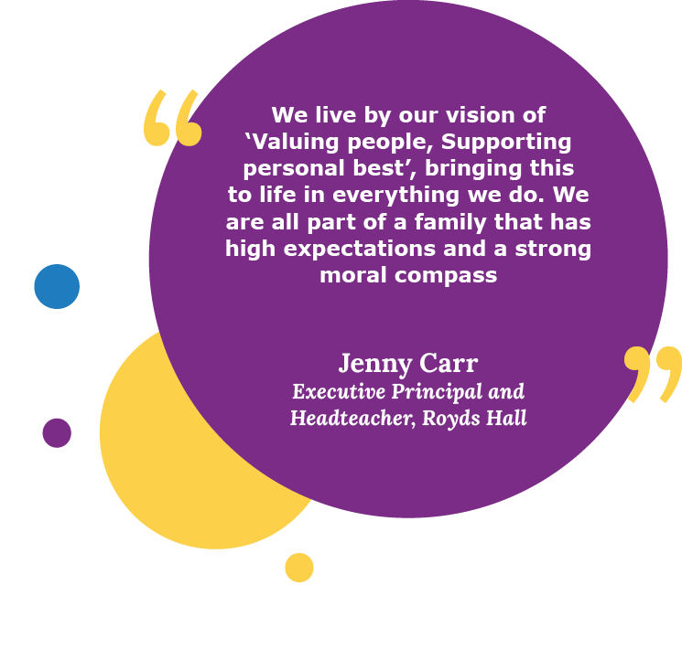
ABOUT US
TESTIMONIALS
JOB DETAILS
Our Shared Vision and Mission




ABOUT US
TESTIMONIALS
JOB DETAILS
Build positive communities that achieve outstanding outcomes, together
Overcome disadvantage, so all pupils achieve outstanding outcomes
Deliver an outstanding curriculum and pedagogy
Recruit and retain an outstanding workforce
Provide outstanding leadership, management and trust infrastructure
People thrive in communities
Teams drive success
Quality is our driving force
Everyone can achieve
We have a clear and ambitious strategy as a trust, so that we can ensure we collectively fulfil our overarching vision and mission. This is built upon our guiding principles, with distinct goals and objectives linked to accountability and performance measures.

Our Guiding Principles













ABOUT US
TESTIMONIALS
JOB DETAILS
*Most recent Ofsted prior to academisation in 2022
Click below to select the location of the vacancy you are interested in to find out more.
Our primary academies
Our secondary academies
Academies

ABOUT US
TESTIMONIALS
JOB DETAILS
Alongside our successful Teaching School Hub and
training accreditations, we take great pride in one
another’s individual successes. Many of our most
senior leaders have progressed through the routes.
That includes the countless colleagues who have enjoyed varied, rewarding, and long careers with our academies and trust, as well as those who are just starting on their journey and are glowing with potential.

We remain committed to developing our staff, who are our greatest asset in achieving our mission.

Through our broad curriculum, first-class careers
education and guidance, and our wide-ranging enrichment offer, we successfully prepare our young people for life beyond the classroom. We ensure no child is left behind, and do so by fostering a safe, inclusive, and nurturing environment where all barriers can be overcome.
enrichment offer, we successfully prepare our young people for life beyond the classroom. We ensure no child is left behind, and do so by fostering a safe, inclusive, and nurturing environment where all barriers can be overcome.
At SHARE, we are proud of the high standards and expectations we set and uphold, across the board. Consequently, we consistently surpass both national and regional school results. Our academies consistently secure excellent academic outcomes, with achievement levels being amongst the highest in our region.
Supported by robust, well-resourced, and accountable improvement plans, we have a proven track record of significantly improving our academies, as reflected in national performance measures and our strong Ofsted outcomes.

Our Outcomes


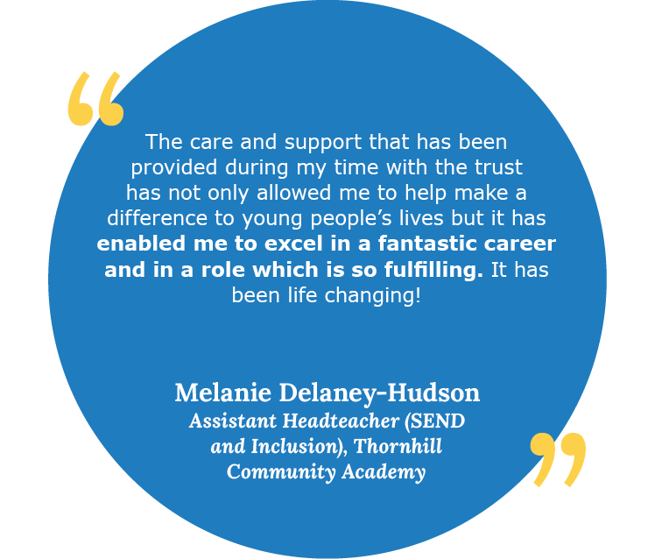
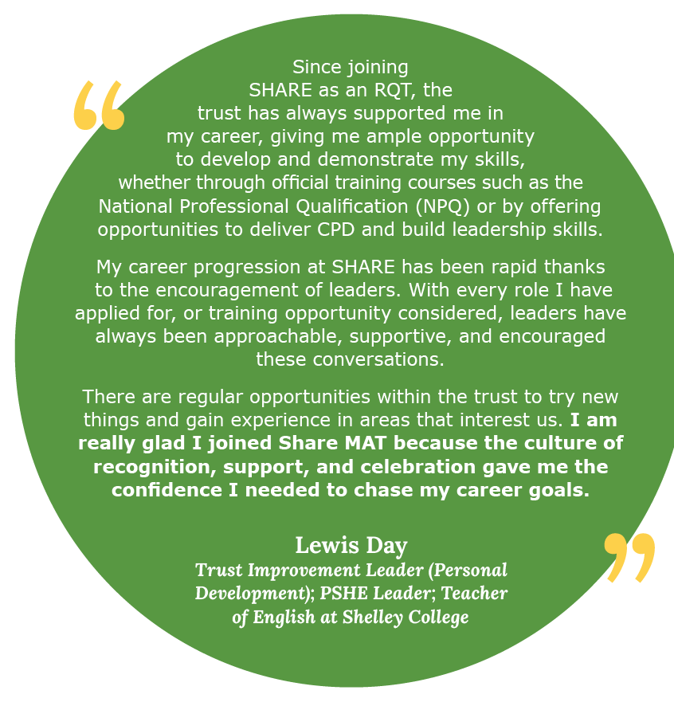
ABOUT US
TESTIMONIALS
JOB DETAILS

What our colleagues say


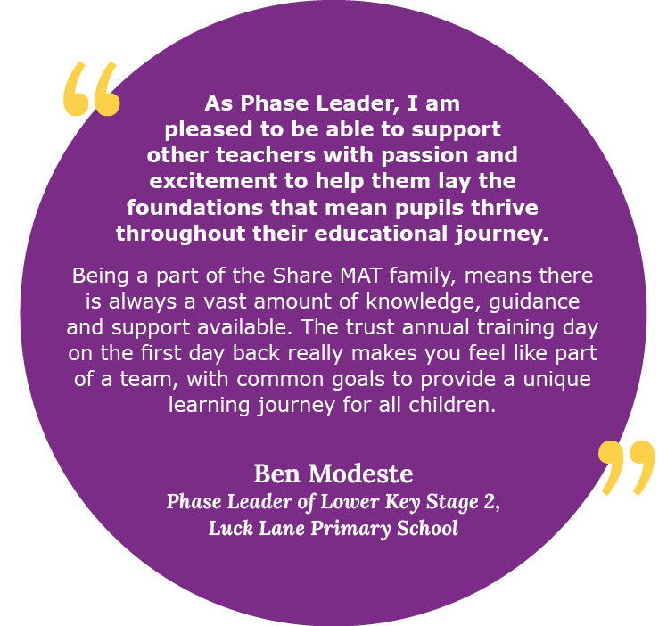

ABOUT US
TESTIMONIALS
JOB DETAILS
What our colleagues say



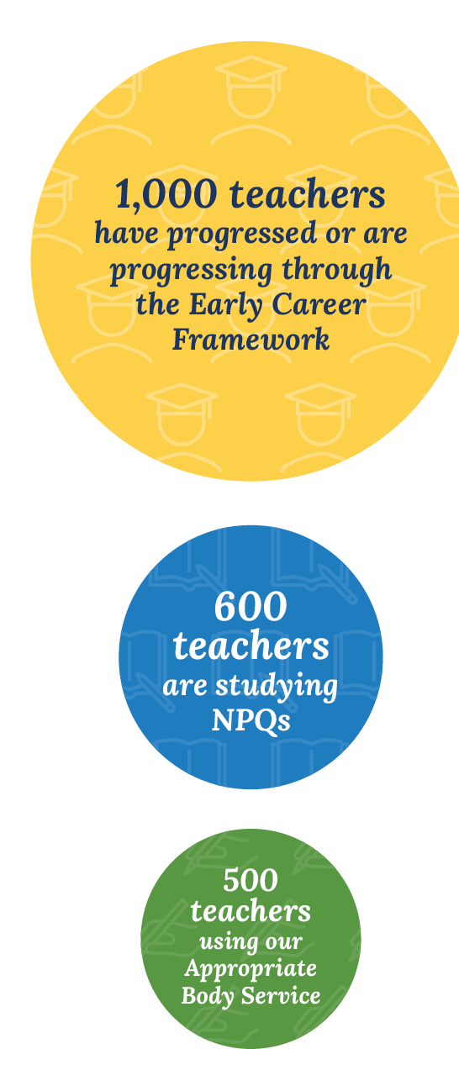
ABOUT US
TESTIMONIALS
JOB DETAILS
specialist and leadership National Professional Qualifications (NPQs), offer Lead Practitioner positions for those with classroom-based preferences, alongside middle and senior leadership training programmes for new and aspiring leaders. With additional development opportunities for staff including research projects, subject enhancement training, and access to The National College online development platform, we are dedicated to supporting our staff to develop and grow as educators.

Our success as a trust depends entirely on our colleagues who are the bedrock of all we do. That’s why we’re determined to recruit and retain the best staff by offering first-class training and support, alongside highly competitive packages.
First-class careers, through
bespoke training and support
Across the trust, we pledge to deliver outstanding professional development and training opportunities that are bespoke for our teaching and support staff. We support colleagues through ongoing training, coaching, and mentoring using the latest evidence-based research, to strengthen their expertise.

Alongside career pathways carved out for our support staff, we similarly offer a variety of progression and promotion routes for teachers. In addition to the traditional progression journey, we deliver a full suite of specialist and leadership National Professional Qualifications (NPQs), offer Lead Practitioner positions for those with classroom-based preferences, alongside middle and senior leadership training programmes for new and aspiring leaders. With additional development opportunities for staff including research projects, subject enhancement training, and access to The National College online development platform, we are dedicated to supporting our staff to develop and grow as educators.

We also champion cross-trust collaboration and best practice sharing, maximising the opportunities and expertise available across our schools. All colleagues are encouraged to meet regularly, including through various forums where they can discuss ideas, and share experiences and resources.

We also champion cross-trust collaboration and best practice sharing, maximising the opportunities and expertise available across our schools. All colleagues are encouraged to meet regularly, including through various forums where they can discuss ideas, and share experiences and resources.

Alongside career pathways carved out for our support staff, we similarly offer a variety of progression and promotion routes for teachers. In addition to the traditional progression journey, we deliver a full suite of
We are committed to protecting our staff’s wellbeing by providing the support, guidance, and training needed to achieve the highest standards they are capable of.

Just as we encourage our pupils to achieve their personal best, we want the same for our staff, with colleagues having their own personal development plans.

ABOUT US
TESTIMONIALS
JOB DETAILS
Since its launch, we are delighted that 1,000 new teachers have progressed or are progressing through our Early Careers Framework Course, with over 600 studying NPQs. We also continue to provide the Appropriate Body Service for nearly 500 new teachers.
Having the Hub as a central part of our trust family means it continually informs our approach to staff development and how we can enhance our training based on learnings and insights. It has also shaped our approach in recognising that development is a long-term, meaningful investment in our colleagues and therefore our pupils.

Endless opportunities through our Teaching School Hub and Training Accreditations
Our commitment to professional development and raising opportunities and aspirations in the communities we serve and beyond, is best reflected through our Teaching School Hub and Training Accreditations.

We are immensely proud to be the Teaching School Hub for Calderdale and Kirklees, enabling us to connect with, shape, and inspire teachers and practitioners of the future.
Through our Teaching School Hub and training platforms, we induct Early Career Teachers (ECTs) into the profession through an outstanding Initial Teacher Training programme. All our academies similarly play an important role in supporting trainee teacher placements through the Hub and with other local trainee teacher providers. We also offer a full suite of specialist and leadership NPQs through the Hub, including for staff themselves to facilitate Early Career and NPQ frameworks.

JOB ADVERT

Job title:
Wellbeing Mentor |  |  |  | 
Academy:
Whitcliffe Mount, A SHARE Academy
Headteacher:
Rebecca Hesmondhalgh, Headteacher
Section: |  |  |  | 
Pastoral
Reporting to:
Inclusion Assistant Headteacher
Contract type:
Permanent | Fixed Term

Time commitment:
37 hours per week term time plus 1 day
Band/Range:
E SCP 12 -17

Further salary information:
£20,915.82 to £22,921.50 actual salary
Academy information:
Whitcliffe Mount Academy is a large secondary academy in Cleckheaton, within close commuter distance of Huddersfield, Bradford, and Leeds. The academy is committed to supporting all pupils to achieve, develop and thrive so that they can be happy and successful.

The academy is a proud partner of the well-regarded and high-performing SHARE Multi-Academy Trust and is part of the Teaching School Hub for Kirklees and Calderdale. Whitcliffe Mount provides staff with a wealth of support and a wide range of opportunities to collaborate, network, and share best practice.

Whitcliffe Mount has a wonderful academy community and is a great place to work, where all team members play a vital role in making a positive impact on the life chances of others.

The academy is proud to offer:

- A supportive and ambitious environment where all students are encouraged to go beyond what they think they can achieve and to enjoy learning, helping them to lead successful, healthy and happy lives

- A vibrant place to work which equips staff to deliver their best every day, under the strong belief that Valuing People, Supporting Personal Best is the key

- A commitment that staff are happy, engaged and well supported at work, taking pride in students’ attendance, behaviour, progress and development as well as their own

- Excellent training and guidance relevant to individual job roles, so expectations are understood and staff are motivated

- Great benefits, as an employer of choice, including outstanding CPD, supportive line management, and meaningful networking opportunities across the trust to aid personal development

- Supportive leadership, encouraging healthy work-life balance

- A high-quality teaching and learning environment, alongside good facilities

- A culture where children are happy, settled and confident, accessing a broad and balanced curriculum which provides a memorable educational experience for pupils and staff.
We are looking to recruit:
It is an exciting time for Whitcliffe Mount as we seek to build our Pastoral and Inclusion Team. We are looking to recruit an enthusiastic and energetic Wellbeing Mentor who has high aspirations for all and a passion for supporting students with SEND and/or SEMH needs. The successful candidate will seek to reduce the barriers for students attending mainstream lessons and support them to achieve their best.

The ideal candidate will:
The ideal candidate will:

- Educated to GCSE standard or equivalent;
- Experience of working with children at secondary school level who experience barriers to learning;
- Have the ability to engage and influence others whilst providing the vision, clarity of communication and leadership for a team of mentors;
- Love encouraging, motivating and inspiring young children through the support they give in order to encourage their learning;
- Be committed to our ethos that all pupils can achieve at Whitcliffe Mount Academy;
- Have great references demonstrating they are a suitable candidate, safe to work with children.

For more information, get in touch with:
Sarah Brierley – sarah.brierley@sharemat.co.uk

JOB DESCRIPTION
Overall purpose of the role:
To work under the direction of the Student Engagement and Wellbeing Manager to support the learning, progress and care of identified groups of students, to help them achieve their personal best. You will support with safeguarding issues and provide wellbeing support to ensure their social, emotional, mental health needs are met.

You will lead on providing whole school extra-curricular year group support e.g. Year 11 exam stress and year 7 break clubs. You will also support effective liaison and communication between the wellbeing team, SEND team, Pastoral team and teaching staff to improve progress overtime for students with SEMH needs. You will work with the wellbeing team and SEND team to identify students with SEMH needs and will deliver interventions to these students.
Safeguarding requirements:
This post requires the post holder to work in settings with children and young adults. Any employment offer is therefore subject to the results of an Enhanced Disclosure from the Disclosure and Barring Service (DBS). People who may have contact with younger children (i.e. primary school age) are also required to complete a declaration about family or other members of their household. Applicants MUST complete the MAT’s standard application form to be considered, will be required to provide evidence of identity and qualifications and offers of employment will be subject to satisfactory references. For applicants who work or have recently worked in a school, one of the references must be from the Headteacher.
Key Outputs:
- To Provide skilled delivery and support of structured SEMH interventions and programmes which increases student independence under the direction of the Student Engagement and Wellbeing Manager.
- Provide one to one support to students or working with groups of students on pre-planned activities or students in crisis to support the learning and maximise student progress and achievements.
- To work under the guidance of the Student Engagement and Wellbeing Manager to monitor and track students' progress in all aspects of their education. Ensuring the progress is clearly recorded in the relevant systems and relates to the objectives/goals for students.
- Plan and lead activities outside of lesson times, or supervise groups of students at lunchtimes, and break times, to ensure such students are safe and are participating in valuable activities to develop socially and emotionally.
- Undertake varied roles and responsibilities including completing student observations, providing feedback and guidance to staff around specific students, liaising with appropriate external agencies, transitioning students to lessons, all under the guidance of the AP and Wellbeing Manager
- Actively encourage the inclusion of all students to participate in the life and activities of the school and access a broad, balanced and aspirational curriculum
- Liaise with departments, pastoral and SEN teams to help ensure the needs of all students are met fully.
- Ensure key staff are informed of progress and developments through regular feedback and updates.
- To contribute towards reviewing student profiles, My Support Plans and EHCP reviews under the direction of the SEND team, frequently communicating with parents, students, teachers and outside professionals.
- Proactive liaison with other Mentors within the team, SEND Team, AP and Wellbeing Manager, Pastoral Team and teachers, to help the students make strong progress overtime
- Make relevant referrals to outside agencies to access support for students
- Lead in the planning and delivery of assemblies and tutor time programmes, and whole school CPD training to staff about emotional wellbeing.
- To support on some Safeguarding cases
- Actively encourage the inclusion of all students to participate in the life and activities of the school and to access the national curriculum to the best of their ability.
- Maintain regular, positive contact with staff, students and parents/carers as appropriate.
- Seek feedback about own performance and the quality of support offered.
- Undertake and commit to ongoing professional development in order to ensure your knowledge is up to date.
- Carry out your duties with due regard to current and future policies, procedures and relevant legislation.
- As part of your wider duties and responsibilities you are required to promote and actively support the school’s responsibilities towards Safeguarding. Safeguarding is about keeping people safe and protecting people from harm, neglect, abuse and injury. It is about creating safe places, being vigilant and doing something about any concerns you may have.
- Any other duties commensurate with the band and post as agreed with and directed by the Headteacher/Line Manager.

Dimensions:
- Range of Teachers and Support Staff approximately 200 across the whole school.
- Range of Pupils approximately 1250.
Work/Business contacts:
Internal: All teachers and support staff to advise how effectively to support students to achieve their Personal Best at all times.
External: Alternative provision providers, other academies within the MAT, School Partnership contacts, parents/carers and families.

Expertise in role required (At selection – Level 1):
ESSENTIAL
- GCSE English and Mathematics to Grade 4 equivalent or above
- Experience of working with secondary pupils in school
- Experience of working with children who have SEND/SEMH
- Ability to engage and influence others
- Experience of working across departments and with external organisations
- Excellent communication skills
- Excellent behaviour management skills
- Commitment to the safeguarding of young people
- Ability to monitor and evaluate impact of interventions and strategies
- Competent in ICT use and data analysis

DESIRABLE
- NVQ 3 for Teaching Assistants or equivalent qualifications or experience
- Working knowledge of relevant policies and codes of practice – e.g. Safeguarding and Special Educational Needs
- Willing to work flexibly within scope of overall hours, e.g. occasional evening meetings
- Use coaching and mentoring skills with adults and pupils
Expertise in role – After initial and advanced development:
- Ability to deal with students who require physical restraint and interventions, using such methods as Positive Handling, under the direction of the Headteacher
- Understanding of Student Profiles, MSPs and EHCP's
- Specialist skills/training in curriculum or learning area
Structure/Department Information:

HOW TO APPLY
Please note that CVs will not be accepted. To apply, please complete an application form on the Every Candidate Portal using the application link below.
Application link:
https://candidates.every.education/Vacancies/Details?advertKey=d353aaf9-39bc-4dc6-a5d0-36dc646f6c86
Closing date:
Friday 16th August 2024 – 12noon
Interview date:
Week commencing 19th August 2024

Share MAT is committed to the Equalities Act 2010 and also to promoting the welfare and safeguarding of children and young people, by adhering to the “Keeping Children Safe in Education” guidance. All staff and volunteers are regularly trained regarding our expectations in keeping our students safe. An enhanced DBS is required for every post. An online search will be undertaken for all shortlisted candidates.


www.sharemat.org
whitcliffemount.co.uk
Ready to start your career with Share MAT?
Get in touch:
Visit
Email
whitcliffe.office@sharemat.co.uk
Call
01274 851152
Address
Whitcliffe Mount, A SHARE Academy
Turnsteads Avenue, Cleckheaton, West Yorkshire
BD19 3AQ
Visit the trust website
Valuing People,
Supporting Personal Best

