Welcome to The Bishop Fraser Trust from the Chief Executive, Tania Lewyckyj

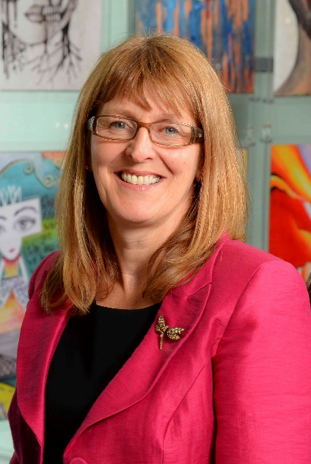
The Bishop Fraser Trust is a new MAT set up on the 1st December 2017 with St James’s CE High School (11-16) and Canon Slade School (11-18). Bolton St Catherine’s Academy joined the trust on 1st May 2018.
All our schools are situated in Bolton and all remain part of Bolton’s collaborative network where 17 high schools work together through the Bolton Learning Alliance. We are an outward facing trust and constantly look to learn and collaborate with others. We are also part of St James’s Teaching School Alliance, which offers excellent CPD and school to school support. Our links with Manchester Diocese continue to be strong.
We became a trust to secure the special nature of our individual schools as we do not think that one size fits all. We also wanted to secure our ethos and distinctiveness, enabling us to work together and to become the trust of choice for local families and staff. Staff are very important to us as we rise or fall by the professionalism and dedication of our staff.
Tania Lewyckyj is the CEO of The Bishop Fraser Trust and is also in her tenth year as the Headteacher of St James’s CE High School. Tania started her career in teaching 34 years ago and has worked in a number of schools across the North of England, as well as a year teaching English in Japan.
Tania is an NLE and set up the St James’s Teaching School in 2012, which has gone from strength to strength and offers excellent training and development opportunities from NQT to Headteacher level for the trust and beyond.

Tania said of her appointment:
“It is an absolute privilege to have the opportunity to make a difference in the lives of our young people. From 2 to 18 years old, we have the potential to enhance life chances in all of our schools and improve our town at the same time. Our focus is on more than exams; it is about the development and wellbeing of the whole child, allowing them to effectively thrive in this fast moving world in which we live. If this is the first time you have heard about us, we hope you are inspired and feel that you could thrive within our positive and aspiring trust”.

Great people……
We aim to recruit outstanding people who have the right attitude. If you have a love for teaching and are passionate about seeing children succeed, we would love to hear from you! For our part, we will provide excellent development opportunities, leadership training and the time to develop all of this so that you can be the best you can be.
Recruiting the right teachers and staff helps us to achieve the goals we set for our children. We are always keen to hear from educators who are passionate about working for the schools and communities we serve. We would rather make no appointment than appoint someone who does not share the same positive ethos that runs through our Academies. For this reason, we try to articulate clearly our vision, values and expectations when putting together information for applicants.
We aim to recruit staff who:
- are excited by their role and by the prospect of working with young people, even those who are less well motivated;
- love the processes of learning and teaching and are keen to continually develop their own skills;
- recognise that teaching can be a demanding job but react positively to those demands with resilience;
- wish to make a real difference in the lives of others;
- will subscribe to the ethos of the Trust and ‘go the extra mile’ in terms of time and commitment to get the very best from our young people;
- are quick to praise and slow to criticise; and are not afraid to admit to seeing themselves as potential leaders of the future.

CPD and training
Continual Professional Development is seen as a priority at all our schools. It is vital that staff have the time to further develop themselves and to stay abreast of changes within education, developing pedagogy and practice through innovative processes which are research based. On a Wednesday afternoon, the pupils leave school slightly earlier and staff have two hours of training and development. This provides an opportunity to work with our trust schools and has allowed us to do cross moderation and joint training. It also allows valuable time for departments, encouraging joint planning and subject development.
The Bishop Fraser Trust, via the St James’s Teaching School Alliance, offers a clear professional development route, from NQT to headship, allowing staff to take opportunities within leadership at all levels, should they wish to. We are proud of the work carried out by our 35 Subject Leaders in Education (SLEs) and hope to grow more in the future.

The Trust and Vision
We are a new Multi Academy trust which currently runs with a family of three schools.
- St James’s CE High School (11-16 ) Judged outstanding by Ofsted
- Canon Slade School ( 11-18) Judged outstanding by Ofsted
- Bolton St Catherine’s Academy (2-19) judged RI by Ofsted but primary and sixth form are seen as good.
Our schools are supported by St James’s Teaching School Alliance and the Bolton Learning Alliance.

Bolton St Catherine’s Academy is based in a new state of the art building, whilst St James’s and Canon Slade’s buildings are more traditional in appearance but in good condition. However, it is what we do in the building that matters!

Our vision is based on our strongly held Christian values:
To allow all children to experience ‘life in all its fullness’, no matter what their starting point. (John 10:10)
We aim to offer
- A high quality, inclusive and distinctive education
- A caring and nurturing environment based on our Christian values, recognising the uniqueness of each child

About the schools in the Bishop Fraser Trust
Canon Slade School
Canon Slade School has a long and distinguished history, originally founded in 1855 by the then Vicar of Bolton, Canon James Slade. Over those one and a half centuries, the school has served families throughout Bolton and much farther afield in providing an outstanding education set firmly within a strong Christian ethos.
Though the school has changed much since its inception, our motto “Ora et labora” (Pray and Work) is still the guiding principle. It is this commitment to work and the Christian life that ensures the success of the school and its ability to flourish in a constantly changing and challenging world.
A visit to the magnificent school chapel bears witness to the centrality of Christian faith. Every member of the school community is involved in an act of Christian worship each day and everyone is expected to do their best in every aspect of their work. High standards of behaviour are demanded and mutual respect is part of the embedded culture.
Christian values of compassion and love for one another allow each individual to grow in a safe, caring community which has high expectations for all.
The Ofsted inspection of December 2012 rated the school to be outstanding in each of the four categories judged under the Inspection Framework. The National Society Statutory Inspection of Anglican School Report was also judged to be outstanding.
Canon Slade School is a friendly, vibrant and exciting place in which every member of the school community is recognised and valued for the individual they are, made in the image of God, and where each is given every opportunity to fulfil their potential

St James’s C of E Church of England High School
St James’s is a Voluntary Aided Church of England Secondary School, judged ‘Outstanding’ by Ofsted. The school is currently judged to be in the top 3% of schools nationally for teaching and learning.
The school motto of ‘Caring for Others † Achieving Excellence’ is central to everything we do. When young people join the school, they become part of the school family and through this develop their potential through academic success, personal and social development and self -discipline, based on the beliefs and values of Christian faith.
Academic standards are very high and well above the national average. The school curriculum offers a personalised approach, meeting the needs and abilities of each young person, whether they are gifted and talented or have special educational needs.
It is very important that students feel confident and secure at school and display the Christian values of respect for self and others. The whole school, including its Pastoral Care provision, was rated ‘Outstanding’ by Ofsted and the school takes pride in the close links it has with parents and carers. Work within the community, locally and internationally, allows students to see how they can take an active role in society and make a difference in the world.
Pupils and parents are expected to be fully supportive of the Christian principles which form the foundation of the education and care provided. The school intake reflects the commitment of parents to our Christian foundation and also recognises other faiths and service to others.

Bolton St Catherine’s Academy
Bolton St Catherine’s Academy educates children and young people from 3 to 19 years of age. The values of Bolton St Catherine’s Academy are underpinned by a growing Christian ethos. They are an inclusive Academy for those of Christian faith, for those of other faiths, and those of no faith. St Catherine is the patron saint of students and scholars and at Bolton St Catherine’s Academy, learning is at the heart of everything.
Students will leave the Academy with:
- Good academic outcomes
- The Christian values of respect, tolerance and service
- A positive and enduring outlook

so that they live happy, healthy and purposeful lives – irrespective of their background or circumstances.
The entire Academy is geared to support every single child as they develop and progress, guaranteeing success for each individual. Bolton St Catherine’s Academy is located in a £36million building with innovative spaces and state of the art facilities to support children’s learning. These facilities are amongst the very best in the country and support in delivering a rich, varied and relevant curriculum.
Challenging targets and goals are set for every single student and staff work tirelessly to ensure these are achieved. Children learn and develop most effectively when they are happy and secure. At Bolton St Catherine’s Academy staff strive to develop an environment in which learners thrive, working to develop trust and mutual respect between everybody within the Academy and beyond.
It is through these values that the Academy continues to build on the progress it has made. In 2016 Ofsted judged the Primary School and Sixth Form as "Good". The Primary school has also gained the best KS2 results of any school in the BL2 postcode area in 2018 and in the top 3% of schools in the country for progress made.

