Dear Colleague

Thank you for your interest in the position of Deputy Head Teacher at Holmes Chapel Comprehensive School & Sixth Form College. The purpose of this letter is to give you some general information about the school and some specifics about the post.

The Advert

Deputy Headteacher L20 to L24
Starting September 2018

- Do you want to contribute to the leadership of an outstanding National Support and Teaching School with a national reputation for excellence?
- Are you an exceptional, innovative and inspirational leader.
- Are you ready to embrace change and use it for the benefit of our learning community?

If you can answer yes to these questions you may be the person we are looking for as a key member of our Core Leadership Team.

We are looking to appoint a dynamic and enthusiastic candidate for the position of Deputy Head. This role is integral in nurturing the family ethos of our vibrant learning community and inspires curiosity and an appetite for learning.
As a member of the Core Leadership Team, and working with the Executive Head, you will contribute to the strategic leadership and management of the school. You will ensure exceptional outcomes for all learners through the delivery of outstanding teaching and learning. Working closely with the Head of School you will continue the development of learning intervention to remove barriers to learning and minimise gaps in performance.
You must have a strong track record in leadership and management and be a positive role model. You must be forward thinking , solution focussed and an outstanding team player.
To arrange an informal discussion or to visit the school please contact Sarah Bradney, HR Manager.
For further details please visit our website: www.hccs.info.
N.B. Applications will only be accepted on the school’s application form.

Holmes Chapel Comprehensive School & Sixth Form College is an equal opportunities employer and the Academy is strongly committed to safeguarding and promoting the welfare of children and young people. The successful candidate will need to undertake an Enhanced Disclosure via the DBS.

The School

The successful candidate will be working at a highly successful, dynamic, innovative and ambitious Teaching School, National Support School and Academy with a national reputation for excellence. National Teaching School at the core of the Chimney House Teaching Schools Alliance.
We are fully committed to developing strong professional teachers across our network and Continuing Professional Development is at the cornerstone in achieving this. For our students, we pride ourselves on the expectations of good behaviour, underpinned by our values driven Respect Charter.
Our Students thrive in an environment where they are keen to learn, progress, and achieve outstanding results. Our drive is to ensure that every child, becomes the very best that they can be. Situated in the beautiful surroundings of rural Cheshire, our school boasts a range of outstanding facilities.
We work closely with the National College for Teaching and Leadership in modelling, promoting and disseminating best and next practice.
Academic standards are outstanding, with 80% of last year’s Year 11 gaining 5 or more A*-C
grades including English and maths at GCSE and a pass rate of 100% at Advanced level.

The dashboard.ofsted.gov.uk. for HCCS shows that attainment and progress remain outstanding and it is our mission to make it world class.

As an outstanding school we are not subject to routine inspections. However at each HMI “interim assessment” our academic performance, student progress and attendance have been judged as `Outstanding’.

We, like most successful schools, maintain that success by regularly revisiting our values, vision and guiding principles in order to ensure that they remain apposite and relevant in a world that is changing so rapidly.

The ‘rainbow diagram’ below provides an immediate visual representation of “the basics” that contribute so much to the HCCS family and guide us as we strive for ever higher standards of progress and achievement.

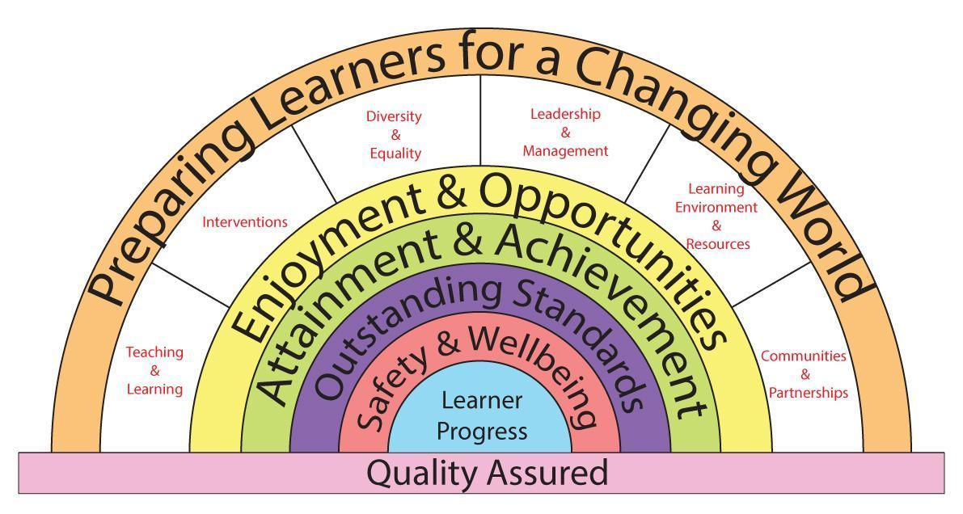

We have expressed our core values as a set of key principles which we use as our touchstones in designing our curriculum and in assessing its success and relevance to the needs of our learners.

Key Principles
The Curriculum at HCCS
1. Is about the development of the whole individual.
2. Ensures equality of opportunity in learning.
3. Provides personalised pathways and ways of learning.
4. Inspires drive, passion and commitment.
5. Promotes high standards, success and achievement.
6. Embodies responsibilities, entitlements, Safety & Wellbeing.
7. Develops respect, tolerance and courtesy.
8. Reflects the learners place in their communities.

The school serves a socially mixed, although generally prosperous rural community centered on the village of Holmes Chapel in Cheshire.
Currently numbers on roll are 1286, including 246 in the Sixth Form. Our intake in September 2017 was 208 students. We have around 82 teaching staff, including myself as Executive Head teacher.
We occupy an attractive site overlooking open countryside but close to modern, private housing estates and with easy access to the M6 at Junction 18. In the last few years we have considerably enhanced our facilities by building a new Sixth Form and Arts block with purpose built Theatre and a new 3G. AstroTurf pitch.

There are four super faculties within our school including:
iSTEM comprised of ICT, Science, Technology and Mathematics.
Communications comprised of English and Modern Foreign Languages.
Performance Studies comprised of Arts and Physical Education.
World Studies comprised of Humanities and Social Sciences

The Learning Support Team operates across all super faculties and subjects.

Teaching groups change as students’ progress through the school. In Humanities, all students are taught in mixed-ability groupings.

Year 7
Teaching groups are mixed-ability except in Maths, where students are set on entry, and
Modern Foreign Languages, which are set in February of Year 7.

Year 8 & 9
Teaching groups are mixed ability in Science.

Years 10 & 11
Our curriculum consists of a core of Maths, English, Science and PE, together with options which are designed the meet the needs of our learners and which are tailored to provide maximum student satisfaction levels and a range of progression pathways.
In our Sixth Form College we offer a broad set of pathways made up from a choice of 30
Advanced Level subjects.

Learning Support is tailored towards the needs of individuals throughout the school including the sixth form and is very successful in doing so.
The school was awarded the Inclusion Quality Mark and OFSTED commented that at Holmes Chapel Comprehensive “Care, guidance and support are outstanding”. We are very proud of our support framework which everyone in our school community is committed to and lives by. Care and support for our students is provided by the Student Services Team and delivered across the whole school through our highly effective House System.

The successful candidate will be an inspiring teacher who can motivate students across the ability range.

I hope it is clear, from the skills and competencies required, what will be expected from the successful candidate, and what qualities we will be looking for in the application and selection process. In applying for the post please write a separate, succinct (no more than 2 sides of A4), letter of application in which you address the skills and competencies required and also describe your philosophy and style of teaching.

The deadline for the closing date is Monday, 16th April 2018, 4pm

Interviews will take place on the 25th and 26th April 2018

I look forward to reading your application and welcoming a creative, energetic and inspirational teacher to our school community.



Yours sincerely
D Oliver
Executive Headteacher

