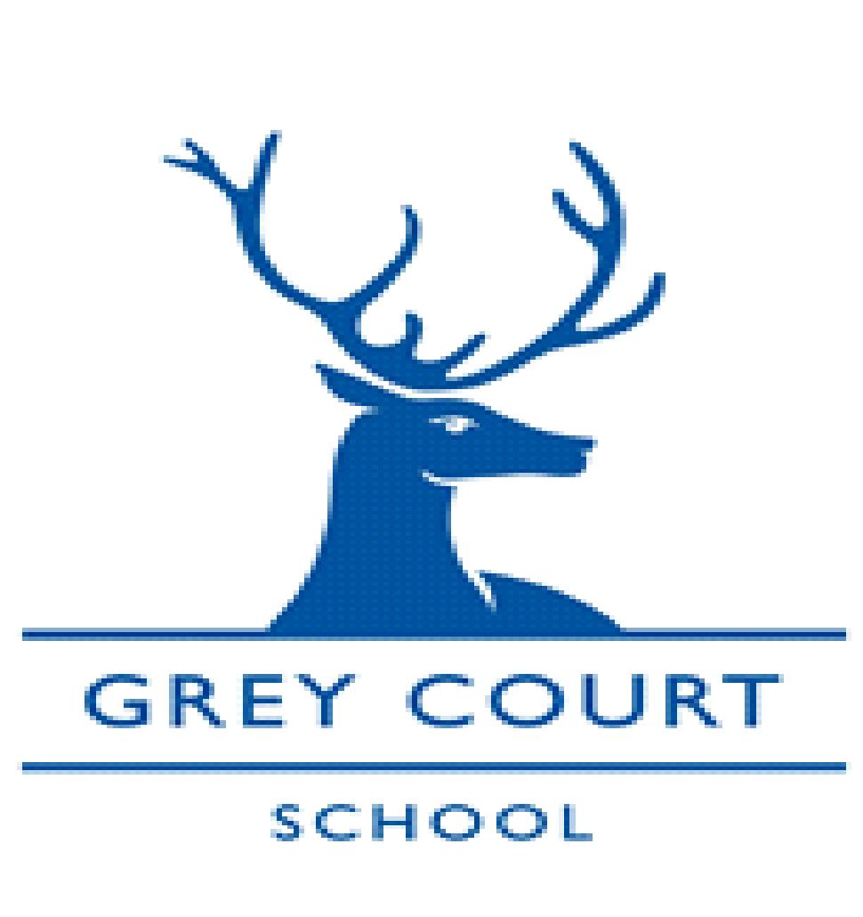

Senior Lab Technician
January 2022 start

Part time 36 hours per week - 39 weeks (term time, some out of hours working may be required)
NJC Scale 5 pt range 12-15 (£25,135 – £26,519 pro rata)
No holiday may be taken during term time

Grey Court is a successful and oversubscribed academy serving a diverse community in an outstanding environment, situated in the London Borough of Richmond and in very close proximity to the beautiful River Thames.

Graded Outstanding by OFSTED (for the second time) in January 2018, the school opened its sixth form in September 2014, with our cohorts of Year 13 students achieving continuously exceptional results in the first 3 years. In 2016 we became part of the Every Child, Every Day Multi Academy Trust and consequently, have further developed extremely strong working relationships with our partner schools. We are very excited about the future and the opportunities the MAT has brought to staff and students alike.

We are looking to appoint a senior lab technician from January 1st 2022 to help with the smooth running of a very successful science department. You will be working alongside, and managing, three other very supportive technicians.

The ideal candidate would be an enthusiastic and well qualified technician, willing to help support the teaching staff in the delivery of a dynamic curriculum whilst ensuring that the Health and Safety responsibilities are met. Reporting to the Head of Science you will be responsible for managing a team of three technicians, coordinating the use of and development of practical resources and facilities, including liaising with all areas of the school, the multi academy trust and outside organisations.

It is important that applicants have excellent interpersonal skills and enjoy working as part of a team with a natural ability to use their initiative whilst being committed to the Every Child, Every Day academy trust.

If you would like to apply for the post then please see application details on our website under vacancies

Closing Date: Friday 10th December 2021

Interview Date: w/b 13th December 2021

The Governing and Trust Bodies are committed to safeguarding and promoting the welfare of all our children and expect all staff to share this commitment. Any offer of employment will be subject to receipt of a satisfactory Disclosure and Barring Service check.

The schools within the Trust are committed to all aspects of personal development, are inclusive and seek to ensure every student achieves to the best of their ability.

For more information about Grey Court School, Job Descriptions and Application Forms please go to the school website or call 020 8948 1173. For an informal discussion please contact Ms Amy Moran, Head of Science on 020 8948 1173 ext 407 or email amoran@greycourt.org.uk

