`

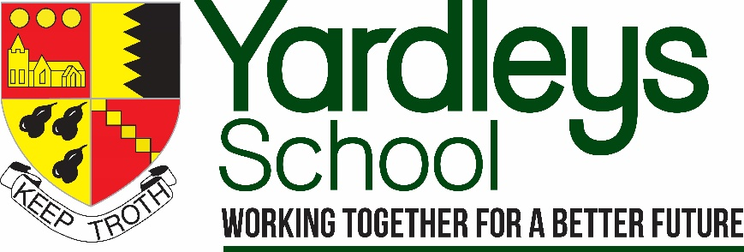

INFORMATION FOR PROSPECTIVE CANDIDATES

Headteacher: Mr B Evans B A (Hons.), NPQH
Reddings Lane, Tyseley, Birmingham, B11 3EY
Tel: 0121 464 6821
www.yardleys-vle.com

Information for candidates
“This outstanding school exemplifies the very best in educational provision, showing that young people can achieve exceptionally well, irrespective of circumstances that for many would put them at risk of failure” – Ofsted 2010

Context and basic information
Yardleys School is a highly successful mixed 11-16 comprehensive and stand-alone academy serving an area of high socio-economic deprivation. Yardleys is a multi-cultural school which reflects the diversity of the local community. 97% of the pupils are from minority ethnic backgrounds and the percentage of pupils with English not as first language currently stands at 78%. The school also has more boys than girls (55% to 45%) on its roll. The school has a much higher than the national average number of students who are eligible for Pupil Premium (at 49%).

Overall standards and reputation

The school has an excellent reputation both locally and across the city. This is reflected in the school being significantly over subscribed with a further increase in demand in recent years.

The school is highly focused on raising standards of pupil attainment and is successful at doing so. Yardleys School is ‘above average’ and in the top 20% of schools nationally for progress (Progress 8 +0.48 for 2019) despite the average attainment of students arriving in Year 7 being well below the national average. The progress of pupils is above the national average in most subjects including Maths, English and Science. The achievement of boys and disadvantaged pupils have improved in recent years to above the national average.

The school was judged ‘outstanding’ in 2010 and was recently inspected in February 2020. This Section 8 inspection focussed on pastoral care, behaviour and safeguarding. We are delighted that Yardleys continues to be an outstanding school, with inspectors highlighting a wide range of strengths and positive features.

There are well established and effective leadership roles and pastoral systems. This has resulted in a very well-ordered school. Indicators such as attendance and exclusions are all better than national averages.

Other indicators of high standards include:
- Positive feedback from staff, pupils and parents
- High staff retention
- A well organised school
- Excellent standards of financial management and regulatory compliance

Vision and values

The school has two mottos; firstly, the traditional words of ‘Keep Troth’ (keep faith) – which can be seen on the traditional school badge – signifies the school’s longstanding determination to foster belief and resilience in our young people. The second - ‘Working together for a better future’ - again identifies the ethos of collaboration but also the very clear ambition to continually improve the school and the life chances of our pupils and the wider community.

As well as the overall mission the school has three key aims which inform its work:
- To achieve academic excellence
- To educate the whole child
- To work collaboratively and ethically to deliver the highest standards of education

At the heart of everything that we do as a school community are our values of Positivity, Integrity, Empathy, Curiosity, Resilience and Reflection. These, together with our three school rules of being ‘Ready, Respectful and Responsible’, are encapsulated in our Yardleys School Charter.
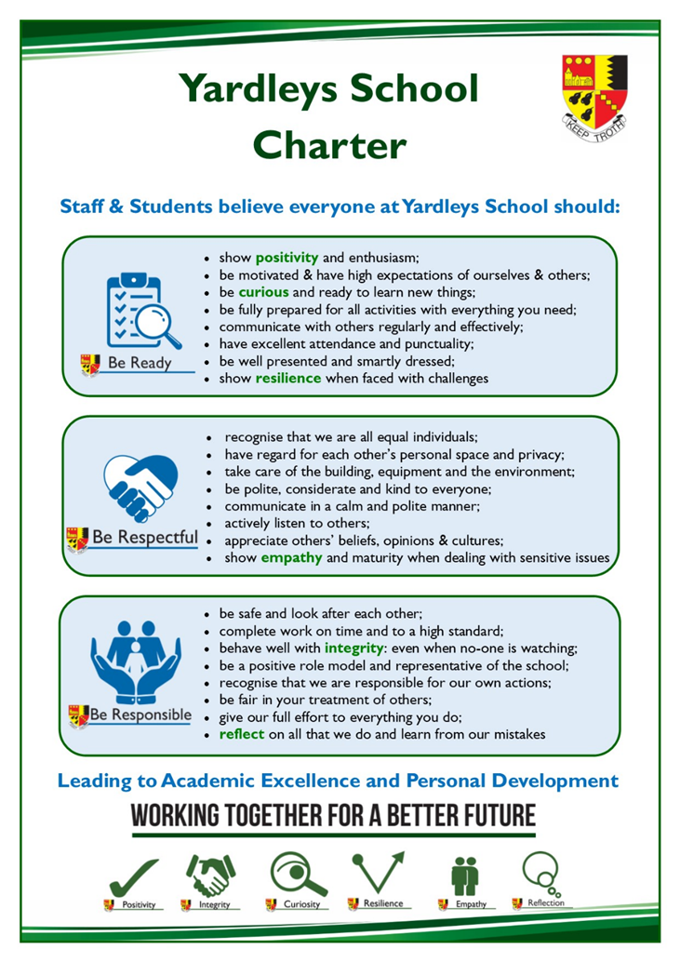

School leadership and governance
The current Headteacher has been in post since 2015, having been the Deputy Headteacher in the school previously. There are two Deputy Headteachers and two Assistant Headteachers and a Business Manager who constitute the senior leadership team. SLT members are highly visible around the school and proactively support children and adults alike. The senior team recognises the vital importance of both being organised and communicating regularly with staff. To this end they hold a daily briefing with all staff

where notices, reminders and public ‘thank yous’ are shared every morning. School leadership and management is viewed very positively by staff.
There is a wealth of experienced and effective middle leaders including Heads of Department/Subject, Heads of Faculty and Heads of Year. The school has moved towards more distributed leadership with some of these middle leaders having whole school responsibilities.
The school is a stand-alone academy having chosen to convert in 2013. There is a ‘flat’ governance structure, where Governors are both members and directors of the Trust. The Governors are extremely supportive of the Headteacher and leadership team, believing that an excellent school is based on teamwork. The Governors recognise the important distinction between governance and management and work tirelessly to ensure the success of the school. They regularly visit the school to see first-hand different aspects of the school in action. Governors are forward thinking and retain a deep commitment to ensuring the school continues to serve its local community.
School leaders and Governors have identified several key priorities for the future development of the school including:
- Re-establishing normal school life and standards after the prolonged disruption of the Covid-19 pandemic
- To use the OFSTED template of ‘intent, implementation and impact’ to further develop the curriculum, particularly academically and at subject level
- To further improve standards of pupil safeguarding, attendance, behaviour, motivation and personal development
- To ensure the continued sustainability of the school through effective management of staffing, school finances and other resources

Staffing
One of the main factors in the sustained educational excellence at Yardleys can be attributed to the expertise, commitment and hard work of all staff. There are currently 100 members of staff including 60 FTE teachers. The school is fully staffed with no vacancies and this is a typical feature at Yardleys.
There is a distinct and highly valued ethos of collaboration and mutual support which makes Yardleys a special place to work. It is not uncommon for supply teachers to comment on this positive atmosphere. Surveys and exit interviews show that staff are proud to be part of Yardleys and enjoy their work. Staff are ambitious for further school improvement as can be seen in the objectives they set themselves and their teams.
Another key feature at Yardleys is how all staff are respected and treated by both children and colleagues regardless of their role or position. Teachers understand the important role that support staff play in organising and managing issues away from the classroom, which allows them to focus on their classroom teaching and this significantly reduces their workload.
The school places high importance on the training and professional development of all staff, particularly those new to the school. This includes an induction, mentoring, weekly training sessions and subject collaborative planning. Performance management is far more focused on improvements in teaching practice rather than just exam results. The School has consistently achieved Investors in People status, most recently re-gaining the Silver award in 2018.

The Academic curriculum
The curriculum shares the same aims as the school, which means a focus on teamwork to provide an excellent academic education as well as one that educates the whole child.
Academically there is a broad and balanced curriculum. The school offers the full Ebacc but this is not compulsory for any of our pupils, as the school has always prioritised curriculum breadth and pupil choice. As a result, subjects such as DT, Media Studies and RE are popular and successful choices for many pupils. The curriculum has a two-year KS3 with GCSE subjects starting in year 9. We have found this to be invaluable in helping pupils academically as well as supporting them personally by reducing the pressure of completing challenging GCSE studies in less than two years. All pupils study the three separate sciences rather than a combined course. There is also a general studies interdisciplinary course studied by all year 9, which looks broadly at world history and global issues.
At the core of the curriculum are the individual subjects and departments. The majority of these are highly effective and well-led with subject teams who are well qualified and experts in their fields. Consequently, there are very good standards of teaching and learning across the curriculum. Across all subjects we emphasise the learning of core knowledge and direct instruction as the most effective pedagogy but at the same time giving teachers and subjects the flexibility to develop their own curricula.
There is a school-wide focus on reading and literacy. We offer extra literacy lessons in year 7 & 8 for pupils to improve their reading and writing. Many subjects have reading as a core element in their lessons. In addition, all pupils start the day with a 25-minute reading session led by form tutors.
Other features of the curriculum include: the use of knowledge organisers; providing whole class feedback and the use of online homework tasks and quizzes. Pupils are explicitly taught how to study and revise and are provided with a range of online resources to support them. Learning is checked through regular tests and all pupils sit internal exams during two whole school assessment weeks in December and July.
At the heart of the school’s CPD programme are subject mastery sessions where departments come together each week to further and deepen their subject knowledge, improve planning and develop their pedagogical skills and assessment practice. There are also many other opportunities for teachers and support staff to develop themselves professionally including access to the school CPD library and sharing good practice with each other.
In recent years school leaders have understood that whilst there needs to be monitoring and accountability of teaching and academic standards this needs to be balanced with professional trust, autonomy and workload. This ‘intelligent accountability’ (or what the educational commentator Mary Myatt calls ‘high challenge and low threat’) has seen the school adopt approaches such as collaborative subject reviews and a performance management system that values and rewards commitment to professional improvement rather than a judgment based purely on attainment data.

Educating the ‘whole child’
At Yardleys, we value the education of the ‘whole child’ as much as academic success. There is an emphasis on traditional values, high standards and expectations in all aspects of school life. Yardleys has outstanding pastoral care including safety, behaviour and personal development. This is confirmed through positive staff and parent feedback as well as during the recent OFSTED inspection in February 2020. The school operates a year group system. Each Head of Year has substantial non-timetabled, protected time to carry out their duties to a very high standard. As a result, teachers frequently comment that they are able to focus on teaching in this well-ordered school environment. Yardleys enjoys an excellent local and citywide reputation in this area and regularly attracts other practitioners who seek to learn from our outstanding pastoral team.
Pupils are very hard working and enjoy coming to the school (reflected in the school’s excellent attendance statistics). Behaviour is very good with pupils responding to the regular routines and consistent expectations. Pupils respond positively and demonstrate good leadership qualities when asked to become involved in school life such as organising charity events, participating in school council discussions or becoming prefects. The many displays of pupils’ work reflect the vibrant and creative nature of the school. The school offers a range of enrichment activities including the Duke of Edinburgh award scheme, educational visits, extra-curricular and sporting opportunities. The school has a dedicated enrichment period on Wednesday afternoons, during which pupils can experience activities such as chess, knitting, origami, dance and jewellery-making alongside a range of sporting and other outdoor pursuits.
All teaching staff can expect to be form tutors. There are two form periods every day with the first focussed on reading and the second afternoon period on pastoral issues, homework completion, study skills and personal development.
In terms of personal development the school has introduced a new, taught course, which covers both statutory aspects (sex and relationships) as well as other important issues such as physical and mental health, careers education and personal finance. Students develop strong values of mutual respect and tolerance of those with different faiths, beliefs and characteristics.

Academy business management
Highly effective business management has, for years, provided the bedrock to the school’s high standards and successes. Consequently, the school is extremely well-organised, with well-established and highly effective systems which enable teaching staff to focus on their core business of educating pupils. This impacts positively on staff workload and is a major factor in the school’s extremely high rate of staff retention and successful recruitment. As a result, all staff are valued equally because pupils and colleagues can clearly see the important role that everyone plays in the school.
There is excellent financial management and compliance which means the school has consistently set balanced budgets, has a healthy surplus and an impressive track record of audit and compliance.

Partnerships
A significant strength of the school in recent years has been its work to engage with a range of external partners locally, nationally and regionally. Yardleys School is part of a collegiate of local schools which offers a range of further support and opportunities for all staff. The school has strong working ties with the local schools, post-16 providers and the wider local community. The school also works with three ITT providers – the University of Birmingham, The King Edward’s Consortium and Teach First.

Premises and facilities
The school is fortunate to enjoy excellent facilities on a modern, single site which was re-developed under a PFI arrangement. The building is organised into faculty areas with extensive modern facilities for, in particular, ICT, Science, Mathematics, Sports and Performing Arts. The majority of teachers teach in the same location throughout the week. Other features include an interactive whiteboard and visualiser in every room and laptops being provided for teachers. We work hard to continually maintain and update our facilities, most recently adding two new classrooms and a multi-purpose hall in January 2019. Alongside the new building the school has extensive playing fields and a roof garden.

Covid-19
Like all schools and the rest of the world, this has been a challenging time for Yardleys. The school re-opened in June 2020 after the first lock down and has endeavoured to support pupils both academically and pastorally through 2020 and the start of this new year.
The school has adopted its usual approach of planning thoroughly, being diligent in the implementation of measures, providing regular communication and supporting each other to the best of our ability.
Provision has been made for home learning in a variety of ways including both digitally and with books. We have supported pupils through a summer school, home visits and, when school has been open, high standards of education and efficiency.

Thank you for your interest in our school. More information on many of the points in this document are available on the VLE – www.yardleys-vle.com.

We look forward very much to receiving your application.

