

SIMS, Data & Website Manager

CANDIDATE INFORMATION PACK

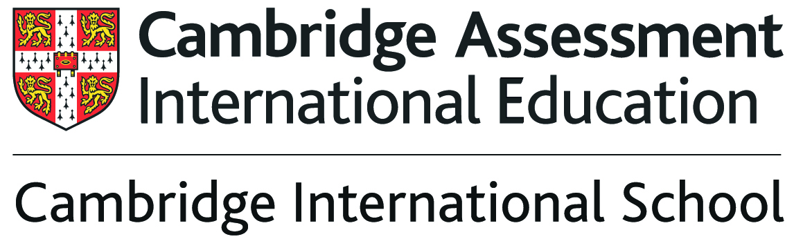

Contents

Letter from the Principal 3

Information about Network International School 5

Vacancy Advert 9

Application Process 10

Job Description 11

Person Specification 12

School Facts and Statistics 14

Vision Statement 15

Helpful Information about Myanmar 16

Letter from the Principal

Dear Candidate

Welcome to Network International School, which caters for over 700 students between the ages of 2 and 18 years and will expand to over 900 students by 2022.

Thank you for your interest in the post of Secondary Subject Teacher at Network International School. I am delighted to have this opportunity to give you some details about Network and to describe the kind of candidate I hope to appoint.

Network is one of the leading British International Schools in Yangon, Myanmar and we have been providing a high-quality education since 1996 based on the UK National Curriculum and Cambridge IGCSE’s and ‘A’ Levels. In 2016, 2017 and 2018 our Year 11 and Year 6 cohorts achieved progress equivalent to Outstanding Schools progress in the UK.

Network comprises a dedicated team of highly qualified international teachers from the UK and other English speaking countries and skilled Myanmar teachers. Every class has an externally trained international teacher, an experienced Myanmar Associate Teacher and in the Primary School at Network one Teaching Assistant. This allows for a high ratio of teachers to students, ensuring each student receives the support they need.

The vision for this school is to provide an outstanding education for students from across the globe. Our International community is represented by students from over fifty five different countries and our aim is that every student leaves the school as a highly qualified young adult, well prepared for the next stage of their education and with a wealth of experience in the wider world. We aim to achieve this by ensuring everyone associated with the school commits to achieving outstanding progress, enjoys and engages in their learning whilst being prepared to take on challenges they might meet. An extensive range of extra-curricular activities such as trips, clubs and a range of sporting opportunities support our academic curriculum.

The school sets the highest expectations for all students and by working together in a triangular partnership of teachers, students and parents we enable our students to lead enriched, happy and fulfilled lives, making a contribution to Network International School, Myanmar and the global community.

The post will suit an outstanding teacher who is interested in developing their career in an international setting. The candidate needs to be passionate about their subject and have a desire to make a difference to international children’s lives. The successful candidate will be an inspirational role model and share in our commitment to the education of the whole child.

We are looking for someone who is starting out in his or her career or who already has an outstanding record in the classroom to join us in August 2019. We can offer the right candidate a hugely exciting and unique opportunity to be involved in an international school.

Please visit our website at www.networkinternationalschool.com for further information about Network International School.

I look forward to hearing from you.

Yours sincerely


Carl Dent
Principal - Network International School

Information about Network International School

Today’s ever changing world is an exciting place for young people overflowing with fascinating opportunities and challenges. At Network International School we open a door to that world and with our support students from across the globe can create rewarding lives, successful careers and make their mark on society.

Network International School is Cambridge accredited and caters for over 900 students between the ages of 2 and 18 years.

The school vision is to provide an outstanding education for students from across the globe. Our International community is represented by students from over fifty different countries. Our aim is that every student leaves the school as a highly qualified young adult, well prepared for the next stage of their education and with a wealth of experience in the wider world. We aim to achieve this by ensuring everyone associated with the school commits to achieving outstanding progress, enjoys and engages in their learning, whilst also being prepared to take on challenges they might meet.

Outstanding academic achievement is very important for future success, as is the need to develop an affinity with lifelong learning. Students at Network International School make outstanding progress. Our curriculum is delivered through our student centred education with a positive climate for learning permeating every phase of the school. It provides high-quality inspirational learning from the Early Years Foundation Stage onwards to develop students’ responsibility for their own learning in preparation for university and the world of work. The curriculum blends high-quality imaginative learning with small class sizes and a low student teacher ratio, to impact positively on student achievement.

Teaching and Learning
We aim for the very best in classroom education enabling all pupils to achieve success and gain valuable knowledge and skills. A wide range of techniques, tailored to meet the needs of all students are used in lessons and we strive to develop transferrable skills across the curriculum.
In every lesson we expect to:
- Stretch, challenge and support our students
- Inspire interest and curiosity
- Develop reading, writing and mathematical skills
- Provide opportunities to work in groups as well as developing independence and resilience
- Build confidence, encourage students to take responsibility and expect students to push themselves to make the best progress

Supporting our students
Support for our students is based on our triangular partnership of students, parents and school. Every member of our teaching staff is committed to supporting students so they can reach their full potential. We want everyone to feel part of the Network family. We employ a team of skilled and specialist staff whose role it is to ensure that all students progress and feel happy and secure in their surroundings.
We want parents to be involved in their child’s education and hope they will attend the various events, performances, award ceremonies and sporting activities that take place throughout the year. Network International School hosts dedicated teacher/parent conferences and provides written reports in all phases, which gives parents information about their child’s academic and personal progress.
This prospectus is designed to give a flavour of what Network International School offers its Myanmar and international students but there is far more than we are able to show in these pages. If you would like to see more, visit our website at www.networkinternationalschool.com or better still why not arrange a visit?

Network International Early Years Foundation Stage

Children in the Early Years Foundation Stage learn by playing and exploring, being active, and through creative and critical thinking which takes place both in class and beyond. We aim to provide valuable and meaningful experiences that will set every child up for a successful learning career. We aim to do this in an environment, which is happy, constructive and nurturing.

Foundation 1

The aim of Network Foundation 1 is to give children between the ages of two and three years a safe and happy environment, where they can grow in confidence and independence in preparation not only for school but for life. In Foundation 1 we believe that every child is an individual and that by nurturing their uniqueness through play and creative expression, they will continue to grow and blossom into confident and enthusiastic learners.

Foundation 2 and 3

In Foundation 2 and 3 the British EYFS curriculum is followed. There are seven areas of learning and development. All areas of learning and development are important and inter-connected. Three prime areas are particularly crucial for igniting children’s curiosity and enthusiasm for learning, and for building their capacity to learn, form relationships and thrive. These three prime areas are:

- Communication and language
- Physical development and
- Personal, social and emotional development.

We also support children in four specific areas, through which the three prime areas are strengthened and applied. The specific areas are:

- Literacy;
- Mathematics;
- Knowledge and understanding of the world; and
- Expressive arts and design.

The Early Years Framework prepares children for the National Curriculum when they progress into our primary school.

Network International Primary School

We believe that the primary years shape students futures. As well as giving them the essential tools for learning, primary education is about students experiencing the joy of discovery, solving problems and being creative. Our aim is to provide an inspirational outward looking global curriculum that develops high standards of literacy and numeracy as well as stimulating students’ creativity. English and Maths are taught every day to ensure clear progression; Art, Computing, Music, Physical Education, PSHRE, Science and Topic complete our curriculum. This provides our primary students with the self-confidence and skills to become lifelong learners whilst also preparing them for the transition to secondary education.

Key Stage 1

In Key Stage 1 there is a strong focus on the transition to a more formal structure of the curriculum and children learn the necessities to build a solid foundation for their learning. The curriculum is strongly based on learning through tangible activities giving students opportunities to settle into a more formalised classroom setting. Through the provision of a well-rounded curriculum children are able to build the necessary skills to allow them to progress and develop at their own rate. The children are also introduced to the culture and language studies of Myanmar to help build on their knowledge of the country they live in.

Key Stage 2

In Key Stage 2 students are further challenged; strengthening and developing the skills they have learnt in Key Stage 1, thus enabling them to perform well in all subjects. All students follow the National Curriculum and learn through experience and inquiry based learning. This helps them to become more independent learners, allows them to take ownership of their learning and enables them to become secondary ready by the end of their primary education. During Key Stage 2 students gather the skills needed to become confident learners and show their creativity within their learning. Myanmar studies, due to the importance of the culture we live in, are further developed in lessons during this Key Stage.

Network International Secondary School

Our secondary students flourish at Network International School. Each learner is valued and respected equally and enjoys the highest possible standard of education. Our secondary education promotes the highest standards of achievement in academic attainment enabling every student to leave Network International School academically well qualified through Cambridge IGCSE and Advanced level qualifications and well prepared for University life and their chosen careers.

Key Stage 3 Curriculum

In Key Stage 3 all students follow the revised 2014 National Curriculum adapted for an International context with a full range of subjects including English, Maths, Science, Art, Drama, French, Geography, History, ICT, Music, Myanmar Studies, Personal, Social, Health and Religious Education, and Physical Education. Learning provides the foundation for study at Key Stage 4 and is enjoyable, meaningful and exciting. Students develop learning and thinking skills as part of their independent learning repertoire.

Key Stage 4 Curriculum

In Key Stage 4 students study for IGCSE qualifications awarded by the Cambridge Examinations Board. The two-year IGCSE programme is academically challenging and Cambridge IGCSE is the world’s most popular international qualification for Key Stage 4 students. It is recognised by leading universities and employer’s worldwide, and is an international passport to progression and success. All students study a core curriculum of English, Mathematics, Science, and Physical Education. Students then have access to a range of Cambridge IGCSE option courses where they will be able to make a guided and informed choice from subjects such as: Additional Mathematics; Art; Business Studies; Computer Science; French; Geography, Global Perspectives; History; ICT Physical Education and the Sciences.

Network International School Sixth Form
Network International School seeks to provide a Sixth Form experience which promotes confidence, creativity, leadership and learning ensuring students leave the school academically qualified and with a breadth of experience in preparation for their University courses. The Sixth Form curriculum provides high-quality inspirational learning, enabling students to enter the University of their choice.

Key Stage 5 Cambridge Advanced Level Qualifications
In Key Stage 5 students study for Advanced Level qualifications awarded by the Cambridge Examinations board. Network International School offers a wide range of courses for students to choose from and the syllabi develop a deep understanding of each subject and independent thinking skills. Cambridge International Advanced Level qualifications are a ‘gold standard’ and a passport to success with students gaining places at the top universities all over the world including Cambridge, Oxford, Harvard and Yale
Sixth Form is a transition from IGCSE to University with an increased emphasis on independent study and individual development. As a student in Network’s Sixth Form you will have greater flexibility and more study time, which will provide you with a taste of the experience you can expect at University. From the very beginning of Year 12, students will have the opportunity to develop their leadership skills and full guidance is given on careers as well as University applications.

Vacancy Advert
Job Title: | SIMS, Data & Website Manager
Salary: | Competitive salary based on skills and experience
Contracts: | Two Year permanent
Hours: | Full Time
Start Date: | August 2019

Are you interested in working in a unique international school and share in its exciting future as Myanmar develops rapidly as a country over the next few years?

About the school:
- All through 2-18 international school in Yangon, Myanmar
- Network is one of the leading British International Schools in Yangon
- Network comprises a dedicated team of highly qualified international teachers
- Network is a small school setting with three classes in each year group
- The vision of Network is to provide an excellent education for young people so they may become independent, active and responsible members of society

We offer:
- Competitive salaries based on experience and skills
- One Return air fare per year
- Worldwide Health Insurance
- Rental allowance per month
- An international community
- A Continuing Professional Development Programme
- 100% school fees remission for dependent children
- Visa run allowance in terms 1, 2 & 3

Application Process

We hope that after reading the information pack you will want to apply for the post advertised.

For an application pack please email careers@networkintlschool.com or visit the school website. To discuss this post please contact Carl Dent principal@networkintlschool.com
Skype interviews will be held from w/c 04 February 2019.

If you would like to visit the school please contact Tracey Westwood at tracey.westwood@networkintlschool.com

Please send your CV with a supporting statement, addressing the Person Specification to careers@networkintlschool.com.

Network International School is committed to safeguarding and promoting the welfare of children and young people and expects all staff to share this commitment. To that end identity, security and medical checks will be required from the successful applicant. The school is also an employer committed to equal opportunities and welcomes applications regardless of age, gender or ethnicity.

Job Description - MIS, Data, Website & Personnel Coordinator at Network International School

About the Role
Job Title | MIS, Data, Website & Personnel Coordinator - Network International School
Salary | Competitive
Hours of Work | Permanent, Full Time
Accountable to | School Business Manager & Principal
Job Purpose
Leading & Managing the Schools Management Information System, data, school website and personnel support to ensure a high quality education is provided for all Networks students.
Areas of Accountability
- Leadership, management and development of the schools Management Information System.
- Responsibility for and development of the school website and Facebook accounts.
- Technical and developmental support for student data and reporting processes.
- Provision of MIS support for the admissions process.
- To carry out any such duties as may be reasonably required by the Principal of Network School.
Specific Duties and Responsibilities
- Management of all aspects of the MIS System:

- Prepare and publish the MIS user guides/reports
- Co-ordinate the training of new staff and updating existing staff with new updates on the MIS and support staff in their day to day use of the system
- Overseeing and co-ordinating the attendance officer
- Manage system permissions, issuing passwords and ensuring all staff have correct access to the MIS
- Create and maintain the assessment database and ensure that assessment data held on students is accurate and complete
- Manage the production and development of all school reports from EYFS to secondary
- Ensure and manage the smooth transition from one academic year to the next with all sections of the MIS
- Ensure all student and staff photographs have been uploaded onto the MIS
- To be responsible for effective communication with the Principal & Admissions Officer to ensure effective administration of admissions and archiving of students
- To produce a monthly on/off roll information sheet to ensure that this is communicated to the Principal and Admissions Officer
- To support the annual EYFS/Primary & Secondary transfer process by supporting the ranking of incoming students in order to group students effectively; ensuring all relevant student records are imported into the MIS and that details are checked for accuracy.
- To ensure that twice a year contact details are sent out to parents to check contact details are correct and updated on the MIS with any changes.
- To produce reports, information and data as required using SIMS and other Microsoft applications
- To input, analyse and evaluate data and information.
- To be responsible for gathering, processing and presentation of student assessment information.

2. To provide MIS support in liaison with the Examinations Officer:

- Providing assistance to the examinations officer with regard to the MIS data for examination entries

3. Managed Learning Environment & Strategic Development of ICT

- To oversee effective use and updates relating to the school website, Facebook & LinkedIn accounts
- To ensure all student news/planned events/newsletters/parent letters relating to the school are uploaded to the school’s website
- Co-ordinate with teaching and support staff any updates needed on the website
- To coordinate and implement the school App information to parents
- To coordinate and send out school emails to parents

4. Management of Visa, Personnel & Library Requirements:

- To update lists of Personnel who require Visas and to ensure staff are advised when their Visa is due to expire
- To ensure all visa information is accurate, up to date and available to staff
- To provide staff with letters and documentation relating to Visa updates
- Managing email accounts: adding accounts, removing accounts and checking email accounts for staff through Gsuite (Google Accounts)
- To manage the school Admin email account, ensuring all emails are responded to or forwarded to the relevant person(s)
- Managing insurance for international staff: liaising with our insurance group to manage all members and provide staff with their medical certificates/cards
- To oversee Library book orders
- To liaise with staff and oversee sports uniform orders

5. Other Specific Duties

- Play a full part in the life of the school community, supporting its distinctive mission and ethos, encouraging and ensuring staff and students follow this example, including representing the school in a professional and positive light at all times and to all stakeholders
- Comply with any reasonable request from the Director or SBM to undertake work of a similar level that is not specified in this job description.
- To proactively engage with professional development in relevant areas and participate with the school’s Performance Management process.

6. Safeguarding Children & Safer Recruitment

The school is committed to safeguarding and promoting the welfare of children and young people as required.

School Facts & Figures

Type of School | International School
Owned by | Network International
Age Range | 2-18
Location | Yangon, Myanmar
Denomination | Secular
Co-Educational or Single Sex | Co-educational
Number on Roll | 700
Class Size | Maximum 22

Vision Statement

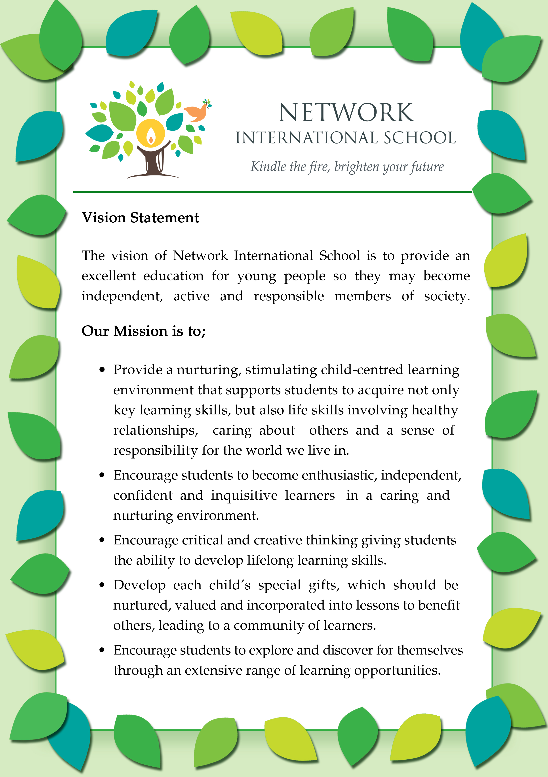

Helpful Information about Myanmar

Potential candidates are encouraged to research Myanmar in addition to the information given below:

General Information on Yangon
Information on Yangon can be found on many Google search engines to get details about the country, climate, vaccinations, weather, clothing, shopping, getting around, living and accommodation costs.

Visa
When you join Network International School we will provide you with all the necessary documentation which will include an invitation letter from us which you will need to produce at Immigration at Yangon airport for obtaining your business visa.

You can also obtain your visa by taking the documentation we provide you with, together with our passport to the Myanmar Embassy before you come to Yangon. If you decide to obtain your visa this way it will save you time when arriving in Yangon. You will need to contact the Myanmar Embassy to find out the cost, duration of the process and what you need to take with you to the Embassy.

Once you have left Yangon twice and have come back into the country and have obtained two immigration stamps in your passport, you will be eligible to apply for a one year visa. This means you can come and go as much as you wish without having to complete and submit documentation each time you arrive in Yangon. It also saves a lot of immigration stamps in your passport which in turn will save many of your passport pages from being used.

If you would like to know more about Myanmar visas, you can get more information on this website which can be found on the link below:

http://www.mip.gov.mm/portfolio/types-of-visa-fees-and-duration/

Currency
Cash is the main form of money you will use in Myanmar unless you are paying online. You can open a Myanmar bank account where you will be given a cash card which can be used for withdrawing money from an ATM machine, you are also able to use this card in some restaurants and shops in Yangon and for booking flights and hotels etc. You are not able to transfer money in and out of Yangon from overseas bank accounts.

The currency is Myanmar Kyat (MMK) and as the exchange rate with US $ is fluctuating, at the present time it is advisable for applicants to check on XE Exchange website or similar exchange sites. You can exchange money in most places you go in Yangon and the rates vary. They are very fussy about the condition of the US notes and you get a better rate for $100 bills; they must be clean and crease free.

Remember to let your banks/credit or debit card providers know that you will be here if you want to still use your card here (e.g. flights, hotel bookings etc), otherwise they may see the transactions as fraudulent. International teachers are paid in US dollars in cash on the last Friday of the month.

Please always wash your hands or use hand sanitizer after handling the money in Myanmar as they are sometimes not in good condition.

Accommodation
Teachers will need to make and pay for their own hotel arrangements when they initially arrive. We recommend they use www.agoda.com or airbnb but if they require any assistance then the school is happy to help. The school will help you find an alternative that suits you once you are here. Rent is requested from the majority of landlords for twelve months with payment upfront. The school is happy to cover the initial cost with monthly payments being taken from an employee’s salary.

Some apartments for foreigners are fully furnished or partly furnished, but many also require you to purchase at least some furniture.

On Arrival

On arrival new teachers will receive the following:
- Telephone SIM Card + 3,000 Kyats on the telephone card
- 50,000 Kyats Cash
- A set of bed linen

Transport
The best possible method of transport is probably a taxi. They are everywhere you go and the prices are extremely reasonable with most journeys in town around 1500- 3000 MMK. The majority of the drivers speak very basic English so you should easily be able to get from A to B and you can negotiate your fare.

Weather
There are three seasons – wet season, cold season and hot season, each lasting approximately 4 months. At no point does it ever really get cold here unless you are travelling up north.

Internet Access
Wi-Fi is available at most places in Yangon. The majority of restaurants, cafes, bars and shopping malls have free access – you just need to ask the staff for the password. If you’re staying at a hotel then they usually supply you with free Wi-Fi. The internet is not as fast here unfortunately but it is getting better and it’s good enough to Facetime or Skype family and friends. The schools are all equipped with Wi-Fi if you need to access the internet for teaching resources. If you are renting, it is possible to have Wi-Fi installed if you wish. It is relatively expensive for the installation but then the monthly costs aren’t too bad. Alternatively, use a SIM card to use the internet. Further information can be obtained once new recruits join the school.

EYFS & Primary: 23 Inya Myaing Road, Bahan Township, Yangon | Phone: 519306/534212/513057 | admin@networkintlschool.com

Secondary: 29 Highland Avenue, Pyay Road, Mayangone Township, Yangon | Phone: 660565 | secondary@networkintlschool.com

