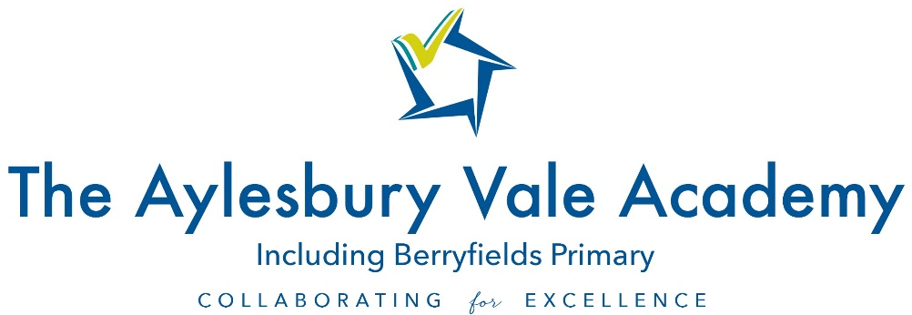

TEACHER OF RELIGIOUS STUDIES AND HUMANITIES

JOB DESCRIPTION

GENERAL DESCRIPTION OF THE POST

The holder of this post is expected to carry out the professional duties of a teacher as described below.

Meet the Professional Standards for Teachers and actively support the vision, ethos and policies of the Academy.

Accountable to: Curriculum Leader

MAIN PURPOSE

To ensure all students reach their potential through delivery of high quality teaching and learning alongside effective monitoring, assessment and target setting.

DUTIES AND RESPONSIBILITIES:

- Encourage and enable all students to achieve the highest possible standards of learning by:

- Setting and sharing clear aims, goals and purposes
- Planning, conducting, reviewing and evaluating learning experiences with regard to continuity and progression content, activities, resources, feedback.
- Making sure the learning environment in the teaching space is stimulating, well organised, attractive, safe and secure.
- Ensuring that the best possible quality resources are used.
- Ensuring that a variety of teaching methods and styles are used with students.
- Making sure that all students have an equal opportunity to succeed.
- Undertaking accurate, relevant and regular assessment, recording and reporting of achievement.
- Deploying support staff and other adults effectively in the classroom, involving them, where appropriate in the planning and management of students’ learning.
- Secure a high standard of student behaviour in the classroom by establishing appropriate and high expectations and dealing with inappropriate behaviour in the context of the Behaviour Policy of the Academy.
- Support team commitment, through collaborative planning and by sharing good practice to create a stimulating learning environment for teaching and learning.
- Evaluate your own teaching critically and use this to improve your effectiveness. Take responsibility for drafting performance management objectives and ensuring agreed evidence is available for review against agreed criteria. Take a positive attitude to professional development.
- Comply with the Academy’s Health and Safety policy, to undertake risk assessments as appropriate.

