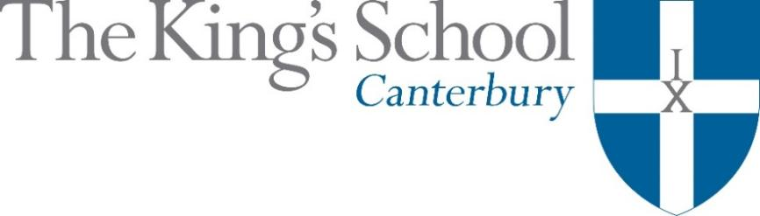

Appointment of a Teacher of Economics
September 2019

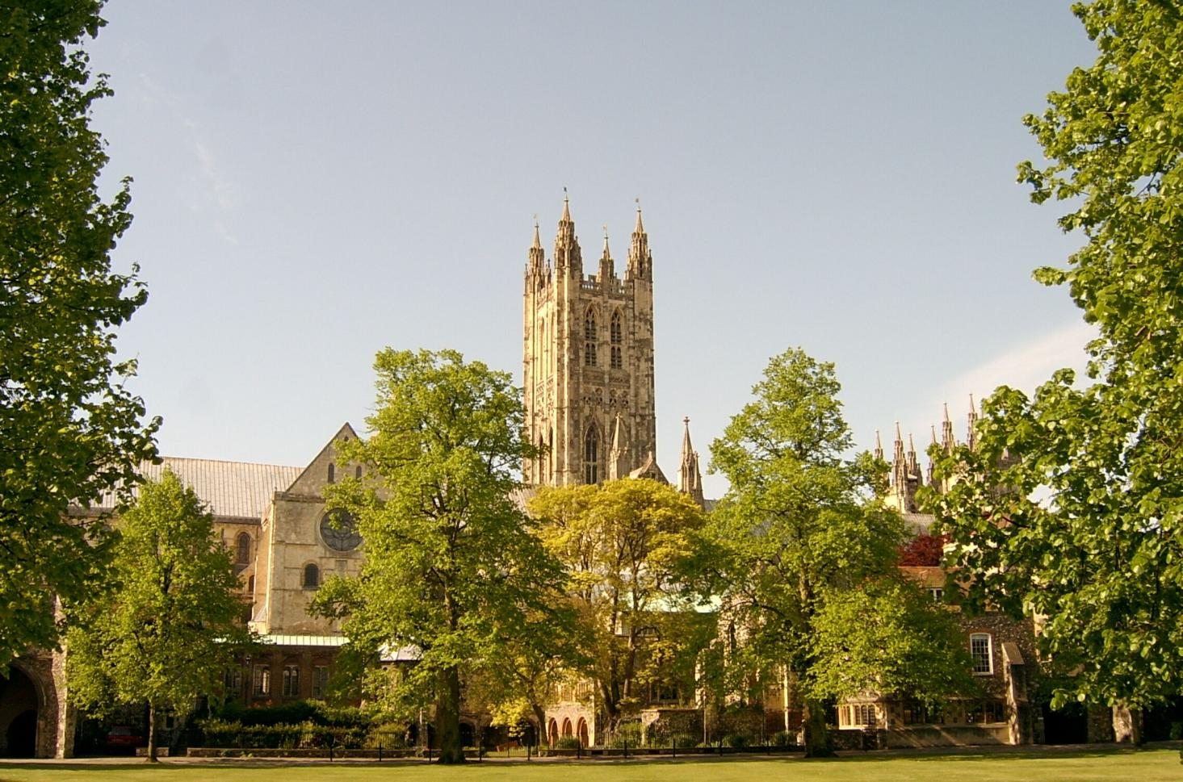

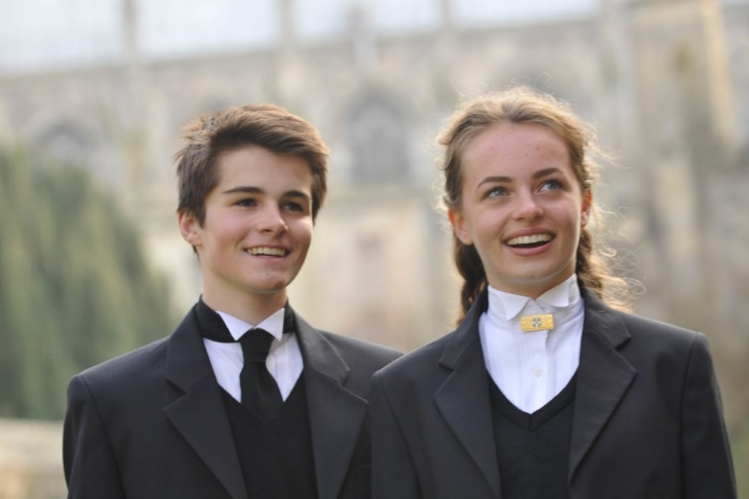
THE KING’S SCHOOL is a leading independent co-educational boarding school, situated in the heart of the historic cathedral city of Canterbury in Kent.

The precincts of Canterbury Cathedral are part of a world heritage site, a centre of pilgrimage and study, and host to over 1 million visitors each year from many different cultures. This international dimension deeply influences the life of the city and the school.

The origins of King’s date back to the arrival of St Augustine in 597 AD and the school’s Christian tradition remains at its heart although pupils and staff subscribe to many different faiths and beliefs and none. Embracing this diversity, there is a desire to foster fairness, tolerance, courage, perseverance, mutual respect and understanding. The Benedictine tradition of developing mind, body and spirit within a community given to hospitality still influences the life of the Cathedral and the school lives out its life in that context. Thus, academic excellence and scholarship take their place alongside the school’s commitment to physical and cultural endeavour. Sport is strong, with a number of boys’ and girls’ teams at national level. Music and drama are outstanding, both having the finest traditions and producing performances of the highest standards. King’s Week, the school’s own Festival of Creative and Performing Arts, attracts thousands of visitors each summer.

The curriculum at King’s is based upon strong academic roots. It emphasises and relies upon what is best in traditional school education: scholarly excellence supported by a caring pastoral and tutorial system, and a wide-ranging co-curricular programme. The curriculum is continually adapting and reacting to the changing demands of modern education: new subjects are added, new teaching techniques adopted, and there is an increasing awareness of the need to provide programmes of study that match individual needs and skills. The school does not gauge its success by exam results alone but by broader measures of educational attainment and personal development, helping pupils to achieve their potential and equipping them to play an active and responsible role in society as young adults.

Our family of schools comprises The King’s School, Canterbury (KSC), The Junior King’s School (JKS) and, from September 2018, the International College. At KSC there are currently 851 pupils, split 50-50 boys-girls, of whom about 80% are boarders. There are six boys’ boarding houses, seven girls’ boarding houses and three mixed day houses. Junior King’s occupies a fine rural site on the banks of the River Stour, in Sturry, two miles from Canterbury. There are over 375 pupils at Junior King’s of whom 20% are boarders.

The King’s School occupies various sites around the Cathedral and its precincts. Many teaching departments and the majority of houses are in the beautiful ancient buildings around Green Court on the north side of the Cathedral. To the east of the Cathedral the St Augustine’s site is home to five boarding houses, a medieval refectory, and the magnificent neo-Gothic school library (shown in the picture below). There are two major sites for sport: Birley’s, and the Recreation Centre, both within walking distance of the school, with rowing at Westbere Lakes in Sturry. The International College opened in September 2018 as the third school in the King’s family, and a fourth school will open in Shenzhen, China, in 2019.

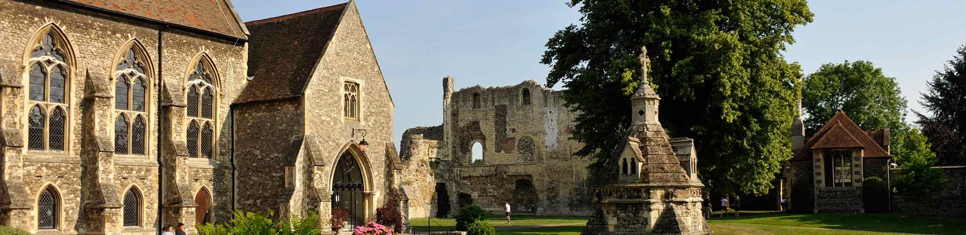

The school library, Undercroft, and ruins of St Augustine’s Abbey on the St Augustine’s campus at King’s

www.kings-school.co.uk

The Role
We seek to appoint a qualified and motivated graduate to teach Economics A Level from September 2019.
The post is suitable for a man or a woman who is a fine communicator and who combines academic ability, charisma and energy with good humour, flexibility and tolerance. The successful applicant will be able to share a genuine passion for Economics and will be able ultimately to teach the subject across both the Micro and Macro halves of the course.
A PGCE or equivalent is desirable but not essential, and no teaching experience is necessary: we welcome applications from those finishing their degree courses, recent graduates, as well as experienced teachers; those considering a change of career are also welcome to apply.
Economics at King’s
The department comprises five full-time members of staff who are academic, colourful characters and multi-talented. It has a balance of youth and experience plus a wide range of expertise outside of the classroom (four members of the department came into teaching from previous careers in business and finance). In addition to working hard to achieve outstanding examination results, we contribute to the wider running of the school e.g. coaching sport, running young enterprise and the business club activity, actively supporting UCAS and careers activities and contributing to King’s Week (the annual summer Arts Festival). All teachers look after tutees and fulfil weekly house duties. One of the department is a Housemaster and another is the Deputy Head of Sixth Form.
Students follow the Edexcel A level Economics course, have two teachers (divided Micro and Macro), and are put into mixed-ability sets of between nine and thirteen pupils. The subject is very popular in the Sixth Form with about 140 students taking Economics (45% of 6b, Year 12, and 40% of 6a, Year 13). Results are impressive (90% A*-B Grades at A level) and last year over forty leavers elected to read Economics or a related subject at university.
Economics teachers at The King’s School are very active in running extra-curricular programmes related to their subject. Students are expected to deepen their classroom understanding and apply their newly gained knowledge by participating in a wide range of activities outside of the classroom. The Economics Society meets weekly and provides the opportunity for students to discuss and debate topical news. Students take part in various national competitions e.g. the Student Investor Share Challenge. Several economics study field trips are organised each year e.g. six days in New York; a day trip to local Kent businesses (Dover Port, The Shepherd Neame Brewery, Thanet Earth, Dreamland) and visits to London businesses (including Lloyds, Shell International, the Bank of England). External speaker events are regularly held on site (e.g. from an HSBC Global Risk manager and the Editor of the Economist) and students are taken to public talks (e.g. the Marshall Society Conference at Cambridge University).
Additional coaching is provided for students who are entering essay competitions. In 2016 a King’s School student won the prestigious Royal Economics Society essay competition, beating 1,700 students to the first prize of a £1,000 (in 2017 a King’s student was highly commended). Extra teaching support is given to those doing an Extended Project on a title related to Economics and Business. Those pupils who apply for Oxbridge Economics also receive a special, more intensive, programme of study.
The department is very well-resourced. The Economics section in the main library is well-stocked and coordinates on line access to all the key Economics journals, magazines and newspapers. Each of the Economics classrooms retains a core library for immediate teaching reference and are equipped with interactive white boards. There is Wi-Fi throughout the school and all teachers are issued with an iPad. The Economics intranet website is extensive and used frequently by both staff and students. Departmental budgets are in place for the funding of external speakers and conferences.
APPLICATIONS
Applications should be submitted online through the King’s School website (www.kings-school.co.uk – Staff Vacancies), and should include a personal statement for the Headmaster and a CV by 9am on Tuesday 23rd April 2019. If you have any difficulties accessing the internet please contact the School Office: reception@kings-school.co.uk; 01227 595501.
Those considering applying but requiring more information can contact the Head of Economics, Charlie Chester,
for an informal discussion: snc@kings-school.co.uk.

