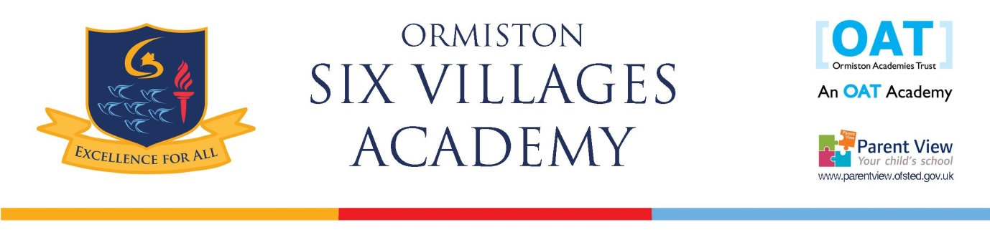
Science Teacher
Ormiston Six Villages is an 11-16 Academy. Since the new Principal commenced in role in January 2016 the academy has been on a transformational journey leading to a Good Ofsted rating in September 2017. With more still to do, this is an exciting time to join our team and to be part of building a beacon of educational excellence.

We are looking to appoint an inspirational Science teacher who shares our belief in the highest standards of academic attainment in a comprehensive setting. This is a rare opportunity to be centrally involved in establishing an outstanding department and school. The role is suited to a main scale science teacher or an NQT looking to develop further as an outstanding teacher.

The successful candidate will:
- Have excellent subject knowledge
- Demonstrate the ability to achieve outstanding student outcomes
- Possess the skills and determination to make a significant difference to the lives of the community we serve

They will have the opportunity to:
- Play a significant role in the development of Ormiston Six Villages Academy
- Be involved in the design and development of the science curriculum
- Join the OAT family and receive comprehensive CPD through the school and associated networks

If you are seeking a challenging and highly rewarding position where you enrich the lives of the pupils who attend Ormiston Six Villages Academy, then we want to hear from you.
For a candidate information pack and a confidential/informal discussion, please contact Mrs Canadas 01243 546802 or ccs@ormistonsixvillages.org.uk. Visits to Ormiston Six Villages Academy are encouraged and can be booked through Mrs Canadas. Please include a supporting statement with your application of no more than 2 pages of A4 outlining how your knowledge, skills and experiences to date have prepared you effectively for the role of Science teacher at Ormiston Six Villages Academy.

Location: Westergate, Chichester
Reporting to: Head of Department
Start date: September 2018 or sooner
Deadline: 4th January 2018 at noon
Interview date: 12th January 2018
Salary: Mainscale/UPS

The Academy is committed to safeguarding and promoting the welfare of children and young people/vulnerable adults and expects all staff and volunteers to share this commitment. The successful candidate will be subject to an enhanced DBS check.

