



DBS Online Disclosure Guide (e-Bulk)
Applicant Guidance Notes

APPLICANT GUIDANCE NOTES

An online DBS check can be completed by accessing the internet from any PC/Laptop that has this facility. If you do not own your own computer you can go to any internet café or local library. Please be aware that you must complete your application form in full as part completed applications form cannot be saved.

LOGGING ONTO THE SYSTEM

Please enter the following address in the web browser:

https://disclosure.capitarvs.co.uk/stoke/

If you are not taken directly to the ‘Start New Application’ page, please click on ‘Start Application’ in the orange box entitled ‘DISCLOSURE AND BARRING SERVICE (DBS) APPLICATION’ to enter the system and start your application.

Please note at this stage of the process your login details are case sensitive.

1. Enter the Organisation Reference that has been supplied to you by the company that you will be/are working for.

2. Enter the Password that has been supplied to you by the company that you will be/are working for.

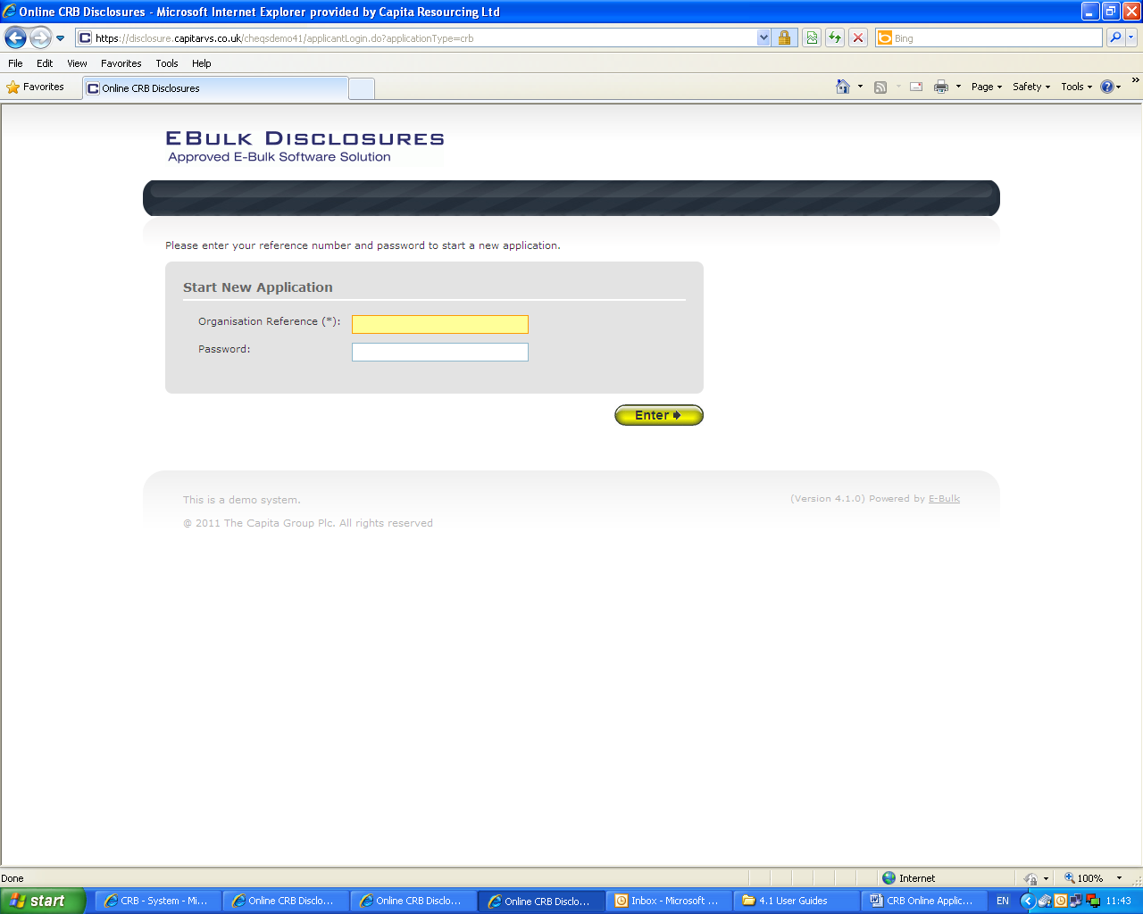

Once you have completed this section click ‘Enter’.

DBS Online Disclosure Guide (e-Bulk)
Applicant Guidance Notes

STATEMENT OF FAIR PROCESSING

You will now be taken to the ‘CRVS Statement of Fair Processing’ outlining CRVS’s terms and conditions. Please read the statement and tick the box to confirm this has been read and agreed to.

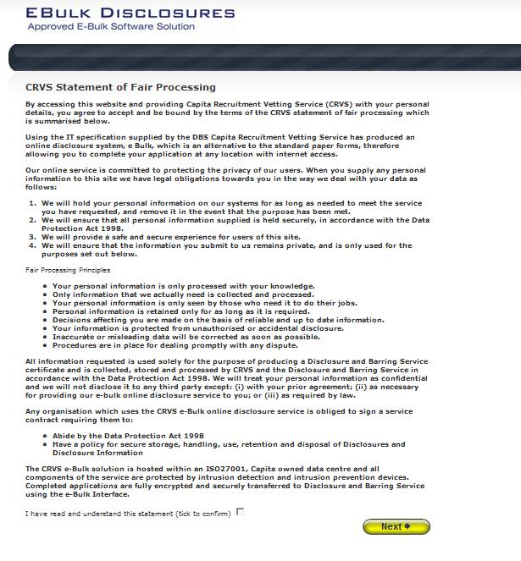

Once you have ticked the consent box please click ‘Next’

g

DBS Online Disclosure Guide (e-Bulk)
Applicant Guidance Notes

APPLICATION PRE-ENTRY STATEMENT

You will now see the application pre-entry statement; this gives concise information in regards to the requirements by the DBS regarding acceptable identification in support of your DBS application.

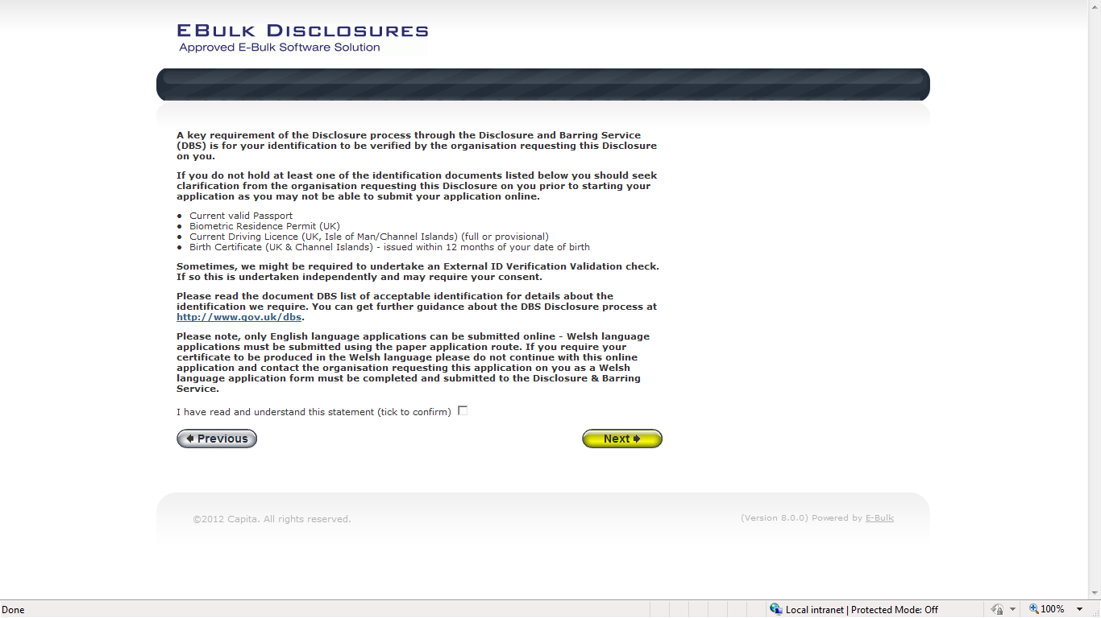

Once you have ticked the consent box please click ‘Next’

- The application form is a simple 5 step process. Please complete all fields.

- Mandatory fields are denoted by (*)

Mistakes on the application form will cause delays in processing.

DBS Online Disclosure Guide (e-Bulk)
Applicant Guidance Notes

SECTION 1 – ABOUT YOU

Please enter your personal details.

If you have any middle name(s) ensure that you enter these details, particularly those that appear on your identity documents, e.g. passport, driving licence, birth certificate, etc. Any missing information from this or any other section can severely delay the processing of your criminal record check.

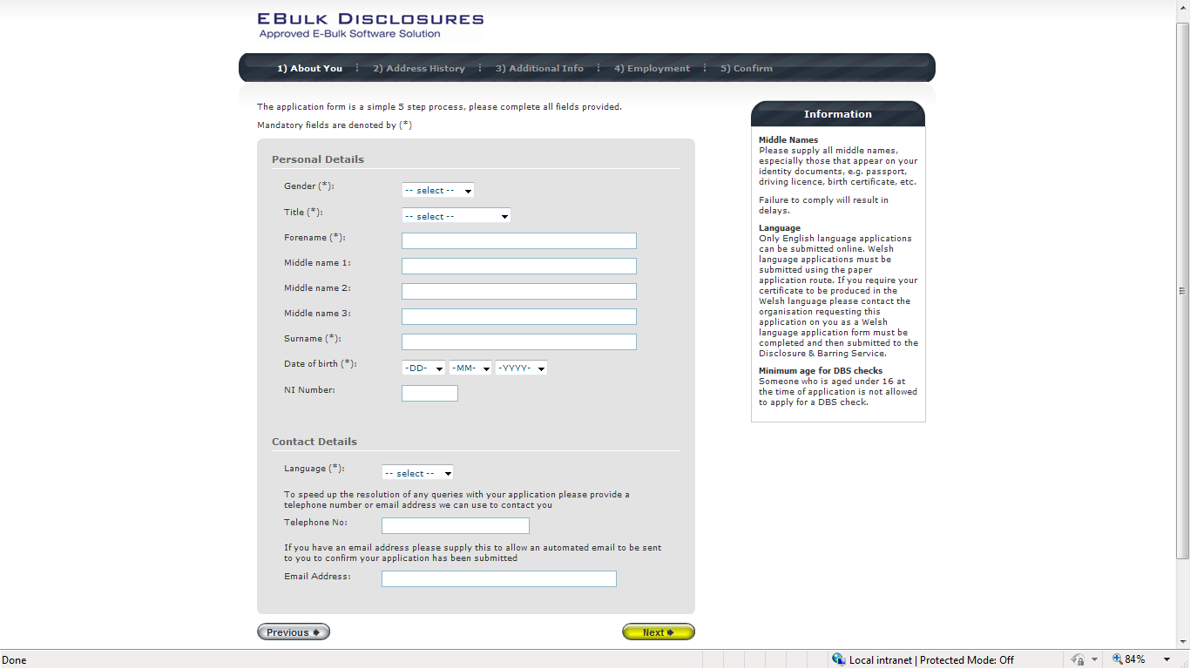

Once you have completed this section click ‘Next’.

DBS Online Disclosure Guide (e-Bulk)
Applicant Guidance Notes

SECTION 2 – ADDRESS HISTORY

Please enter your current address. If you have not lived at this property for more than five years, you will be taken to another screen. Here you will be required to add any additional addresses to ensure your address history goes back the required five years. Please note if you do not provide a minimum of five years address history, you will not be able to proceed to the next stage of the application process.

Address Dates

There cannot be any gaps/overlaps in your address history. Please ensure that the month and year of each address follows that of the previous address. Students who switch between their permanent residence and education establishments must enter each address with dates consecutively, e.g. parents’ address Dec 2009 – Jan 2010, university address Jan 2010 – March 2010, parents’ address March 2010 – April 2010 etc. Do not run addresses/dates simultaneously as your application form will be rejected by the DBS. Once an address has been entered, you can edit any information by clicking on the ‘Edit’ button.

Postcode

Please ensure that all UK addresses have a full postcode; if you cannot remember your postcode please use the Royal Mail UK Postcode Finder link provided within the address information box.

No Fixed Abode UK

If you were of no fixed abode within the UK please enter the nearest hostel address to the location you were based.

Foreign Addresses/Travelling Overseas

If you have travelled overseas and cannot supply the address for a foreign country then please enter ‘no fixed abode’ for Address Line 1. Please then enter the Town/City and Country of where you were residing within this period.

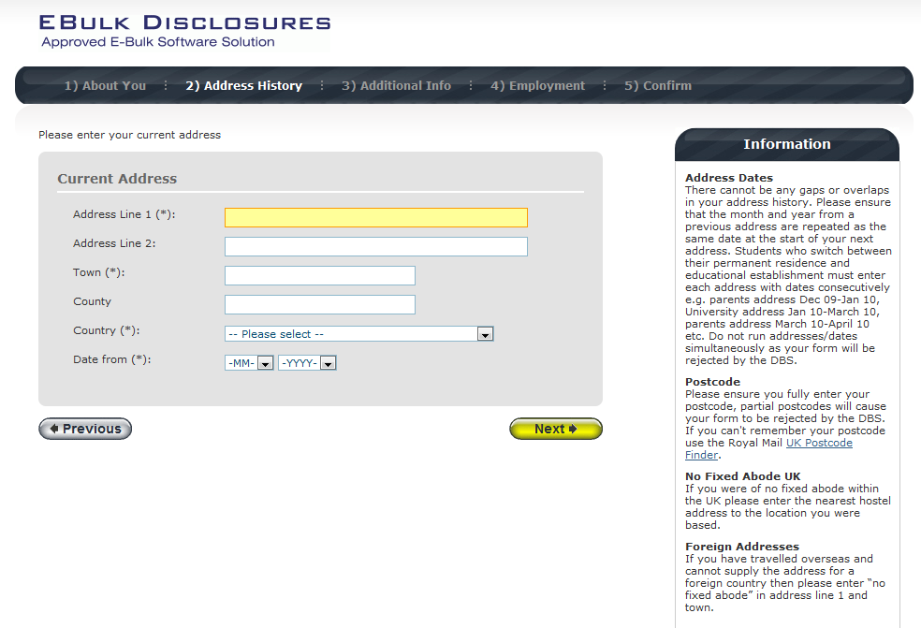

Once you have completed this section click ‘Next’.
a

DBS Online Disclosure Guide (e-Bulk)
Applicant Guidance Notes

SECTION 3 – ADDITIONAL INFO

Place of Birth

Please enter details of your place of birth.

Nationality at Birth

Please enter your Nationality at birth and state YES or NO as to whether this has changed since you were born. If this has changed, you will be required to enter your current nationality.

Changed Surname

If you have changed your surname please provide your birth surname and the year you changed it. Please ensure that where names change they run in date order and with no gaps.

Other Names

Please provide details of any other names used at any time during your lifetime and the dates during which the names were used. Please enter each forename, middle name(s) and surname separately using the 'Add Name' button below. If you have used any aliases, e.g. William known as Bill, please also supply these details.

Failure to supply any additional information may cause your application to be delayed.

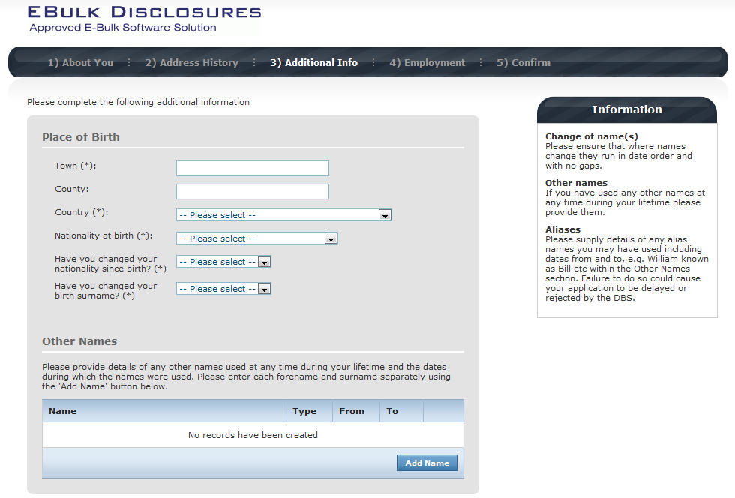

Once you have completed this section click ‘Next’.

DBS Online Disclosure Guide (e-Bulk)
Applicant Guidance Notes

SECTION 4 – EMPLOYMENT DETAILS

Position Applied For

Please insert the correct job role as supplied to you by your current/new employer. You will either be required to select your job role from the dropdown list provided or enter this manually. No abbreviations are permissible, e.g. Admin Asst should read Administrative Assistant. If you are a volunteer do not enter just volunteer, please enter in which capacity your job role is, e.g. Coach.

Failure to enter the correct job role may cause your application to be delayed.

Employer Name

This has been defaulted to the organisation you are applying through and should not be amended.

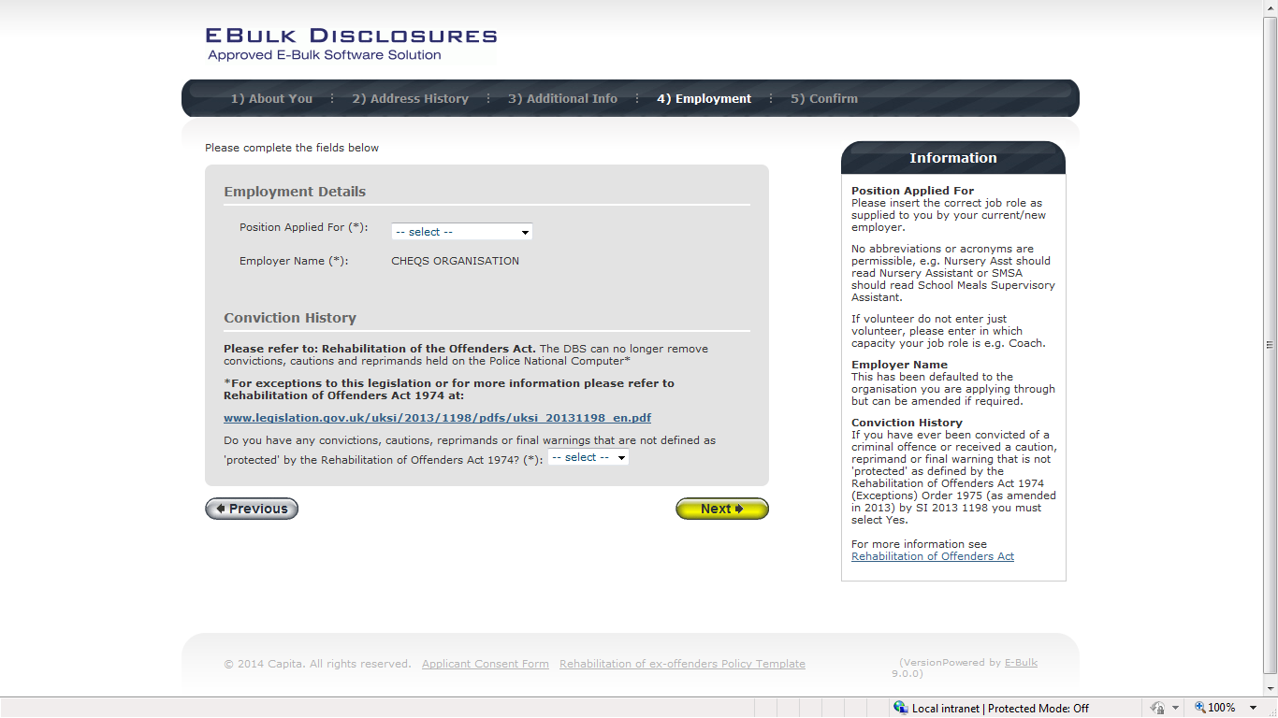

Conviction History

If you have never been convicted of a criminal offence or never received a caution, reprimand or warning then please select ‘No’. If you have been convicted of a criminal offence, or received a caution, reprimand or warning that is ‘protected’ as defined by the Rehabilitation of Offenders Act then please also select ‘No’.

If you have ever been convicted of a criminal offence, caution, reprimand or warning that is not ‘protected’ as defined by the Rehabilitation of Offenders Act then please select ‘Yes’.

For more information, please refer to Rehabilitation of Offenders Act 1974 at:

http://www.justice.gov.uk/guidance/docs/rehabilitation-offenders.pdf

Once you have completed this section click ‘Next’.

DBS Online Disclosure Guide (e-Bulk)
Applicant Guidance Notes

SECTION 5 – CONFIRMATION AND CONSENT

Now please read through your application to ensure that there are no omissions/errors before you submit your application. If you wish to edit a section of your application click on ‘edit’ next to the section of the form that requires changes.

At the end of the application please make sure that you complete the Applicant Consent section.

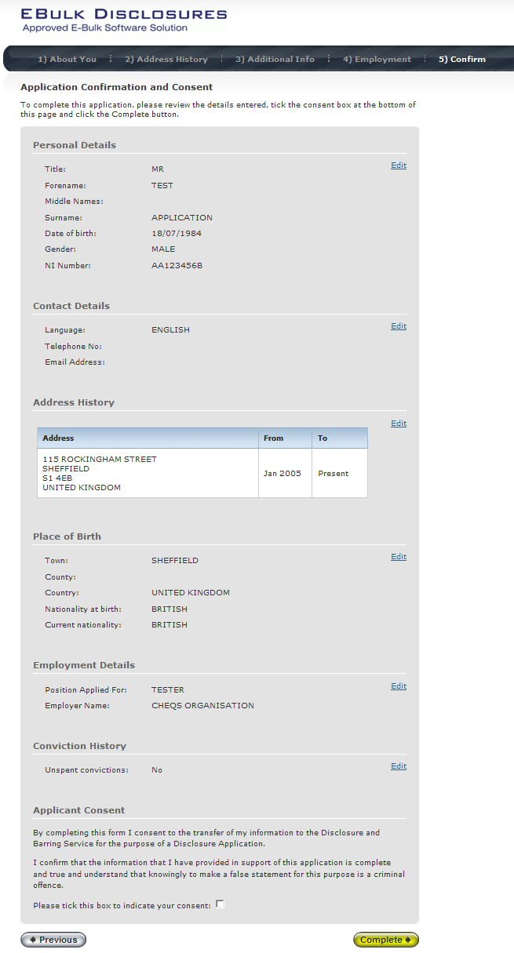

Now click ‘Complete’.
a

DBS Online Disclosure Guide (e-Bulk)
Applicant Guidance Notes

You have now completed your application form and you will be given a submission reference number. Please make a note of this number for reference purposes. If you entered an email address onto your application form you will receive a confirmation email containing these details.

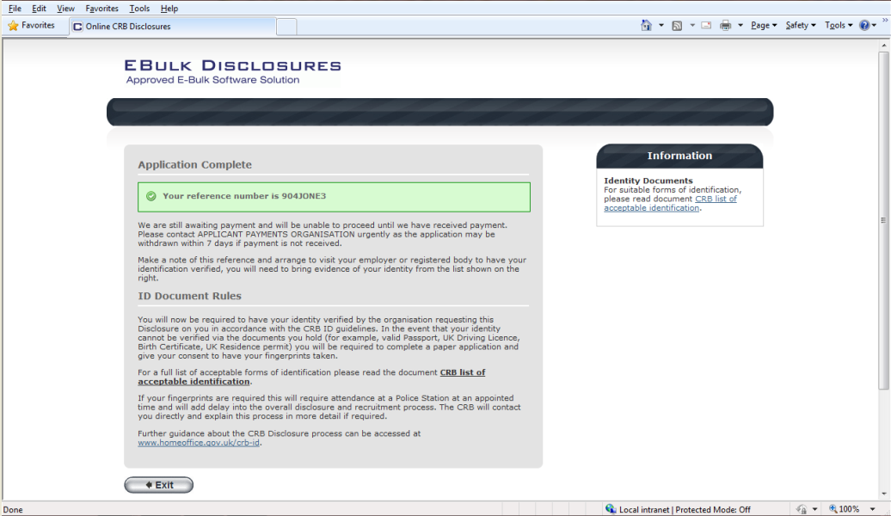

Your application form will be processed by your employer once they have verified your identity. Please see below for guidance on identity verification.

Next step - identity verification

In line with the DBS code of practice all applicants requiring a DBS check must have their identity verified.

How do I have my identity verified?

Please provide original identification to your Company’s Nominated Person (usually Recruitment or HR Manager) and provide identification as listed in the acceptable ID table (see table below). Your application form will be processed by your employer once they have verified your identity, and then sent onto the DBS.

Tracking the progress of your application with the DBS

If you supplied an email address whilst entering your application, as soon as your application has been received at the DBS and is assigned a DBS Application Reference number you will receive a second email detailing this information. This email will also include details and links to the DBS website to enable you to track the progress of your application from the moment the disclosure process commences.

CONTACT DETAILS

Please contact Pay & Condition Services if you have any queries in regards to the DBS application process on 01782 237710.Lines open 9.00am-5.30pm Monday to Friday. Alternatively you can contact us by e-mail at Katrina.ibinson@stoke.gov.uk

DBS Online Disclosure Guide (e-Bulk)
DBS List of Acceptable Identification

