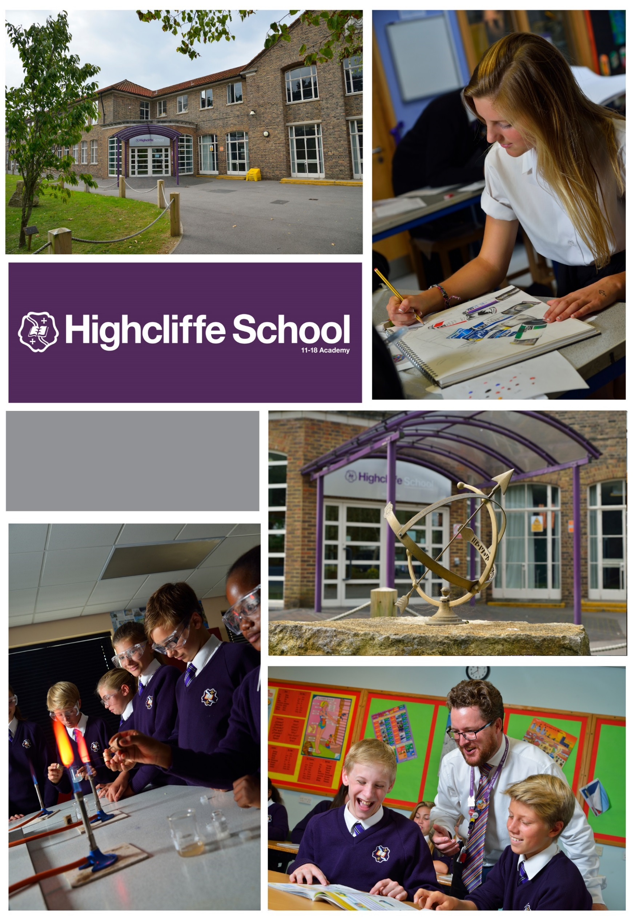

TEACHER OF
PRODUCT DESIGN & GRAPHICS

We value the power of education to change lives
Dear Colleague,
I am delighted you have expressed interest in applying for a post at Highcliffe School. Please find enclosed information, which, I hope, provides an insight to our school and the opportunities that await the successful candidate.
Highcliffe is a remarkable school with a special atmosphere. We are very highly respected in our community, with whole generations of families coming here for over 50 years. Former students, current students and their parents frequently speak of their powerful emotional bonds to our school lasting a lifetime. This is a result of our caring and aspirational ethos combined with our engaging curriculum and excellent package of extra-curricular opportunities. Former students go on to work in the Paris fashion houses, in international finance, law, education, politics, engineering, medicine and science, or as great chefs, carers, artists, musicians, mechanics, gardeners and much more – but not before they have thrived at Highcliffe academically, creatively and socially. Our students are lovely young people to work with. Our record of success means we are significantly oversubscribed in the main school. We have an excellent record of success placing students into the top universities in their chosen field. In the last 3 years, Sixth Form students go on to study at either Oxford or Cambridge universities. In 2016, we were the highest performing Sixth Form in Dorset and in the top 10% nationally for A Level performance. We are an outwardly focused community with extensive school links in Germany, France, Spain and Japan. Our Ofsted in October 2017 confirmed the school as Good and identified the Sixth Form as a particular strength.
Our teaching staff are highly experienced, knowledgeable professionals who work together superbly. Our SEN, pastoral, clerical, financial, technical and site staff are also extremely good at their jobs and committed to the school’s success, and form a great team. We are a friendly, welcoming and supportive environment in which to work or learn, located in a great part of the country. Our strategic plan aims to improve examination results still further by developing more effective ways of tracking and intervening on student progress (including our new assessment system at Key Stage 3); by further developing our teachers’ professional skills through our extensive in-house staff CPD programme; and by deepening our distinctive Highcliffe teaching and learning pedagogy. We work collaboratively within the Christchurch Learning Federation on a range of common school improvement issues.
Art, Design and Technology are housed in the exceptional Da Vinci building purpose-built about 10 years ago. Facilities for staff and students in Da Vinci are superb and they underpin the mature, independent and aspirational learning ethos created by the ADT team. Exam results and extra-curricular achievements in Art, Design and Technology are first-rate.
We welcome applicants who share our ethos, bring outstanding professional skills and personal qualities, and believe in their ability to make a difference to young lives through education. Unfortunately, we will not be able to contact every applicant and take this opportunity to thank you for responding.

I look forward to hearing from you but whatever your decision, I wish you all the best for your professional future.
Regards
Patrick Earnshaw BA (Hons) MA
Headteacher Registered in England and Wales Number: 07631213

Application:

Completing the application form
Submitting a personal letter or statement, explaining your vision, skills and experience relevant to the post.

Please note that CVs only will not be accepted.

Application Form

The form must be completed in full and signed. Please use black ink or word processing as your form will be photocopied. Please complete all sections of the application form and ensure that your employment record is set out in full with an explanation of any gaps.

Please do not include photocopies of open testimonials. We will always write to your current or previous employer for a reference and to ask for a professional assessment of your suitability for the post. We reserve the right to approach any previous employer for a reference.

Please complete the application form carefully and ensure that you sign it at the end. You should use section 5 to set out your relevant skills, knowledge and experience.

Your completed application form and letter should be returned to Angie Parsons, PA to the Headteacher, Highcliffe School, Parkside, Highcliffe, BH23 4QD. Or you can email aparsons@highcliffeschool.com. Applications will not normally be acknowledged.

Information about the area
Highcliffe School is situated minutes from Highcliffe and Avon beaches, Mudeford Quay and Christchurch Harbour. A few minutes’ drive or cycle away are the beaches of Bournemouth while Poole Harbour, a mecca for watersports, is approximately 12 miles away. As a result, sailing, kitesurfing, kayaking, paddle boarding, surfing and beach life are prominent parts of life in the area.

Highcliffe is also on the doorstep of the New Forest, meaning that equestrian sports, cycling, walking and running are also prominent features of local life. There is an extensive range of top-class pubs, cafes, clubs, theatres and cinemas throughout the area catering for people of all ages and tastes.

Highcliffe School is easily accessible from the urban centre of Bournemouth and Poole. With its large student population Bournemouth uniquely offers a multicultural city buzz combined with the relaxed South Coast surfing and holiday culture. London, the South East and the South West are easily reached by road or rail links. The European mainland is easily reached by ferry from Weymouth, Poole, and Portsmouth, while Bournemouth and Southampton airports offer continental and worldwide flights.

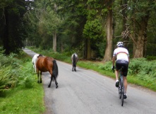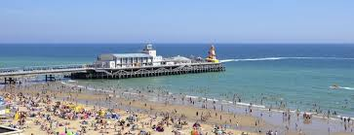
Information about the School
We encourage potential applicants to explore in depth the School’s website which includes recent publications and a prospectus. Potential applicants are also encouraged to read both the most recent Ofsted reports which are available via the school website or directly from www.ofsted.gov.uk and the published performance data available on the DfE performance tables site. www.education.gov.uk/schools/performance

Curriculum Area Information
The curriculum area of Art, Design & Technology consists of 12 teachers and 3 support staff.
Art and Design & Technology are taught in the purpose built Da Vinci Centre. A building of exciting concept, designed to embrace Highcliffe schools commitment to an integrated approach to this area of the curriculum. Particular features of the Da Vinci Centre include:
• A high & spacious atrium for exhibiting and celebrating student outcomes.
• Glazed and illuminated display provision along both sides of the corridors.
• Separate, yet interconnected, studios / workshops for Product Design, Graphics, Textiles / Printing, 2D & 3D Art, together with Food and Catering areas.
• Floor to ceiling glazed Key Stage 5 Art studio space.
• Bespoke ceramic teaching space housed within one of three spacious Art classrooms.
• Excellent Textiles Design equipment is housed adjacent to the Textiles Technology and Art spaces.
• Traditional dark room facility accommodated adjacent to the Art Studio.
• A spacious Computer Aided Manufacturing area complete with Laser Cutter, CNC Lathe, CNC Mill, 3D printer and CNC Vertical Router.
• Excellent provision for IT. There are three fully equipped computer spaces supporting Adobe software, Solidworks and numerous other subject specific packages. Additionally, there is discrete access to computers across the curriculum area.

Curriculum
In Years 7 and 8, students are taught in mixed gender and ability groupings for Design Technology and gain contact time for 5 hours a cycle. Art is taught in single hour lessons per week and students are taught in tutor groups. A significant number of Students achieve high levels of attainment throughout key stage 3 and may opt to follow GCSE courses in Art, Design & Technology starting in Year 10. GCSE courses in Art & Design - Fine Art, - Graphic Communication, - Textiles Design, Food and Nutrition and Product Design are currently offered. Results are often far exceeding the national average. Last year saw students attain the following: Fine Art (83% 9-4) Textiles Design (95% 9-4).

Sixth Form Curriculum
Curriculum developments continue post 16 as new specifications are embraced and
their popularity increases. Currently followed are A-levels in Fine Art, Textiles Design, Graphic Communication, Photography and Product Design. Results are consistently strong with large numbers of students opting for courses in ADT and also extending their study within the Da Vinci building in non-contact sessions.

Staff are highly motivated and passionately believe Art, Design & Technology should be enjoyable and play a prominent role in the life of the school. This is reflected in their enthusiasm for, and commitment to, the subject as well as the outcomes produced by their students. A wide variety of outcomes are generated by our Art students; they employ a variety of media to record their studies. These outcomes are well founded in reason and judgement and their development is rigorously recorded in sketchbook form. Being within an Art, Design and Technology curriculum area affords our students the ability to more easily extend the materials and methods with which they respond. We believe that creativity needs nurturing and Art, Design Technology aims to provide an environment in which students feel secure and reassured to take creative risks.

Recent extra-curricular activities include:
• Students are encouraged to exhibit their work in public exhibitions including Highcliffe Castle and Spudworks in Sway and the end of year annual summer exhibition hosted in the Da Vinci building.
• STEM extra-curricular programme raising student awareness of Science and Engineering.
• Curriculum booster sessions
• London gallery & exhibition visits as well as visits to the local Arts University.
• GCSE and A Level students contribute to an end of year exhibition hosted within the curriculum area.
• Catering celebrates the ‘Best of British’ food and traditions with Highcliffe’s Indian and Japanese ‘partner’ schools and is involved annually in the Christchurch Partnership Food festival as well as hosting a Rotarian meal annually.

Teacher Person Specification

CONTEXT: Before making an application candidates are asked to match their qualifications, experience, skills and abilities against the criteria listed below.

ATTRIBUTES | ESSENTIAL | DESIRABLE | EVIDENCE
QUALIFICATIONS | - Qualified teacher status.  - Good Honours degree (2:2 or above) or equivalent in relevant subject. | 2:1 Honours degree or above.  Further relevant qualifications and or In-Service training | Application.
EXPERIENCE | - Secondary School teaching or teaching practice across Key Stage 3, 4 & 5 and ability range  - Evidence of outstanding teaching practice with a positive impact on student progress/outcomes. | Using information technology in the classroom and for management.  Working in partnership with parents | Application.  References.
TRAINING AND  PROFESSIONAL  DEVELOPMENT | - Knowledge and understanding of excellent practice in learning, teaching and assessment.  - Knowledge and understanding of current issues relevant to the subject.  - Familiarity with & involvement with the National Curriculum, assessment, reporting & recording procedures at KS3 & KS4. Awareness of the new GCSE, A Level and BTEC specification. | Familiarity with & involvement with the National Curriculum, assessment, reporting & recording procedures. | Application.  References.  Interview.
PERSONAL QUALITIES AND SKILLS | - Energy and presence to lead by example, in terms of both departmental development, classroom management and organisation.  - Commitment to raising achievement.  - Commitment to staff development.  - IT Skills appropriate to the role.  - Ideas for implementing the School’s vision.  - The ability to develop good relationships with students, staff, colleagues & community members.  - Manage time effectively and be highly organised.  - Good interpersonal skills, communicate effectively (both orally and in writing) to a variety of audiences.  - Create a happy, challenging and effective learning environment.  - Plan for changing needs and circumstances and be able to adapt quickly.  - Report clearly and thoroughly on work completed.  - Actively listen.  - Ability to influence others.  - Have the drive, determination and enthusiasm to work effectively.  - Ensure that issues of equality are addressed in all aspects of work.  - Commitment to the success of an extra-curricular programme. | Experience of partnership working and dissemination of ideas/materials.  Experience of report writing | Application.  References.  Interview.

Academic Year 2019-20
Post Profile – Teacher
Name of Teacher:
Line Manager: Head of Art
Core Purpose
It is the role of the subject teacher to deliver high quality lessons to maximise students learning and contribute to the realisation of our mission statements:
- To provide a safe, nurturing environment that promotes happy confident learners possessing self-discipline, self-motivation and respect for others, who acknowledge their responsibilities toward each other and the wider community
- Through our teaching to allow students to develop into talented, ambitious young adults equipped with the intellectual and practical skills to enhance their own lives and of those around them
- To use our resources responsibly to secure maximum achievement in all aspects of our students’ education

Responsibilities
Assessment and Feedback:
- To complete KS3 Continuous Assessments and KS4/5 progress checks and profiles carefully and promptly
- To adhere to the school’s procedures for formal assessments and examinations

Attendance and Punctuality:
- To record attendance electronically in line with the school student information system
- To ensure that class registers are accurate and maintained on a timely basis
- To insist on punctuality and to lead by example in this respect
- To ensure that each lesson starts and ends in an orderly fashion

Preparation:
- To ensure that all lessons are thoroughly prepared and carefully structured in line with the scheme of work and that the work is appropriate to the needs and abilities of each student
- To ensure that assessment tasks are well planned, organised and hold value
- To utilise the most effective Learning and Teaching strategies in the planning of individual sequences of lessons.
- To use SEN profiles to inform learning, teaching and assessment practice
- To plan opportunities to utilise the expertise of support staff to aid all students in their learning on a 1:1 or small group basis within the classroom

Homestudy:
- To set homestudy that is relevant, meaningful and reasonable in length which extends the studies undertaken in school and provides students with valuable life-skills, experience in self-discipline and individual responsibility
- To set homestudy regularly on the night/s specified in the homestudy timetable in accordance with the school policy and record it online on the homestudy log
- To expect home study to be completed and handed in on time. If home study is not handed in then appropriate action should be taken (for example, issuing a demerit)

Marking:
- To ensure that over time marking and feedback reflects the purpose and principles of the school’s ‘Marking and Feedback’ policy – ‘Praise, Progress, Response’
- To mark work regularly using agreed strategies from the marking and feedback toolkit (i.e. in line with faculty practice)
- To maintain a secure overview of the starting points, progress and context of all students

Meetings:
- To attend and contribute to subject, faculty, year team and learning and teaching development group meetings as per the school’s calendar
- To attend parents’ evenings and any other meetings as directed by the Headteacher

Students:
- To praise students in line with school policy on rewards (for example rewarding individual or collective achievements using commendations (the basic currency of all rewards)
- To adhere to the schools Behaviour Management Policy and utilise effective behaviour management strategies.
- To ensure that any unacceptable behaviour is recorded using a demerit. Any further unacceptable behaviour should be followed up as set out in the school’s behaviour policy

Whole School Development:
- To assess, plan and teach to the same consistent high standard with common long-term goals in mind:
- To improve the impact of teaching and assessing on all our students, to improve their learning
- To improve the behaviour and learning skills of all our students, to improve their learning and improve the general learning ethos
- To improve the attendance of the lower attenders so they progress better
- To motivate a higher number of the brightest students from inside and outside Highcliffe School into joining our Sixth Form

Working Environment:
- To ensure that teaching areas are organised appropriately and provide a pleasant, stimulating and tidy working environment

General Conduct (including corridors and external areas):
- To work within the Code of Conduct and Guidelines for Safe Working Practices for the Protection of Children and Staff
- To be courteous to colleagues and students and provide a welcoming environment for visitors
- To maintain high expectations which inspire, motivate and challenge our students
- To ensure high standards of personal and professional conduct consistently displayed

Duties:
- To know when and where your weekly duties are. All teaching staff will have two duties on a set day of each week. Duties should be attended promptly
- To inform the Operations Manager (with as much advance notice as possible) if unable to attend a particular duty
- To be proactive whilst on duty, moving around the duty area and interacting with the students, maintaining a positive presence
- To promptly address any examples of inappropriate behaviour from students

Associated Responsibilities:
- To work collaboratively within and across teach to monitor, self-evaluate and improve the quality of teaching
- To engage in the learning and teaching strategy by fully participating in the activities of the Learning and Teaching Development Groups
- To follow subject specifications and schemes of work and contribute to their enhancement and development
- To contribute to and make good use of the relevant curricular performance and student progress data to inform Learning and Teaching
- To take responsibility to extend professional expertise by seeking, identifying and undertaking relevant personal professional development
- To contribute to and comply with agreed policy and priorities as per the Learning and Teaching policy
- To undertake any other reasonable duty, as required, and from time to time, by the Headteacher
- To undertake any other duty as specified by STRB (not already mentioned)

Professional Entitlements and Expectations:
- As set out in the schools 1265 time budget
- 44 teaching contact periods 10% PPA
- Gained time: Work programme - subject to direction and delegations of the Headteacher through Senior Curriculum Leaders/Directors of Learning
- Additional ‘non-contact’ (over 10%) will be assigned to priorities as outlined in the School Development Plan
- Rarely cover. Please note: Schools are required to ensure that teachers may be required to cover only rarely (paragraph 53.7 STPC 2016). This is consistent with current practice and therefore should not be interpreted as ‘if ever’ or ‘never’
- NQTs: 90% timetable ‘contact’ that is 40 periods per cycle
- We are strongly focused on investing in the best possible teaching in each subject in the curriculum to ensure lessons are stimulating and absorbing for students. As such we are heavily committed to the on-going professional development of our staff

Signed: ................................................................................ Teacher Date:……………………………..

Signed: .................................................................................. Headteacher Date:…………………………….

Equal Opportunities
This school is an equal opportunities employer. Our policy is to ensure that no job applicant or employee receives less favourable treatment because of race, colour or nationality, sex, marital status, religion or disabilities. Selection criteria and procedures will be frequently reviewed to ensure that individuals are selected or promoted based on their individual relevant merits and abilities. All employees will be given equal opportunities and, where appropriate, further training to progress within and beyond the organisation.

Disclosure of Criminal Convictions
The post you have applied for is subject to a police check with the DBS. If you are offered the position, you will be required to complete a Disclosure Form. The result of the police check will be sent to you.
The school will need to see and note some original documentation as part of the police check procedure. To speed up the process and avoid important documents getting lost in the post, if you are called to interview please can you bring the following documents which establish your identity and date of birth in addition to certificates of qualifications gained and in order to meet the requirements of the Asylum and Immigration Act, and a formal document showing your National Insurance Number.
- Pay slip, P45 or P60
- Passport or driving licence
- Birth certificate/marriage certificate
- Utility bill showing your current home address and dated within the last 3 months

Medical Fitness
In accordance with the Education (Teachers) Regulations 1993, all teachers are required to satisfy their employers of their medical fitness on entry to the teaching profession and during the subsequent employment. In this connection, teachers will be required to complete a medical questionnaire, which will be considered by a Medical Officer.

No Smoking Statement
The School operates a No Smoking Policy.

