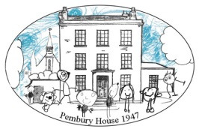

**Pembury House Nursery School**

**and Children’s Centre**

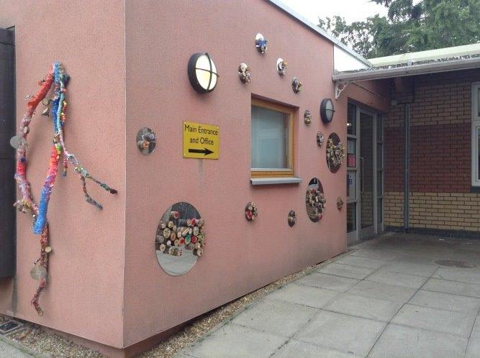 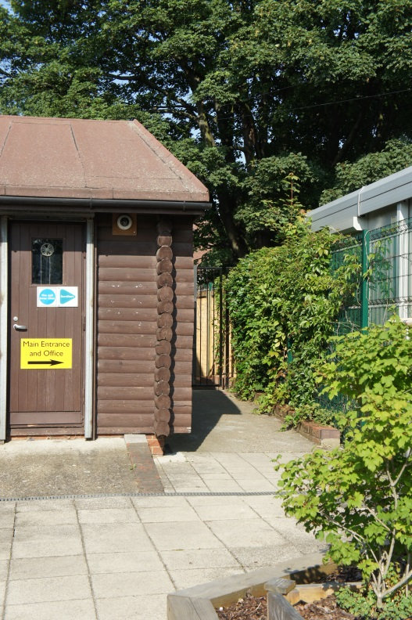

***Main Site – Over 3s Nursery Class Hartington Park – Under 3s Nursery***

**Educational Approach, Services & Locality**

**Pembury House Nursery School and Children’s Centre**

**Lansdowne Road**

**Tottenham**

**London**

**N17 9XE**

**Tel/Fax 020 8801 9914**

**e-mail: admin@pemburyhouse.haringey.sch.uk**

**website: www.pemburyhouse.haringey.sch.uk**

**Headteacher: Sue Moss**

**Chair of Governors: Melian Mansfield**

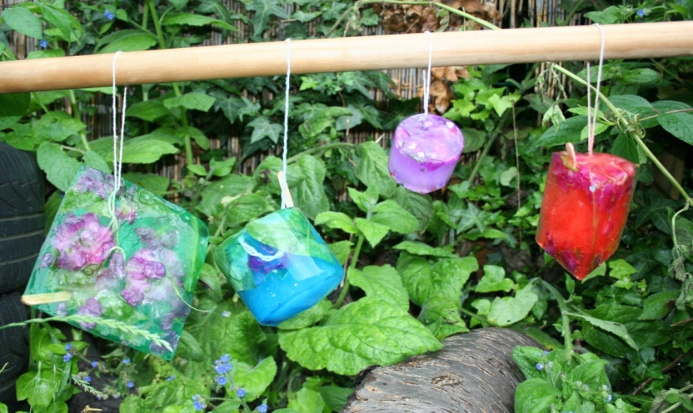

*Hanging Ice and Petal Sculptures*

 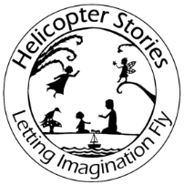   

**At Pembury House Nursery School and Children's Centre, we believe that high quality nursery education can transform the lives of young children and that partnership with parents provides the basis for successful learning.**

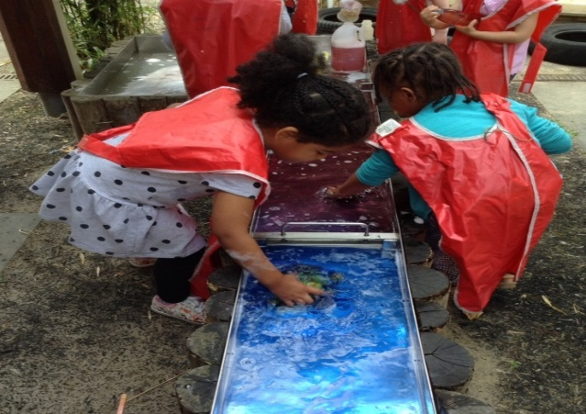

Welcome **Page 3**

Our Vision **Page 4**

Our History **Page 5**

Nursery School Educational Approach & Services **Pages 6-8**

The Haringey’s Nursery School Consortium **Page 9**

Locality **Page 10**

Transport Links **Page 11**

Contents

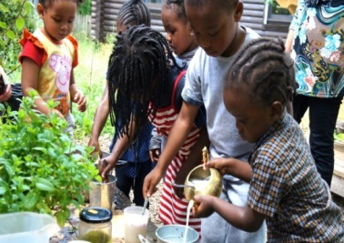

**Our caring, qualified and experienced staff team give you a warm welcome to Pembury House Nursery School and Children’s Centre.**

Here you will find both nursery education and children centre services available in our well- resourced and purpose built building.

We believe that children learn best through play, first-hand experiences and meaningful conversation. We want to inspire children to become independent curious learners. Therefore in our nursery school we provide a creative curriculum and offer children exciting, challenging opportunities to explore.  At Pembury, children enjoy a variety of research, artistic and creative projects and we are lucky to have a resident artist and specialist musician. We also have a wonderful garden for children to play and learn through nature.

It is important to us that we work together in partnership with parents and carers, to share children’s interests and learning, and to help them be the best they can be.

We have fantastic on-site children’s centre facilities offering a range of health, education and advice sessions for families with children under 5. These include our popular parent and toddler ‘*Stay and Play’* sessions and Baby Groups.

We invite you to take a closer look at our school community that we are so proud of.  Please visit, explore our website or ask our friendly office team for more information.

**Sue Moss**

**Head teacher**

**Welcome!**



**Pembury House Nursery School and Children’s Centre**

***Inspiring Inquiring Minds***

**Our Vision**

At Pembury House we believe that high quality nursery education can transform the lives of young children and their families, and that partnership with parents provides the basis for successful learning. We work as a team to ensure that children:

* Are valued as individuals.
* Feel happy, confident and secure in the nursery school and children’s centre.
* Share our commitment to inclusion and use it as an opportunity to listen and learn from each other.
* Develop confidence, independence and a positive view of themselves.
* Learn through play and first-hand experiences.
* Acquire the knowledge, skills and attitude they need, now and in the future, in a rapidly changing world.

**Ofsted**

**Our Ofsted rating is ‘OUTSTANDING’***.* In May 2017, Ofsted reported that:

* Teaching is consistently of a high quality.
* The quality of provision, both inside and outside, is exceptional.
* Children flourish in a stimulating and well - resourced environment.
* Staff plan interesting and fun activities to motivate and engage children
* A high proportion of children leave the school with knowledge and skills that exceed those typical for their age - this represents outstanding progress.
* Children are very well prepared for primary school.
* The school provides a broad curriculum, which promotes children’s spiritual, moral, social and cultural development well.
* Staff arrange many activities and visits, which enrich children’s learning.
* Children’s behaviour is exemplary- they work and play together happily, showing tolerance and respect for each other.
* Parents speak highly of the school and are confident that their children are safe and well cared for.

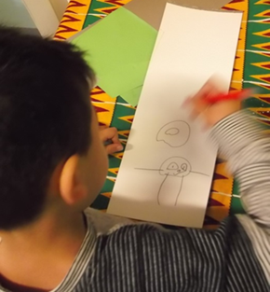 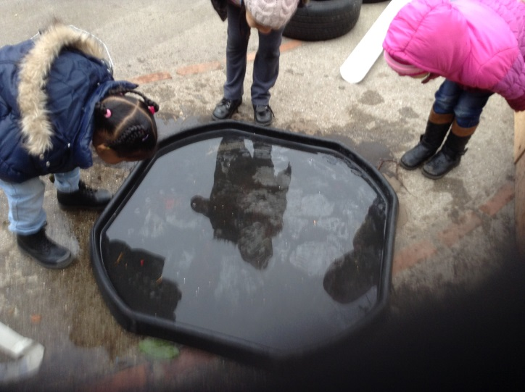

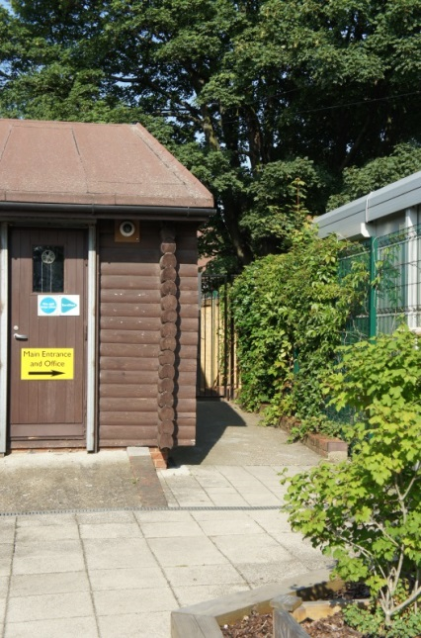****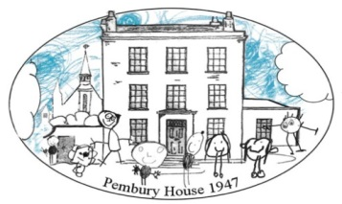

**Welcome To…**

**Pembury House Nursery School and Children’s Centre**

**A Tradition of Education and Care in the Community**

**Our History**

Number 632 High Road, Tottenham, named Pembury House, was owned by William Henry Plaister MRCS. He was a surgeon, medical officer and public vaccinator for Tottenham Lower District. Dr Plaister lived at Pembury House until 1923.  
   
During the 1940s, a day nursery was built in the garden of number 632 for children whose mothers were working to help the Second World War effort. Many of the unusual trees and the original garden wall were retained. A pram shed and an air raid shelter were added.  
   
On 1st October 1946, Pembury House Day Nursery was changed into a school and renamed Pembury House Nursery School. The School admitted more children and opened for the usual school week, term and year. The interior was slightly modified and remained like that until early autumn 1995. This saw the end of the temporary wartime measure, making way for a new building for Pembury House Centre for Childhood, Education and Training for the Community.   
   
In addition to the nursery school, the new building offered extended opening hours and all year round provision. A training room catered for community education and family support services were gradually introduced. In 1997, Pembury House acquired Early Excellence status and continued to expand upon its work in the community. Links were made to the local Sure Start programmes of Park Lane and High Cross. In December 2005, the Centre was designated as one of the first Children’s Centres in Haringey.  
   
A new extension was built in 2006, to allow space for the development of additional services on site. Pembury House Nursery School now has established links to partner sites in the area and works with local schools to bring the core offer of Children’s Centres to the community of South East Tottenham.

**Nursery School Educational Approach and Services**

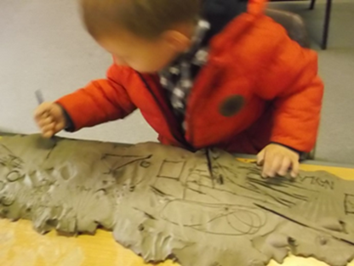

Pembury House Nursery School & Children’s Centre is set in South East Tottenham, North London with a diverse population, representing a rich cultural and ethnic mix. The main ethnic groups attending are Black African, Black Caribbean, Eastern European and Turkish. Many families here face a range of challenges, including poor housing, low income, unemployment, few educational qualifications, domestic abuse and mental health problems. Many families have fled their home countries, have no family here in the UK and speak little English. We provide the support which the families need. The special feature of our school is that despite these challenges, children make excellent progress and parents are given opportunities to develop the skills and experiences necessary to improve their lives.

Our on-site Sure Start Children’s Centre offers a range of health, counselling, debt management and adult education services.

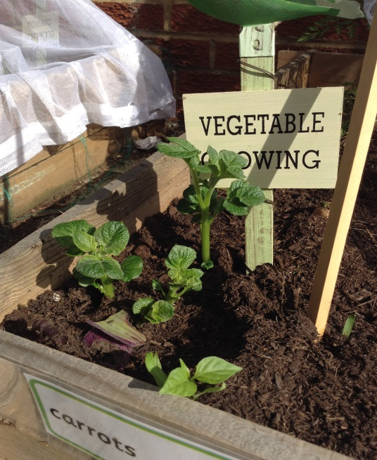 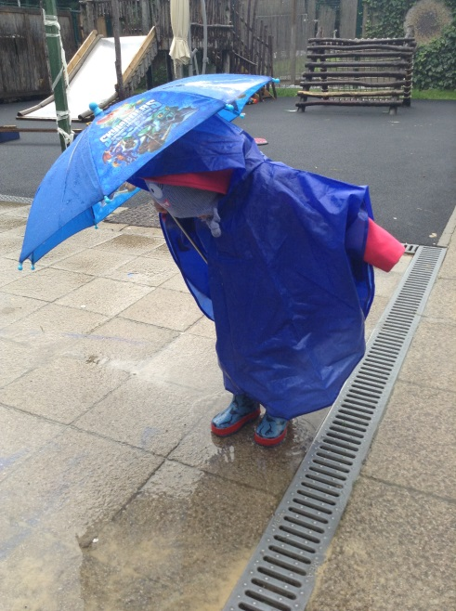

Pembury House Nursery School & Children’s Centre is on a split site and housed in two buildings, one for children aged 2 years old, and the other building for children aged 3 and 4 years old. It is a busy setting with around 185 children aged two to school age attending daily. There are 42 employees, including 5 teachers’ with QTS, 1 Family Worker and 20 Early Years Educators (16 with childcare qualifications). The Children’s Centre Team comprises of 1 Children’s Centre Manager, 2 Early Intervention Outreach Practitioners, 1 Early Learning Practitioner and 1 Learning & Volunteer Coordinator.

The Nursery School is an inclusive setting and we have systems to support children with additional needs. Over half the children speak a range of 20 languages, with Turkish, Polish and Romanian being our main community languages. We assess their stage of English so that we can identify and provide for next steps in language acquisition. We use the ‘Leuven scale of well-being and involvement’ to support children with emotional needs. We have provision for children with special educational needs and disabilities and a programme of support is organized for them. Our building has disabled access and we have a sensory room. Visiting health professionals include: Educational Psychologist, Psychotherapist and Speech and Language Therapist.

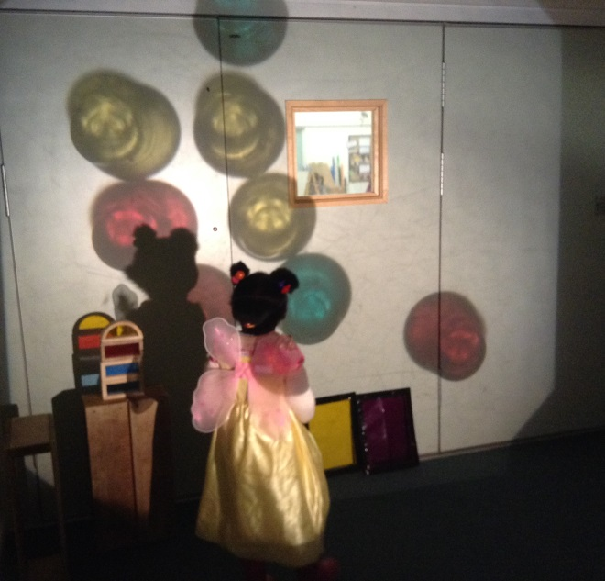 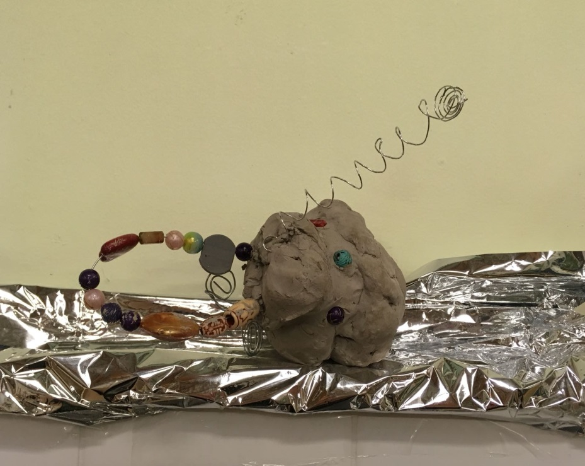

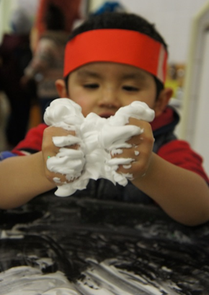The Nursery School follows the ‘Early Years Foundation Stage Framework’ and we have been rated as ‘outstanding’ by ‘Ofsted’ (May 2017), the national inspection organisation. Personalized, seasonal and cultural learning form the basis of our educational approach. We are a Natural Thinkers School and staff plan an inquiry based programme, full of natural resources and found materials, based on children’s interests and fascinations. Teaching and learning at Pembury House Nursery School is influenced by the Italian Reggio Emilia approach and Nordic Rain and Shine Forest Schools. We encourage children to become curious, independent, and willing learners, explorers and problem solvers. Outdoors, as well as providing access to climbing and sports equipment, we encourage children to become ‘natural thinkers’ and offer urban forest school and eco-school environmental activities. Children attend daily ‘dialogic reading sessions’ in small focused teaching groups to develop ‘Talk for Writing’ literacy skills and we use ‘Helicopter Stories’ story making sessions to develop a strong sense of narrative. We have a part-time artist leading art projects, and a part-time music teacher leading music projects.

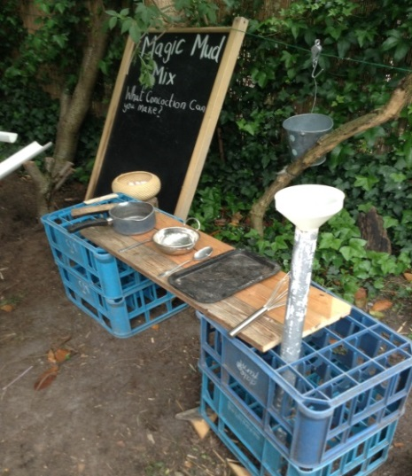

*Mud Kitchen Shaving Foam Play*

Pembury offers a range of family learning opportunities including a ‘HENRY’ healthy eating programme. Our adult learning programme offers ESOL and Volunteer programmes, as well as vocational courses in childcare and early education for those wishing to study Levels 1-6. We have a community garden and families are encouraged to grow and eat organic produce. ‘Terrific Tuesday’ parent workshops are on a range of topics to e.g. help with improving children’s sleep and behavior. ‘Wow Wednesday’ family activities are provided weekly, for parents to find out about the Early Years Foundation Stage as they participate in learning activities with their children.

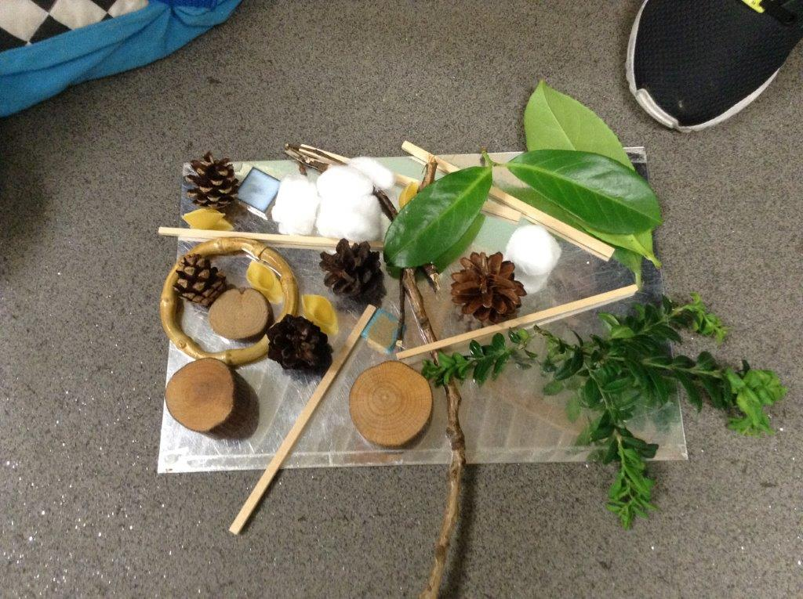

*‘No glue’ Transient Art*

The Nursery School has a communication rich environment that promotes opportunities for curiosity in an inquiry based curriculum. We look for ways to involve ourselves in leading edge practice and follow current research about learning in the early years. We provide a range of opportunities for staff to reflect on their practice both individually in supervision sessions, and in team meetings. Staff and children reflect together on the learning that has taken place in ‘Learning Stories’ (based on the work of Margaret Carr and Wendy Lee) – powerful documentations of children’s learning. These are shared with parents and children in order to plan children’s next steps and diminish differences in learning.

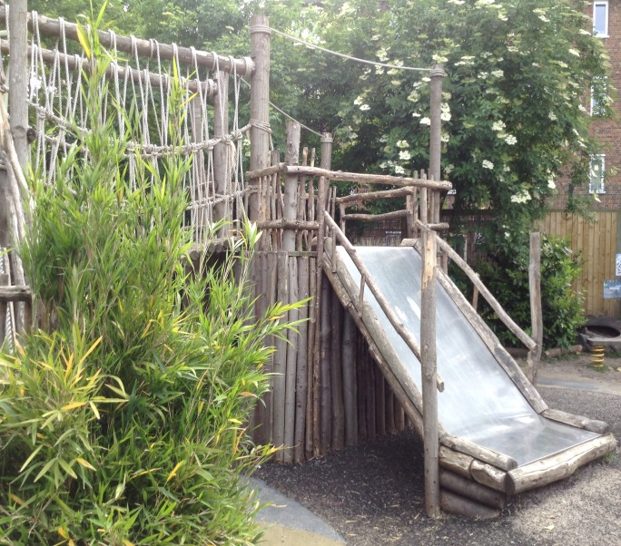 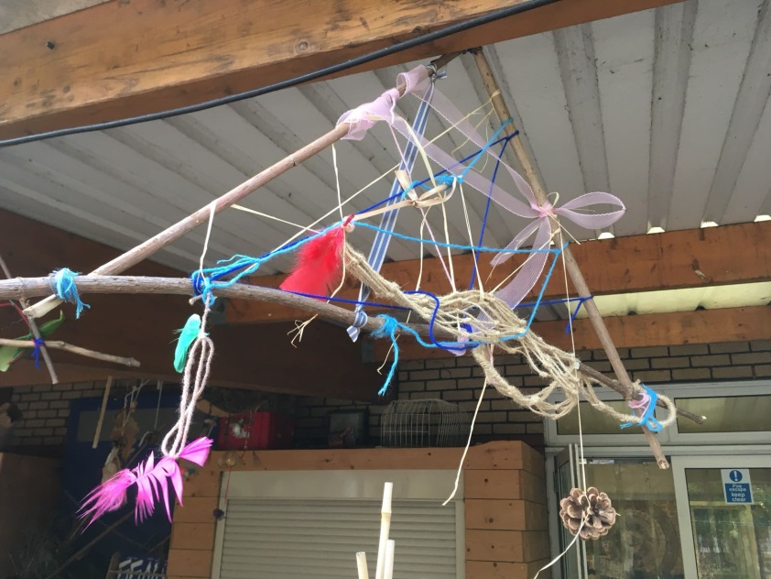

We belong to HEP - the Haringey Education Partnership of schools; as well as a range of national Early Years organisations. We attend meetings, conferences and exhibitions to find out about the latest research and theories. As part of a local schools network community, we meet to assess and share our practice. We consistently carry out evaluations and self-evaluations of our practice to improve performance, and monitor and improve work quality.

**The Haringey Nursery Schools Consortium**

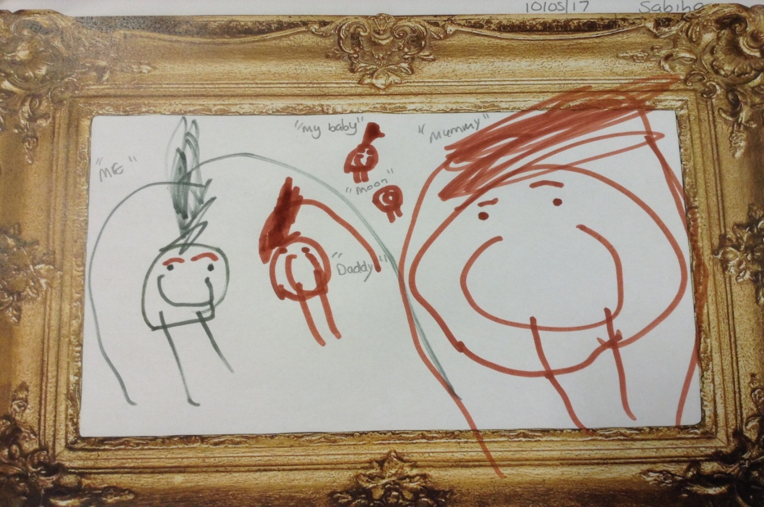

We are actively involved in upskilling the Early Years workforce locally and nationally. We are an Early Years Teaching Centre and are part of a Consortium with the two other Haringey Nursery Schools. We offer QTS teacher training placements, and provide university accredited training for Early Years practitioners, childcare CACHE qualifications levels 1 – 5, as well as professional development workshops and an annual conference. Our employees run a range of training sessions and present their experiences at local and national professional meetings and conferences.

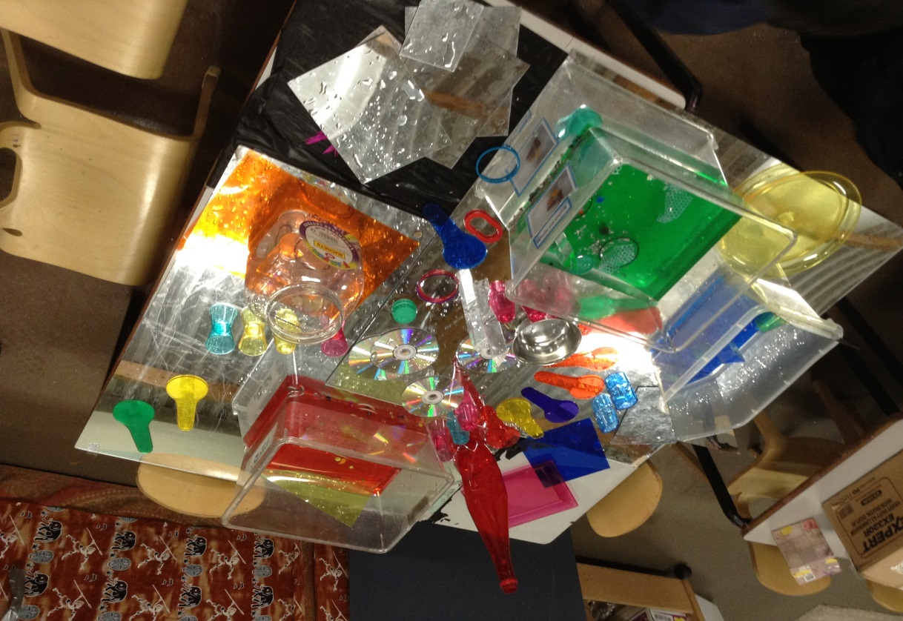

*Exploring reflection and light*

**Locality**

Pembury House Nursery School & Children’s Centre is a friendly, happy, lively place.

We are based in South East Tottenham, right next to busy, diverse Tottenham High Road and the brand new Tottenham Hotspurs Football Ground. Nearby is the ‘up and coming’, Tottenham Hale.

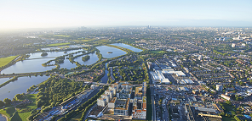

Tottenham Hale is part of a regeneration plan to become London’s next great neighbourhood – a bustling new centre with an international transport hub, residential quarter and thousands of new job opportunities.

Set alongside the stunning vistas, abundant open space and waterways of the Lee Valley Regional Park, Tottenham Hale offers an increasing range of fantastic places to live, work and shop – including a successful retail park with 24 brand-name stores. The newly-opened ‘Wetlands’ provides beautiful walks in nature.

Haringey Council’s Strategic Regeneration Framework (SRF) which was approved in March 2014 sets out an ambitious vision for Tottenham Hale as:

‘… *a destination where people can easily access the open space and waterways of the Lee Valley Park whilst enjoying retail, leisure and business opportunities. Tottenham Hale will feel like a new town centre with an attractive network of streets and public spaces.’*

**Fantastic Transport Links**

* Bruce Grove Station - on the London Overground Network with links to Enfield Town / Cheshunt and Liverpool Street
* Seven Sisters Tube Station - on the Victoria Line with fast links to Walthamstow, the West End and Brixton
* London Bus Routes
* Tottenham Hale - the London interchange for passengers arriving from Stansted Airport with services to Stratford City. Tottenham Hale is undergoing a transport revolution – with £110million investment in a new Tube, rail and bus station, road network improvements and public realm works.



**Transport Links**

**Where are we situated?**

Please note we are on a split site. Unless otherwise directed, please go to our main site.

**Main Site (Over 3s and Children’s Centre services)**

Pembury House Nursery School and Children’s Centre

Lansdowne Road, Tottenham, London, N17 9XE

**Hartington Park Site (Under 3s and Children’s Centre services)**

Pembury House Nursery School and Children’s Centre

Burlington Road, Hartington Park, London, N17 9UH

**Phone Number:** 0208 801 9914

**Car Parking** – please note we cannot take responsibility - **parking is at your own risk!**

We **do not** have a staff car park. Locally there is lots of free parking, but **please take care and read the signs as there are some restrictions** and if you are in a restricted area you will get a parking ticket. Where there is free parking, there may be a parking restriction **from 5pm** on weekday match days when Spurs are playing at home – the football ground is very nearby. You will therefore need to return to your car by 5pm.

**Free parking (please check) is available on**:

* Lansdowne Road (where the main site is based)
* Spencer Road
* Tilson Road
* Baronet Road
* Siddons Road
* Hollington Road
* Poynton Road
* Cedar Road
* Ruskin Road
* Pembury Road
* Lordship Lane

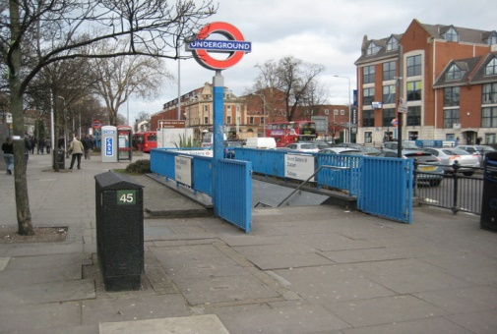 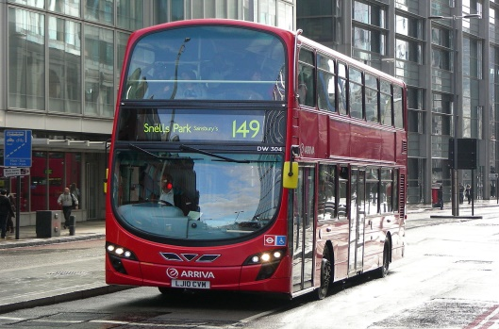

**Public Transport Links**

* **London Bus Routes** include:

123,149, 243, 259, 279, 318, 341, 349, 476, W4

There are bus stops right outside on Lansdowne Road and just around the corner on The High Road depending on which bus you catch.

* **Tube stations:** **Seven Sisters** (nearest tube) or **Tottenham Hale**, both on the Victoria Line with fast links to Walthamstow, the West End and Brixton.

Seven Sisters tube station is approx. 30 minutes’ walk along the High Road, so you may want to hop on a bus.

* **Seven Sisters and Tottenham Hale** also have Overground services.
* **Tottenham Hale** has services to Stratford City and is the London interchange for passengers arriving from Stansted Airport.

There are 8 trains per hour to Liverpool Street Station.

* **Bruce Grove Station** is on the London Overground Network with links to Enfield Town / Cheshunt and Liverpool Street. This is our closest station - approx. 15 minutes’ walk.

**Google: ‘Transport for London’ for accurate and up to date travel information**

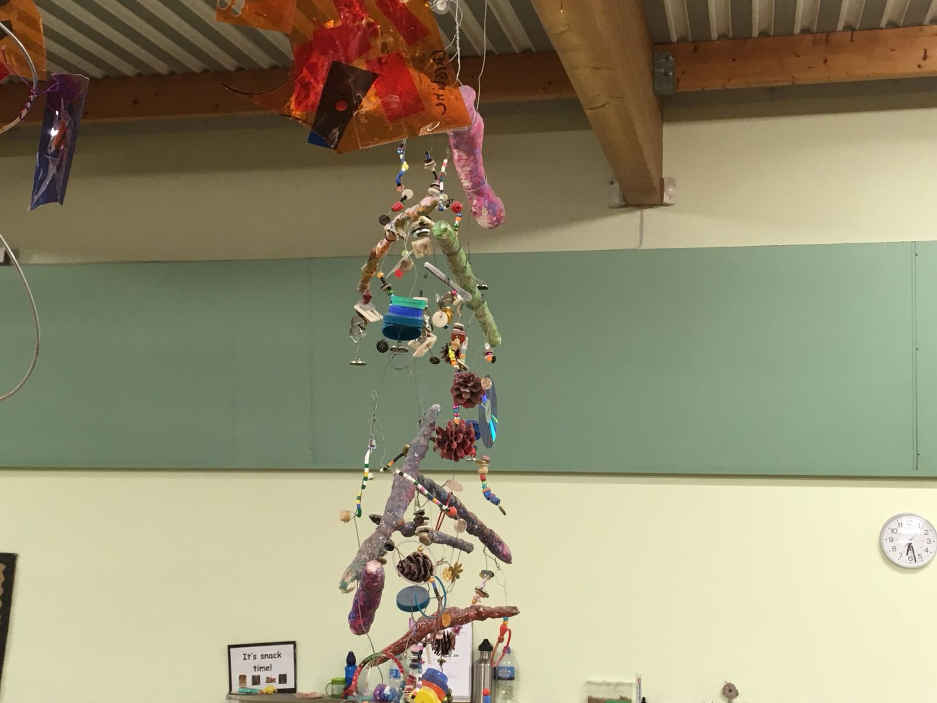

*Mobile built using a range of skills and techniques: wrapping and painting ‘mod roc’ around branches, drilling holes in materials to thread, and connecting items with wire twisted with pliers*