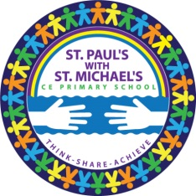
Teacher Post
St. Paul’s With St. Michael’s Primary School is a vibrant one-form entry Church of England school situated behind the Broadway Market. Our recent Ofsted Inspection in March 2017 rated our school Outstanding in all areas. Our pupils come from dynamic and diverse economic backgrounds typical of an inner London borough, bordering the affluent City of London.
We provide a fully inclusive education and strive to bring out the best in all our pupils, irrespective of their social, cultural, ethnic and other backgrounds. Our Christian faith enables us to offer a warm and caring environment and as demonstrated in our Mission Statement: “Through God’s love, we value, nurture and challenge everyone to achieve their best; aspiring to a promising future.”
We are seeking an inspirational Teacher to join our dedicated team. The successful candidate will demonstrate proven ability to engage pupils in learning, monitoring achievement and raising pupil attainment. In return, we offer a friendly and supportive team, competitive salary, continuing development and the chance to make real changes to pupils’ lives.
The successful candidate will be required to start on 29th April 2019 on a one-year fixed-term contract, subject to renewal based on performance.
We are committed to being a good Equal Opportunities employer. We are also committed to the welfare of all our pupils and staff. The successful candidate will be DBS checked at an enhanced level before a final job offer is made. The Broadway Market/London Fields area has very good transport links and great recreational venues.
•Application Form
•Job Description/Person Specification
Closing date: Friday 8th March 2019
Interviews will be conducted week commencing 11th March 2019
All applications can be posted to:
St. Paul’s With St. Michael’s Primary School
57A Brougham Road
London E8 4PB
Phone: 020 7254 1927
Fax: 020 7923 2449

Or by e-mail: lfava@spsm.hackney.sch.uk

