Appointment of

Teacher of Biology (Maternity Cover – 0.6)

For September 2017

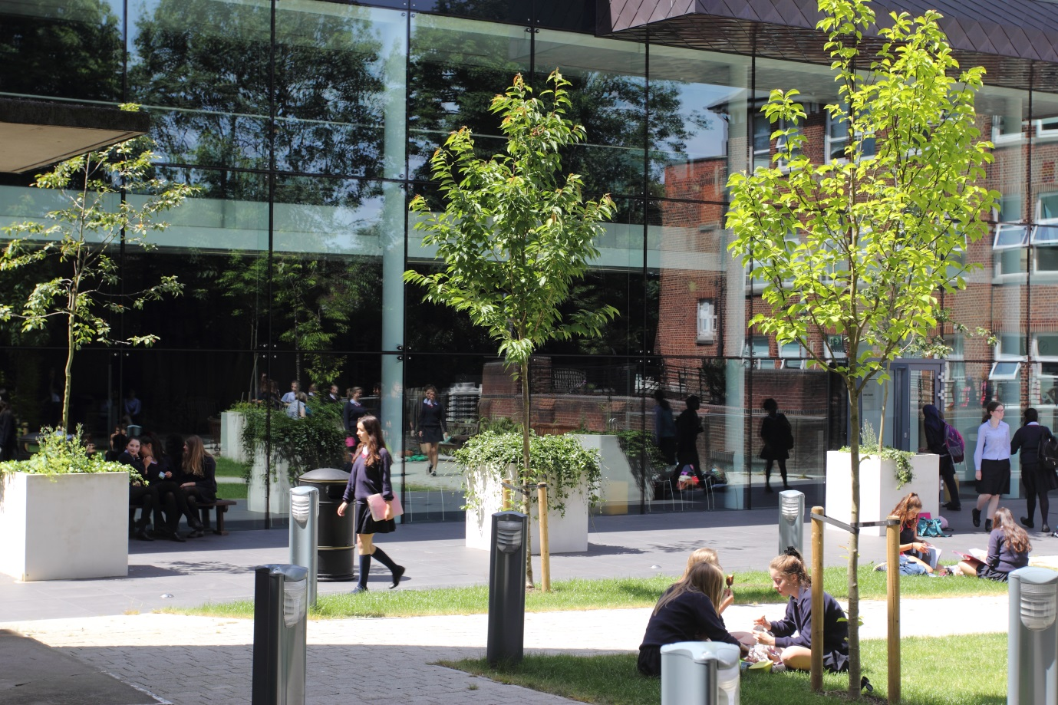

About the School
Notting Hill & Ealing High School is one of London’s leading independent girls’ day schools. Founded in 1873 it is the oldest of the 26 schools which make up the Girls’ Day School Trust having begun life in Notting Hill and moved to Ealing in 1930. The school is a friendly and welcoming community of just over 900 girls, together with approximately 220 teaching and support staff. We occupy a site in suburban, leafy, west Ealing with excellent transport links. (We are an easy walk or bus ride from Ealing Broadway or West Ealing stations: District and Central underground lines, mainline trains and Crossrail from 2018.) The school is oversubscribed and a very popular choice at all ages with girls joining us from most parts of West London as well as areas further afield.
NHEHS is an academically selective school. Our girls are bright, enthusiastic and eager to learn and teaching here is a great experience. In our latest ISI inspection we achieved the highest possible grades across the board and the inspectors noted that ‘the quality of the pupils’ achievements and learning is exceptional.’ Public examination results are consistently outstanding and girls go on to study a wide range of subjects at prestigious universities. (Latest results and the university destinations of Leavers can be found on our web site). Our facilities and teaching and learning resources are excellent and the GDST has an ongoing strategy of development and investment in all its schools. .
We are an all through school (ages 4-18). Around 300 girls attend the Junior School with 600 in the Senior School of whom 150 are in the Sixth Form.) The Junior and Senior Schools occupy their own parts of the site and in day-to-day terms operate independently. There are strong links between staff in both Junior and Senior departments with some notable examples of integrated teaching particularly in music and sport.
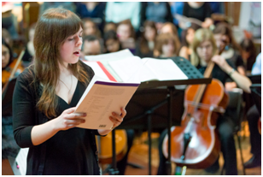
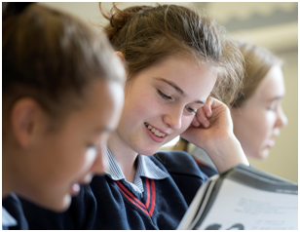
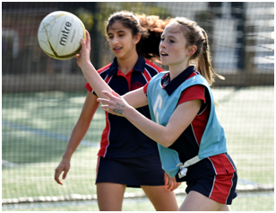
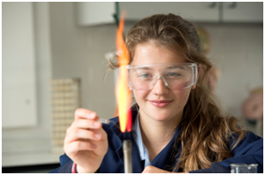
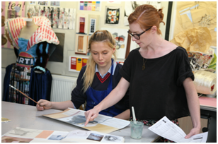
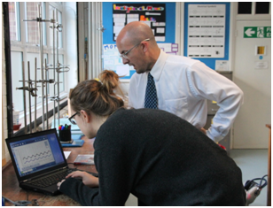
You will find Notting Hill & Ealing girls to be well grounded, confident and independent. They are proud of their school and value kindness and laughter, fun and friendship. The school is highly regarded for the way it achieves its outstanding results within a particularly warm and supportive environment. We put pastoral care and achieving the best for every girl at the heart of everything we do here and there is a deep-seated ethos of respect, tolerance and understanding.

“We are delighted that you are considering NHEHS and hope that you will want to apply for this post once you have found out a little more about us. Our website, www.nhehs.gdst.net will tell you more about the school and give you a taste of the atmosphere here.”

Matthew Shoults, Headmaster

Teacher of Biology (Maternity Cover – 0.6)
The Post
The post is available from September 2017.

The vacancy provides the opportunity for a well-qualified, inspirational teacher of Biology to teach up to A-level, and to contribute to a flourishing department in both its curricular and extra-curricular activities for a minimum of one year and possibly more.

Person Specification
We are looking for a well-qualified graduate of Biology or a related discipline with excellent subject knowledge and a passion for the subject. She/he will have excellent organisational and time management skills and the ability to produce creative solutions to challenges. She/he will be a good communicator who can enthuse and inspire pupils and will have exciting ideas about the teaching of Biology and ways in which girls can be inspired both within and outside the curriculum. The ideal candidate will be fully committed to the vibrant extra-curricular life of the school.

The Biology Department
The Biology Department is successful at all levels up to and including A-level. It aims to inspire students at all levels about science and its applications in daily life. In recent years, the uptake of Biology at A-level has increased and our results at GCSE and A-level are excellent. The Biology Department strives to provide all pupils with the best possible opportunities to fulfil their potential in this subject.
The department has three laboratories housed in a building dedicated to the teaching of science and is well equipped with resources for experiments including at A-level. The department has developed a comprehensive website filled with resources for teachers and pupils. This is backed up by the generous IT provision and support which the school enjoys. There are ICT rooms and individual laptops and ipads for pupils.
The Biology Department currently comprises three teaching staff including the Head of Biology as well as one biology technician. All the separate sciences have their own designated teaching and preparation area. The Heads of Biology, Chemistry and Physics, led by the Head of Science, work closely together on department policy and initiatives to promote enjoyment of science within the school.

The Curriculum

As a Core subject through to Key Stage 4, Biology plays a key role in the Senior School curriculum. At Key Stage 3, all girls are taught by subject specialists in weekly double lessons (2x 35 minute periods), giving them 2 biology lessons per week. At Key Stage 4, the biology provision increases to 3 x 35 minutes lessons per week. Biology is offered at A-Level and a large number of girls regularly choose to pursue this course. A significant number of girls also choose to go on to read science related degrees at leading UK universities.

Years 7, 8 and 9 (Key Stage 3)

The programme is informed by the National Curriculum and is specifically designed to enthuse students about science and to prepare them for the Edexcel IGCSE course.
Years 10 and 11 (Key Stage 4)

The Biology department, along with the Chemistry and Physics departments follow the Edexcel IGCSE syllabus. Most students are entered for the triple science qualification, with the remainder completing double award.
A Level

The department currently follow the Edexcel specification. Girls in Year 12 have seven lessons per week, and Year 13 have eight. The department has embraced the move to linear A levels enthusiastically, enjoying the opportunities afforded for more in depth and independent learning.

Extra-curricular provision

For KS3 students visits to the Science museum and Natural History Museum are offered, while Year 10 and A level students attend a lecture days in central London featuring a range of high-profile, specialist speakers.
The Science Department runs Science week, an annual event, to raise the profile of science within the School, which typically includes a Science Fair, a programme of speakers, events and competitions, including photography and science-themed cake baking.
Science surgeries are run by teachers during one lunch break in each of the separate sciences to support pupils at all levels, and there is also a mentoring scheme in place whereby Sixth Form pupils help to encourage girls in younger years.
At A-level, we encourage the girls to visit evening lectures in London, and these are enthusiastically attended. We also have a programme of visiting speakers.

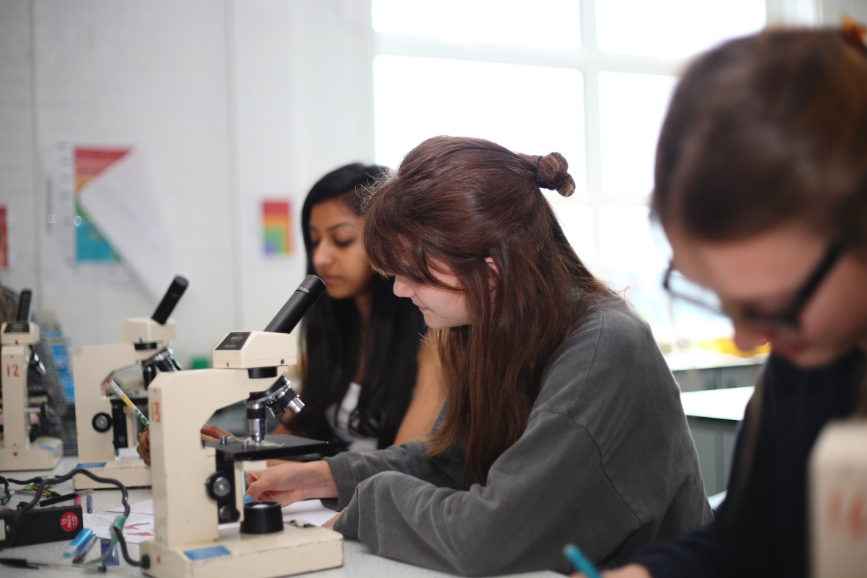

Terms and Conditions of the Post
Salary is according to qualifications and experience.
Benefits include:
Staff Fee Remission – staff are eligible for fee remission, currently 50% of the basic school fee for a full-time employee subject upon their daughter(s) meeting the academic conditions for entry; part-time staff are eligible to a reduction on a pro-rata basis
Membership of Teaching Staff Pension Scheme
Season Ticket Loans - Interest free loans are available to staff to enable them to buy annual season tickets.
Computer Loans - Interest free loans are available to staff to enable them to buy a computer for personal use at home.
Cyclescheme – the School is part of the scheme, which enables staff to purchase bicycles and equipment at a tax advantageous rate and pay for the equipment over 12 months.
Lunches – free lunches are provided to all staff during term time.

Application and Interview Process
Applications should be submitted by midday, on 3rd July 2017 at the latest; however, applications may be considered in advance of the deadline. Candidates should complete the application form provided and also include a covering letter and full curriculum vitae with details of qualifications and experience and the names, addresses, telephone numbers and email addresses of two professional referees, one of whom should be the Head of their present or most recent school.
Completed applications should be sent to:

Mr Matthew Shoults
Headmaster
Notting Hill & Ealing High School
2 Cleveland Road, London W13 8AX

or may be emailed to: recruitment@nhehs.gdst.net

Shortlisted candidates will be invited for interview which will be held during week beginning 3rd July. As part of this process, they will be expected to teach a lesson of up to 35 minutes for which a full prior briefing will be given. All applications will be acknowledged and candidates who have not heard from us further within two weeks of the closing date should assume that the post has been filled.
All adults employed at the school are cleared for working with children and young people through the Disclosure & Barring Service. Please see attached full information regarding the Girls’ Day School Trust guidelines on the Safeguarding of Children.

Further information about the school can be found on our website at: www.nhehs.gdst.net
Application Form

