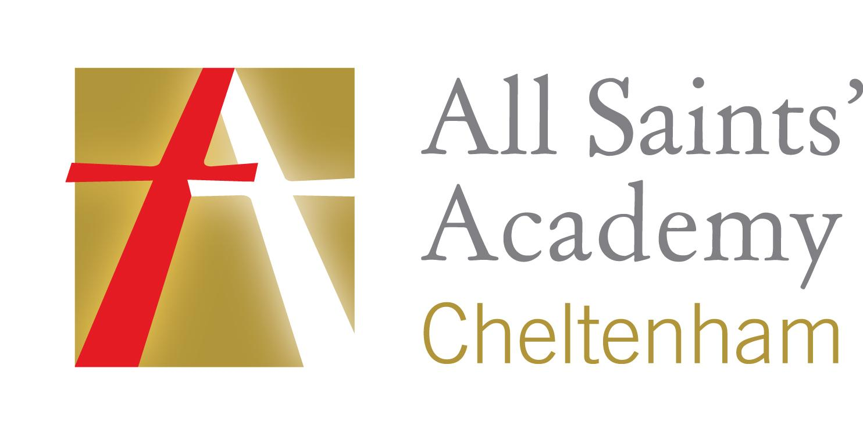



www.asachelt.org

All Saints’ Academy, Cheltenham, Gloucestershire.
Principal: Mr Dermot McNiffe

Design Technology and Food Technician
Start date: ASAP
Salary: Grade E Points 13-19 £17,391-£19,446 pro-rata
Hours of work: 37 hours per week/ Term time only plus one week for Inset days
Closing date: 9am Monday 16th September 2019

As a DT Technician at All Saints’ Academy you will be part of a dynamic team who are passionate about Academy improvement. All Saints’ Academy are looking to appoint a highly motivated team player for the position. The ideal candidate will have a willingness to support Design Technology across product design, engineering and catering.

The Academy is looking for an enthusiastic individual to help with:
- Preparing and clearing away materials and equipment
- Assisting teaching staff with demonstration lessons and practicals
- Making arrangements for maintenance and repair services to equipment
- Assisting in the maintenance of health and safety standards
- Contribute to the planning, development and organisation of systems/procedures/policies
- Ordering, receiving and accounting for new stock and equipment
What we can offer:
- The Academy is in an attractive new building, within easy access to Cheltenham, Tewkesbury and the M5.
- Entry into the Local Government Pension Scheme or Teachers Pension
- Free access to the onsite gym facility
- Cycle Scheme
- Free onsite parking
The Academy is committed to safeguarding and promoting the welfare of children and young people, and expects all staff and volunteers to share this commitment. Successful applicants will be subject to enhanced DBS clearance.
To apply for this role please send a covering letter and a completed Support Staff Application Form to Katie Jordan, HR Officer at hr@asachelt.org

