January 2020

Dear Applicant

Thank you for your enquiry regarding the post of Mathematics Teacher at Alexandra Park School. We are looking to appoint an enthusiastic candidate to join our very successful school. We are a confident, well-established community with an excellent reputation within the local area. We are consistently the most oversubscribed school in the Borough.

Alexandra Park School is an exciting and rewarding place to work. There is very strong staff morale and a real commitment to ‘go the extra mile’ for our students. We are classed as an Outstanding School and we have also been designated a National Teaching School. At the end of the 2018-2019 academic year, Progress 8 was 0.63, Attainment was 58.7 and 84% of students achieved good passes in five GCSEs including English and Maths. This places us in the top 10 of schools nationally. This success is mirrored in our large sixth form which is consistently ranked in the top 5% for performance. Having said all this we are no exam factory. Students enjoy school, studying a broad and balanced curriculum and getting involved in a wealth of extra curricula opportunities. For more information on the school visit our website on www.alexandrapark.school

I look forward to receiving your application for this post by midday on Monday, 20th January 2020. Please contact Sue Levi, HR Manager by email: slevi@alexandrapark.school if you require any further information or would like to visit the school. The successful candidate will be required to undergo pre-employment checks and an enhanced DBS check.

Please note we reserve the right to bring the deadline forward depending on application numbers; therefore, we would urge candidates to submit an application as early as possible. If you are shortlisted for interview, we will contact you by telephone or email. We regret that we cannot acknowledge every application.

Good luck and thank you for considering Alexandra Park School.

Yours sincerely
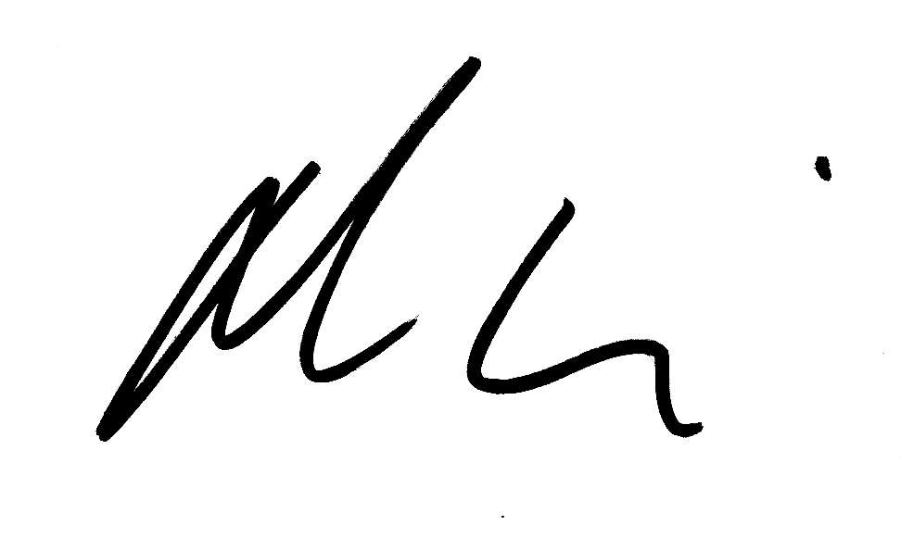

Michael M^{c}Kenzie
Headteacher

