

Applicant Pack - ALS Assistant

Salary: £21,388.29 to £22,856.57 (£24,953.00 to £26,666.00 per annum FTE) – Points 7 to 10 of the Support Staff Pay Scale

Working hours: 37 hours per week, 8:30am – 4:30pm, Monday to Thursday & 8:30am – 4:00pm Friday (30-minute unpaid lunch), term-time only (39 weeks per year).

FTE: 0.8571

Pension: West Yorkshire Pension Fund – Employer contribution rate of 21.5%, plus Death in Service Grant of 3 x your annual salary

Contract type: Fixed-term contract from 26 August 2025 to 31 August 2026

Other benefits:
- Access to Kirklees Employee Healthcare (e.g. private counselling, physio, etc).
- Eye test vouchers.
- Flu vaccination vouchers.
- Cycle to work scheme.
- Health and wellbeing events throughout the year, including dedicated staff wellbeing day.
- Enhanced maternity and paternity pay.
- Personal and professional development opportunities.

Reports to: ALS Manager

Closing date: Friday, 30 May 2025

Start date: Tuesday, 26 August 2025

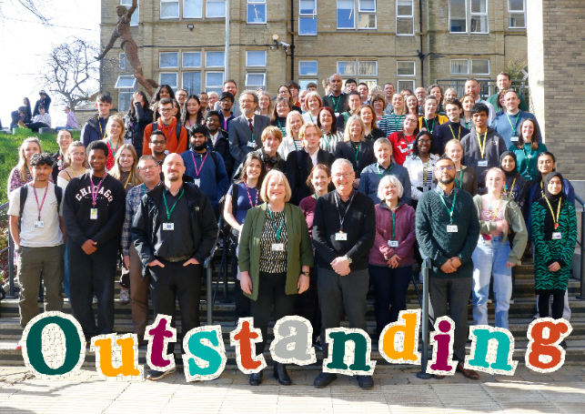

Welcome Letter

On behalf of Greenhead College, thank you for your interest in the post of ALS Assistant. We are pleased that you are considering Greenhead College as the next stage in your career, and we hope, subject to matching our criteria, you will apply.

Greenhead College is located on an attractive campus close to Huddersfield town centre, adjacent to the picturesque Greenhead Park. We are a short drive from the M62 and within walking distance of the train and bus station. Therefore, the College is an easy commute from much of the Northwest and Yorkshire.

Approximately 2750 students attend the College studying predominantly A Level courses across 35 subjects, and the College has ambition to grow to at least 2800 students by 2025-26. The academic structure of the College is based on Heads of Curriculum who are subject specialists. The College also maintains a unique tutorial system, with all Personal Tutors being fully qualified teachers, highly experienced in pastoral care, careers guidance and trained in Mental Health First Aid. Students are also offered numerous extra-curricular enrichment activities and a comprehensive programme of projects and work placement opportunities as part of our ‘Step Into Your Future’ scheme.

In February 2025, OFSTED once again graded the College as ‘Outstanding’ and as making a strong contribution to skills needs, with no areas of weakness identified. In July 2024 the College secured the Further Education Mental Health Gold Award, due to the level of support it provides to both students and staff. Both the Ofsted outcome and the Mental Health award recognise the resilience, ambition and success of our students, and the hard work and support provide by all staff, irrespective of their role.

The College is a great place to work, with a warm, inclusive atmosphere existing between students and staff. Our staff are recognised for their hard work and are encouraged to inspire each another, and to develop and grow. We are proud to have a strong and able College Leadership Team, and a highly experienced Board, who work collaboratively to deliver the College’s purpose and principles, and strategic priorities.

This is an exciting time to be joining Greenhead College. We were one of only 50 schools and colleges nationally to be granted a multi-million-pound funding to build a new four-storey science block, which opened in November 2023. The final building work and landscaping is ongoing but will be completed by August 2025. The College has ambitious plans for future growth and development on its estate on site.

If you have any queries about this role, please contact our Human Resources Team via email jobs@greenhead.ac.uk who will be happy to help.

We look forward to receiving your application.

Best wishes,

Mo Bunter
Principal

Job Description – ALS Assistant

Duties & Responsibilities:

The successful candidate will provide assistance to enable students to access all parts of college life. Targeting support through addressing any barriers to learning and encouraging independence. The candidate will be able to adapt approaches according to the changing needs of the individual learner, whilst working within the framework of the College SEND policy.
Role-specific responsibilities:

- To provide in class support for students with additional learning needs.
- To provide support on College trips for students with additional learning needs.
- To contribute to and deliver interventions for students with additional learning needs.
- To deliver study skills support through 1:1 mentoring sessions or group work.
- To monitor student support and progress.
- To contribute to the administrative work of the ALS department.
- To ensure that any additional support is recorded using the relevant systems.
- To attend ALS team meetings and training sessions as required.
- To support students in internal and external exams as required, including the set up and use of use assistive technology
- To modify class and assessment resources to meet the needs of the student
- To contribute to and attend EHCP annual reviews and parent meetings
- In exceptional circumstances there may be a requirement to support students with personal care, appropriate training will be provided.
- To keep up to date with SEND developments in Further Education and in equality and disability legislation.
- Any other duties as may be reasonably requested by the line manager to allow for the efficient running of the college without changing the general character or level of responsibility.

Safeguarding:

- All staff and senior postholders have a duty for safeguarding and promoting the welfare of children and young persons. Staff must be aware of the College’s procedures for raising concerns about children's welfare and must report any concerns to the Designated Person without delay. Staff must also ensure they attend the appropriate level of safeguarding children training identified by the College as relevant to their role.

General duties - the post holder will also:

- Promote, act as a role model and implement the College’s policies, practices and procedures including those relating to diversity and inclusion.
- Take reasonable care of the health and safety of self, other persons and resources whilst at work. This entails supporting the college’s responsibilities under the Health and Safety at Work Act.
- Demonstrate day to day commitment to the College’s core values of community and mission statement.
- Carry out such reasonable additional duties as may from time to time be determined by or on behalf of the Corporation.

Diversity and inclusion Statement:

The College will seek to ensure that all existing and potential employees and students are given equal opportunities for employment and education. It is committed to the elimination of unlawful or unfair discrimination on the grounds of sex, age, marital status, colour, race, nationality or other ethnic or national origin, disability, sexual orientation, trade union membership or activity and religious background.

The College will seek to ensure that no applicant for employment or education is disadvantaged by conditions or requirements which cannot be justified. The College provides an open, welcoming and safe environment for all its students, employees and visitors.

Safeguarding Statement:

The College is committed to safeguarding and promoting the welfare of children, young people and vulnerable adults, and expects all staff to share this commitment.

Employee Wellbeing Statement:

The College is committed to promoting and supporting employee wellbeing to improve working lives and allow our staff to flourish and reach their potential. The employee wellbeing priorities of the College are integrated throughout, embedded in our culture, leadership, and management. Staff are encouraged to talk about mental health, have good self-care routines, and seek help where needed. Employee wellbeing is an integral part of the College’s performance management process, which allows Heads of Departments and the College Leadership Team to regularly review workloads and deadlines in a meaningful way. The College has a holistic framework in place to support staff, including early access to specialist sources of help, such as counselling and physiotherapy, as well as an employee assistance programme, occupational health service and dedicated employee wellbeing days.

Prevent Statement:

The successful applicant will be required to uphold the values of democracy, rule of law, individual liberty and tolerance and have mutual respect for those with different faiths and beliefs.

Mo Bunter
Principal

ALS Assistant

Closing Date:

The closing date for applications is Friday, 30 May 2025 and interviews will take place on Thursday 5th or Friday 6th June.

Applicants for this post are asked to:

- Complete the College’s application form or TES application form and Equality and Diversity form.
- Write a supporting letter of application, with CV if you consider it useful.

Please send the completed documents to:

Jen Rothery, HR and Recruitment Manager, as an email attachment to jobs@greenhead.ac.uk

Safer Recruitment:

Greenhead College is committed to safeguarding the welfare of all of its students and staff. The successful candidate will have to meet the requirements of the person specification in order to be offered the post and will be subject to safer recruitment checks. This position is working in regulated activity and therefore exempt from the Rehabilitation of Offenders Act 1974. Applicants will be required to self-disclose particular criminal convictions should they be shortlisted for interview. Further details can be found within the DBS filtering guide at https://www.gov.uk/government/publications/dbs-filtering-guidance

All offers of employment are subject to the following pre-employment checks:

- Two satisfactory references
- Enhanced DBS check with barred check list
- Overseas check if you have lived or worked abroad within the last five years
- Evidence of the right to work in the UK
- Prohibition check order
- Qualifications
- Fitness for Work

In line with KCSIE 2024 guidance, all shortlisted candidates will be subject to an online search.

If you apply and are unsuccessful in being called to interview, can we thank you in advance for your time and trouble in making this application. Due to time constraints, it would be impossible to respond to everyone individually - we hope that you will understand.

The college is committed to Diversity and Inclusion and welcomes applications from all sections of the community.



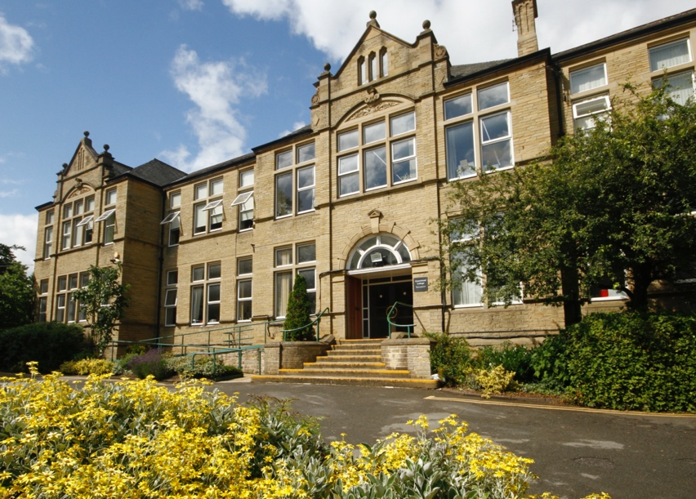


Person Specification – ALS Assistant

 | Essential | Desirable
QUALIFICATIONS:
A good standard of education | x
First aid qualification or willingness to undertake one. |  | x

 | Essential | Desirable
KNOWLEDGE / UNDERSTANDING:
Excellent IT skills | x
Excellent Microsoft Word Skills | x
Familiar with Microsoft Office IT package |  | x
Familiar with Text Help software |  | x

 | Essential | Desirable
EXPERIENCE:
Experience of working with students in a school/College |  | x
Experience of supporting students who have Access Arrangements |  | x
Experience of modifying resources |  | x

 | Essential | Desirable
SKILLS / ABILITIES:
Ability to motivate learners to achieve their full potential | x
Ability to empathise with 16-19 age range | x
Excellent organisational skills | x
Ability to communicate effectively with a wide range of individuals | x
Ability to work with accuracy | x

Essential | Desirable

ATTRIBUTES
Courteous, positive, and can-do approach | ×
A commitment to quality and the development of skills | ×
A willingness to be flexible and have a proactive approach to work | x
A proven commitment to safeguarding and promoting the welfare of young people | x
A proven commitment to diversity and inclusion and an understanding of the College’s policies | x
Positive and professional approach with a high level of commitment to the College | x

The above criteria will be assessed by the: Letter of Application, Interview & Assessments.

