

Job Description

Teacher of Maths (REF: PEN005)
Teachers’ Main Scale / UPS

Closing Date │ 9.00am Monday 19th February 2018
Interview Date │ Week Commencing 26th February 2018

Charlestown Road, St Austell, Cornwall, PL25 3NR
Telephone 01726 72163

Head of Maths │ Gerald Parry – gparry@penrice.org.uk
Head of Maths │ Samantha Lawrence – slawrence@penrice.org.uk


Principal │ Mr Richard Baker



Mathematics at Penrice Academy

Our department prides itself on the strength of the team, with every teacher knowing their role within it. We are a vibrant, forward thinking department, driven by a desire to make maths accessible to all, whilst stretching and inspiring our most advanced students. Developing a mastery approach in students when teaching mathematical concepts, as well as understanding the importance of nurturing a growth mindset are the keys to our success.

Our team consists of 13 specialist maths teachers, including a MAble and Pupil Premium Lead and two full-time HLTAs. We have fully equipped teaching spaces including break-out areas for small group work, two faculty offices and excellent student ICT provision in the form of 180 iPads dedicated to the department. Our teaching expertise range from primary trained specialists working with those students who have needed expert support to bridge the gap between primary and secondary maths, to those who lead students through additional qualifications such as Further and Additional Maths in KS4.

Regardless of role, we all work tirelessly to ensure our learners make significant progress and understand why maths is so important in the real world. Over the last three years this has been reflected in our results which have consistently been above national averages at grade 4+/C (78% in 2017).

Job Description

We are seeking to appoint an inspirational teacher to deliver challenging lessons and work with an outstanding maths faculty. The successful candidate will teach an exciting and developmental curriculum to a range of ages and attainment levels. A strong commitment to raising achievement and standards is required along with an informed and creative approach to curriculum delivery.
The development of exceptional reasoning and problem solving skills within a mastery approach to teaching and learning maths is a key driver for us as a faculty and the successful candidate will show a strong willingness to adopt this approach to help drive the department forward.
This is an exciting opportunity for a committed and motivated professional and would be suitable for an experienced teacher with a proven track record of success or an outstanding practitioner seeking their first role looking to join a driven and forward thinking team.

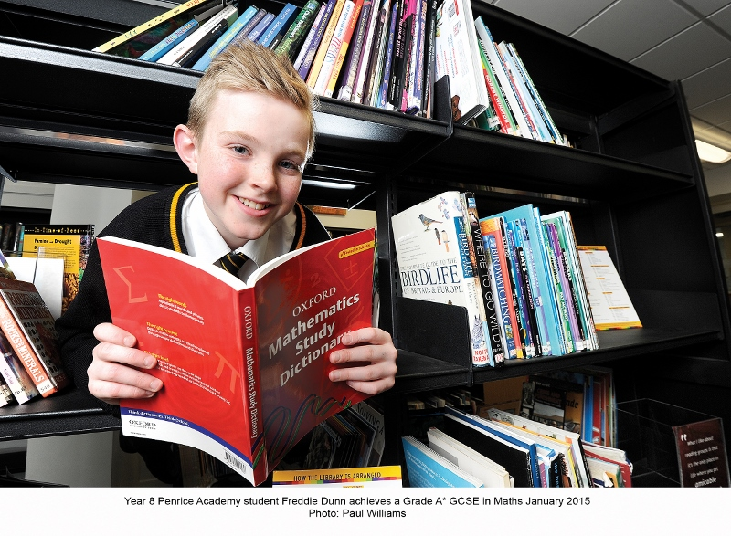

Person Specification

The Person Specification outlines the essential and desirable qualities concerning the person we are seeking for this post.

Essential | Desirable
- Mathematics or related subject at degree level  - Professional teaching qualification  - Experience of teaching at Key Stage 3 and Key Stage 4  - An understanding of the national curriculum, the requirements of KS3 and KS4 GCSE Mathematics (new specification) and numeracy  - A developmental/creative mind – a good team contributor with a willingness to be involved in curriculum innovation  - A desire to teach maths for true depth of understanding with an appreciation of the importance of mathematical reasoning and problem solving  - An innovator with a clear passion for their subject  - An ability to deliver a curriculum designed to engage all students  - An outstanding teaching practitioner  - An ability to demonstrate a versatile approach to teaching strategies  - A working knowledge of ICT and how it can be used to analyse and track attainment  - A sensitivity to students’ needs  - A commitment to pastoral tutoring  - An interest in the broader education of students through extra-curricular enrichment activities  - A commitment to safeguarding young people  - Strong interpersonal skills – a high standard of written and spoken English | - Experience of teaching at Key Stage 5  - An understanding of how mathematics relates to other National Curriculum areas and the national changes to the reformed qualifications  - Evidence of curriculum, classroom materials which you have developed  - Experience of teaching a range of years and attainment levels

