Head of Learning Support

Required from September 2019

We are looking to appoint an experienced and enthusiastic Head of Learning Support to lead the School’s provision for students with special educational needs. This vacancy has arisen due to the retirement of the current post-holder and represents an excellent opportunity for someone with the right blend of skills and experience, looking to take on a key role in the Senior School.

The successful candidate will have specialist knowledge and experience of the wide range of specific learning difficulties and disabilities. They should hold a current Specific Learning Difficulties Assessment Practising Certificate or a similar post-graduate specialist qualification at or equivalent to a Level 7 in individual assessment, and should be familiar with the Joint Council for Qualifications (JCQ) regulations regarding the processing of access arrangements for public examinations. They will also be required to teach small groups of students within the Senior School. A willingness to contribute to the extra-curricular life of the School is also a requirement.

Burgess Hill Girls is a GSA day and boarding school, with 450 students aged between 3 and 18 years. The majority of students are of above average ability and the school has an outstanding record of academic success at both GCSE and A level. Students with specific learning difficulties make excellent progress and achieve highly. Last year, nearly all pupils obtained at least 9 or more GCSE passes at Grade 4 or above and the vast majority of sixth formers proceeded to Higher Education.

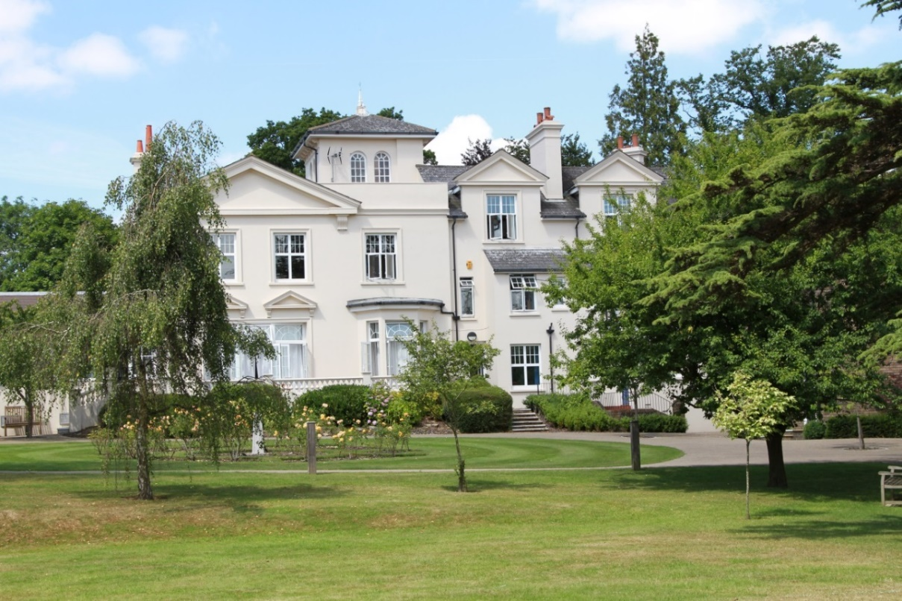

ABOUT THE SCHOOL

Location
The School is situated in a very pleasant thirteen-acre site in the conservation area of the town. Burgess Hill is a medium sized town with its own theatre, orchestra, cinema and leisure centre. Burgess Hill is approximately ten miles from Brighton and Lewes, fifteen miles from Crawley and fifty miles from the centre of London. It is well served with fast roads – the M23 and M25. The school is a three minute walk from the railway station.

Facilities
The School is a blend of Victorian buildings and ultra-modern facilities and there has been a steady development of the facilities.

Curriculum
The School offers a full range of GCSE and A level courses in preparation for university entrance.

Pastoral care
Our pastoral system is designed to encourage and support the development of each individual student from the moment she arrives in school until the time she leaves. We want to provide each student with the skills and confidence to help her to make the most of her time with us, at university and beyond. Implicit in the School aims is the expectation that every teacher will accept responsibility for the development in each pupil not only of the highest academic standards, but also of the confidence and self-esteem, which comes from being valued as an individual within a community.

Co-curricular and extra-curricular activities
We believe that education is about giving young people the chance to be successful in as wide a range of areas as possible, and to feel a sense of pride in their achievements. Extra-curricular activities give each student wonderful opportunities to explore her own talents and develop her individual skills to her full potential. The successful applicant will be expected to play a part in the co-curricular and extra-curricular programme, drawing on their own interests and expertise.

LEARNING SUPPORT DEPARTMENT

The Learning Support Department currently comprises the Head of Learning Support and an Assistant. Specialist support is provided from other departments where required. In addition to the members of the departmental team, the SENCO works closely with the Assistant Head Academic and the Examinations Officer.

The Department is located in the centre of the School with a classroom and office providing a welcoming space for students to access academic and pastoral support.

The Department is well-resourced with assessment and other support materials. The Learning Support Department has a classroom with five networked computers equipped with specific software to support the development of literacy and numeracy. Technical support is outstanding.

Years 7 and 8

Pupils with an Educational Psychologist’s report, a specialist diagnostic assessment report, or who are currently receiving support in the Junior School, begin Year 7 with a one-to-one support lesson each week on a rotation basis. In line with the School’s SEND policy, amendments are made to a pupil’s curriculum only where necessary. Students who follow a reduced curriculum because they require additional provision from the Learning Support department receive this small group teaching in place of a modern foreign language.

Years 9, 10 and 11

Any pupil who has had a one-to-one lesson in Year 8 will continue this arrangement if they begin a full complement of GCSE subjects. Students who require additional provision from the Learning Support department receive this small group teaching during designated lessons within the timetable, in place of a language.

Sixth Form

As students move into the Sixth Form we anticipate that they have acquired the study skills and subject knowledge necessary for success in their chosen A level courses. However, when the volume and complexity of the work increases, pupils might require additional targeted support to develop appropriate study skills or to tackle specific challenges. The Learning Support Department offers this targeted intervention as appropriate during a pupil’s non-contact periods.

Additional Services
The Learning Support department provides a range of services for students following a reduced curriculum and, where possible, those who need short-term additional intervention but who remain on a full complement of academic subjects. Services include but are not restricted to:

- Literacy and numeracy support
- Support with the sciences
- In-house testing in order to support an application for exam access arrangements
- Subject-specific support
- Supervised prep / on-hand access
- Training and rehearsal for public exam access arrangements

HEAD OF LEARNING SUPPORT ROLE

Managerial
- Ensure that the legal requirements of the SEND Code of Practice are met
- Oversee and manage the provision for SEND students across the curriculum
- Lead on the development of SEND provision across the School
- Keep up to date with latest developments in SEND provision
- Be accountable for the attainment, achievement and progress of students with SEND
- Maintain the SEND Register and Monitoring Register
- Manage and lead the Learning Support Department
- Liaise with the Junior School Individual Needs Co-ordinator to ensure consistent provision across the whole school.

Teaching
- Provide high quality teaching to small groups of SEND students across Key Stages 3, 4 and in the Sixth Form, where appropriate

Examinations
- Ensure access arrangements are in place for students undertaking internal and public examinations
- Process Access Arrangements Online applications in accordance with JCQ regulations

Monitoring and Review
- Regularly review and record progress of SEND students
- Provide regular information to the Head Teacher regarding SEND provision
- As part of an annual review, undertake a review of the School’s SEND provision.

Liaison Role:
- Liaise closely with parents, carers, teaching staff and outside agencies to ensure a high quality and appropriate service is provided for each student with SEND. Attendance at parents’ evenings.
- Ensure that SEND Information sheets are devised for each student on the SEND Register and disseminated to all relevant teaching staff

Staff Development Role
- Lead in the continuous professional development of staff in relation to SEND

Undertake any additional duties as may be reasonably delegated by the Head or SLT.
A management allowance is paid in addition to salary.

The Head of Learning Support, Mrs Margiad Eckstein can be reached by email on mags.eckstein@burgesshillgirls.com for any specific questions about the department and the role.

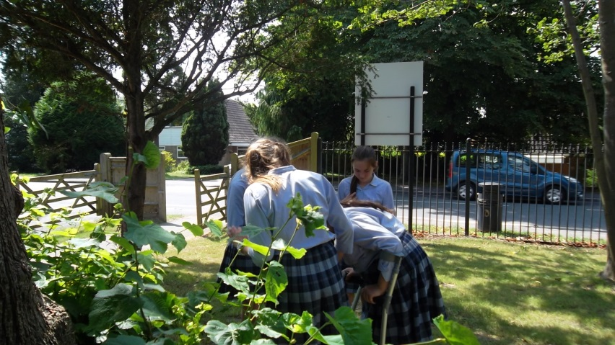

RECRUITMENT PROCESS

Candidates are required to submit an application form with supporting letter and details of two referees. One reference should be able to comment on the teaching skills of the candidate. References will be taken up prior to interview.

Closing date for applications is 5.00pm on Wednesday 24th April 2019

Short-listed candidates will be contacted by telephone and interviews will take place on Wednesday 1st May 2019.

Candidates who have not heard from the School by the end of May should presume that we will not be taking their application further.

All appointments are made in accordance with our equal opportunities policy and applicants should let us know of any special needs they may have.

The School is committed to safeguarding and promoting the welfare of children and applicants must be willing to undergo child protection screening appropriate to the role, including checks with past employers and the Disclosure and Barring Service.

