
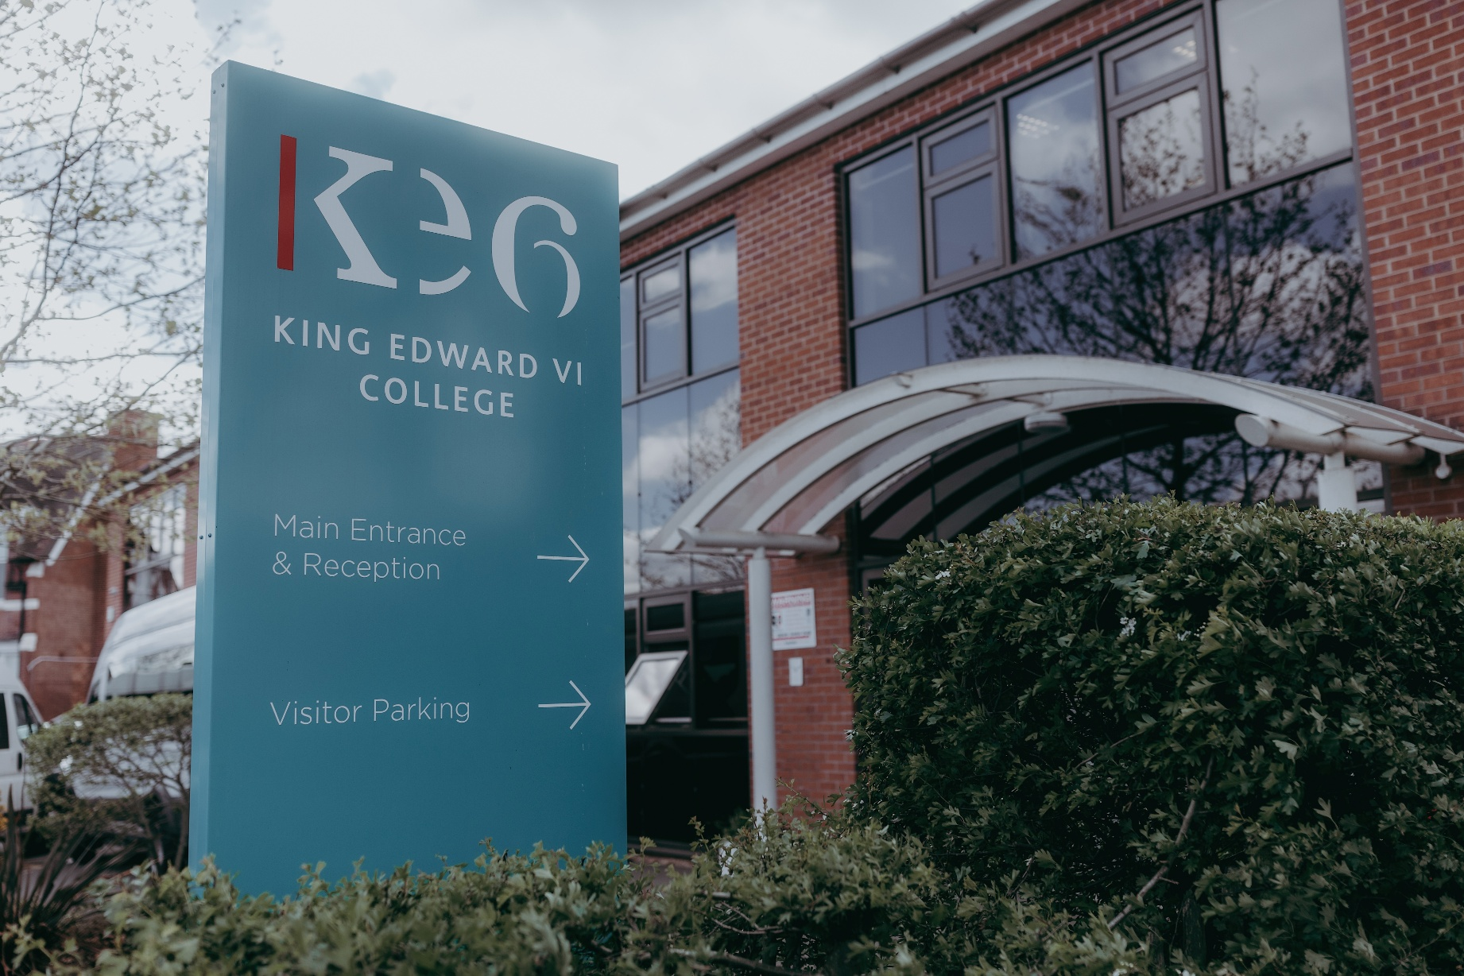
Candidate Pack
King Edward VI College

Introduction from the Principal



Dear Applicant,
Thank you for enquiring about our advertised role at King Edward VI College.
We are looking for someone who has the desire and vision to assist us in building the college vision of the future, building on the foundations already in place to help take the college, and wider Trust organisation, on the next stage of its journey to becoming sector defining.
We are part of a multi academy Trust that is a modernising force for post-16 education, sharing best practice amongst high performing colleges, drawing inspiration from sectors beyond education and working in collaboration with one of the most entrepreneurial higher education organisations in the country. It’s an incredibly exciting place to work but takes us all out of our comfort zones. If that appeals, then we look forward to hearing from you.
Successful candidates will be ‘Team Players’, skilled in a variety of areas including the ability to support our students in order for them to fulfil their potential. You will be working within successful and ambitious teams as well as the wider college community to ensure that the college continues to prosper through the changes and challenges of the coming years. It will be all our mission to uphold and strengthen the vision and values of our organisation, to evolve its ethos and culture, to provide an inclusive, ambitious and supportive environment in which our students can continue to flourish personally, academically and socially.
We are not necessarily looking for someone who has done it all before. The right attitude and outlook, aptitude and enthusiasm, and a willingness to work hard and learn quickly are likely to be as important as experience. As we continue to grow the structures of the college and wider organisation will evolve. Development is central to our organisation and an ability to embrace change is desired.
The following pack will hopefully give you a better picture of our college and Trust. If the role appeals to you, we look forward to receiving your application.
Stuart Noss, Principal

Message from the Student Voice

All students should be encouraged and supported to be active contributors in the college community, from our president to the student in the classroom.
Student Voice is fundamental in the development of the college and hence, we believe that accountability of those responsible is vital, from us to the Principal and from them to us, to ensure that we are all fulfilling this responsibility.
We want the college to be a thriving environment which offers the best experience to our students, where they can grow and reach their goals.
We look forward to working with staff who are passionate about the college and who will walk through its doors, and challenge current thinking and take fresh approaches to provide the best experience possible. We are committed to partnership working to actively help our members and hope that our teaching and support staff are too.
We are also excited to be part of a MAT, giving us the chance to work with other students and colleges to further enhance the student experience for all.
Help us to be co-creators of the college experience, and together we can help the college reach its full potential.
As a Students’ Union we believe students should be at the heart of all the college does.

The Students’ Union

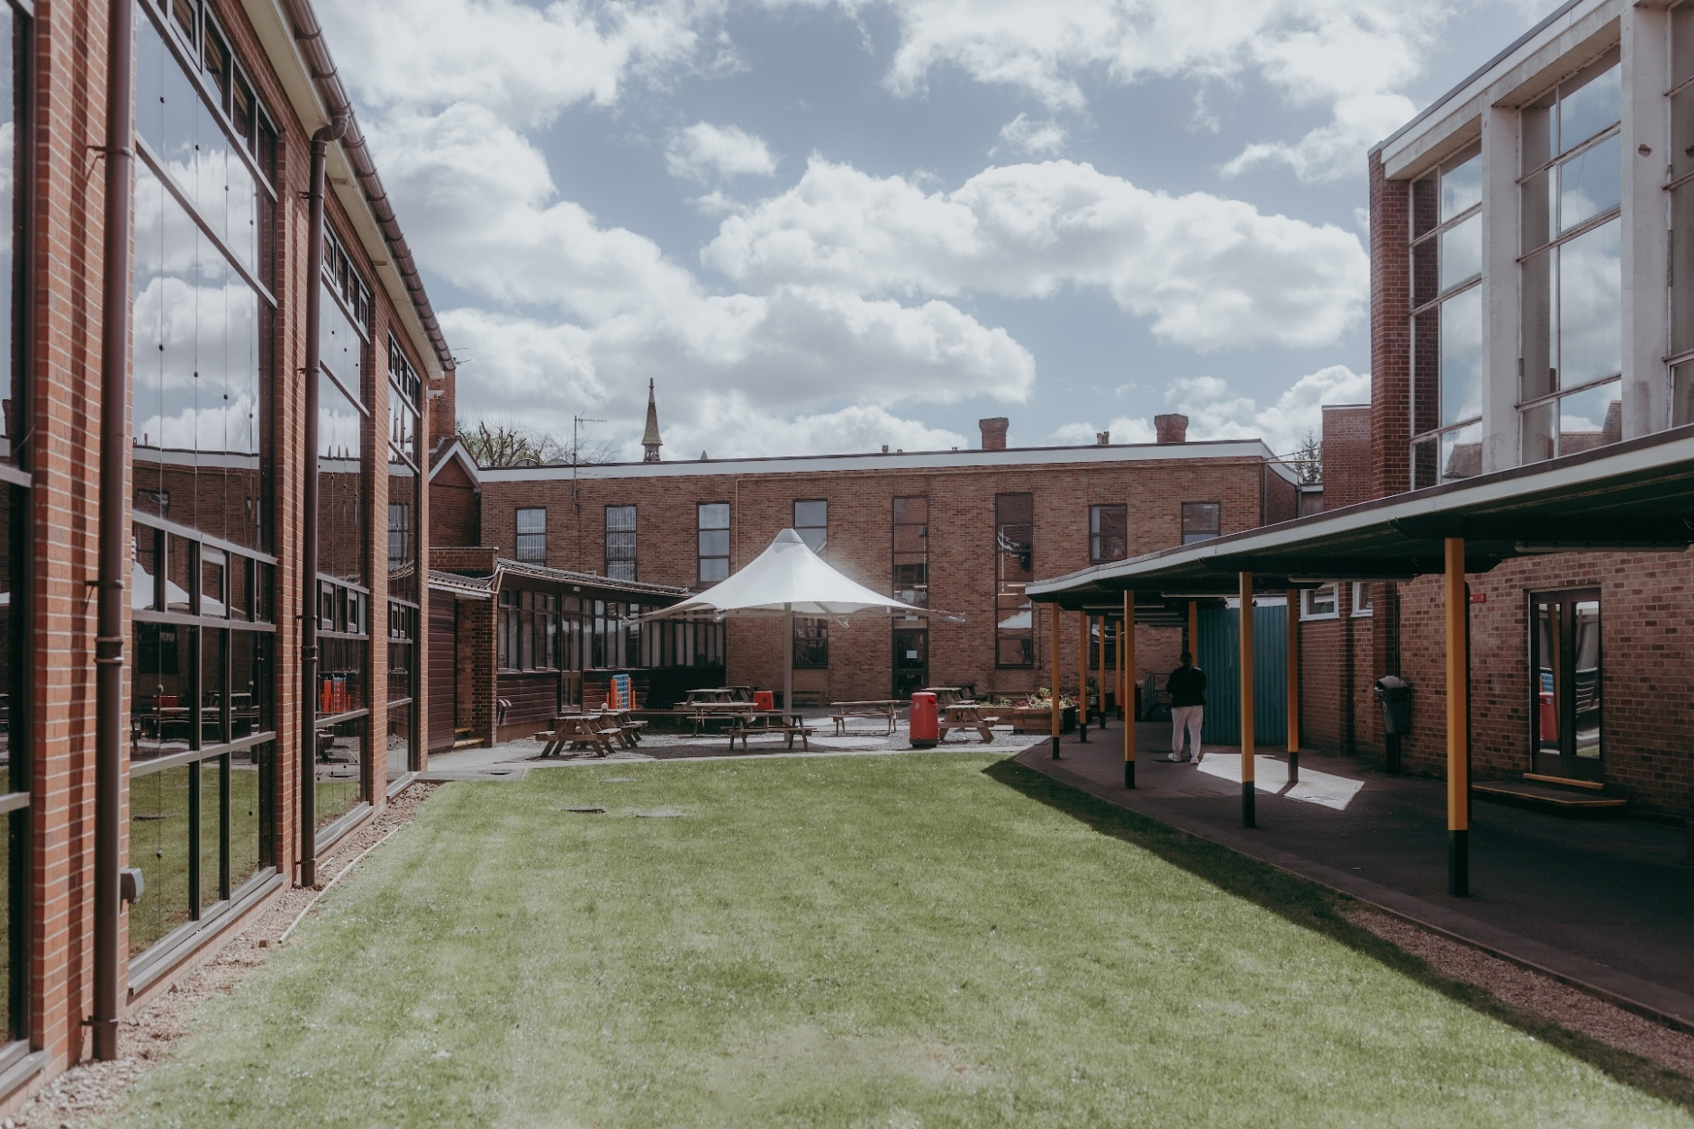

Mission Vision & Values

Mission:
We inspire young people to gain the skills they need to thrive in an ever-changing world as we transform Sixth Form Education.

Vision:
Our students will be recognised locally and nationally for the remarkable impact they have on their communities.

Values:
- Involved. We are one community with a shared responsibility
- Ambitious. We are curious to create exciting and aspirational ways to succeed
- Genuine. We are honest with ourselves and each other
- Supportive. We help each other improve with an optimistic and positive outlook.

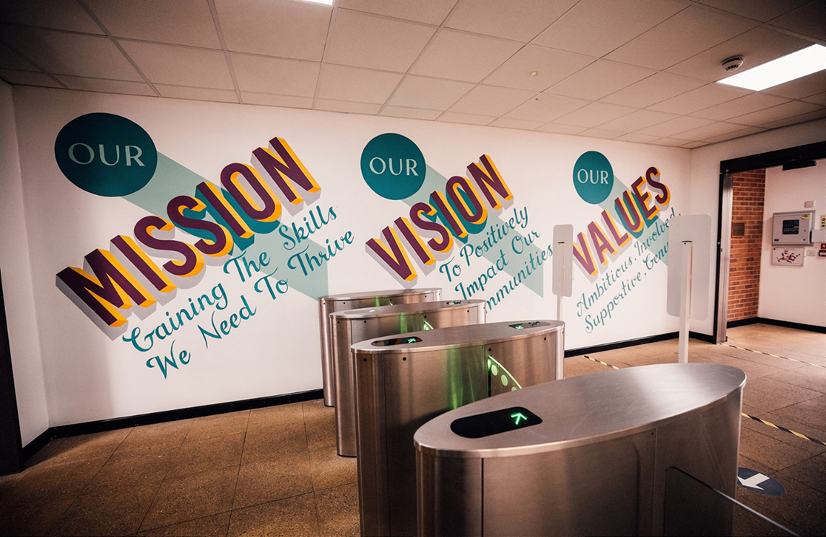

Key facts about the College

Our Mission, Vision and Values

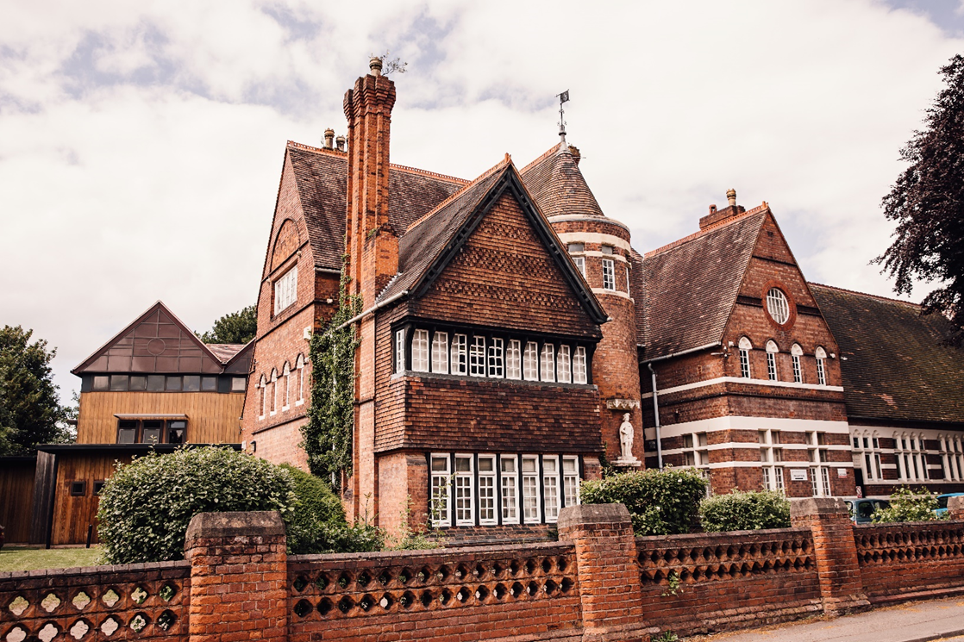
We offer over 40 different level 3 subject courses and have a well populated Foundation Programme for those needing to increase their GCSE grade profile. The college believes in developing the whole individual, so invests heavily in a diverse range of enrichment courses, as well as trip, guest speakers and more. In addition to our 16-19 work, we are slowly increasing the number of higher-level courses, with Media, Fine Art and Business currently on offer.
In November 2017 the College was inspected by Ofsted and was judged as continuing to be ‘Good’.
In January 2019 the college became the founding member of Better Futures Multi Academy Trust (BFMAT), an SFC focussed Trust sponsored by Coventry University.
The college has a long history in the town of Nuneaton, tracing back to the establishment of an education provision in 1552. For much of its recent life, the college was a boys Grammar School, with the existing grade II listed ‘R Building’ being built in 1880. The town retains a fondness for the college and still commonly refers to it as ‘KEGS’.
Since re-designating as a Sixth Form College over 45 years ago, the core purpose of the college has remained the same: to meet the needs of young people from across Nuneaton and areas beyond.
We are the only Sixth Form College in Coventry and Warwickshire and currently have approximately 1500 students and over 150 staff.
We have been educating the young people of Nuneaton and the surrounding areas since 1552.
College Facilities

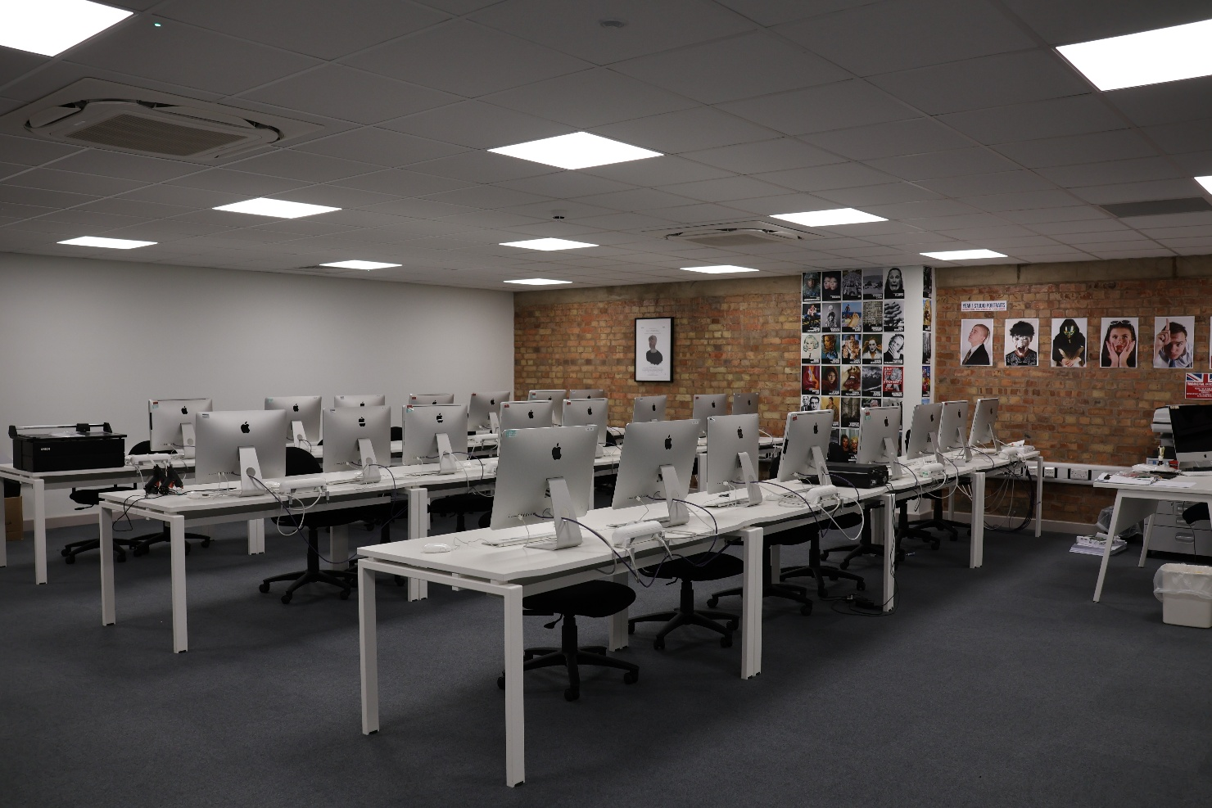

The college sits on a historical site, just outside of Nuneaton town centre. It is well served by public transport, allowing students from Warwickshire and Leicestershire to travel to the college. It is an exciting time to join the college, as we embark on a ten-year programme of refurbishment, enhancement and development. We have outgrown the existing site and so are looking for new opportunities to develop our campus footprint.
The existing college site includes a library, study centre, the Unity Hub (support centre), canteen, common room, a one court sports hall, two external quads and a large playing field.
Classrooms vary in size but are well served with IT and resources. For many subjects, specialist equipment is needed. We provide all the necessary materials and equipment to help students get the most out of their course.
The college utilises a six-block timetable and we begin the teaching day at 9am and continue until 4.30pm. Staff development and meeting time is located on a Monday afternoon (3-4.30pm) and enrichment (Link) is held cross college during the middle of the day on a Wednesday. Friday afternoon we finish the timetable at 3pm.
Each block in the timetable houses two lessons of 2 hours in length with additional 50-50 support. Students are allocated a progress tutor to support them through their time at college and help achieve positive destinations onwards. Students have a Progress Session once per week, as well as regular one to one meetings.

Better Futures Multi Academy Trust

A bit about Coventry University.

Coventry University Group (CU) is nationally and internationally recognised as an innovator in the higher education world. The CU Group is made up of a range of educational and innovation services companies, headquartered in Coventry but with sites throughout the UK and the world.
The University has a growing reputation for research in niche, interdisciplinary domains such as peace, trust and social relations, water and agroecology and transport, as well as a long-standing reputation for Engineering, Business and Art & Design.
The University has achieved TEF Gold and in the Guardian University Guide, is ranked as 15th amongst UK HEIs, securing its place as the highest ranked modern university in the UK for the seventh year running.
The Group is number one in the UK for working with small and medium sized enterprises. In recent years the group has expanded its range of provision with campuses based in Coventry, East London and Scarborough. These sites offer high quality alternative and flexible provision at a competitive price, increasing access to HE.

A bit about Better Futures MAT.
The trust is at an interesting stage of its development. KE6 formally joined as a founding member on 1 January 2019, followed shortly afterwards by Bilborough SFC and Gateway SFC.
With the three founding members in place, we are focussed on co-creating ‘The BFMAT way’, not only what we want to do to achieve our vision and fulfil our mission, but just as importantly, how we intend to do this. Setting out our agreed ways of working, our collective expectations of each other and how we will measure our progress toward is crucial towards reaching our vision.
As a leadership member of the Trust, you will be actively involved in owning and driving forward some of our projects across the colleges and will work with colleagues from the Trust central team, other colleges and university to develop new ideas and ways of working.
Better Futures MAT (BFMAT) has as its focus Sixth Form Colleges and Sixth Form Education and how this sector can gain mutual benefit from a structural relationship with a leading HE provider.
The MAT takes a collaborative, collegiate approach in its formation and development, seeking to connect colleges and share best practice, whilst retaining their unique identities.
A key aim of the MAT is to understand how best to improve the educational experience of the students in post-16. As a result, members of the MAT find themselves retaining high levels of autonomy while still having access to the financial benefits of a MAT and the opportunity to be a leading player in some exciting ‘systems leadership developments in the sector.

What we offer
The chance to work with fantastic students who have chosen to continue their learning at King Edwards | The trust, autonomy and freedom to take creative risks | A truly progressive approach to how an educational institution operates
The chance to work with open minded colleagues who are ready to work in new and exciting ways | An organisation that wants all of their staff to be happy and achieve at work. | A friendly but fast paced & optimistic culture
A truly purpose rich job where your success is based on helping others | Consistent but emotionally intelligent feedback to help remove your blind spots and to accelerate your development | A safe, values led institution that put the wellbeing of students and staff first
The opportunity to work at a place where students are genuinely at the heard of our decision making. | Financial investment in your professional progression | We are not obsessed with hierarchy. We are obsessed with the student experience.
A flexible and contemporary approach to and view of work | A culture where mistakes are seen as a learning opportunity | Collaborative opportunities to work with colleagues from two other sixth form colleges and a University

Who we are looking for and what we expect
We are looking for adaptive and people centred staff. The college prides itself on having supportive, reflective and ambitious staff who work to achieve the best outcomes for students. We treat our staff and students with respect, listen to both and involve all in our continuous development.

We see our college as a community, one we seek to contribute to the growth and impact of. Within this community we seek staff and students that demonstrate a relentless commitment to their own and their peer’s development. Progress and success are not measured by a narrow set of metrics, but rather a diverse range of rounded information that enables people to thrive in a challenging world.

We would like someone who can truly inspire students and staff to do things which inspire them. We want someone who is reflective and asks for help when they need it. Someone who always sees the best in our students and is willing to support the wider college and trust. No one specialism is essential, and no one set of experiences more valuable than another. We are looking for people that can contribute across a range of areas.

Whatever your area of expertise, we are looking for people who have curiosity and are open minded to new things and new ways of working. As educators we love to learn and aim to foster a passion for learning. We aim to give professional space in our organisation and allow discretion to make the best and right decisions. As a people centred organisation, we take a positive view of staff and students, building optimism about our own and each other’s capacity to grow and develop.
There is an aspect of all this that is demanding. We require positive impact. We are looking for people who embrace feedback and can do so with candour. Honesty is crucial and seeking feedback just as important as giving. We believe in creating a space in which risks can be taken and new ideas supported. Mistakes are seen as useful opportunities to learn but we must learn from them and move forwards.
Finally, we want the most creative, dedicated and effective people in education to join us and we will do all we can to make that happen. We want all appointments to believe in our mission and values. We expect the best of people and will work tirelessly to give the best conditions and opportunities in return.
The College is committed to the safeguarding and promoting the welfare of young people
The successful candidate will be required to undertake a criminal record check
via the DBS services
The College promotes diversity and welcomes applications from
all sections of the community
All candidates with a disability will be offered an interview should they meet
the minimum requirements of the post
The College is committed to the continuing professional development of all staff

