“Be Brilliant Today” | IT Technician-Equivalent to NJC Scale 4 Points 7-11  Responsible to: IT Technical Manager/Head of Academy/Executive Principal
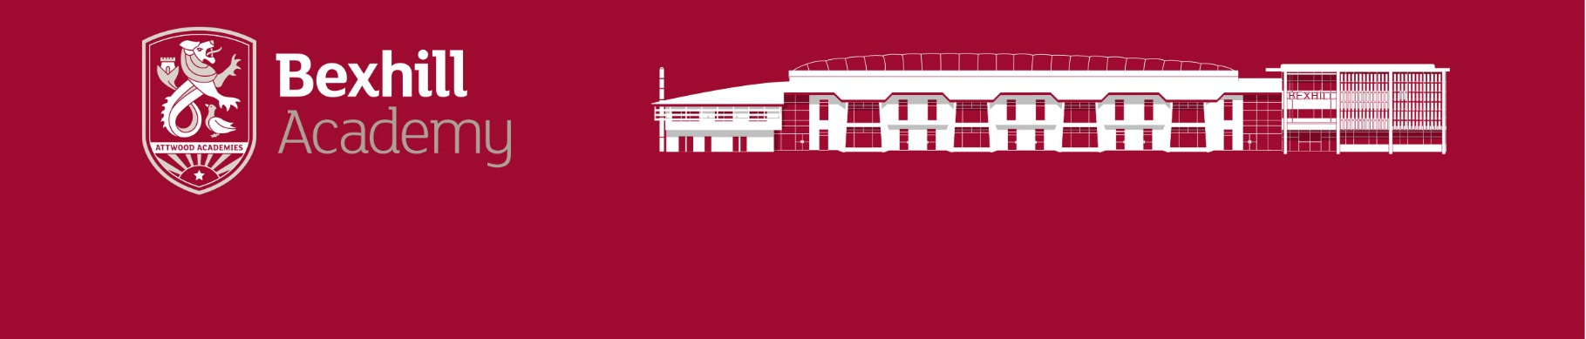

Specific Responsibilities
- To develop an understanding of all areas of the Academy system, both hardware and software
- To work with the Senor Technician as necessary to maintain an efficient and reliable system
- To help maintain all internal systems and related hardware
- To communicate effectively with the IT Technical Manager in all matters relating to IT
- To work effectively and efficiently with other departments, wherever necessary
- To maintain and administrate all the academies’ G-suite products
- To be the Academy co-ordinator and administrator of all curriculum on-line platforms used by the Academy
- To maintain the departments deployment systems, creating and maintaining the MDT solution
- To assist all staff in on-line meetings, web conferences etc
- To provide assistance as necessary to assembly / large scale learning / conference presentations
- To assist the ICT team in monitoring all ICT Suites throughout the Academy, maintaining them in the best condition possible
- To maintain a clean and organised working environment
- To identify issues negatively affecting the Academy system and suggest solutions to the IT Technical Manager
- To assist the IT Technical Manager in identifying the best and most cost effective method of maintaining and improving the Academy systems
- To maintain the Helpdesk system as an effective method of communication with all staff as well as a record of actions taken
- To maintain a clear record of work undertaken
- The specific responsibilities described are subject to annual review by the Business Director or relevant Senior Manager

General Responsibilities

- To assist the IT Technical Manager in maintaining the Academy systems and network as an efficient and reliable system
- To deliver a safe, effective IT resource for use by staff and students
- To provide a high quality and timely ICT support service to all pupils and staff across the Academy.
- To ensure that all legal and contractual obligations relating to IT resources, systems and services are met
- To have a responsibility towards own professional development

Other post and Academy requirements

- To play a full part in the life of the Academy community, to support its distinctive mission and ethos and to encourage staff and students to follow this example
- To actively promote the Academy’s corporate policies
- To continue personal development for yourself as agreed
- To comply with any reasonable request from the IT Technical Manager to undertake work of a similar level that is not specified in this Job Description
- To be courteous to colleagues and provide a welcoming environment to visitors and telephone callers
- To adhere to the Academy’s dress code, presenting a professional image to students, parents, governors and the wider community.
Whilst every effort has been made to explain the main duties and responsibilities of the post, each individual task undertaken may not be identified.

This job description sets out the duties of the post at the time it was drawn up. Such duties may vary from time to time without changing the general character of the duties or the level of responsibility entailed. Such variations are a common occurrence and cannot of themselves justify a regarding of the post.

The Academy will endeavour to make any necessary and reasonable adjustments to the post and the working environment to enable access to employment opportunities for disabled applicants or continued employment for any employee who develops a disabling condition
PERSON SPECIFICATION
Qualifications
Essential:
- Good standard of general education – minimum of A*-C in GCSE English and Maths or equivalent.
Desirable:
- IT related and or level three or higher qualifications.
- First Aid at Work
- Full driving licence

Experience
- Experience of working in a busy ICT environment preferably although not essentially within education.
- Experience of Windows 10 , Windows Server operating systems, NTFS permissions, Active Directory and other Windows Domain networking technologies
- Experience in configuring and deploying Microsoft operating systems using MDT
- Experience in managing on-line Internet platforms used in education

Skills, Knowledge and Understanding
- Ability to relate to young people 11-16
- The ability to liaise with hardware maintenance and other suppliers or
contractors in relation to routine matters and fixing simple faults
- Good knowledge of internet technologies and the basic range of functions of browsers
- An understanding of wired and wireless networking topologies, including managed switches, VLANs and routing
- Knowledge of software (Microsoft OS , Apple OS and Chrome OS) and network integrity and security
- The ability to install, test and maintain hardware and software for networks
and stand-alone use
- The ability to perform maintenance and repair procedures
- A willingness to undertake further training and professional development
- Knowledge of health and safety requirements

Personal Qualities
- A commitment to the safeguarding and welfare of young people
- Ability to form and maintain appropriate relationships and personal boundaries with children and young people
- The ability to solve problems and make decisions remaining calm under pressure or during unexpected circumstances
- The ability to work flexibly and supportively with staff and students
- The ability to communicate, orally and in writing, clearly and effectively and to understand the view of others
- The ability to plan time effectively and to organise oneself well
- Willingness to undertake training and personal professional development
- Able to maintain confidentiality
- Be highly organised and work in a methodical manner
- Understand the importance of keeping track of progress on jobs and informing others of work
- Strong problem solving skills
- Ability to work independently and as part of a team
- Good time management skills and the ability to prioritise work dealing effectively
- Have an excellent record of attendance and punctuality

The Academy is committed to safeguarding and promoting the welfare of children and young people and expects all staff and volunteers to share this commitment.
The successful applicant will be subject to an Enhanced DBS check.

