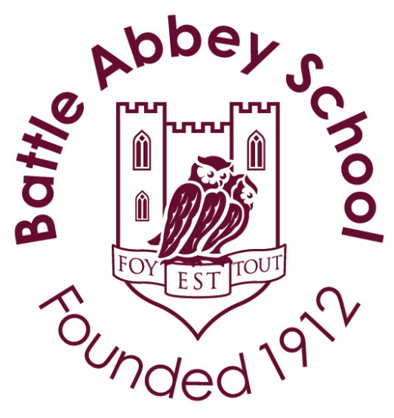

Information for Applicants
English Teacher
Required for September 2025
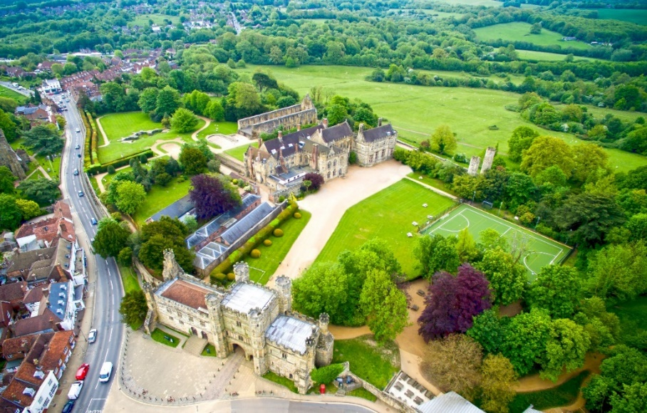
Battle Abbey School, High Street, Battle, East Sussex TN33 0AD
Tel: 01424 772385
www.battleabbeyschool.com
For further information please contact Hannah Blake at Headteacher@battleabbeyschool.com
CONTENTS

- Letter from the Head

- The English Department

- Job description
- Person specification

- Key dates

Dear Applicant,

Thank you for your interest in our exciting vacancy for a part-time English Teacher. We are looking for someone who can join us for four days a week, however we are open to discussing full-time if the candidate can offer other subject teaching.

Battle Abbey School is an all-through school for children from 3 months to 18 years of age. We are an independent, co-educational day and boarding school in East Sussex and have the privilege of the Senior School being based at the English Heritage site of Battle Abbey and the Preparatory School being close to the beautiful Bexhill coastline. This allows us to provide a wealth of educational opportunities steeped in history and quintessential English countryside blended with the needs of 21st century learning, literacy and life skills.

Our size creates a caring and supportive family environment, in which a strong community of both pupils and staff focus on the importance, wellbeing, and potential of each individual child. Embracing continuous improvement, it provides high quality pastoral care and sensitive discipline, allowing excellent academic outcomes. Located in a unique historical setting, the School’s rich past and many of its traditions are based on Christian values but importantly, the School welcomes students from all faiths and none. The Governors regard the safeguarding of children as paramount in the school and work to ensure that this is reflected in all elements of school life.

We are a mixed-ability school that embraces diversity and inclusive teaching for learning strategies for the success of all in our community. We are very proud of our pupils many and varied achievements and their wellbeing, along with our staff wellbeing, is very important to us. The successful candidate must therefore support the School’s ethos and become an active, caring and valuable member of our community.

We are looking for an excellent teacher of English for September 2025. This is an ideal opportunity for either an experienced or Early Careers Teacher to join a thriving department in our Senior School, teaching students aged 11-18. The successful candidate will enjoy teaching English at Key Stage three and four. They will teach mixed-ability classes in Years 7 and 8 and sets in Years 9 – 11. In the future, there may be an opportunity to teach A level. They will be required to contribute to the development of appropriate syllabuses, resources, schemes of work, marking policies, assessment and teaching for learning strategies in the department.

All staff take part in our timetabled societies lesson and lunchtime and after-school clubs. Therefore, the ability to offer something to contribute to our supra-curricular or extra-curricular provision would be an advantage, particularly of a creative nature, or an activity involving public speaking. There are also numerous opportunities to get involved with our Preparatory School, Boarding and House system as well. In addition, an interest in literacy development, co-ordinating library resources and offering another subject at GCSE and A Level would be most welcome, but not essential.

Battle Abbey School has gone from strength to strength in recent years and we are in an exciting phase of our development where we are expanding our teaching and learning facilities, our curriculum and our professional development opportunities for staff. Our staff team is highly skilled and brings a wealth of experience and expertise with the aim that every child is encouraged, enabled and empowered to succeed in whatever field and endeavours they may choose. I hope this information will help you in your decision to apply for this new post but if you have any questions, please contact the HR Manager, Mrs Alison Ambrose, on 01424 772385 or via email at headteacher@battleabbeyschool.com. I look forward to receiving your application.
Yours sincerely,
Hannah Blake
THE ENGLISH DEPARTMENT
The English department at Battle Abbey School is a dynamic and successful one. The key teaching rooms provide a stimulating environment in which to learn. Students follow the syllabus for AQA exams at both KS4 and KS5. Many of our students join us from the Battle Abbey Preparatory School and we aim to maintain strong links with the English department there. In Year 9, we are joined by students from local preparatory and state schools and at this stage we introduce setting in English. We are a boarding school, so we teach students from around the world, some of whom join us for a term, while others often live and study at the school from Year 7 to Year 13. All of our international boarders follow the same syllabus as those with English as a first language.
From Year 7, students are encouraged to take ownership of their work and to become independent learners. A holistic approach to teaching, linking texts and topics to students’ own experiences, allows students to view the subject in the context of their own lives. The primary aim is to allow students to become confident practitioners of English and to achieve this through stimulating, structured and relevant lessons. The ability to write sustained and technically accurate work is of paramount importance. By the end of each key stage, students must feel equipped to achieve their personal best in both internal and external examinations. To achieve this, the curriculum is informed by the criteria and philosophy of examining bodies but not circumscribed by exam syllabi. The English curriculum facilitates the transition between each year and key stage and allows students to build on previous success and skills learnt. This has contributed to very good results at GCSE, with 100% achieving 9-4 in both Language and Literature last year.
English Literature is a popular subject at A Level. A high proportion of students achieve A and A* grades, but equally important to us are the personal achievements of students and the progress that they make. In previous years students have gone on to study the subject at Oxford and Cambridge.
We currently run trips to The Globe as well as lecture trips for our sixth formers. In addition to the weekly James Joyce English Society, we run a creative writing and book club. We also enter a range of creative writing competitions and the annual Rotary Club ‘Youth Speaks’ competition. We would welcome any contribution to these activities as well as new ideas to provide students with opportunities to use English in diverse and enjoyable ways.
JOB DESCRIPTION
We are looking for a candidate with excellent subject knowledge and experience teaching English Language and Literature from KS3 to KS4 and, ideally but not essential, English Literature at KS5 and Drama at KS3. Equally important is enthusiasm for both the subject and teaching it, combined with a willingness to contribute to the development of The English department and the school’s extra-curricular activities programme. We will consider applications from Early Careers Teachers. We can offer the successful candidate commitment to your Continuing Professional Development, the opportunity to teach across the key-stages and to be part of a friendly and hard-working department. We are looking for someone who can join us for four days a week, however we are open to discussing full-time if the candidate can offer other subject teaching.

JOB DESCRIPTION – TEACHER

The Headteacher expects Battle Abbey School teachers to uphold the high standards of personal and professional conduct laid down by the Department for Education Teachers’ Standards and the Battle Abbey School Staff Code of Conduct and Handbook.

Teachers’ Standards
Teachers make the education of their pupils their first concern, and are accountable for achieving the highest possible standards in work and conduct. Teachers act with honesty and integrity; have strong subject knowledge, keep their knowledge and skills as teachers up-to-date and are self-critical; forge positive professional relationships; and work with parents in the best interests of their pupils.

Part One:
- Set high expectations which inspire, motivate and challenge pupils
- Promote good progress and outcomes by pupils
- Demonstrate good subject and curriculum knowledge
- Plan and teach well structured lessons
- Adapt teaching to respond to the strengths and needs of all pupils
- Make accurate and productive use of assessment
- Manage behaviour effectively to ensure a good and safe learning environment
- Fulfil wider professional responsibilities, including making a positive contribution to the wider life an ethos of the school.

Part Two:
A teacher is expected to demonstrate consistently high standards of personal and professional conduct.

In addition, teachers are expected to:

- Other activities:
  - Fulfil the role of a form tutor, attending daily registrations and weekly assemblies
  - Attend school special days (eg Founders Day, Speech Day) in addition to the usual expectations for Parents’ Consultations and weekend Open Days.
  - Support school functions as required (eg sports events, trips, drama productions, etc).
  - Participate in meetings and INSET which relate to the academic, pastoral and safeguarding arrangements.

- Boarding: support the boarding life of the School by contributing to weekend activities.

- Professional and School Development: participate in arrangements for the appraisal of staff, departmental reviews and school development opportunities as well as engaging in professional development to support both themselves and other colleagues.
- Absence/Cover: undertake an appropriate share of the collective staff responsibility to cover for absent colleagues when required.

PERSON SPECIFICATION

Attribute | Essential | Desirable | How identified
Qualifications | - Good honours degree in relevant subject area  - Teaching qualification | - A good track record of recent, relevant professional development | - Application form  - Qualification certificates
Experience | - Both experienced and Early Careers Teachers or those are the start of their career are welcome to apply | - Experience of teaching Across KS3, KS4 and KS5  - Experience of teaching extra-curricular and supra-curricular classes  - Experience of working with relevant examination boards | - Application form
Skills | - Excellent communication of subject knowledge  - Ability to use range of teaching strategies  - Classroom management skills  - Ability to work as part of a team  - Excellent written communication, oral, IT and organisational skills  - Knowledge and ability of adaptive teaching to support mixed-ability classes | - Use of variety of teaching and learning styles  - Interest in application of ICT skills to learning and teaching of subject  - Maintain awareness of new developments in subject  - Ability to teach other subjects e.g. Drama, Humanities or PSHE | - Covering letter  - Application form  - Interview  - References  - Lesson observation
Personal competencies | - A desire to work collaboratively within departmental and pastoral teams  - A sense of excitement about teaching and working with young people  - A desire to seek continuous professional improvement  - Have a good understanding of current educational initiatives  - Willingness to participate actively in the wider school community | - Be positive about innovation and change  - Sense of humour  - Personal impact and presence  - Ability to teach a wide range of children  - An effective team member who can form positive relationships with colleagues | - Application form  - Interview  - References  - Lesson observation
Interests | - A willingness to contribute in a boarding school setting  - Potential to offer something extra to the School and its pupils that will enhance the pupils’ learning and life experience | - Evidence of involvement in extra-curricular activities | - Application  - Interview

REMUNERATION AND BENEFITS PACKAGE

Battle Abbey School has its own salary scale. Experience and qualifications are considered when setting starting salaries. The School offers a generous defined contribution APTIS pension scheme for staff. All staff benefit from a staff discount on basic tuition fees of 50% for full-time staff, pro-rata for part time staff, and qualify for this benefit immediately.

Other Staff benefits include:
- Lunch throughout term time and tea and coffee available throughout the day. Meals are provided for staff who are required to work in the evening for school events or boarding activities.
- Free on-site parking is provided.
- CPD is encouraged and the school has current membership of the Society of Heads, PiXL and other academic, pastoral and safeguarding agencies that offer training and support. PGCE placements are offered through various universities, and current staff are able to complete these and QTS programmes as part of their own career development.
- Staff have agreed access to the swimming pool and gym.

APPLICATION FORM AND KEY DATES

- Closing date for receipt of applications: Wednesday 23rd April 2025 at 9am

- Interviews for shortlisted candidates: Week beginning Monday 28th April 2025
Applications must be made on the attached application form and should be emailed, together with a short covering letter, to Mrs Hannah Blake (Headteacher) at headteacher@battleabbeyschool.com.
Should you wish to discuss any aspect of your application or require any further information, please do not hesitate to contact the school via headteacher@battleabbeyschool.com.

