"To inspire every member of the school community to achieve their full potential and enjoy the experience".

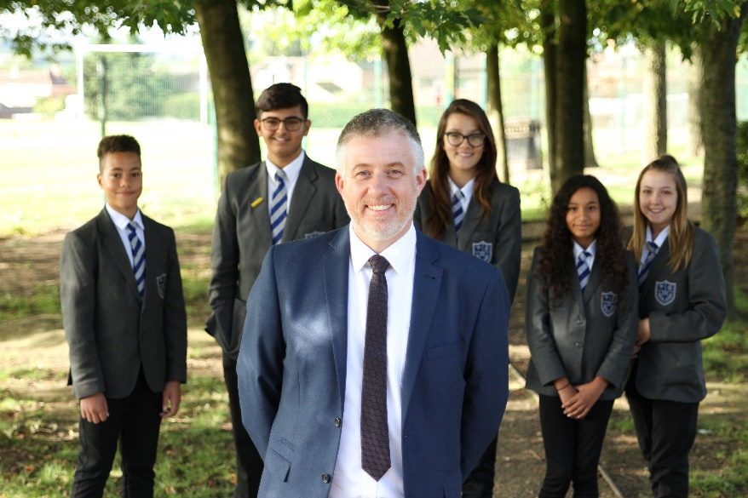

Thank you for your interest in applying for a post at Selston High School. I am pleased that you wish to find out more about our school and in these few words I would like to give you a clear sense of our vision and priorities.
First and foremost, Selston is a great place to work. Students and staff share high expectations of each other and we enjoy good relationships with parents who support the school’s aims. Our mission statement is very clear; ‘To inspire every member of the school community to achieve their full potential and enjoy the experience.’
As the new head teacher I have quickly been made to feel welcome and I am amazed daily at the positive attitude and respectful behaviour of Selston students. They work hard, look smart, support each other and actively try to do well in all of their subjects. They are proud of the school and enjoy school.

These attitudes are the hard won gains of a collective drive to set and maintain high standards across all areas of school life. I am determined to maintain these standards and further develop the culture of the school. I want students and staff to feel happy and motivated, working hard together every day to improve their skills and knowledge.
As a small school (NOR 761) we take marketing very seriously and there is no better way of spreading the good name of the school than happy and successful students and a motivated staff keen to improve further. As examination outcomes over time continue to improve, the school is becoming increasingly popular and as a result our finances look healthy for the foreseeable future

All staff at Selston are fully supported to develop professionally. Our in-house CPD programme is a particular strength. Each member of staff is encouraged and expected to tap into the array of professional development opportunities on offer.
The standard of teaching and of support is high at Selston High School. Sustaining these standards is my number one priority. From this, all good things follow.
To develop and improve the school further we need to recruit the best staff at every opportunity. We are looking for people who are committed to improving the life chances of Selston students and who can fit the friendly, hard-working and ambitious profile of the staff already here. Of course, each new member of staff will also bring something new and add to the deep pool of talent at the school.
If you haven’t already, I would recommend that you visit the school and see us in action. We are always happy to meet prospective applicants and to talk openly and honestly about the school and the post on offer.
In the last Ofsted Inspection, February 2014, the school was graded 'Good'. We will not rest on laurels but work tirelessly to provide the very best education for our students in order that they leave school with the confidence and ambition to take their place in the world as productive citizens.
Selston High School is a great school to work in and will become even better as we continue to build towards a happy and ambitious future. I look forward to receiving your application.

Paul Halcro
Head teacher

