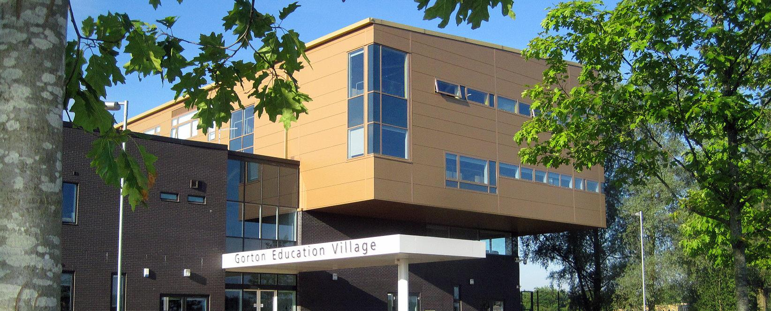
- HARDWORK
- ASPIRATION
- RESPECT
[Cite your source here.]
Cedar Mount Academy, 50 Wembley Road, Gorton, Manchester. M18 7DT
VACANCY: Assistant Progress Leader

CEDAR MOUNT ACADEMY
INFORMATION PACK

HOW TO APPLY | Page 2
ABOUT BRIGHT FUTURES EDUCATIONAL TRUST | Page 3 & 4
CEDAR MOUNT ACADEMY – HISTORY & CONTEXT | Page 5 & 6
CEDAR MOUNT ACADEMY – STUDENT INFORMATION | Page 6
CEDAR MOUNT ACADEMY – VISION, MISSION & CULTURE | Page 7
WHY WORK FOR US | Page 8 & 9
JOB DESCRIPTION | Page 10 & 11
PERSON SPECIFICATION | Page 12 & 13

CONTENTS

HOW TO APPLY

This information pack is designed to provide you with further information on Bright Futures Educational Trust, Cedar Mount Academy and the role of Assistant Progress Leader at this academy.

If having read the information pack and wish to apply, please follow the link to the online application platform: https://bfet.jotform.com/222072078250852

Closing Date: Friday 26th August 2022
Start date: As soon as possible

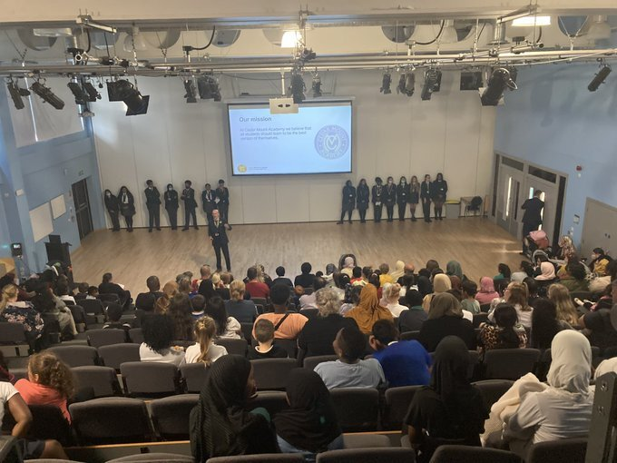

ABOUT BRIGHT FUTURES EDUCATIONAL TRUST

Bright Futures Educational Trust (The Trust) is a multi-academy trust (MAT) set up in 2011. The Trust is made up of a richly diverse group of schools in Greater Manchester and Blackpool. We are passionate about working together within and beyond the Trust to achieve our aspirational vision: the best for everyone, the best from everyone. We are an organisation that is underpinned by values of: community, integrity, and passion. In everything we do, we remember that we are accountable to the children, families, and communities that we serve.



Our schools have their own identities and form one organisation and one employer, Bright Futures Educational Trust. Bright Futures’ Board of Trustees maintains strategic oversight of the Trust and delegates some of its responsibilities to the Executive Team, Principals, and local governing bodies. We place a high value on integrity and probity and take seriously our accountabilities for making the best use of public money. How decisions are made is described in our delegation framework. You can find out more about the Trustees and the Executive Team on our website: About Us

The central team comprises the Executive Team: John Stephens, CEO; Edward Vitalis, Chief Operating Officer; Gary Handforth, Director of Education; Lisa Fathers, Director of Development, Partnerships and Teaching School Hubs; Lynette Beckett, Director of HR & Strategy. The focus of these roles is to work with schools, providing high quality and timely guidance, leadership, challenge, and support. In addition to the Executive Team, we have central operations for Finance, HR, Educational Psychology, Marketing and Communications, and Digital Technologies. Please see our website brochure which explains our central operations: Working together for a Bright Future.

Bright Futures Development Network is another important outward facing component of our organisation made up of a number of hubs and networks at the heart the Trust. In January 2021, after significant national reforms to the teaching school policy Bright Futures was designated with two new large-scale Teaching School Hubs, which replace the Alliance for Learning Teaching School. This growth and expansion in our outward facing work brings about a significant increase in accountability and reach. The two Bright Futures Teaching School Hubs are designed to provide strong strategic regional leadership to build robust partnerships to support teachers and leaders in every phase and type of school, at each stage of their development. A crucial part of the hub remit is carefully ensuring structured collaboration. The Teaching School Hubs are at the forefront of providing high quality professional development, playing a significant role in the implementation and delivery of: The Early Career Framework, National Professional Qualifications (NPQ), Initial Teacher Training and Continuous Professional Development (CPD). The Hubs work directly with the Department for Education and national NPQ/ECT providers. In addition to this, the Hubs enhance the professional development needs of Bright Futures schools and academies. Within this outward facing area of Bright Futures Educational Trust, we have a commercial offer run through the Alliance for Learning which provides first-class school improvement services and CPD to over 700 schools, further complementing the work of our Teaching School Hubs. Our School-Centred Initial Teacher Training (SCITT) Bright Futures SCITT is also an integral part of the Teaching School Hubs, with over 10 years’ experience and judged Good by Ofsted, we offer Early Years, Primary and Secondary teacher training programmes. Within the Bright Futures Development Network, we are also proud to have a Maths Hub: NW1 Maths Hub offering a wide range of maths specific high-quality professional development opportunities and training/coaching to 500 schools.


Collaboration and strong relationships form one of the ‘commitments’ in our Strategy and all components of the Bright Futures’ family work closely together. Our Strategy was developed collaboratively and can be found on our website: Our Strategy

CEDAR MOUNT ACADEMY – HISTORY & CONTEXT

Cedar Mount opened in 2000 as a replacement for Spurley Hey High School and moved to the current site (a new building as part of the Gorton Education Village) in 2008. It is co-located and works well with Melland High School, an outstanding special school also within the Bright Futures Educational Trust.

Cedar Mount has a Published Admission Number of 180 per year group and therefore should have 900 on roll. The school was judged by Ofsted as Requiring Improvement in July 2017. The most recent Ofsted inspection was January 2020 and whilst the school was judged RI overall it was judged as being good in both personal development and leadership and management demonstrating the huge improvements that have taken place under the new leadership. The report states that, “Cedar Mount Academy is improving strongly. Leaders have a clear and ambitious strategy which has pupils’ best interests at its heart” and “some of the improvements that leaders have put in place have made a real difference to the quality of pupils’ education.”

The number of students on roll currently stands at 873 and we expect it to reach 900 in 2023.

Cedar Mount is situated in South Gorton, the 5th most deprived ward in the country according to the latest set of figures. The Free Schools Meals percentage currently stands at 57% but this still does not reflect the actual situation, due to high numbers of international new arrivals and families not registering for FSM. 64% of the school population speaks English as an additional language with 46 different home languages being spoken. There has been a significant shift in the school population in recent years with EAL numbers rising by over 20 percentage points since 2014.

The last 3 years have seen real progress at Cedar Mount, and it now needs to be built on and sustained for the students to get the education that they deserve. Students now have much more success in sports (we are City Champions in a range of events), public speaking (we were the top ranked school in the country for Debate Mate in 2018-19), drama (students have taken part in a range of performances within Manchester) and much more. Students are also able to take part in far more trips, visits, and residential opportunities than previously, which is enabling them to improve their knowledge and confidence in a range of areas. Behaviour has also shown great progress with fixed term and permanent exclusions reducing significantly; the school is a cohesive community.
.

CEDAR MOUNT ACADEMY – STUDENT INFORMATION

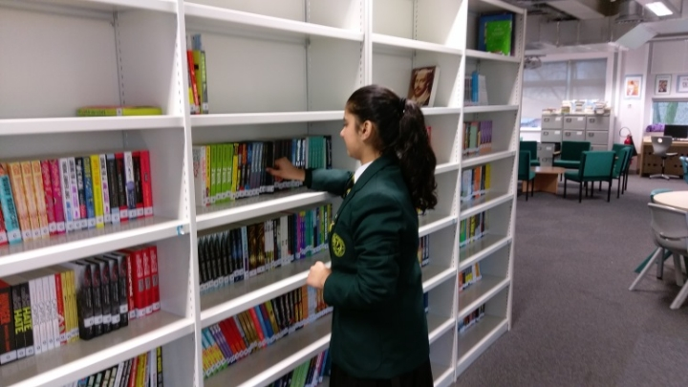

Type: Mainstream School
Phase: Secondary
Funding status: Public - Academy
Gender: Mixed
Religion: Mixed
Age Range: 11 - 16 years
No of students on roll: 873
PAN: 900
SEN Students: 24.28%
EAL Students: 65.7%
FSM Students: 57.27%
Address: Gorton Education Village,
50 Wembley Road,
Gorton,
Greater Manchester.
M18 7DT
Telephone: +44 161 248 7009
http://www.cedarmount.manchester.sch.uk

Cedar Mount Academy is located within Gorton Educational Village in Gorton, East Manchester and shares the campus with two of our partner schools in the Trust; Melland High School, a Special Educational Needs school for 11-19 years and Rushbrook Primary Academy.

CEDAR MOUNT ACADEMY – VISION, MISSION AND CULTURE
Vision

The best for everyone, the best from everyone

Mission

At Cedar Mount Academy we believe that all students should learn to be the best version of themselves, so that they leave school after five years as happy, caring and knowledgeable young people ready contribute as global citizens. This is a school designed to support and develop its local community and driven by our three values of hard work, aspiration and respect.

Overarching principles

Education is the entitlement to powerful knowledge that takes students beyond their experiences. The curriculum at Cedar Mount Academy is designed to enable students to acquire knowledge, understanding, skills and behaviours that take them beyond their context. This is knowledge that our students may not have had access to before. This understanding is the narrative of human culture. These skills and behaviours enable students to become useful citizens in a global society.

Social and cultural mobility are the keys to securing high quality, lifelong, positive academic outcomes for our students and allow them to be the best versions of themselves.
Our non-academic curriculum teaches students how to behave, present themselves and represent their community.

Running throughout this is a relentless desire to support the wellbeing of our students. We believe in challenge with compassion: every student will be given the opportunity to achieve academic success in a supportive and creative environment.

Values
Hard work

I believe that through hard work I can overcome challenges as I meet them. I am resilient and have a desire to complete every task to the best of my ability. Hard work is valuable because it allows me to be the best I can be and gives me the experience I need to succeed.

Aspiration

I believe that having high aspirations can motivate me to work hard and achieve my goals without excuses. I have high expectations in everything I do. Aspiration is valuable because it allows me to look beyond my current experiences and to understand, interpret and change the world.

Respect

I believe that respect is the most important element in a kind and cohesive community. Respect, and self-respect, means that I take things seriously and that I care about myself and others. Respect is valuable because it allows me to understand the differences in our community, and to know how to behave for the best benefit of that community

WHY WORK FOR US?


We offer a great opportunity to join an organisation which really lives its values. Our working environment is very inclusive and whilst you can expect to be challenged in your role, you will be supported through professional learning, treated fairly and with dignity and respect. Please see the Equality,
Diversity, an Inclusion statement on our website.

About the Vacancy

The role of Assistant Progress Leader is pivotal to the academy and our students. Working with Progress Leaders, Attendance Officer and wider Pastoral staff to ensure students in a designated year group are supported academically, personally and socially.

Terms and Conditions

Salary: NJC scale points 21 to 25 (Bright Futures scale 6). The full-time equivalent pay is £26,975 rising to £30,095 per annum. The actual pay based on the below working pattern commencing £23,098 rising to £25,770, per annum actual pay. Pay progression is linked to performance.

Working weeks: This is a great opportunity for flexible working as the role will work 39 weeks during school term time including 5 INSET (school training days)
Hours: 36.25 hours per week over 5 days.

Holidays: You will be paid for the prorate equivalent of 25 days, plus 8 public holidays. This increases to 30 days plus 8 public holidays after 5 years’ service.

Pension: Local government pension scheme. Please take a look at the website: https://www.gmpf.org.uk/.

Other: We offer salary sacrifice schemes for purchasing bikes used for travel to work and technology for personal use, through monthly interest free salary deductions.
We also offer opportunities for professional development.

How to Apply

We can only accept completed application forms, rather than CVs. This is because the regulatory guidelines of Keeping Children Safe in Education (2021), require us to check various details of job applicants and an identical application format for each candidate enables us to do this. We use a process that does not identify personal characteristics to the shortlisting panel. This is part of our commitment to equalities and diversity.
Our application form is available online, along with the disclosure of criminal background form. The portal link is https://bfet.jotform.com/222072078250852

Please upload your application form by Friday 26th August 2022 at 12 Noon.

If you would like to visit our academy or discuss this vacancy before applying, please contact the office on 0161 248 7009.

We will send selection details to shortlisted candidates as soon after the closing date as possible. Applicants who we do not contact during this period may assume that they have not been successful but are thanked for their interest. Unfortunately, we are unable to provide feedback to unsuccessful applicants not invited to the selection process.
We do not wish to recruit for this vacancy via recruitment agency
Keeping Children Safe in Education

Bright Futures Educational Trust is committed to safeguarding and promoting the welfare of children and young people and we expect all staff and volunteers to share this commitment. This post is exempt from the Rehabilitation of Offenders Act 1974; pre-employment checks will be carried out and references will be sought for shortlisted candidates and successful candidates will be subject to an enhanced DBS check and other relevant checks with statutory bodies.

Data Privacy

You can read the details of how we use the personal data that you provide us with in our Job Applicants’ privacy notice on our website: Applicant Privacy Notice

CEDAR MOUNT ACADEMY

Assistant progress leader

Grade 6 Scale 21-25

Assistant Progress Leader, reporting to the Progress Leader and works with the larger pastoral and attendance teams to ensure students within a designated year group are fully supported and safeguarded to enable them to develop their personal, social and academic qualities to the full.

All members of Academy staff are expected to be a professional and active member of the Academy community working as part of the team to raise standards, improve outcomes and opportunities for all students and promote a lifelong love of learning.

It is expected that all staff within two years of joining CMA will be operating at a minimum of good with outstanding features and working towards being outstanding in their specific role.

Cedar Mount Academy is a member of Bright Futures Educational Trust

Specific Responsibilities
1. Assistant Progress Leader
- Support the Progress Leader, Form Tutors and Attendance Team to raise standards of attendance, behaviour and outcomes for all students in the designated year group through:
  - Tracking and Monitoring attendance and punctuality for the designated Year.
  - Taking part in rewards and sanctions programs in line with Academy policy to raise standards of attendance and punctuality
  - Taking part in parental meetings and events to address attendance and punctuality issues, including attendance panels.
  - Taking part in targeted intervention programs to raise standards of attendance for individual and groups of students.
  - Tracking and monitoring standards of behaviour for the designated Year.
  - Supporting consistent application of the Academy Behaviour Policy and involvement in activities linked to the execution of that policy including management and coordination of internal and external exclusions.
  - Keeping accurate records of student behaviour both in lessons and around the Academy premises.
  - Being a high-profile presence to support all Academy staff to better manage student’s behaviour.
  - Taking part in targeted intervention programs to raise standards of behaviour for individual and groups of students.
  - Working closely with students to ensure they understand Academy expectations.
  - Making contact with parents to review student behaviour patterns and identify actions needed to improve standards of behaviour and in turn building strong relationships with parents and carers.
  - Liaising with other relevant support agencies such as SEN, attendance team, YOT, social services and Connexions etc to support students in difficulty.
  - Having an in depth knowledge of individual students in the designated Year
  - Communicating key issues regarding individual students to relevant members of staff
  - Taking steps to prevent bullying and support victims of bullying and play and active role in the Academy anti-bullying agenda.
  - Arranging and promoting reward activities within the designated Year.
  - Taking relevant actions to ensure all students in the designated Year are effectively safeguarded and protected from abuse or neglect.
  - Taking part in meaningful assemblies.
  - Contributing to the transition strategy from primary school which ensures that the students sustain their development from Year 6.
  - Taking part in student voice and leadership programs.

2. General Responsibilities
- To use initiative in time management to organise own workload in order to meet deadlines.
- To provide cover for other colleagues when required.
- To be aware of and comply with policies and procedures relating to child protection, health and safety, security, confidentiality and data protection, reporting all concerns to an appropriate person as they arise.
- Be aware of and support difference to ensure equal opportunities for all.
- To attend and participate in relevant meetings as required.
- Help to identify own personal development needs

Other Expectations of all Academy Staff
- To work professionally and effectively as part of a specific and wider Academy staff team.
- To be a positive professional role model for all students.
- Treat all students with dignity, building relationships rooted in mutual respect, and at all times observing proper boundaries appropriate to staffs professional position.
- Have regard for, and promote the need to, safeguard students’ well-being, in accordance with statutory provisions and Academy policy.
- To carry out supervision duties as directed in the Academy duty rota.
- Engage actively in the Academy performance management process.
- Engage actively in the Academy CPD program to develop skills and improve practice.
- Be familiar with, and follow, all Academy policy and practice to ensure a consistent high standard approach to all aspects of the Academy.
- Play a full part in the life of the Academy, to support its distinctive mission and ethos.
- Attend Academy events and activities as directed by the Principal.

Person Specification – Assistant Progress Leader

 | Essential | Desirable
Relevant  Experience, qualifications and training | Posses good numeracy and literacy skills  Experience of following procedures and instructions  Experience of establishing and maintaining accurate records  Experience in dealing with parents/guardians.  Experienced of implementing strategies to improve standards of student attendance, punctuality and behaviour  Experience of working with external agencies to organise appropriate care guidance and support for students | Formal qualifications at GCSE level or beyond  Attendance at relevant training events
Knowledge,  skills,  abilities | Knowledge and understanding of child protection and safeguarding issues and legislation  Knowledge of strategies to raise standards of behaviour and attendance  Ability and willingness to ensure good discipline and adherence to Academy rules  Good organisational and record keeping skills.  Ability to work as part of a team  Good ICT skills  Good oral and written communication skills  Ability to be able to manage own workload and prioritise | Knowledge of SIM’s or similar
Others | A passionate commitment to develop the best in young people  Tact and diplomacy in all interpersonal relationships with the public, students and colleagues at work  Self motivation and drive to complete tasks to the required time scales and quality standards  Flexibility to adapt to changing workload demands  Personal commitment to the Academy’s professional standards and code of conduct  A commitment to further training and a willingness to participate in relevant CPD.  Willingness to be engaged in partnership and community activities  Commitment to the aims and ethos of the Academy.  A positive approach to challenges, which seeks solutions to problems and addresses difficulties with cheerfulness and good humour.  A willingness to be first aid trained
Safeguarding | Willingness to consent to apply for an enhanced DBS (Disclosure and Barring Service) check  Commitment to demonstrating a responsibility for safeguarding and promoting the welfare of young people.

