

APPOINTMENT OF EXECUTIVE HEADTEACHER

The Federation of St Alphege Church of England Schools
Solihull

We are committed to providing a warm, welcoming and enabling environment where our pupils can receive an excellent education and experience ‘life in all its fullness’.

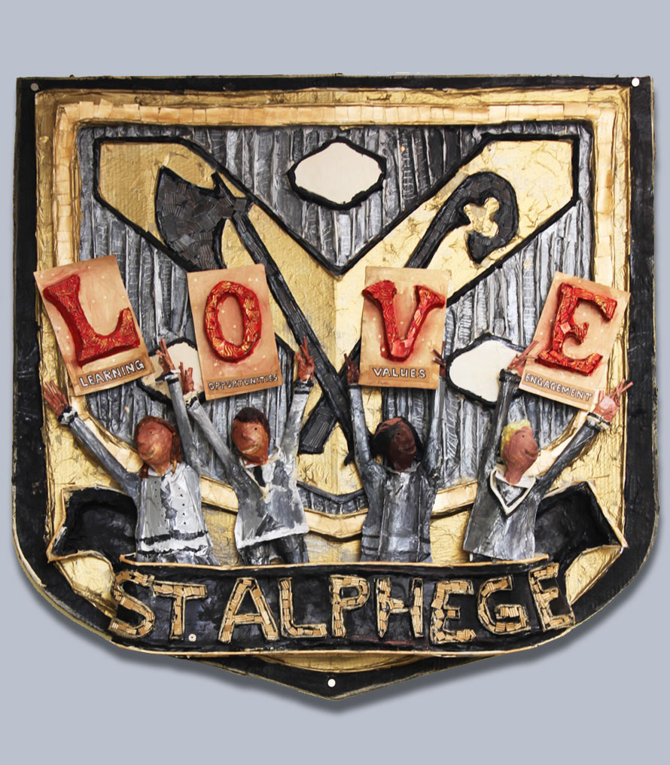

ST ALPHEGE C OF E SCHOOLS

CONTENTS
Letter from the Chair of Governors 4
Application Process and Timescale 5
School Vision and Values 6
About our Schools 7
Assessment Results 8
Highlights of 2021 – 2022 9
Governing Body and Key Aims 10
Friends of St Alphege Schools 11
Parish and Community Links 12
Challenges for our new Executive Headteacher 13

ST ALPHEGE C OF E SCHOOLS

LETTER FROM THE CHAIR OF GOVERNORS
Dear Applicant
Thank you for your interest in this important post. The vacancy has arisen because Rob Morrissey, our Executive Headteacher since April 2017, is leaving us for new challenges. The post will be vacant from January 2023; we realise that we are unlikely to appoint a replacement until Easter 2023 but an earlier start is possible.
The Federations of St Alphege Church of England Schools comprises a Nursery and Infants’ School located in Solihull Town Centre, next to the beautiful old parish church dedicated to St Alphege, and a Junior School situated on a different site 0.6 miles away. The schools are happy and successful and are highly regarded in the local area, with strong Parish and Community links.
The Governors are looking to appoint an exceptional, inspirational and dynamic Executive Headteacher who has a clear vision and sense of direction for our schools; they will need the skills and experience to build upon our achievements to date, and to take our schools forward through the years ahead.
We recognise that we are facing new opportunities and challenges. Our new Executive Headteacher will be supported by dedicated and highly motivated staff, a committed and active Governing Body, and supportive and pro-active parents. Our children are delightful too (!) and are the focus of everything we do.
For further information, please visit our website www.stalphege.solihull.sch.uk . You are most welcome to visit our schools and to see why we are so proud of them.

Yours faithfully
Pam Price
Chair of Governors

ST ALPHEGE C OF E SCHOOLS

APPLICATION PROCESS AND TIMESCALE

APPLICATION
Please note that your application will be copied and distributed to the Selection Committee. It is important that any communication is clear and concise.
SCHOOL VISITS
Interested applicants ae encouraged to visit our schools.
Please contact the Junior School Office on 0121 704 2714 for an appointment.

Please complete the SMBC Application Form. This should be accompanied by a Letter of Application that explains why your career to date had prepared you with the right skills to lead St Alphege C of E Schools at this time. Please refer to the criteria found in the Person Specification and demonstrate how and why you meet these criteria, with relevant examples. The letter should be no more than two sides of A4.
Please ensure that your application includes the details of two professional referees.
Your application should be returned to:
Mrs Alison Vining
Clerk to the Governing Body
St Alphege CE Junior School
Widney Manor Road
Solihull
B91 3JG
Email: avining@solgrid.org.uk

Closing date for applications:
Monday 7th November 2022

TIMESCALE
The timescale for the appointment will be as follows:
Shortlisting:
Week beginning Monday 7th November 2022.

Interviews:
Week beginning Monday 21st November 2022.

COMMENCEMENT IN POST
17th April 2023 or earlier if available.

ST ALPHEGE C OF E SCHOOLS

SCHOOL VISION AND VALUES
The Christian nature of St Alphege Church of England Schools is central to our philosophy and informs every aspect of the life of our two schools. We are committed to providing a warm, welcoming and enabling environment where our pupils can receive an excellent education and experience ‘life in all its fullness.’
Our Christian values of Love, cooperation, honesty, forgiveness, responsibility and valuing difference focus us, as an inclusive community, to be the best version of ourselves. Our values permeate all areas of school life through learning, religious education, prayer, worship and action.
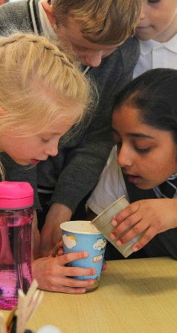
Love: 1 Corinthians 13 v 4 -8
Cooperation: 1 Corinthians 12 v 14 -21
Honesty: Ephesians 4 v 15
Forgiveness: Colossians 3 v 13
Responsibility: Galatians 6 v 5
Valuing difference: Galatians 3 v 28

We value the unique strengths and gifts of the children entrusted to us and strive to provide an excellent education so that, through our teaching, the children may realise their full potential and the love of God.
In partnership with our families, governors and parish, and inspired by our Christian school vision and values, we support and nurture the children of St Alphege. We encourage the children to shine, to have pride in their achievements, to show concern and courageous advocacy for others and contribute to society as responsible citizens.

ST ALPHEGE C OF E SCHOOLS

ABOUT OUR SCHOOLS
The schools of St Alphege have served many generations of the people of Solihull. In 2010 the Nursery, Infant and Junior Schools became federated under the leadership of one headteacher whilst, at the same time, remaining separate schools on different sites approximately 0.6 miles apart. The Nursery has 60 part-time pupils who do either a morning or an afternoon session. The Infants’ School has 75 pupils in each year from Reception to Year 2, organised into three classes. The Junior School has 70 Pupils in each of Years 3 to 6, organised into three classes in Years 3 and 4 and two classes in Years 5 and 6.
Across the Federation there are 15 full-time teachers and 10 part-time teachers in addition to the SENDCo, Deputy Headteacher and Executive Headteacher. Regular supply teachers are available when required. Teachers are very well-supported by part-time teaching assistants, many of whom have a range of roles within the Federation.
Both school buildings are in a good state of repair, and space has been carefully planned so that the needs of all pupils can be met within a stimulating, broad and balanced curriculum. Outdoor playing areas are extensive at the Junior School with a range of tarmac and grassed areas in addition to a play structure and natural/garden area. The Infant School has more limited outdoor space with activities, and the Nursery has a wide range and variety of outdoor space.
Both schools have a breadth of additional clubs and activities which are extremely popular after school activities. These clubs are taught by an extensive group of well-qualified adults.
Our schools are exciting places of learning where excellence and fun go hand in hand. Although our Schools follow all the requirements of the National Curriculum, we are proud to offer a much wider and richer curriculum, making the most of the many and varied opportunities to both broaden and enrich the learning opportunities for all our children. Through our curriculum, we aim to educate the whole child for ‘wisdom, knowledge and skills, for hope and aspiration, for community and living well together, and for dignity and respect.’
Parents tell us that their children love coming to school and they enthuse about the many wide-ranging opportunities available to them. We boast musical and drama successes as well as excellent academic results.

ST ALPHEGE C OF E SCHOOLS

ASSESSMENT RESULTS
Early years
GLD | 72.6%
Average points score | 32.8

Year 1
Phonics screen | 70.3%

Key stage 1
 | Expected | High
Reading | 85.1% | 35.1%
Writing | 79.7% | 23%
Maths | 81.1% | 32.4%
Science | 90.5%
RWM | 73% | 17.6%

Key stage 2
 | Expected | High
Reading | 87.1% | 32.9%
Writing | 78.6% | 20%
Maths | 81.4% | 25.7%
Science | 90%
GPS | 84.3% | 30%
RWM | 67.1% | 8.6%

 | Progress score | Confidence Interval
Reading | 1.0 | (-0.6 to 2.6)
Writing | 0.2 | (-1.4 to 1.7)
Maths | 0.0 | (-1.5 to 1.4)

ST ALPHEGE C OF E SCHOOLS

HIGHLIGHTS OF 2021 - 2022
Just 1 or 2 highlights…
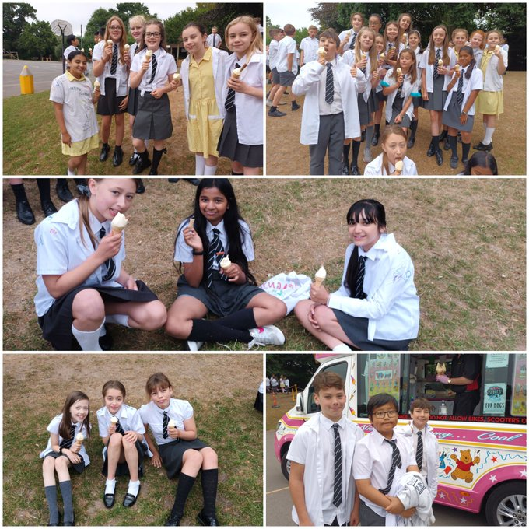
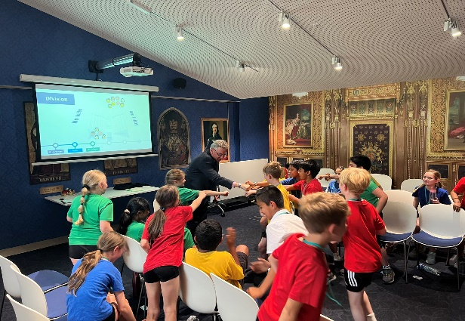
Year 5 trip to House of Commons

Year 6 last day at St Alphege
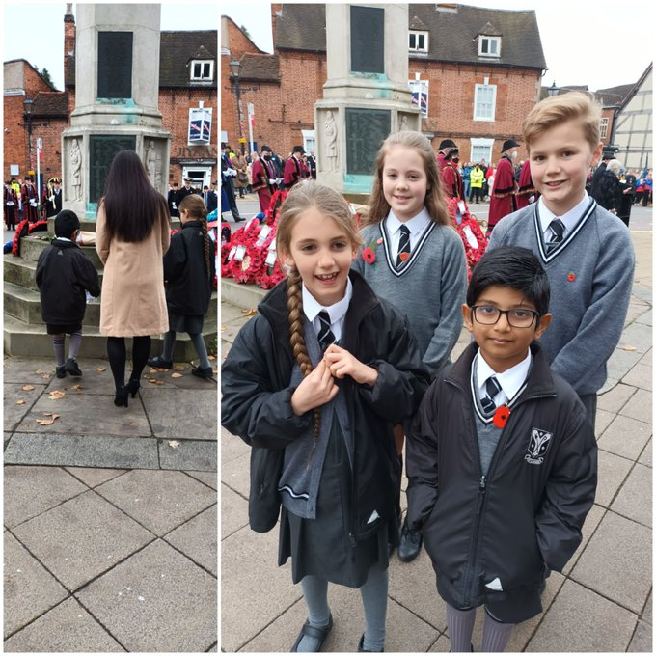
Remembrance Sunday

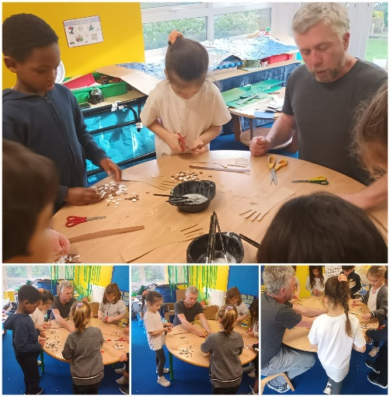

Remembrance Sunday

Artist Darrell Wakelam

ST ALPHEGE C OF E SCHOOLS

GOVERNING BODY AND KEY AIMS
GOVERNING BODY
The Schools of St Alphege have an extremely effective and supportive Governing Body. This includes elected representatives of parents and teachers as well as representatives of the Local Authority, Solihull School, the Diocese and the Community.
The Governing Body and its committees meet regularly each half term to make decisions which affect the general policy of the school, the appointment of staff and the management of finances.
COMMITTEES AND RESPONSIBILITIES
STANDING
Strategic overview, Corporate Structure, Personnel, Executive Headteacher Performance, Senior Appointments, Appeals
CURRICULUM, LEARNING AND ASSESSMENT
Learning provision and assessment, Standards, School Data Analysis, Safeguarding.
FINANCE
Financial Management, Budgeting, Buildings, H&S, Lettings.
ADMISSIONS
Admissions Policy, Admissions to Nursery, Infant and Junior Schools.

KEY AIMS
Objectives for 2021 - 23
- To create the optimal conditions for effective professional learning.
- To ensure the school’s curriculum intent and implementation are consistently articulated and embedded across all phases so that children’s learning is of high quality in all subjects.
- To ensure the Early Years Foundation Stage (EYFS) reforms are understood and embedded in provision, promoting success for all and a readiness for the next key stage.
- To create a culture where children show that they are resilient in the face of difficulties.
- To ensure that the ambitious longer term vision for all pupils (in particular those identified as vulnerable) is shared and implemented by all.
ST ALPHEGE C OF E SCHOOLS

FRIENDS OF ST ALPHEGE SCHOOLS
The PTA at St Alphege Schools is called The Friends of St Alphege Schools.
During the course of each year a number and variety of events and initiatives take place, some of which occur on an annual basis and other which may be topical, associated with local, national or international issues.
The committee meets regularly and is always seeking to recruit more members to add to the interests, strengths and skills of the group. Fundraising successes have included a Fireworks Evening, the Christmas Fayre, a Spring Ball, and Mothering Sunday and Fathers’ Day sales.
The money raised by FSAS is used to enhance the environment, resources and opportunities for our children. Examples include ICT equipment, an Adventure Playground, Playground markings and refurbishment of the School Libraries.

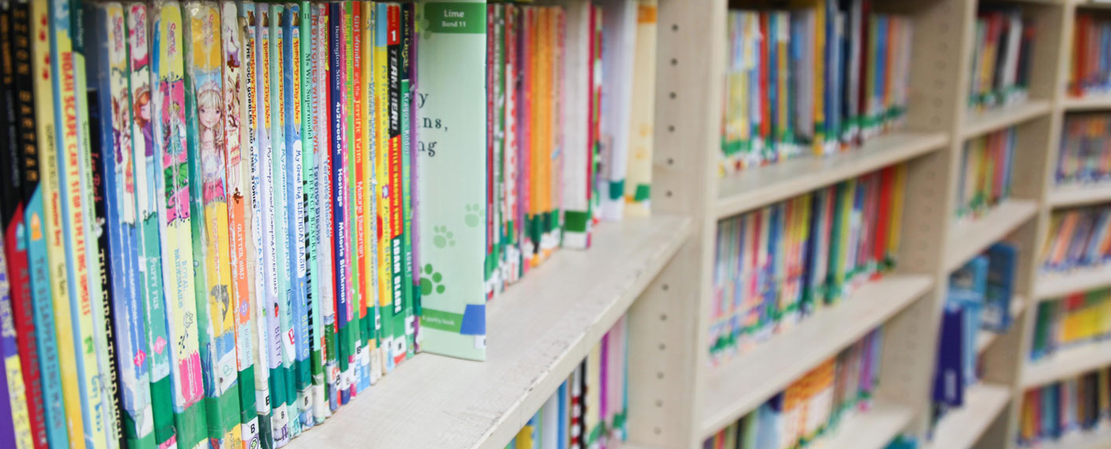

ST ALPHEGE C OF E SCHOOLS

PARISH AND COMMUNITY LINKS
Close links are in place with the church of St Alphege in Solihull. Acts of worship are led by clergy both in schools and in the church. There are termly services for the whole Federation. A number of older pupils are members of the church choirs. Nursery staff work closely with St Alphege Pre-School, as many children move from there into our Nursery at the appropriate time. Parents, carers and grandparents are always welcome in school and in church, and many of them attend shared acts of worship.
Both schools have an open-door policy. Open evenings and open days are held at regular intervals in addition to curriculum sessions and other events. Music has a high profile in the schools; concerts and plays are enjoyed by everyone. The Junior School Songsquad is frequently invited to sing at concerts with choirs and orchestras in the Local Community.
Parents are sometimes invited to have lunch at the schools.
At the end of Year 6, St Alphege pupils transfer to a number of Local Authority, Grammar and Independent Secondary Schools. Particularly strong links exist between the academies of Tudor Grange and Alderbrook, in addition to Solihull School. A near neighbour of the Junior School is Solihull Sixth Form College.
Both the Infant and Junior Schools are members of the Synergy Cluster – a group of schools which are broadly based in the surrounding area. This group is very active, providing excellent opportunities for professional development, in addition to improving teachers’ knowledge, understanding and expertise at every level.
The Schools have strong links with Birmingham Diocese Education Department which provides training and conferences for teachers and governors, as well as church services for pupils.

ST ALPHEGE C OF E SCHOOLS

CHALLENGES FOR OUR NEW EXECUTIVE HEADTEACHER
We recognise that there are exciting times ahead for our schools; these may be viewed as opportunities or challenges. We see our most immediate challenges as:
- With the Government drive to create academies, to decide if and how our schools should become an academy and to lead us through this process.
- To build on the successes of our previous Executive Headteacher in bringing together our schools as one Federation.
- To carefully manage the schools’ finances to ensure a secure financial future for the years ahead.
- To continue to improve our schools so that they are both outstanding centres of excellence.
- To meet the increasing needs of an inclusive and diverse intake of children within the needs of a constrained budget.

