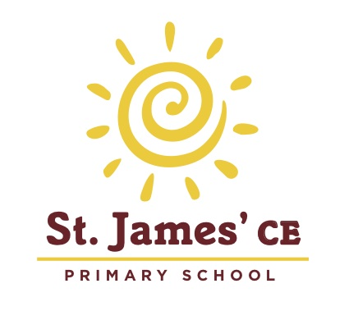
St. James’ Church of England Primary School
Old Jamaica Road, London, SE16 4SU
Tel: 020 7237 3111 opt. 2 Fax: 020 7232 1849
Email: office@st-james.southwark.sch.uk
Website: www.stjamesschoolbermondsey.com
Headteacher: Mrs K. F. Willis B.Ed. NPQH

Early Years Educator

Nursery Teacher Maternity Cover
Hours 8.00 – 4.00pm daily
We are looking for an Educator with either EYP/EYT status or NVQ Level 3 in Childcare (who has extensive knowledge and experience) to join our long standing team working with our nursery children.
You will have key group responsibility, excellent training opportunities and on site coaching and mentoring to develop your leadership skills and knowledge.
Applicants should have: Knowledge of the EYFS, full understanding of the nursery systems and record each child’s development

Please send your CV to headteacher@st-james.southwark.sch.uk

Closing date – Friday 22nd September – Visits to the nursery are welcome

