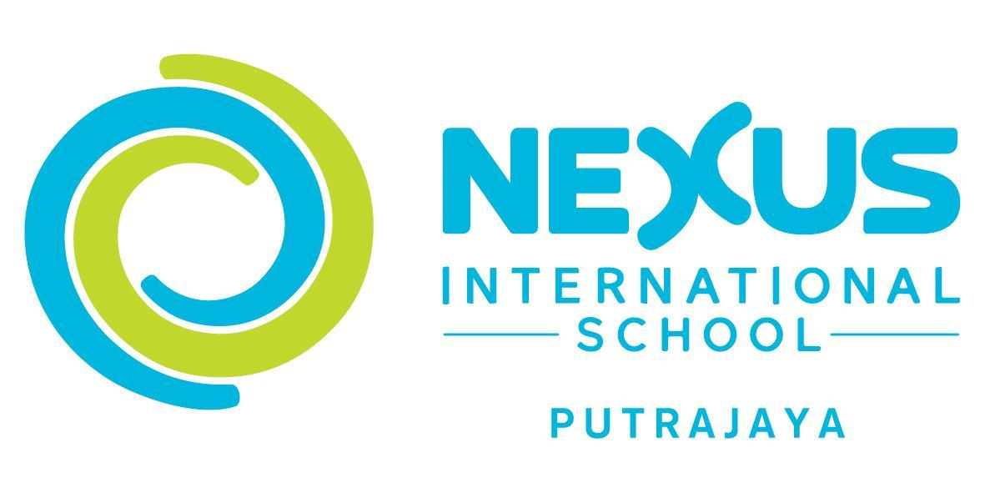
Role Description – Head of Science
(Secondary)

NEXUS INTERNATIONAL SCHOOL, MALYAYSIA
NISP is a privately owned international school in Putrajaya, near Kuala Lumpur, Malaysia. The student body consists of expats from a large number of countries, members of government departments such as the Ministry of Foreign Affairs, and private fee paying Malaysians; the Secondary School roll is currently 380. NISM follows a British flavoured international curriculum, which includes IPC, IGCSE and IB Diploma. Over 60 learners are based in our Boarding House, adding to the diversity of our student population. The school is an inclusive environment and has a focus on personalisation of learning. ICT is fully integrated at all levels in the school; younger children are using iPads, the primary school has access to laptops in trolleys and learners from Year 7 – 13 have their own MacBook Pro laptops which are used across the curriculum. The school is accredited by CIS and is an Apple Distinguished School.

OUR PURPOSE
To educate the youth of the world to take their productive place as leaders in the global community.

OUR MISSION
To be acclaimed by the worldwide international education community as a provider of the highest quality international education which is specifically matched to the needs of our expatriate and local students.

OUR VISION
Nexus International School will be an internationally minded learning community that nurtures and supports every child’s emotional, physical, creative and intellectual needs in order that they can achieve academic success and become globally responsible citizens. We will accomplish this by celebrating diversity and challenging minds.

OUR CORE VALUES
RESPECTING and caring for each other
being dedicated to a culture of EXCELLENCE
openness in COMMUNICATION
acting with INTEGRITY
being PASSIONATE in what we do
creating ENJOYABLE environments

At Nexus International School, we promise to:
• Treat everyone as gifted and talented individuals and foster those talents and gifts through
careful mentorship and guidance that is based on respect for all.
• Provide an environment that allows these talents to ﬂourish; one that is innovative,
progressive and grounded in trust, compassion and respect.

KEY OBJECTIVES OF THE POSITION
Consistent with Nexus International School policies, the Head of Science (Secondary) will be responsible for:
- Establishing goals and expectations: includes the setting, communication and monitoring of learning goals, standards and expectations, and the involvement of staff and others in the process so that there is clarity and consensus about goals.
- Strategic resourcing: involves aligning resource selection and allocation to priority goals. This includes the provision of appropriate expertise through involvement in staff appointments.
- Planning, coordinating and evaluating teaching and the curriculum: direct involvement in the support and evaluation of teaching through regular classroom visits and provision of formative and summative feedback to teachers. Direct oversight of curriculum through school wide coordination across subjects and year levels and alignment to school goals.
- Promoting and participating in teacher learning and development: leadership that not only promotes but directly participates with teachers in formal or informal professional learning.
- Ensuring an orderly and supportive environment: protecting time for teaching and learning by reducing external pressures and interruptions and establishing an orderly and supportive environment both inside and outside classrooms.

ROLE
Establishing goals and expectations
- Promote and develop the school ethos and philosophy through modelling and sharing The Nexus Way.
- Contribute to decision making at leadership level and support outcomes when a decision is made.
- Contribute to the development of the School Improvement Plan (SIP).
- Contribute to the whole school review of the guiding statements and SIP through further development of The Nexus Way.
- Ensure all stakeholders, under your management, implement the school goals and targets so there is clarity and consensus.
- Set high expectations of pedagogy for the Science department

Strategic resourcing and management
- Be involved in the identification and recruitment of staff to continue to further strengthen teaching and learning in your area.
- Allocate appropriate staffing in conjunction with the timetabler.
- Manage academic support/administrative staff, specifically the lab technicians
- Contribute to whole school decisions about resource allocation.
- Gather and prepare budget requests in line with the SIP.
- Order specialist resources and equipment in line with the SIP.
- Effectively track and manage budgets and assets.
Planning, Coordinating and evaluating teaching and the curriculum
- Contribute to school wide curriculum development through relevant collaboration in alignment with school goals.
- Lead a regular review of the curriculum in Science in line with the school goals.
- Work with others to ensure vertical and horizontal alignment of the curriculum
- Ensure that the curriculum is monitored in terms of learning outcomes so that learners make good progress in line with expectations.
- Evaluate and analyse a range of summative and formative assessment data to identify and implement strategies to support all learners.
- Promote a learning focussed culture through regular observations of learning e.g. Looking for Learning, Learning Walks etc. to ensure your team has an open door policy.
- Ensure that all staff receive feedback on their pedagogy
- Ensure the team understand and are following the planning process for each phase.
- Ensure collaborative planning is well managed and effective.
- Promote learning conversations in your team.
- Work with staff to set professional development goals
- Monitor staff progress to support implementation of their professional development goals and address underperformance.
- Support and prepare staff for the Teacher Professional Assurance (TPA) process and conversation
Promoting and participating in teacher learning and development
- Where appropriate., lead whole school and departmental professional learning
- Promote and model best practice
- Identify and or provide appropriate training, through coaching and mentoring, for individuals to meet their professional development goals.
- Ensure team meetings are learning focused and facilitate sharing best practice.
- Be an active participant in your own continuous professional learning
Ensure an orderly and supportive environment
- Ensure new teachers and team members are inducted effectively and supported in their transition.
- Have responsibility for the wellbeing of your team members by managing deadlines and external expectations to minimise stress and promote collegiality.
- Assist in the development and implementation of effective systems for managing routines and processes in your area of the school.
- Ensure there is a team culture that promotes risk taking, favours collaborative and cooperative learning and is culturally sensitive.
- Ensure collaborative planning and meeting times are productive and focused.
- Ensure that decisions made at meetings are promptly communicated to your team.
- Represent the views of your team at meetings as part of the whole school community.
- Ensure relevant policies and procedures related to health and safety are known by all.
- Take a leading role in ensuring the schools health and safety policies and procedures are carried out effectively.
- Ensure the resources and facilities in your area are well maintained and safe.

Other duties and responsibilities

KEY RELATIONSHIPS
The Head of Science reports to the Deputy Head (Curriculum)

PERSONAL SPECIFICATION
Qualifications and Training
A degree plus teaching qualification (or equivalent)
Higher degree or recognised professional qualification (preferred)
Evidence of continued relevant professional development

Desirable Experience
Previous leadership experience
Teaching learners with diverse language and learning needs
A range of settings ideally also in an international school environment
Using technology in learning
Teaching the IGCSE and IBDP curricula

Person Qualities
The successful candidate will:
- Plan, develop and deliver rigorous learning experiences that address learners with a variety of language and learning needs (including autism, global delay, English as an additional language, Dyslexia etc. as well as highly academic learners).
- Develop and foster the learners’ confidence and skills to enable them to become autonomous self regulated learners.
- Build learning focused relationships.
- Have excellent collaboration and teamwork skills that result in effective co-planning and co-teaching.
- Be a confident user of technology to transform learning.
- Be a reflective practitioner and a life long learner. Deal effectively and non-confrontationally with learners, staff and parents to positively influence others.
- Be community and internationally minded and want to participate beyond their classroom.

