

Information for Applicants

Maths Teacher
Required for 19th February 2018 (earlier if possible)

Battle Abbey School, High Street, Battle, East Sussex TN33 0AD
Tel: 01424 772385
www.battleabbeyschool.com
For further information please contact Mrs Alison Ambrose, HR Manager
at hr@battleabbeyschool.com (01424 772385)

CONTENTS

- Letter from the Head

- The Maths Department
- General information
- Historical background
- Ethos, character and aims of the School
- Governance and management
- GCSE and A level exam results (2010 – 2014)
- Recent School leavers’ destinations
- Battle and the local area
- Job description
- Person specification

- Application form and key dates

An aerial view of the Senior School
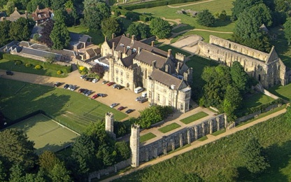

LETTER FROM THE HEAD

From: David Clark BA M Phil (Cantab)

Dear Applicant,
Thank you for your interest in the post of Maths Teacher at Battle Abbey School.
We are seeking to recruit a well-qualified and passionate person to join our successful and ambitious Maths team. We welcome applications from committed teachers with a proven record of accomplishment who are seeking a new challenge. The successful candidate will be an excellent team player with strong interpersonal skills, able to teach up to at least GCSE and with strengths in Key Stage 3 teaching and learning. The Maths Faculty is dynamic and forward thinking and it is essential that the person appointed has a genuine enthusiasm for the subject. Equally important is a willingness to contribute to the development of the school’s extra-curricular activities programme and our boarding community.
We are an independent, co-educational, day and boarding school, taking pupils from the age of 2 – 18 years. We accept pupils with a range of abilities are very proud their many and varied achievements, especially at GCSE and A Level. We also have an excellent reputation for creative arts.
Battle Abbey School celebrated its centenary in 2012 and has gone from strength to strength in recent years. We have achieved a managed growth in pupil numbers and have expanded our facilities with a new Sixth Form Centre and boarding house but I am committed to maintaining the School’s fundamental nature as a happy, family school. Our team are highly skilled and bring a wealth of experience and expertise with the aim that every child achieves their potential in whatever field that may be.
Battle Abbey offers its teachers special opportunities, which do not exist in larger schools, and this, combined with the enchanting Senior School location and buildings and the warm, good-humoured and supportive working atmosphere, makes a teaching post especially attractive.

I hope the information you find in this pack will help you in your decision about applying for this new post but if you have any questions, please contact the HR Manager, Mrs Alison Ambrose, on 01424 772385 or via email at hr@battleabbeyschool.com

I look forward to receiving your application.

Yours sincerely

Battle Abbey School, Battle, East Sussex, TN33 0AD Headmaster: David Clark, BA M Phil (Cantab)
Telephone: 01424 772385 Fax: 01424 773573 Website: www.battleabbeyschool.com
Battle Abbey School is administered by B.A.S. (School) Ltd, Registered Number 779605, a non-profit-making company registered as a harity, Number 306998

THE MATHS DEPARTMENT
Battle Abbey School’s Maths Department is composed of a highly dedicated and supportive team who are committed to providing the highest level of teaching and learning for our students. As a team, we strive to engage interest and inspire pupils to love the subject of mathematics, as we do, for its logic, beauty, objectivity and inherent rewards.
The department is based in a dedicated suite of rooms, which includes a large computer suite and a maths library. Students currently sit the iGCSE offered by Edexcel, with early entry offered to students from as early as Year 9. For these students there is also the option to sit the Further Maths GCSE. A-Level Maths is one of the most popular choices for the sixth form students, with a good uptake for Further Maths A-level also.
As well as the traditional Maths courses, as a department, we also offer a GCSE qualification in Financial Education, a STEP programme to offer extra support to students wishing to study Maths at university, a multitude of STEM opportunities, a very successful engineering society, UKMT Individual and Team Challenges. All of these are with the aim of enhancing the learning experience and opportunities for our students, with Maths being at the heart of this.
Cross-departmental and cross-phase work is a continued focus. The school has developed strong links with feeder primary schools and the Maths department contributes to the transition process. A large number of students feed directly from the Battle Abbey Prep School and we are constantly aiming to improve the links we have with the Maths department there.
We are looking for an enthusiastic and committed teacher capable of teaching throughout Key Stages 3 and 4 with Key Stage 5 desirable but not essential. Equally important is a willingness to contribute to the development of the school’s extra-curricular activities programme. Applications from newly qualified and experienced teachers are welcomed and we can offer the successful candidate commitment to your Continuing Professional Development.
The successful candidate will work alongside three highly dedicated teachers of mathematics- one Head of Department, and two specialist teachers. There are considerable complementary strengths within the team, which offers a broad skills base. The success of the mathematics department is built upon teamwork, a desire to continually improve and the target to become the best.

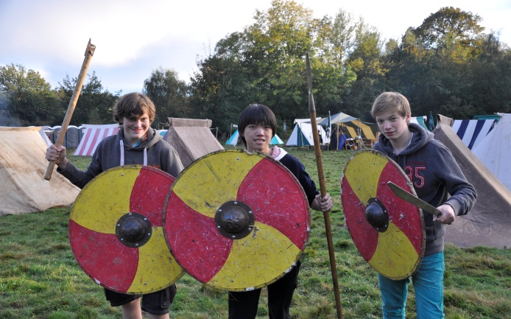 | 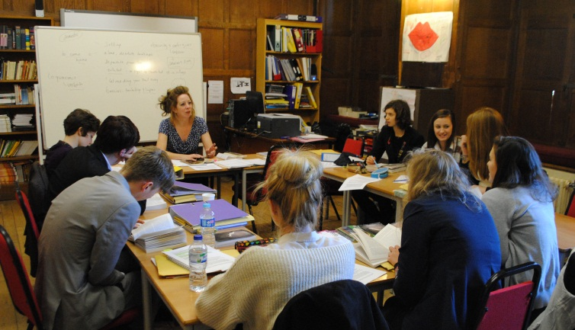

GENERAL INFORMATION
6. Battle Abbey School is a thriving co-educational day and boarding school for children aged 2 – 18 years old and it has a special niche in the local area. The Senior School (years 7 – 13) is located in the historic market town of Battle, near Hastings, and is set in the stunning and prestigious surroundings of Battle Abbey, overlooking the famous 1066 battlefield. The School is housed in some of the original 13th century monastic buildings, which are leased from English Heritage, and also occupies other buildings in the town, including Martlet House.
7. The Preparatory School (Reception to Year 6) is situated 9 miles away in Bexhill-on-Sea and has superb facilities, including a 25 metre indoor swimming pool, playing fields and an floodlit astro pitch. A separate Nursery is situated in the grounds of the Preparatory School. The Nursery is open 0800 – 1730 hours for 50 weeks each year and also runs a mother-and-baby drop-in group. It has good through-links with Reception and runs exciting projects such as beach school and forest school. The Preparatory School and Nursery properties are owned by the School.
8. There are currently 425 pupils on roll with 59 boarders in the Senior School and a 6th Form that averages between 90 and 100 pupils. The majority of pupils live in a 15 mile radius of the School, but a substantial proportion of the boarders are from overseas. There are 125 full and part time staff employed across the sites.

9. The school accepts pupils who have a wide range of ability but consistently enjoys excellent academic results. The Prep School is the only school in East Sussex to be in the Times Top 100, and the Senior School are in the Times Top 150. The School has a particular strength in the creative arts and reliably achieves outstanding results. Pupils regularly take up places at top Art and Drama colleges and each year Music features on the wide list of subjects taken up by our pupils at university. More than a quarter of the school sings in the main choir and there are frequent and high quality drama and music productions. Pupils have also won prestigious art awards at local and regional level.

10. Continuity of education is one of the School’s key attractions and pupils may apply to join at any time during their school career. Preparatory School pupils are guaranteed a place in the Senior School when transferring at age 11. All pupils benefit from a holistic approach to education and the greatest care is taken to ensure that pupils settle happily and thrive throughout their school life. The broad curriculum ensures that each child is given every opportunity to achieve and excel academically, to create and to perform with confidence and to compete on and off the field. We are a leading IT school having achieved e-Mature status in 2012, have excellent IT facilities and encourage the development of IT skills, including touch typing from Key Stage 1.

11. Pupils are well-mannered and motivated to learn and have an immense loyalty to the School and to each other. They talk with great affection of their School, considering themselves part of an extended family. They particularly value the friendships that exist across the various year groups and which are
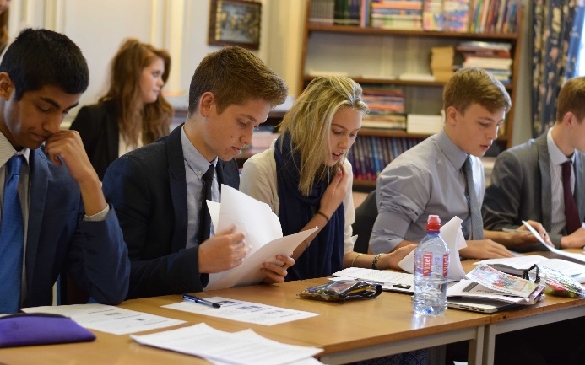 | 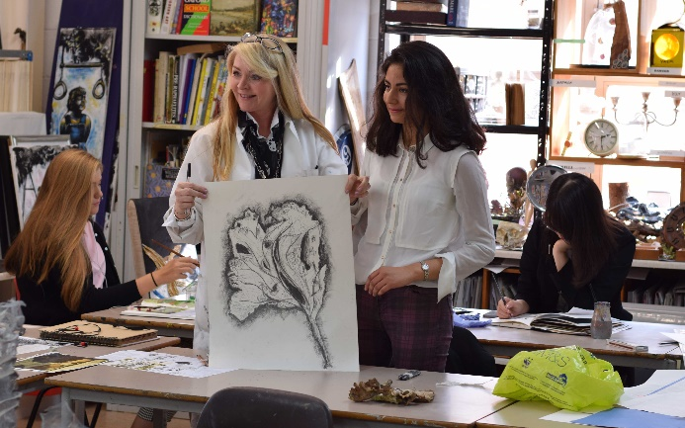

encouraged through the House system, School Guardians, School Bronzes and the Peer Support Groups. The quality of pupil’s spiritual, moral and social development was praised as outstanding in our latest inspection report. The present cohort of pupils is as talented as any we have had in the last fifteen years. The staff, both academic and support, are strong, stable and exciting to work with.
12. Both the Senior School and the Preparatory School encourage pupils to undertake a wide range of charitable and community activities. These include expeditions to Africa to build a Nursery, swimming sponsorships, mufti days and a variety of house-led fundraising schemes. During the past year, up to £10,000 was raised to support local, national and international charities. Cultural diversity is celebrated across the School, and particularly within the boarding community.
13. The School enjoys excellent relations with other local independent and state schools, with whom we share some training and facilities.
14. Parents value the impressive number of extra-curricular opportunities available for their children at both the Preparatory and Senior Schools but above all they value the family ethos and caring atmosphere. Relationships with parents are good and there is frequent communication via the weekly newsletter, regular meetings and events organized by the School and its active parents’ committee known as Friends of Battle Abbey School (FOBAS).
15. The School was inspected by the Independent Schools Inspectorate in March 2017 and underwent both an ISI Education Quality and Compliance Inspection. Applicants are invited to view the School’s latest inspection reports at http://www.isi.net/school/battle-abbey-school-6229.

HISTORICAL BACKGROUND

16. The School was founded in Bexhill in 1912 as a family owned, all girls, senior boarding school known as St Etheldreda's. To cater for rapidly increasing numbers, St Etheldreda's moved to Battle Abbey in 1922 and changed its name to Battle Abbey School. In 1963 the founding family transferred ownership of the School to a charitable company in order to ensure its continuation in perpetuity. That company, BAS (School) Ltd, is administered by a Board of Governors and continues to run the School today.

17. During the 1980s, the national trend away from single-sex boarding schools convinced the Governors that co-education was the way forward. Consequently, in September 1989, they took over the nearby Glengorse and Hydneye Preparatory School, giving Battle Abbey School instant co-education and an instant preparatory department. Despite the recession, Battle Abbey School experienced a steady growth in numbers throughout the years that followed and by 1994 the problem facing the Governors was that of running out of space.

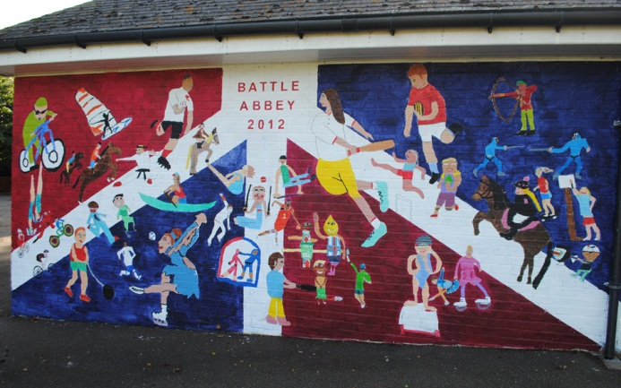 | 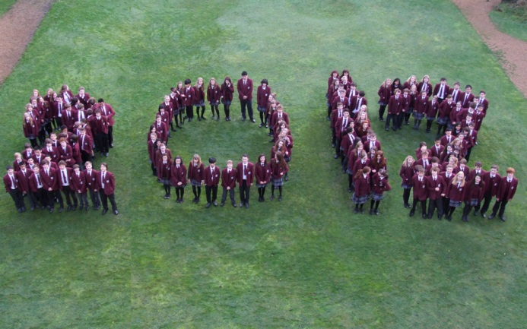

18. At around that time the Governors were approached by The Girls’ Day School Trust who owned Charters-Ancaster School in Bexhill. Following extensive negotiations, Charters-Ancaster School was taken over and merged with Battle Abbey School in September 1995. As part of the merger agreement, Battle Abbey School's preparatory department moved into ‘The Gate’ on Hastings Road, Bexhill (the premises formerly occupied by Charters-Ancaster School's preparatory department).

19. The move of the Preparatory School to Bexhill and the consequent release of valuable space at the Abbey, together with steadily growing pupil numbers, has enabled extensive improvements to be made to the Senior School’s facilities. These include new science laboratories, a Performing Arts Centre, a Business Education Centre and new boarding accommodation in property on the High Street. In 2014, the School purchased a 4.5 acre property one mile from the Senior School which is also used as boarding accommodation for our 6th Form pupils. At the Preparatory School, a separate Nursery facility was introduced in 2006.

20. The School celebrated its centenary is 2012 and is well placed to face the challenges and opportunities of the future.

ETHOS, CHARACTER AND AIMS OF THE SCHOOL

21. Battle Abbey School aims to be a small family school with high quality pastoral care and sensitive discipline, accompanied by strong academic results, focussing on the importance of each individual child. Its specific aims are:

- To continue to inspire pupils to aspire for excellence in all that they undertake and to acknowledge and reward the achievements of each individual according to his or her aptitudes and interests.
- To promote balanced social development through warm and sensitive pastoral care within our disciplined day and boarding community.
- To prepare pupils for life after school by providing an all-round education in which pupils of all ages are valued as individuals and develop the self-respect, self-confidence and empathy for the needs and desires of others that will enable them to contribute positively to our changing world.
- To continue to develop the facilities and resources of the School to ensure that they underpin the achievement of the Schools aims and objectives.
22. When visitors come to the School, they are struck by the family atmosphere, the physical environment and the friendliness of the greeting. The pupils talk with great affection of their School. Battle Abbey School is a gentle place to be and good manners flow naturally from mutual respect, which is encouraged throughout the School. Individuals can thrive and strive to accomplish their best and pupils’ achievements are acknowledged and celebrated. Battle Abbey is a small school and we are good at the things which people associate with such size – nurturing, tutoring and caring.

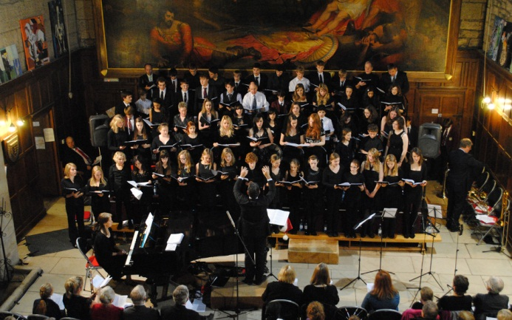 | 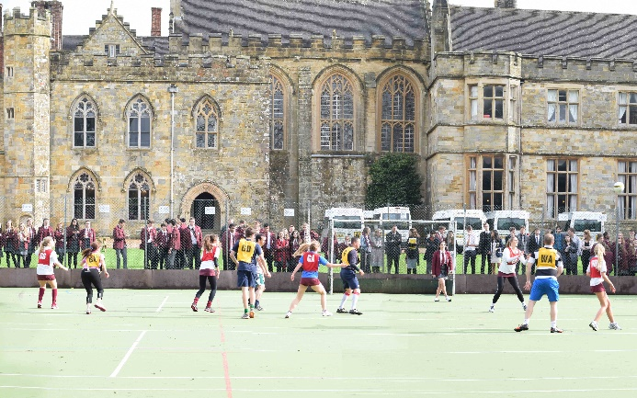

GOVERNANCE AND MANAGEMENT

23. The School is run by B.A.S. (School) Ltd, a registered company limited by guarantee and registered as a charity. The company has a board of Governors (known as the Full Court) who meets at least once each term. The Finance and General Purposes Committee meets twice each term and the Academic Committee meets termly. The Governing body has over the last year or so welcomed a number of new members and currently comprises 10 individuals from a range of professional backgrounds.

24. Following a restructure in 2014, the Senior Leadership Team comprises the Head, Preparatory School Head, Deputy Head, Director of Studies and the Bursar. Within the Senior School there is also a Senior Management Team which comprises the Head, the Deputy Head, the Director of Studies, 3 Key Stage Heads, Head of Boarding and the Bursar. Dedicated, caring and supportive leadership and management at all levels serve the School well, ensuring that it remains true to its aims and ethos.

25. The School is financially sound and the annual accounts are available on the Charity Commission website at www.charity-commission.gov.uk (registered number 306998).

GCSE AND A LEVEL EXAM RESULTS (2014 – 2017)
GCSE results
Total | Pupils | Entries | A*-A (9-7) | A*-C  (9-4) | Z* | A*/A | A*-C  (9-4)
2017 | 44 | 386 | 126 | 321 | 35 | 33% | 83%
2016 | 48 | 430 | 130 | 369 | 43 | 30% | 86%
2015 | 67 | 584 | 248 | 431 | 57 | 42% | 73%
2014 | 37 | 336 | 149 | 299 | 31 | 44% | 89%

Z* - Pupils achieving 5 A*-C including English Language and Maths

A level results
Total | Pupils | Entries | A* | A | B | C | D | E | U | A*-B
2017 | 54 | 171 | 25 | 45 | 42 | 29 | 15 | 12 | 5 | 65%
2016 | 50 | 168 | 19 | 38 | 56 | 31 | 17 | 4 | 3 | 66%
2015 | 44 | 131 | 10 | 24 | 48 | 34 | 9 | 4 | 2 | 63%
2014 | 29 | 89 | 9 | 24 | 22 | 19 | 7 | 6 | 2 | 62%

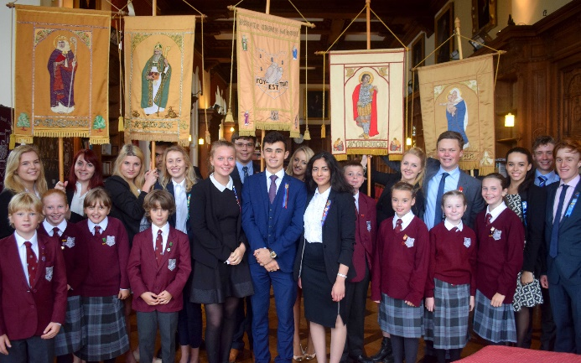 | 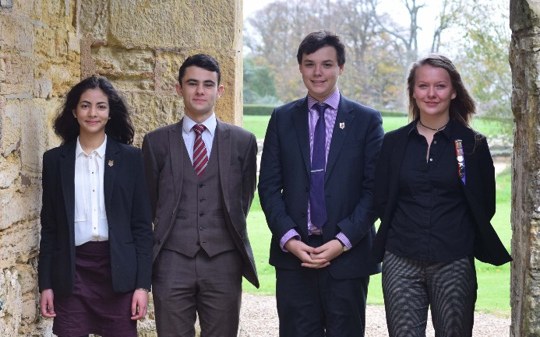
RECENT SCHOOL LEAVERS’ DESTINATIONS

Bath Physics
Bath Politics & International relations
Bournemouth Animation production
Bournemouth Forensic Investigation
Camberwell Art Foundation
Cambridge English
Cambridge Psychology & Behaviour
Chelsea Textile design
Christ Church Law with Business
Christ Church Music
Durham Business & Management
Edinburgh Architecture
Exeter Biochemistry
Exeter Mathematics with Finance
Exeter Civil Engineering
Falmouth Digital Game Design
Heriot Watt Mechanical Engineering
Imperial Biology
Imperial Mathematics with Statistics
Imperial Aeronautical Engineering
Imperial Chemistry
Kent Biomedical Science
Kent Architecture
Kings College Psychology
Kings College Medicine
Kings College French and German
Kingston Film Making
Kingston Interior Design
Lancaster Maths with Statistics
Leicester Law
Leeds History
Liverpool Law
London School of Fashion Fashion Marketing
Manchester Accounting & Finance
Manchester Music
Manchester Environmental Geology
Nottingham Psychology
Nottingham Medicine
Nottingham Veterinary Science
Oxford Biological Sciences
Oxford Earth Sciences
Plymouth Marine Biology
Portsmouth English Literature
Queen Mary’s Aerospace Engineering
Ravensbourne Media Foundation
Reading Business Economics
Royal Agricultural College Farm Management
Royal Central School of Speech and Drama Acting
Royal Holloway English
Royal Holloway Economics
Southampton Ancient History
Southampton Marketing
Southampton Sociology with Anthropology
Southampton Biomedical Science
St Martins Art Foundation
Surrey Psychology
UCL Economics
UCL History
UCL Geography
Warwick Classical Civilisation
Winchester Fashion Marketing & Media
York History

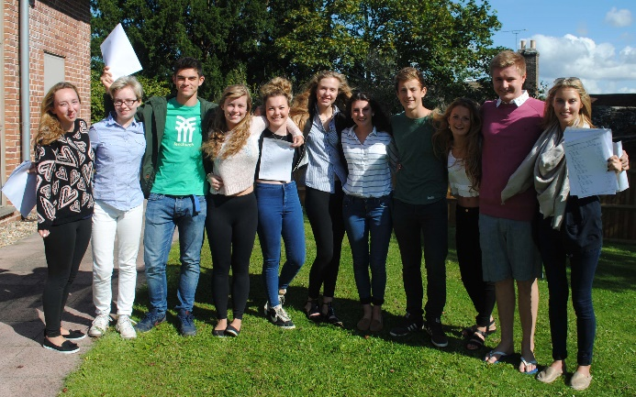 | 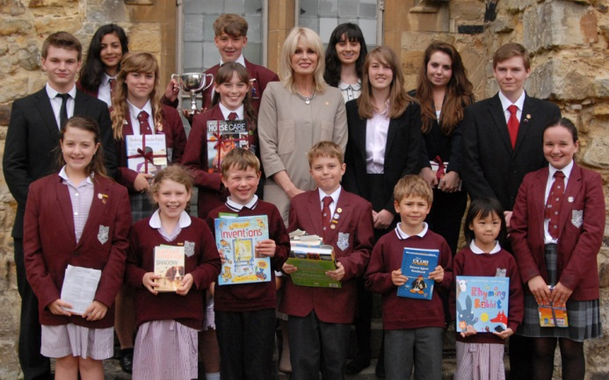

BATTLE AND THE LOCAL AREA

Battle Abbey School is located in the heart of East Sussex, commonly known as the 1066 countryside with its rolling hills, steam railways and historic castles. There are numerous attractions and further information is available at www.visit1066country.com and www.english-heritage.org.uk/daysout/properties/1066-battle-of-hastings-abbey-and-battlefield Transport links to London, Brighton and the continent are excellent. The following extracts from tourist information publications give a feel for the area:

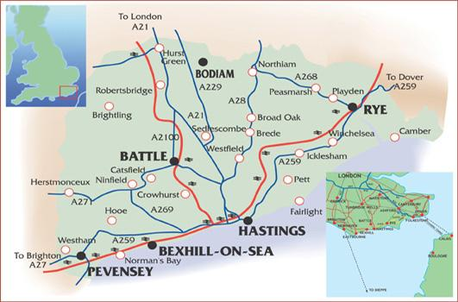

Battle has a unique historical backdrop. The picturesque high street, quaint 'twittens' (passageways) and squares offer treasures of every kind. Visit 'history' attractions, discover beautiful gardens and spend time in quality independent shops and galleries. Battle has great walking and outdoor activities too. Take a self-guided tour around the town with the Battle Town Trail, walk through the nearby impressive Battle Great Wood, play golf on one of our stunning local courses or watch a cricket match on a summer Saturday afternoon on the historic George Meadow. Why not visit Yesterday's World, set in the beautifully preserved 15th century Wealden Hall House and described as 'the very best museum of its kind'. And the town is proud of its superb choice of top class restaurants too. Whatever your taste, you will be able to relax and unwind in a bistro, cafe, inn, pub or tearoom found dotted around the town. | 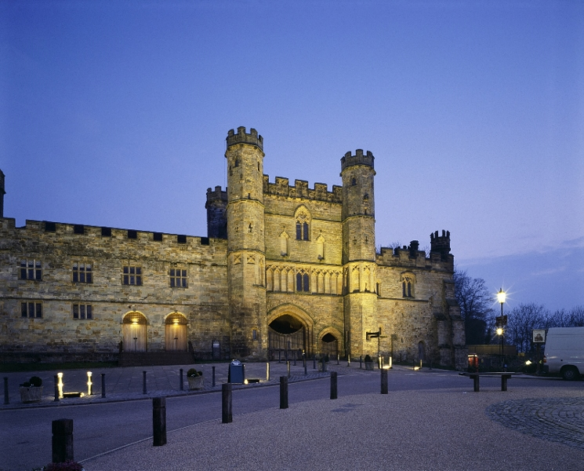

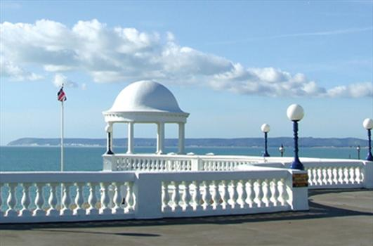 | 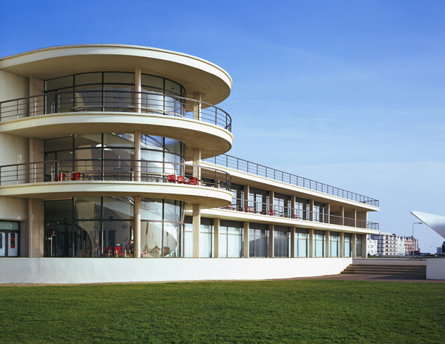
Bexhill-on-Sea, the timeless Edwardian seaside town, is the birthplace of British motor racing, home to the De La Warr Pavilion - one of the UK’s finest examples of modernist architecture - and also has a two mile stretch of level promenade and beach to enjoy.
Bexhill’s colourful history is first recorded in 772 during the reign of King Offa. The 8th Earl of De la Warr developed Bexhill as a fashionable resort - the town was the first place in Britain to permit mixed bathing and had one of the country’s first cinemas.
Bexhill has beach huts to hire, rock pools to explore and the sea is safe for many water sports - sailing, rowing, windsurfing, kite-surfing and angling. Bexhill Sailing Club has a full programme of racing each weekend throughout March to November and members of the local Rowing Club can often be seen on the sea. The picturesque, tranquil Bexhill Old Town is set inland above the town centre with antique shops and charming architecture. Enjoy the classic Georgian buildings, 16th century cottages and the Parish Church of St Peter with its 8th century reliquary stone and the peaceful Manor Gardens. In the town centre there is an excellent selection of small, independent shops including vintage and retro clothing as well as some great restaurants, cafes, tearooms and pubs.
Hastings is home to the largest beach-launched fishing fleet in Europe, the remains of the first castle in England to be built by William the Conqueror, a preserved Old Town and a strong local arts community. It is also home to the Jerwood Gallery, a stunning new art gallery housing a collection of 20th and 21st century British art.  Hastings is a Cinque Port, and up until the 16th century, with other coastal towns provided the ships and men who guarded king and country from frequent and vicious attacks in return for special privileges. This unique confederation of South East England Channel ports was the original force behind England’s maritime power. | 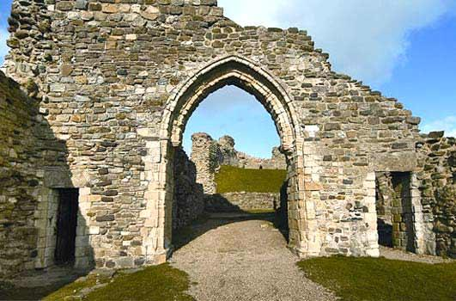
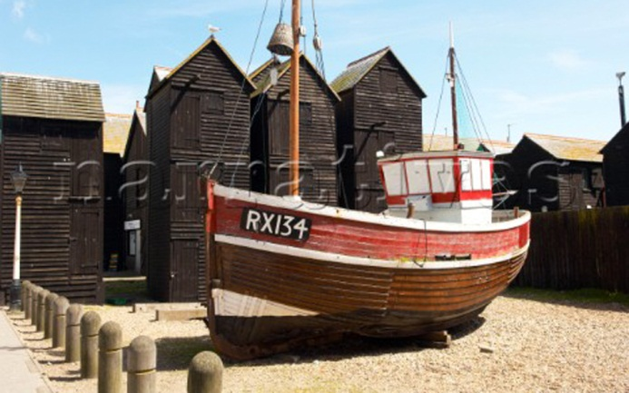 | 

 JOB DESCRIPTION

Battle Abbey School teachers are expected to uphold the high personal and professional standards laid down by the Head, especially with regard to staff dress and discipline. In addition, they are expected to:

- Teaching:
  - Plan and prepare courses and lessons
  - Teach, according to their educational needs, the pupils assigned to him/her, including the setting and marking of work to be carried out by the pupil in school and elsewhere.
  - Assess, record and report on the development, progress and attainment of pupils; in each case having regard to the curriculum for the school.
- Other activities:
  - Promote excellent progress and well-being of individual pupils and of any class or group of pupils assigned to him/her.
  - Provide guidance and advice to pupils on educational and social matters and on their further education and future careers, including information about sources of more expert advice on specific questions.
  - Make records of and reports on the personal and social needs of pupils.
  - Communicate and consult with pupils’ parents and guardians.
  - Communicate and co-operate with persons or bodies outside the school.
  - Participate in meetings arranged for any of the purposes described above.
  - Attend school special days (eg Speech Day) including Parents’ Consultations.
  - Support school functions as required (eg sports events, trips, drama productions, etc).

- Boarding: support the boarding life of the School by contributing to weekend activities (this will usually be one day per half term, ie up to 6 days per year).
- Extra-curricular activities: participate in the running of departmental and school-wide extra-curricular activities, and support and develop programmes designed to engage, stretch and challenge pupils.
- Assessment and reports: provide or contribute to oral and written assessments, reports and references relating to individual pupils and groups of pupils.
- Observation: be willing to observe and be observed teaching.
- Appraisal: participate in arrangements for the appraisal of staff.
- Further training and development:
  - Review from time to time his/her methods of teaching and programmes of work.
  - Participate in arrangements for his/her further training and professional development.
- Educational methods: advise and co-operate with the Head and others on the preparation and development of courses of study, teaching materials, teaching programmes, methods of teaching and assessment and pastoral arrangements.
- Discipline, health and safety: maintain good order and discipline among the pupils and safeguard their health and safety both when they are authorised to be on the school premises and when they are engaged in authorised school activities and elsewhere.
- Staff meetings: participate in meetings which relate to the curriculum, administration or organisation of the school, including pastoral arrangements.
- Absence/Cover: undertake an appropriate share of the collective staff responsibility to cover for absent colleagues when required.
- Public exams: participate in arrangements for preparing pupils for public examinations and in assessing pupils for the purpose of such examinations; record and report such assessments; and participate in arrangements for pupils’ presentation for and supervision during such examinations.
- Management: take such part as may be required of him/her in the review, development and management of activities relating to the curriculum, organisation and pastoral functions of the school.
- Administration:
  - Participate as required in administrative tasks related to the curricular, pastoral, boarding and organisational tasks described above.
  - Attend assemblies, register the attendance of pupils and supervise pupils as necessary.

PERSON SPECIFICATION

Attribute | Essential | Desirable | How identified
Qualifications | - Good honours degree in relevant subject area  - Teaching qualification |  | - Application form  - Qualification certificates
Experience | - Both experienced and newly qualified teachers are welcome to apply |  | - Application form
Skills | - Able to inspire through effective leadership the development of the subject  - Excellent communication of subject  - Ability to use range of teaching strategies  - Ability to teach maths throughout KS3 and KS4 and at all abilities | - Ability to teach KS5  - Use of variety of teaching and learning styles  - Interest in application of ICT skills to learning and teaching of subject  - Maintain awareness of new developments in subject | - Covering letter  - Application form  - Interview  - References  - Lesson observation
Personal competencies | - The ability to work successfully within departmental and pastoral teams  - A sense of excitement about teaching and working with young people  - A desire to seek continuous professional improvement, especially in the classroom  - Positive attitude to use of authority and maintaining discipline | - Be positive about the need for innovation and change  - Sense of humour  - A competency in the use of ICT | - Application form  - Interview  - References  - Lesson observation
Interests | - A willingness to contribute in a boarding school setting  - Potential to offer something extra to the School and its pupils that will enhance the pupils’ learning and life experience | - Evidence of involvement in extra-curricular activities | - Application  - Interview

REMUNERATION PACKAGE

26. The salary will be commensurate with qualifications and experience and is subject to negotiation.

APPLICATION FORM AND KEY DATES

- Closing date for receipt of applications: Monday, 27th November 2017 at 10am

- Interviews for shortlisted candidates: Friday, 8th December 2017
Applications must be made on the attached application form and should be emailed, together with a short covering letter, to Mrs Alison Ambrose, HR Manager at hr@battleabbeyschool.com
Should you wish to discuss any aspect of your application or require any further information, please do not hesitate to contact Alison on 01424 772385 or hr@battleabbeyschool.com

