Barking Abbey School  A Specialist Sports and Humanities College  Sandringham Road  Barking Essex IG11 9AG  Head Teacher: Jo Tupman | 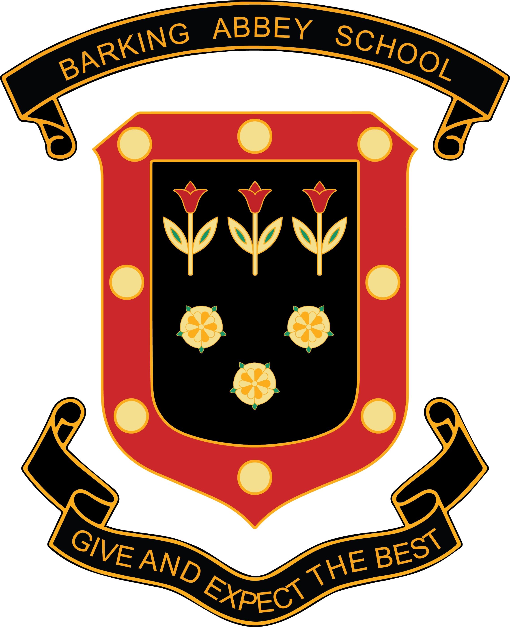
Teacher of Mathematics
Fixed Term
Full Time
Maternity Cover
Start Date: 2nd December 2019
End Date : 1st December 2020
Salary: £29,664 - £48,244 per annum (M1 to UPS3)
(depending on experience)
Ref 0229

Are you one of the best trainees in your year? Perhaps you are already an established outstanding Maths teacher looking for a new challenge?
If so, an exciting opportunity has arisen to join our successful Maths department. We are looking to appoint a dynamic and outstanding Teacher of Mathematics to help continue improving our outcomes for our students. Why not apply to join us?

The successful candidate will be qualified with:
- The ability to teach inspirational and outstanding lessons
- A commitment to Barking Abbey’s high expectations and powerful ethos
- Excellent subject knowledge
- A desire to work collaboratively and to make a real contribution to the future development of our department and the progress of our students

About Barking Abbey School:
- A good school with outstanding features (OFSTED 2017)
- Visitors regularly tell us how our students are calm and well mannered
- A school where we get to know our students well, find out what they are good at and develop their talents

Barking Abbey is a heavily over-subscribed split site secondary school in the London Borough of Barking and Dagenham, and has a well-deserved reputation for its friendly and supportive atmosphere and its excellent academic achievements.

Please click here to find out more informational about what it is like to work at Barking Abbey www.barkingabbeyschool/join-us/staff-vacancies/

To find out more about how teachers can secure rented accommodation at a discounted rate of 20% please contact info@bdsip.co.uk

Interested applicants should download the teachers application form, found on-line at www.barkingabbeyschool.co.uk

Only fully completed application forms will be accepted, CV applications will not be considered.

Please send applications to jobs@barkingabbeyschool.co.uk

Closing Date: Wednesday 16th October 2019
Interviews: Monday 4th November 2019

Barking Abbey is committed to safeguarding and promoting the welfare of children and is an Equal Opportunities Employer.

This post is exempt from the Rehabilitation of Offenders Act 1974 and a comprehensive screening process, including Disclosure check, will be undertaken on all successful applicants.

