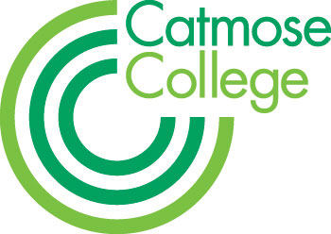
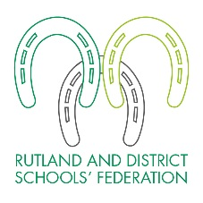
TEACHER OF SCIENCE
MPS + Federation benefits

Required from January 2018
Part time or full time applications considered

We are looking for an enthusiastic KS4 teacher to teach GCSE Science at Catmose College and, if appropriately qualified or experienced, contribute to Science teaching at Harington School. We welcome applications from NQTs who will be well supported by experienced mentors and through our teaching school alliance, as well as from teachers who are looking to return to the profession. For successful candidates there are exceptional opportunities for further professional development and promotion across the Federation.

The role requires the ability to inspire and instil a love of learning, and an up-to-date knowledge of GCSE and potentially A-level curriculum requirements. The candidate must be fully committed to the ethos of the Federation, treating all students as individuals and providing an excellent education in order for every student to maximise their potential. We welcome interest from all subject specialists but in particular those who are able to offer GCSE and an A-level Science.

The successful candidate will be joining a strong and supportive team of specialist teachers who take pride in achieving the best outcomes for all students. Teachers are able enjoy many additional benefits that come as part of working within the Federation. These include, amongst others:

• Teachers at top of scale will receive up to a 2% pay award annually for good performance, in addition to any incremental pay progression;
• Relocation support for hard-to-recruit subjects;
• Vast range of staff training including a funded Masters scheme;
• Outstanding facilities;
• Staff laptops;
• Priority admission for children of staff to the College and Primary.

Catmose College is an over-subscribed 11-16 academy based in a brand new £26m building in Oakham, Rutland. The College was graded as Outstanding by Ofsted in all four categories and overall in February 2012. We have outstanding facilities throughout, with purpose-built classrooms offering excellent teaching resources and access to numerous iPads, laptops and computers; the College is able to offer a truly outstanding technology-led learning environment.

Harington School opened its doors on the Catmose Campus in Oakham in September 2015 and provides a rigorous A-level academic education focusing on the core subjects. The School offers a curriculum designed to develop individual and academic potential, leading the way to the most prestigious universities. In January 2017 the School was judged to be Outstanding in all areas in its first Ofsted report.

Harington School and Catmose College are part of the Rutland and District Schools’ Federation which also includes Catmose Primary and a Preschool provision. This provides wider opportunities for staff, giving them broader experience across different organisations, should their skills and experience be appropriate.

HOW TO APPLY
Application forms and information are available online at www.catmosecollege.com or by emailing office@catmosecollege.com

- You should write a letter of application on no more than 2 sides of A4.
- You should complete all sections of the application form.
- On the form clearly state the names, addresses, telephone and fax numbers, with e-mail address if available, of two professional referees; it is our usual practice to ask for references before shortlisting and always to ask for references before interviews.
- It is a condition of employment that you have a successful DBS check made and can provide proof of identity and qualifications gained.

Please note that due to the high number of applications we receive for positions, your application is unlikely to be considered if you do not follow these requirements. CVs are not accepted. The closing date is 9am on Friday 23 June 2017. You should send your application to Stuart Williams, Executive Principal, Catmose College, Huntsmans Drive, Oakham, Rutland, LE15 6RP. Applications can also be emailed to office@catmosecollege.com

If you have not heard from us by Wednesday 28 June 2017, please assume that on this occasion your application has not been successful. Please enclose a SAE if you would like your application acknowledged.

