Information for Applicants

SENCO
Required for September 2019

Battle Abbey School, High Street, Battle, East Sussex TN33 0AD
Tel: 01424 772385
www.battleabbeyschool.com
For further information please contact Mrs Alison Ambrose, HR Manager
at hr@battleabbeyschool.com (01424 772385)
CONTENTS

- Letter from the Head

- The Learning Plus Department
- General information
- Historical background
- Ethos, character and aims of the School
- Governance and management
- GCSE and A level exam results (2010 – 2018)
- Battle and the local area
- Job description
- Person specification

- Application form and key dates

An aerial view of the Senior School
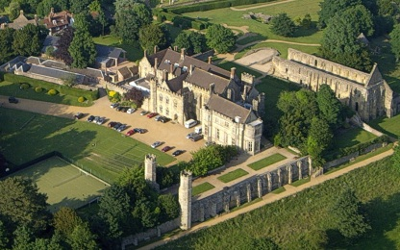

LETTER FROM THE HEAD

From: David Clark, BA MPhil (Cantab)
Dear Applicant,
Thank you for your interest in the exciting vacancy of SENCO.
We are looking to appoint a knowledgeable, creative and driven SENCO, to continue to grow our flourishing Learning Plus department. This is a rare and exciting opportunity for a well-qualified and outstanding teacher, to help drive forward our Learning Plus department to ensure every single pupil is able to fulfil their potential. It is a unique opportunity to work in a historic setting at a school with a growing academic reputation that has a family ethos at its heart.
We are an independent, co-educational, day and boarding school, educating pupils from the age of 3 months – 18 years. We accept pupils with a range of abilities and are very proud their many and varied achievements, especially at GCSE and A Level.
Battle Abbey School celebrated its centenary in 2012 and has gone from strength to strength in recent years. We have achieved a managed growth in pupil numbers and have expanded our facilities significantly. I am also committed to maintaining the School’s fundamental nature as a happy, family school. Our team is highly skilled and brings a wealth of experience and expertise with the aim that every child achieves their potential in whatever field that may be.
Battle Abbey offers its teachers special opportunities which do not exist in larger schools, and this, combined with the enchanting Senior School location and the warm, good-humoured and supportive working atmosphere, makes this teaching post especially attractive.

I hope the information you find in this pack will help you in your decision to apply for this post, but if you have any questions, please contact the HR Manager Mrs Alison Ambrose, on 01424 772385 or via email at hr@battleabbeyschool.com

I look forward to receiving your application.

Yours sincerely

Battle Abbey School, Battle, East Sussex, TN33 0AD Headmaster: David Clark, BA M Phil (Cantab)
Telephone: 01424 772385 Fax: 01424 773573 Website: www.battleabbeyschool.com
Battle Abbey School is administered by B.A.S. (School) Ltd, Registered Number 779605, a non-profit-making company registered as a harity, Number 306998

THE LEARNING PLUS DEPARTMENT

As a small, family school, Learning Plus is central to our ethos to provide for the varied needs of all our pupils. As a non-selective boarding school, we have pupils with a wide range of additional learning needs and we are proud to provide this through our Learning Plus department.
Our Learning Plus department supports pupils who have special educational needs or a disability as well as our EAL pupils from across the globe. The department contains specialist teachers in both EAL and SEND as well as a team of Teaching Assistants. The Learning Plus Department takes an active role in assisting and training our teachers to ensure all our pupils flourish.
We boast enviable facilities and access to technology including:
- Dedicated SEND and EAL rooms;
- Access to IT and Firefly;
- Accelerated Reader and a range of other software to support our pupils.
Many of our pupils also have dedicated time on their timetables for interventions as well as access to in class support. We hold regular meetings with pupils, parents and teachers. We believe it is crucial to involve all the stakeholders regularly to boost the attainment and progress of all our pupils.
The wellbeing of our pupils is at the heart of every decision we make about the children in our care and we are keen to develop this further. The Learning Plus department plays a crucial role in allowing all pupils to be happy and fulfilled; ready to take the next steps in their education with confidence.
We work closely with Battle Abbey Preparatory school to ensure we share good practice and ensure a smooth transition to the Senior School.
We are excited to offer the right candidate the opportunity to join our Learning Plus team and help us to build a school that allows all pupils to thrive.

GENERAL INFORMATION
Battle Abbey School is a thriving co-educational day and boarding school for children aged 2 – 18 years old and it has a special niche in the local area. The Senior School (years 7 – 13) is located in the historic market town of Battle, near Hastings, and is set in the stunning and prestigious surroundings of Battle Abbey, overlooking the famous 1066 battlefield. The School is housed in some of the original 13th century monastic buildings, which are leased from English Heritage, and also occupies other buildings in the town, including Martlet House.
The Preparatory School (Reception to Year 6) is situated 9 miles away in Bexhill-on-Sea and has superb facilities, including a 25 metre indoor swimming pool, playing fields and an floodlit astro pitch. A separate Nursery is situated in the grounds of the Preparatory School. The Nursery is open 0800 – 1800 hours for 50 weeks each year and also runs a mother-and-baby drop-in group. It has good through-links with Reception and runs exciting projects such as beach school and forest school. The Preparatory School and Nursery properties are owned by the School.
There are currently 466 pupils on roll with about 60 boarders in the Senior School and a Sixth Form that averages between 90 and 100 pupils. The majority of pupils live in a 15 mile radius of the School, but a substantial proportion of the boarders are from overseas. There are 125 full and part time staff employed across the sites.

The school accepts pupils who have a wide range of ability but consistently enjoys excellent academic results. The Prep School is the only school in East Sussex to be in the Times Top 100, and the Senior School are in the Times Top 150. The School has a particular strength in the creative arts and reliably achieves outstanding results. Pupils regularly take up places at top Art and Drama colleges and each year Music also features on the wide list of subjects taken up by our pupils at university. More than a quarter of the school sings in the main choir and there are frequent and high quality drama and music productions. Pupils have also won prestigious art awards at local and regional level.

Continuity of education is one of the School’s key attractions and pupils may apply to join at any time during their school career. Battle Abbey Preparatory School pupils are guaranteed a place in the Senior School when transferring at age 11. All pupils benefit from a holistic approach to education and the greatest care is taken to ensure that pupils settle happily and thrive throughout their school life. The broad curriculum ensures that each child is given every opportunity to achieve and excel academically, to create and to perform with confidence and to compete on and off the field. We are a leading IT school having achieved e-Mature status in 2012, have excellent IT facilities and encourage the development of IT skills, including touch typing from Key Stage 1.

Pupils are well-mannered and motivated to learn and have an immense loyalty to the School and to each other. They talk with great affection of their School, considering themselves part of an extended family. They particularly value the friendships that exist across the various year groups, which are

encouraged through the House system, School Guardians, School Bronzes and the Peer Support Groups. The quality of pupils’ spiritual, moral and social development was praised as outstanding in our latest inspection report. The present cohort of pupils is as talented as any we have had in the last fifteen years. The staff, both academic and support, are strong, stable and exciting to work with.
Both the Senior School and the Preparatory School encourage pupils to undertake a wide range of charitable and community activities. These include expeditions to Africa to build a Nursery, swimming sponsorships, mufti days and a variety of house-led fundraising schemes. During the past year, up to £10,000 was raised to support local, national and international charities. Cultural diversity is celebrated across the School, and particularly within the boarding community.
The School enjoys excellent relations with other local independent and state schools, with whom we share some training and facilities.
Parents value the impressive number of extra-curricular opportunities available for their children at both the Preparatory and Senior Schools but above all they value the family ethos and caring atmosphere. Relationships with parents are good and there is frequent communication via the bi-weekly newsletter, regular meetings and events organized by the School and its active parents’ committee known as Friends of Battle Abbey School (FOBAS).
The School was inspected by the Independent Schools Inspectorate in March 2017 and underwent both an ISI Education Quality and Compliance Inspection. Applicants are invited to view the School’s latest inspection reports at http://www.isi.net/school/battle-abbey-school-6229.

HISTORICAL BACKGROUND

The School was founded in Bexhill in 1912 as a family owned, all girls, senior boarding school known as St Etheldreda's. To cater for rapidly increasing numbers, St Etheldreda's moved to Battle Abbey in 1922 and changed its name to Battle Abbey School. In 1963 the founding family transferred ownership of the School to a charitable company in order to ensure its continuation in perpetuity. That company, BAS (School) Ltd, is administered by a Board of Governors and continues to run the School today.

During the 1980s, the national trend away from single-sex boarding schools convinced the Governors that co-education was the way forward. Consequently, in September 1989, they took over the nearby Glengorse and Hydneye Preparatory School, giving Battle Abbey School instant co-education and an instant preparatory department. Despite the recession, Battle Abbey School experienced a steady growth in numbers throughout the years that followed and by 1994 the problem facing the Governors was that of running out of space.

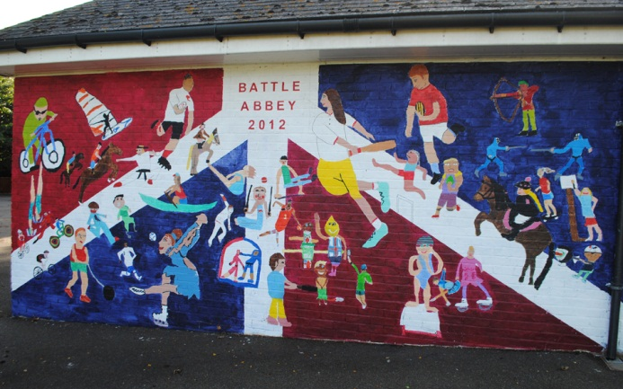

At around that time the Governors were approached by The Girls’ Day School Trust who owned Charters-Ancaster School in Bexhill. Following extensive negotiations, Charters-Ancaster School was taken over and merged with Battle Abbey School in September 1995. As part of the merger agreement, Battle Abbey School's preparatory department moved into ‘The Gate’ on Hastings Road, Bexhill (the premises formerly occupied by Charters-Ancaster School's preparatory department).

The move of the Preparatory School to Bexhill and the consequent release of valuable space at the Abbey, together with steadily growing pupil numbers, has enabled extensive improvements to be made to the Senior School’s facilities. These include new science laboratories, a Performing Arts Centre, a Business Education Centre and new boarding accommodation in a property on the High Street. In 2014, the School purchased a 4.5 acre property one mile from the Senior School which is used as boarding accommodation for our Sixth Form pupils. In 2016 we opened Martlet House, a property on Battle High Street, catering for a variety of Sixth Form subjects, and home to Textiles and Photography. At the Preparatory School, a separate purpose built Early Years facility was opened in September 2018.

The School celebrated its centenary in 2012 and is well placed to face the challenges and opportunities of the future.

ETHOS, CHARACTER AND AIMS OF THE SCHOOL

Battle Abbey School aims to be a small family school with high quality pastoral care and sensitive discipline, accompanied by strong academic results, focussing on the importance of each individual child. Its specific aims are:

- To continue to inspire pupils to aspire for excellence in all that they undertake and to acknowledge and reward the achievements of each individual according to his or her aptitudes and interests.
- To promote balanced social development through warm and sensitive pastoral care within our disciplined day and boarding community.
- To prepare pupils for life after school by providing an all-round education in which pupils of all ages are valued as individuals and develop the self-respect, self-confidence and empathy for the needs and desires of others that will enable them to contribute positively to our changing world.
- To continue to develop the facilities and resources of the School to ensure that they underpin the achievement of the Schools aims and objectives.
When visitors come to the School, they are struck by the family atmosphere, the physical environment and the friendliness of the greeting. The pupils talk with great affection of their School. Battle Abbey School is a gentle place to be and good manners flow naturally from mutual respect, which is encouraged throughout the School. Individuals can thrive and strive to accomplish their best and pupils’ achievements are acknowledged and celebrated. Battle Abbey is a small school and we are good at the things that people associate with such size – nurturing, tutoring and caring.

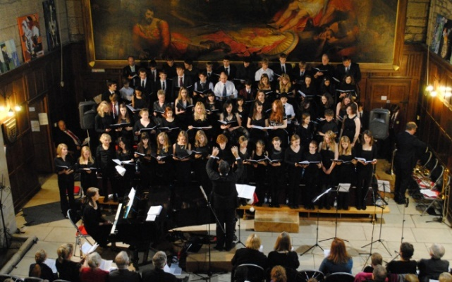 | 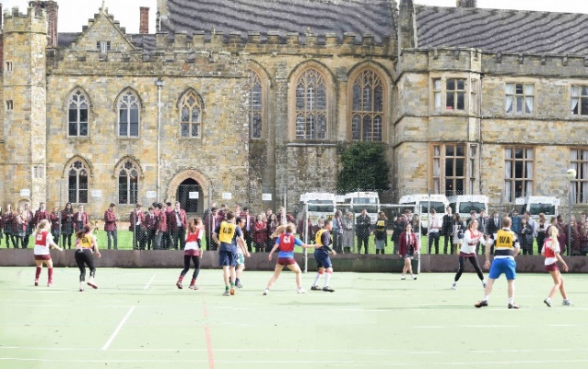
GOVERNANCE AND MANAGEMENT

The School is run by B.A.S. (School) Ltd, a registered company limited by guarantee and registered as a charity. The company has a board of Governors (known as the Full Court) who meets at least once each term. The Finance and General Purposes Committee meets twice each term and the Academic Committee meets termly. The Governing body has over the last year or so welcomed a number of new members and currently comprises 10 individuals from a range of professional backgrounds.

The Senior Leadership Team comprises the Head, Preparatory School Head, Deputy Head, Director of Studies and the Bursar. Within the Senior School there is also a Senior Management Team which comprises the Head, the Deputy Head, the Director of Studies, 3 Key Stage Heads, Head of Boarding and the Bursar. Dedicated, caring and supportive leadership and management at all levels serve the School well, ensuring that it remains true to its aims and ethos.

The School is financially sound and the annual accounts are available on the Charity Commission website at www.charity-commission.gov.uk (registered number 306998).

GCSE AND A LEVEL EXAM RESULTS (2015 – 2018)
GCSE results
Total | Pupils | Entries | (9-7)  A*-A | (9-4)  A*-C | Z* | A*/A | A*-C  (9-4)
2018 | 36 | 342 | 135 | 317 | 35 | 39% | 93%
2017 | 44 | 386 | 126 | 321 | 35 | 33% | 83%
2016 | 48 | 430 | 130 | 369 | 43 | 30% | 86%
2015 | 67 | 584 | 248 | 431 | 57 | 42% | 73%

Z* - Pupils achieving 5 A*-C including English Language and Maths

A level, EPQ and BTEC results
Total | Pupils | Entries | A* | A | B | C | D | E | U | A*-B
2018 | 42 | 136 | 24 | 37 | 40 | 21 | 9 | 4 | 1 | 74%
2017 | 54 | 171 | 25 | 45 | 42 | 29 | 15 | 12 | 5 | 65%
2016 | 50 | 168 | 19 | 38 | 56 | 31 | 17 | 4 | 3 | 66%
2015 | 44 | 131 | 10 | 24 | 48 | 34 | 9 | 4 | 2 | 63%
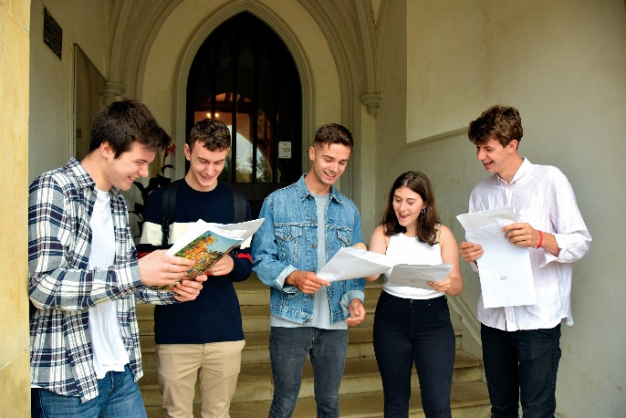

BATTLE AND THE LOCAL AREA

Battle Abbey School is located in the heart of East Sussex, commonly known as the 1066 countryside with its rolling hills, steam railways and historic castles. There are numerous attractions and further information is available at www.visit1066country.com and www.english-heritage.org.uk/daysout/properties/1066-battle-of-hastings-abbey-and-battlefield Transport links to London, Brighton and the continent are excellent. The following extracts from tourist information publications give a feel for the area:

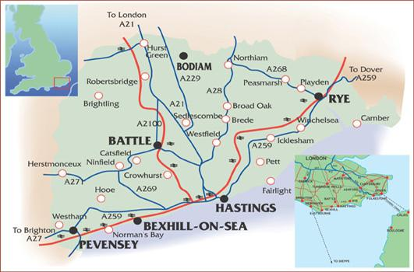

Battle has a unique historical backdrop. The picturesque high street, quaint 'twittens' (passageways) and squares offer treasures of every kind. Visit 'history' attractions, discover beautiful gardens and spend time in quality independent shops and galleries. Battle has great walking and outdoor activities too. Take a self-guided tour around the town with the Battle Town Trail, walk through the nearby impressive Battle Great Wood, play golf on one of our stunning local courses or watch a cricket match on a summer Saturday afternoon on the historic George Meadow. Why not visit Yesterday's World, set in the beautifully preserved 15th century Wealden Hall House and described as 'the very best museum of its kind'. And the town is proud of its superb choice of top class restaurants too. Whatever your taste, you will be able to relax and unwind in a bistro, cafe, inn, pub or tearoom found dotted around the town. | 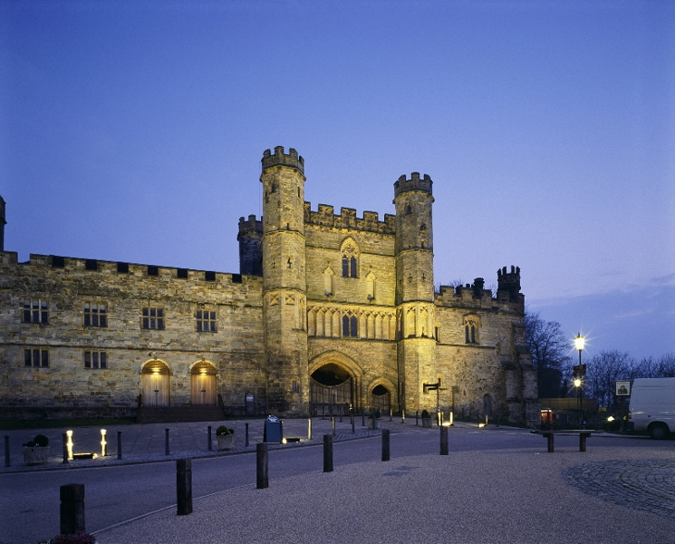

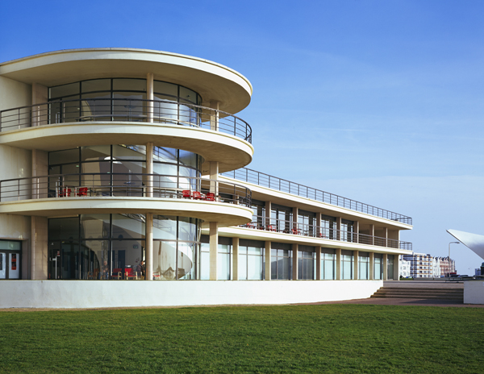
Bexhill-on-Sea, the timeless Edwardian seaside town, is the birthplace of British motor racing, home to the De La Warr Pavilion - one of the UK’s finest examples of modernist architecture - and also has a two mile stretch of level promenade and beach to enjoy.
Bexhill’s colourful history is first recorded in 772 during the reign of King Offa. The 8th Earl of De la Warr developed Bexhill as a fashionable resort - the town was the first place in Britain to permit mixed bathing and had one of the country’s first cinemas.
Bexhill has beach huts to hire, rock pools to explore and the sea is safe for many water sports - sailing, rowing, windsurfing, kite-surfing and angling. Bexhill Sailing Club has a full programme of racing each weekend throughout March to November and members of the local Rowing Club can often be seen on the sea. The picturesque, tranquil Bexhill Old Town is set inland above the town centre with antique shops and charming architecture. Enjoy the classic Georgian buildings, 16th century cottages and the Parish Church of St Peter with its 8th century reliquary stone and the peaceful Manor Gardens. In the town centre there is an excellent selection of small, independent shops including vintage and retro clothing as well as some great restaurants, cafes, tearooms and pubs.
Hastings is home to the largest beach-launched fishing fleet in Europe, the remains of the first castle in England to be built by William the Conqueror, a preserved Old Town and a strong local arts community. It is also home to the Jerwood Gallery, a stunning new art gallery housing a collection of 20th and 21st century British art.
Hastings is a Cinque Port, and up until the 16th century, with other coastal towns, provided the ships and men who guarded king and country from frequent and vicious attacks in return for special privileges. This unique confederation of South East England Channel ports was the original force behind England’s maritime power.
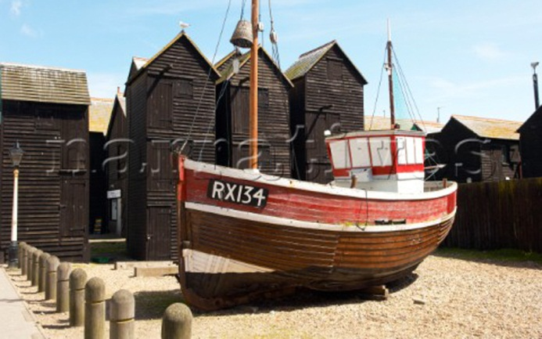

JOB DESCRIPTION

- To ensure pupils with SEND and EAL can meet their potential and make good progress.
- To strategically lead our Learning Plus department.
- To work closely with the SENCO at Battle Abbey Preparatory School and our feeder Primaries to ensure smooth transition and the sharing of good practice.
- To monitor, evaluate and report on the progress and attainment of pupils involved with our Learning Plus department.
- To assist with promoting wellbeing across the school and develop innovative and effective provision in these areas.
- To analyse and evaluate SEND and EAL data available and present positive outcomes, areas for development and areas for concern to the Line Manager, Headmaster and Governors when appropriate or required.
- To plan and teach outstanding lessons whether in a classroom, small group or one to one setting.
- To lead on the implementation of the SEND Code of Practice and SEND policy.
- To develop and oversee provision for EAL pupils.
- To provide the highest levels of support to the SEND and EAL team.
- To ensure all teaching staff have the highest level of training and can access comprehensive support from the Learning Plus department, to ensure every pupil makes progress.
- To keep up to date with national and local developments in SEND legislation, policy, teaching pedagogy and initiatives.
- To liaise with the Examinations Officer and Access Arrangements Assessor to ensure pupils have the right access with examination and validating bodies and the appropriate provision is put in place.
- To manage exam requirements including IELTS and Cambridge First exams alongside our Exams Secretary.
- To help run the Accelerated Reader Programme.
- To take responsibility for the identification and screening of pupils with SEND.
- To quality assure the provision for SEND through observations, data analysis “book looks” and pupil interviews and take the necessary interventions on areas for action.
- To ensure accurate information and data are available to staff via ISAMS and the SEND register, taking account of GDPR practices.
- To write, in liaison with your line manager, an annual development plan, including costings and provide an analysis of the outcomes annually, reporting on the performance and development of the SEND department.
- To promote excellent working partnerships with parents, establishing open channels of communication and provide support for families of SEND and EAL pupils.

PERSON SPECIFICATION

Attribute | Essential | Desirable | How identified
Qualifications | - Qualified SENCO status (or working towards this qualification). | - A good track record of recent, relevant professional development.  - Experience and relevant qualifications for the testing of pupils with SEND needs. | - Application form  - Qualification certificates
Experience | - Experience of working with and ensuring good progress of SEND pupils. | - An up-to-date knowledge and track record of working with pupils experiencing anxiety and other mental health issues as well as promoting emotional and social wellbeing.  - Experience of arranging exam concessions.  - Experience or knowledge of working with EAL pupils. | - Application form  - Interview
Skills | - A clear knowledge of the SEND Code of Practice.  - Outstanding classroom practice and the ability to deliver effective and creative interventions for pupils.  - The ability to articulate and deliver a compelling vision for creating an outstanding Learning Plus department that provides opportunities for all pupils to make excellent progress. | - Evidence of making an impact across a school to improve standards of teaching and learning for SEND and EAL pupils.  - The ability to collate, analyse and present data to inform interventions.  - The ability to deliver CPD across the school. | - Covering letter  - Application form  - Interview  - References  - Lesson observation
Personal competencies | - Enthusiasm and the ability to work in a small, family school.  - A clear recognition of the opportunities and challenges that accompany this setting.  - The ability to lead a large and diverse team.  - To lead training and development of support staff and teaching staff to ensure staff development needs are met on SEND matters. | - The ability to line manage the SEND department and provide a clear vision for staff.  - Personal impact and presence.  - Willingness to participate actively in the wider school community.  - Ability to overcome setbacks. | - Application form  - Interview  - References  - Lesson observation
Interests | - A willingness to contribute in a boarding school setting.  - Potential to offer something extra to the School and its pupils that will enhance the pupils’ learning and life experience. | - Evidence of involvement in extra-curricular activities. | - Application  - Interview

REMUNERATION PACKAGE

The salary will be commensurate with qualifications and experience and is subject to negotiation.

APPLICATION FORM AND KEY DATES

- Closing date for receipt of applications: Monday, 28th January 2019 at 9am

- Interviews for shortlisted candidates: Week starting Monday, 11th February 2019
Applications must be made on the attached application form and should be emailed, together with a short covering letter, to Mrs Alison Ambrose, HR Manager at hr@battleabbeyschool.com
Should you wish to discuss any aspect of your application or require any further information, please do not hesitate to contact Alison on 01424 776808 or hr@battleabbeyschool.com

