
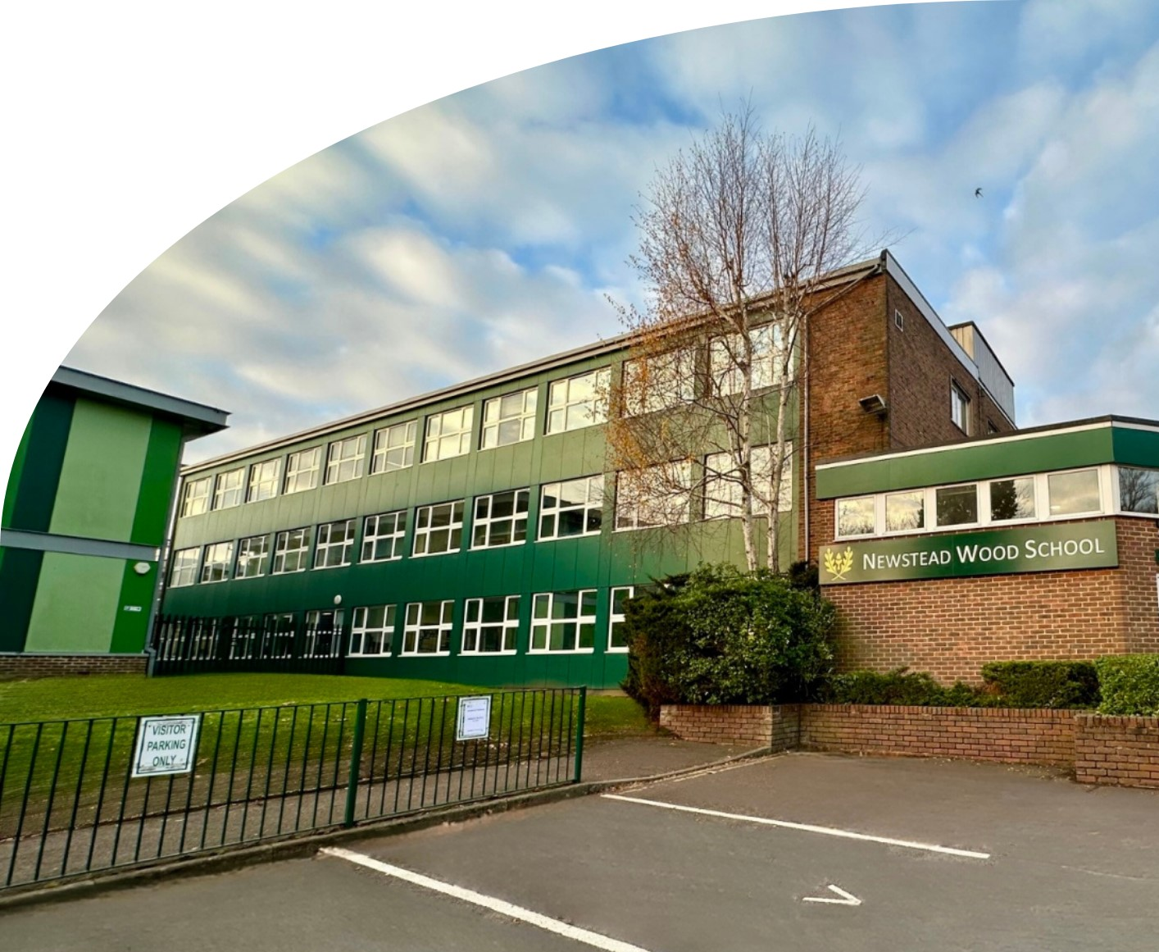

CANDIDATE PACK

JOB ROLE: SEN Teaching Assistant
A highly selective girls' state secondary school, with a co-educational Sixth Form.

OUR SCHOOL

Newstead Wood School, founded in 1954 as Orpington Grammar School for Girls, is renowned for academic excellence and a strong sense of community. With six forms of entry, modern facilities, and the motto Fortitudine Crescamus (‘May we grow in strength’), the school supports both academic and personal growth. Students are assigned to one of six Houses—Nightingale, Wren, Swift, Falcon, Griffin, and Phoenix—building identity and belonging.
The school offers unique opportunities like international trips to Japan, New York, Borneo, and Malta, plus electives in film, photography, classical civilisation, and fencing. With a focus on highly able students and strong career support, Newstead Wood school consistently earns an ‘Outstanding’ rating from Ofsted, with the most recent inspection in 2022.

WELCOME FROM THE HEAD

We are looking for people to join us at Newstead Wood School who are passionate about education and their subject, dedicated to fostering a love of learning, and committed to inspiring our talented and able students. We seek dynamic and inspirational staff who share our vision and commitment to providing a broad and high-quality education. Whether you're a seasoned educator or just starting your teaching career, we welcome individuals who thrive in a collaborative, diverse and inclusive environment and are eager to contribute to our vibrant school community.




We are delighted to have been named as London State Secondary School of the Year 2025 in this year's Sunday Times Parent Power schools guide!
‘The culture in a girls’ school is about smashing the glass ceiling and removing stereotypes. All heads in the STEM subjects are strong, powerful, diverse women. A can-do attitude helps foster the confidence to do well.’
Alan Blount, Headteacher

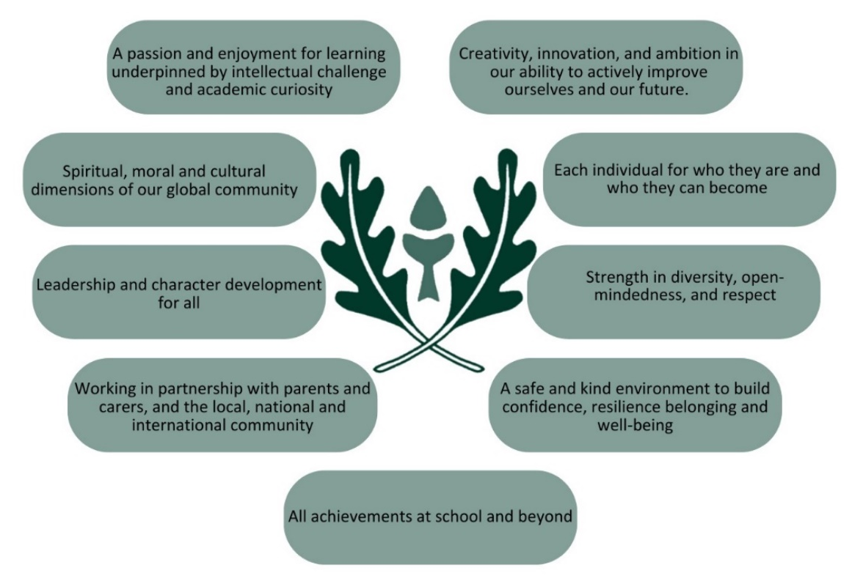

OUR ETHOS AND VALUES
Newstead Wood School is a member of the International Coalition of Girls’ Schools (ICGS)

At Newstead Wood School we value, share and celebrate:

‘The ICGS unites girls’ schools worldwide and we look forward to contributing to this incredible group of instititutions. Girls’ schools foster global changemakers – empowered women who are equipped to tackle the world’s biggest challenges with courage competence and empathy. Research shows that graduates from girls’ schools are more engaged in their communities, culturally competent, and politically active. We are excited about the opportunities ahead and the chance to be part of such a transformative movement!’ Alan Blount, Headteacher

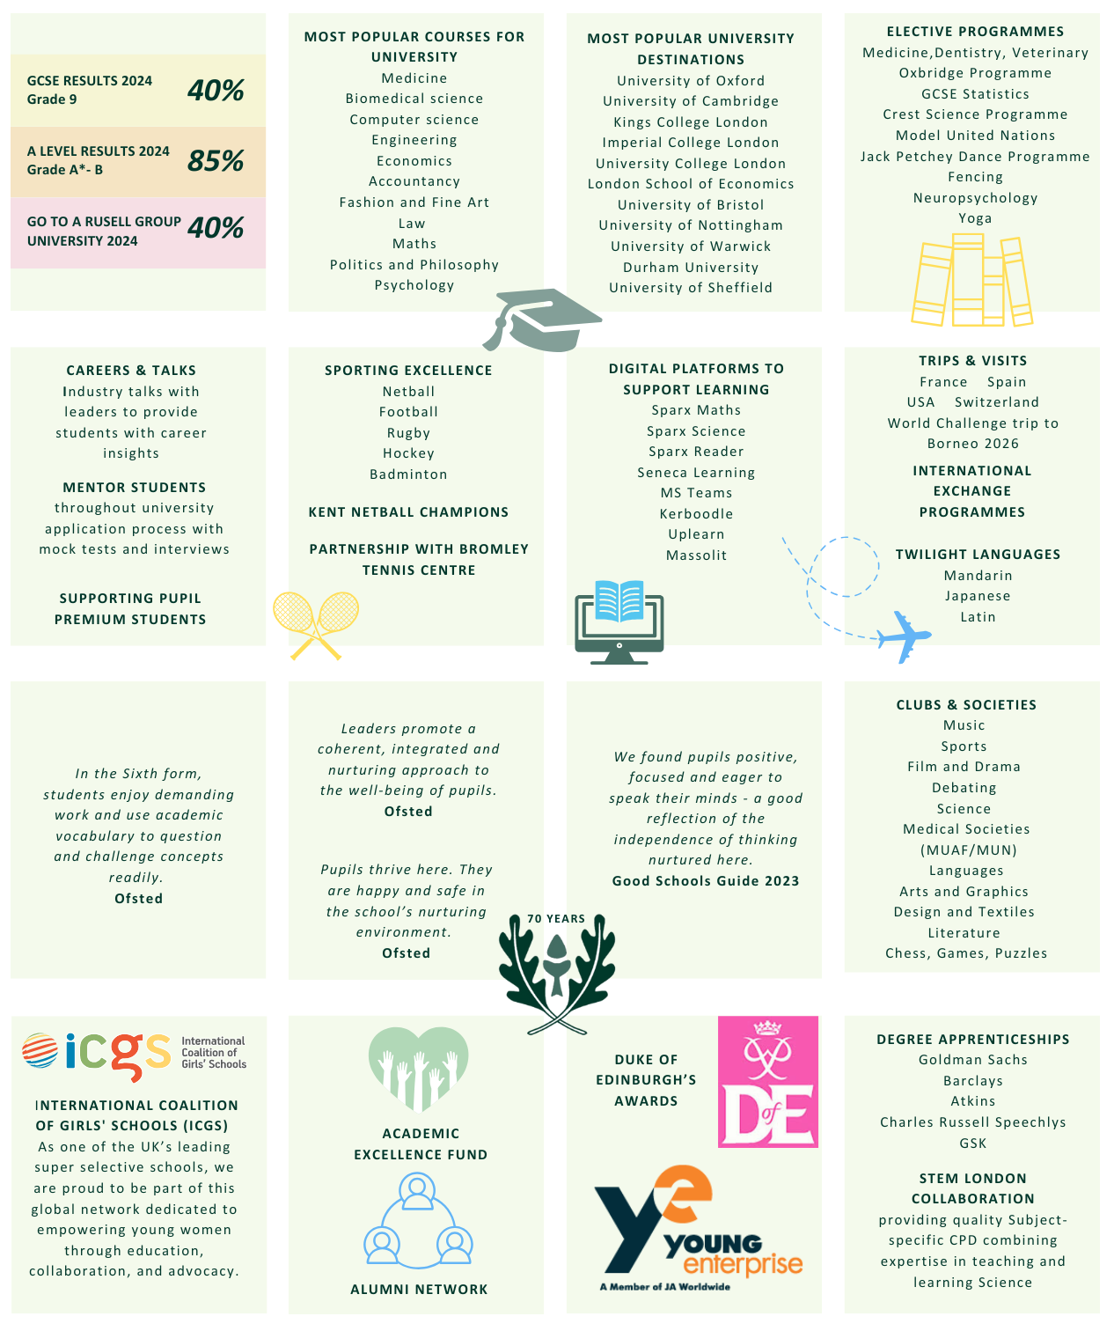
ACADEMIC EXCELLENCE
ROLE: | SEN Teaching Assistant
REPORT TO: | Ms Ricketts - SENCO
DEPARTMENT: | SEN
HOURS: | 37.5
CLOSING DATE OF APPLICATION: | Sunday 22 June 2025
THE ROLE

JOB PURPOSE
To support students with learning needs in the classroom, within small groups or on a one-to-one basis, and to ensure access and safe movement around our school site. Some personal care support outside of lessons may be required and so a background or experience of personal care of young people is desirable.

KEY RESPONSIBILITIES
General Duties:
All duties associated with this role require the highest standards of professionalism at all times in terms of manner, conduct and confidentiality. This role also demands high levels of literacy as all written communication must be in Standard English.

Main Responsibilities
- To work under the direction and guidance of the SENCO to remove barriers to learning for an individual's/group, in or out of the classroom
- To support access to learning for students within the classroom, under the direction of teaching staff.
- To support safe travel around the site and to ensure personal needs are met.

Support for Students
- To use specialist skills/training/experience to support students to make progress in their learning and in their personal and social development.
- To establish productive working relationships with students, acting as a role model and setting high expectations.
- To support classroom learning of individual students/small groups.
- To support the social and emotional wellbeing of students.

Support for Teachers
- To use strategies, in liaison with the teacher, to support students to make progress and achieve their full potential
- To assist with planning and delivery of learning opportunities and intervention sessions
- To monitor students’ responses to learning activities and accurately record achievement/progress as directed by SENCO
- To provide detailed and regular feedback to teachers on students’ achievement, progress and barriers to learning.
- To support students to catch up learning following any absence.

Support for departments
- Undertake structured and agreed learning and administrative duties.
- Support the development of personalisation for SEND students to support progress and engagement.
- Support the SENCO with the specific administrative processes relating to named students.

Support for the school
- To be aware of and comply with policies and procedures relating to the SEND code of practice, Keeping Children Safe in Education (KCSIE).
- To contribute to the overall ethos of the school.
- Participate in training, professional learning opportunities and performance development as required.

Qualifications
- A Level (or equivalent).
- GCSE English and Mathematics.

Experience
- Experience of supporting students’ learning and achievement in a school or similar environment.
- Experience of supporting students with SEND.

Skills & Attributes
- Highly organised with excellent time management skills.
- Strong written and oral communication skills.
- Compassionate and empathetic.
- Ability to be flexible and responsive to changing situations both in school and the wider community involving students’ needs and provision.
- Demonstrate reflective personal characteristics and be able to continually seek positive outcomes for students with SEND.
- Ability to maintain positive relationships with all SEND students, families and the professionals who support them.

This job description is intended as a general guide to the duties attached to the post and is not an inflexible specification. It may, therefore, be altered from time to time to reflect the changing need of the service, always in consultation with the post holder.
Every member of staff at Newstead Wood School has a responsibility to promote and safeguard the welfare of children and young people with whom they come into contact.
We are an inclusive school and strive to be a learning, caring and thriving institution.
We take safeguarding of students and staff seriously at Newstead Wood School. All staff are expected to support this ethos.
The post is subject to an enhanced DBS disclosure and the post holder must be committed to safeguarding the welfare of children.

THE DEPARTMENT
To support students with learning needs in the classroom, within small groups or on a one-to-one basis, and to ensure access and safe movement around our school site. Some personal care support outside of lessons may be required and so a background or experience of personal care of young people is desirable.


EQUAL OPPORTUNITIES
We are committed to equality of opportunity for all staff and applications from individuals are encouraged regardless of age, disability, sex, gender reassignment, sexual orientation, pregnancy and maternity, race, religion or belief and marriage and civil partnerships.
We particularly welcome applications from BAME candidates as they are currently under-represented at Newstead Wood School.


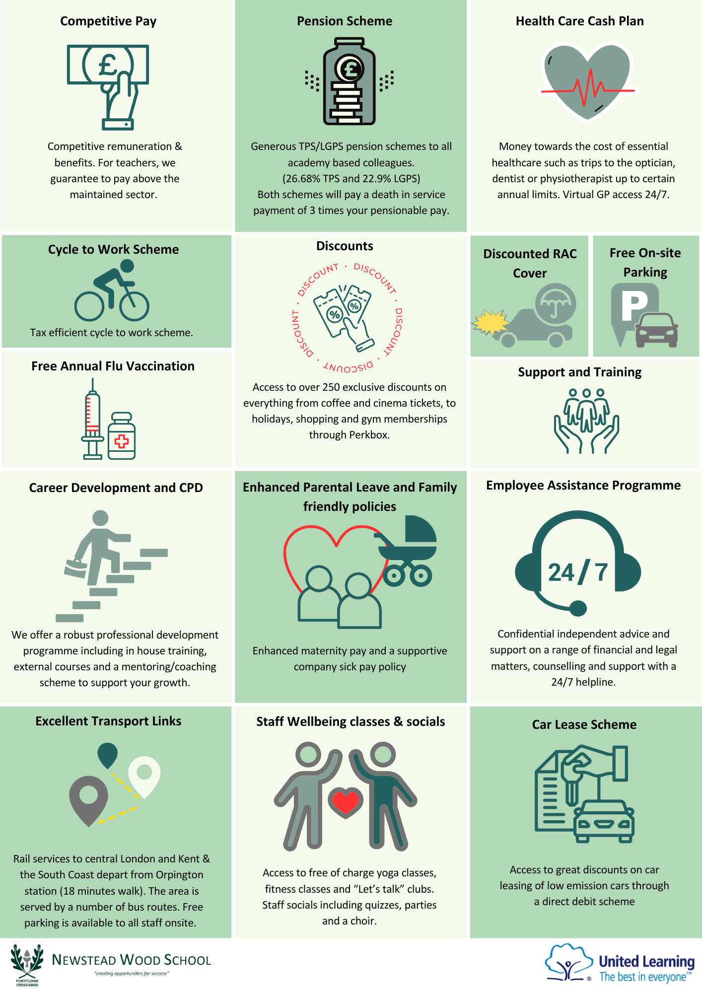
WHY WORK WITH US?

APPLICATION PROCESS
HOW TO APPLY

You can complete the application online via the school website here.
If you have any questions or would like an informal discussion or school visit, please contact our HR Department: recruitment@newsteadwood.co.uk or call 01689 853626.

INTERVIEWS
The closing date for applications is Sunday 22 June 2025
Applications will be reviewed as they are received. The school reserves the right to appoint at any stage of the recruitment process; early applications are therefore encouraged.
Please note, we do NOT accept applications by Curriculum Vitae.

SAFEGUARDING NOTICE
Newstead Wood School is committed to ensuring the highest levels of safeguarding and promoting the welfare of children and young people, and we expect all our staff and volunteers to share this commitment. All offers of employment are subject to an enhanced Disclosure and Barring Service (DBS) check, references, an online search, and where applicable, a prohibition from teaching check will be completed.

RECRUITMENT POLICY
Newstead Wood School is working hard to become a more diverse organisation which is key to our commitment to bringing out the best in everyone. We welcome applications from everyone committed to this ethos and would particularly welcome applications from minority candidates. We always appoint on merit.
If you consider that the provisions of the Equality Act 2010 apply to you, or if you require assistance at any stage of the process, please contact the HR Department, telephone 01689 853626 or email recruitment@newsteadwood.co.uk. Newstead Wood School actively supports equality, diversity and inclusion and encourages applications from all sections of society.

USEFUL LINKS
School Website
School Prospectus
United Learning Group
UL Benefits



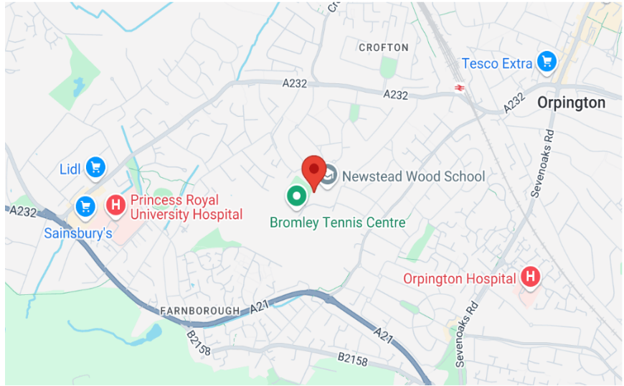

LOCATION:
Newstead Wood School
Avebury Road
Orpington
BR6 9SA
Telephone: 01689 853626

