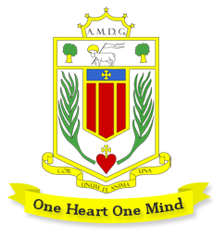
Broughton Hall Catholic High School
Expressive Arts: Music Department

Staffing
Please see: Expressive Arts’ Department Structure.

We aim to inspire, equip and enrich young people through drama and music.
Accommodation and Resources
Expressive Arts subjects have fantastic facilities, ensuring all students are able to meet their fullest potential.
Drama: Drama Studio & Dance Drama performance space
Music Large specialist teaching space, containing:
Teacher iMac, keyboard with amplifier, Promethean board
16 student iMacs & touch sensitive keyboards with full-size keys
Tuned and untuned percussion, including class sets of Djembes & Samba kits
All iMacs have a range of software including Microsoft Office, Logic, Garage Band and Sibelius.
Four practice rooms
Recording Studio

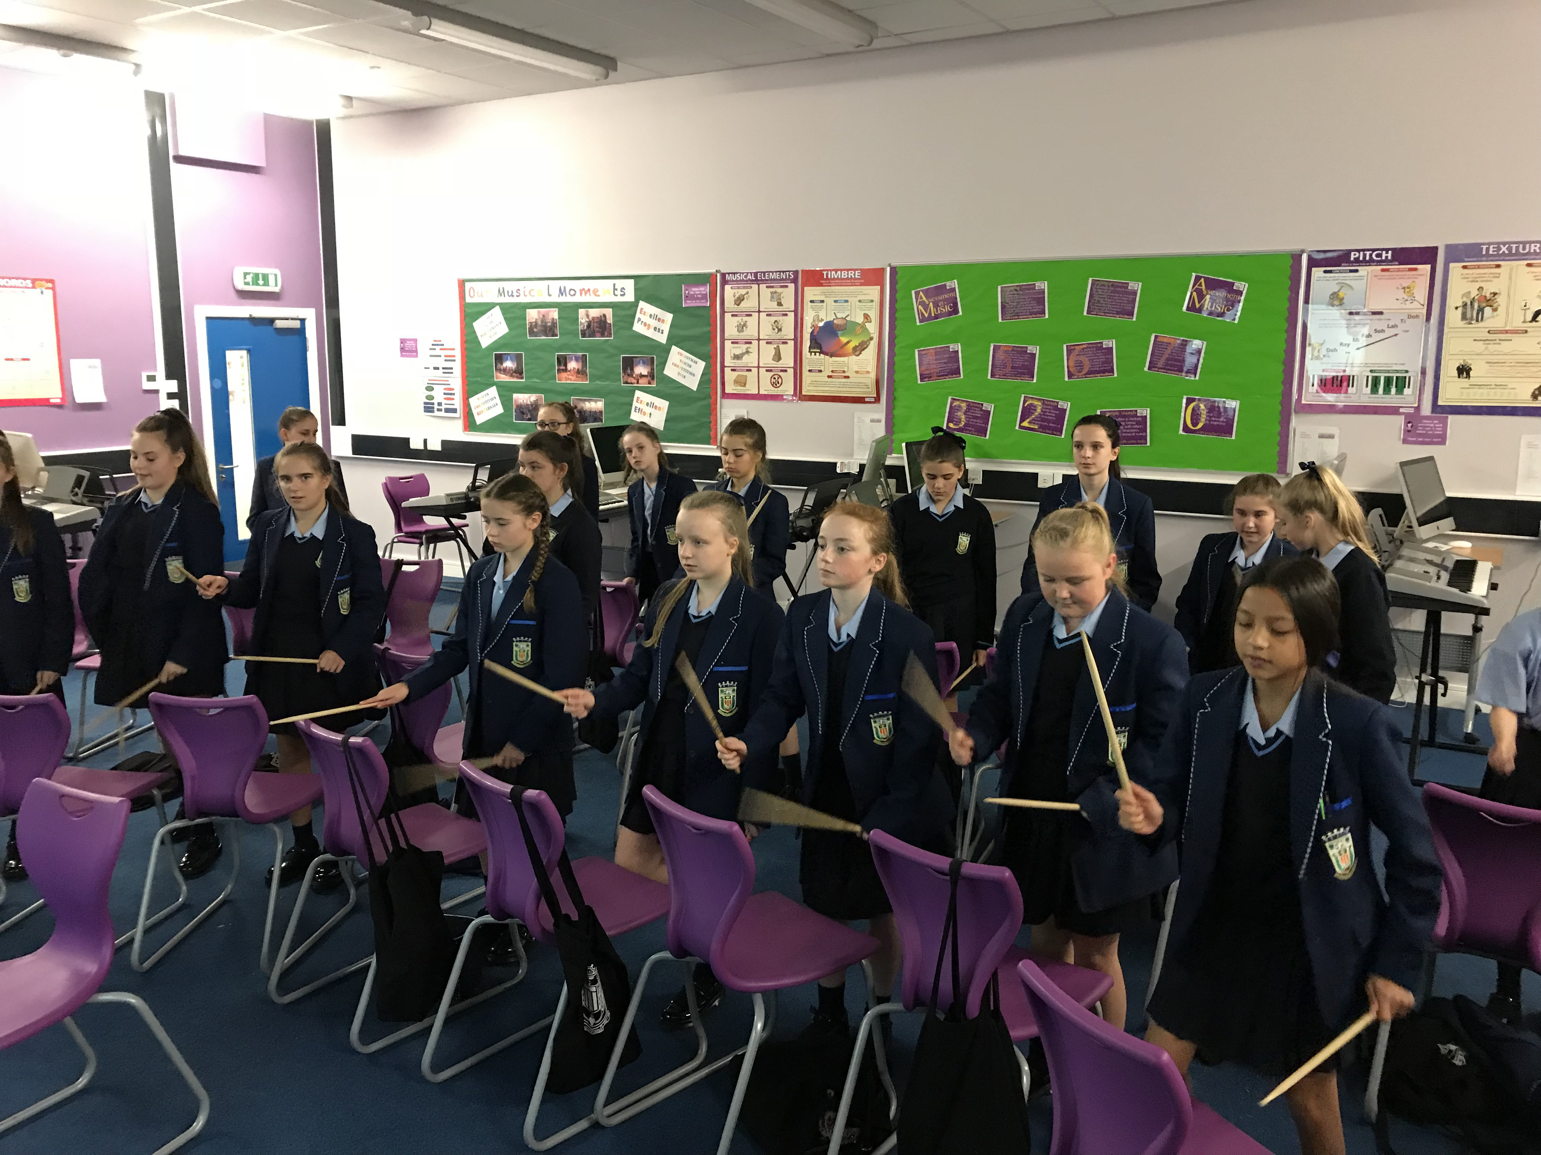
Key Stage 3 Music
One hour per week for Years 7 & 8 for half of the year.
In Key Stage 3 all students learn the key skills of listening, performing and composing, with high expectations that each student will work hard to achieve their potential. They will learn to follow notation, perform (voice, keyboard, chair drumming, guitar, ukulele) and use Logic software on iMacs to explore and develop their skills. Lessons are rigorous but highly practical and above all, we want the students to love music-making!

Students can expect to be formally assessed every 4-8 lessons, with attention paid to developing knowledge, skills, co-ordination and technique. They will receive individual verbal feedback plus a written target at least once every 8 lessons and homework is set when appropriate. Each student has a Music Progress Sheet to record achieved grades and all assessments are evidenced in recordings (video and audio).

Key Stage 4: GCSE Music (Edexcel)
Year 11: 12 students
Year 10: 1 student
Year 9: 6 students
Some of these students will have had additional individual instrumental or vocal tuition prior to Key Stage 4 but many will not. We don’t see this as a barrier to success, as our teaching enables all to make good progress at Key Stage 4. Music has great facilities, dedicated teachers and strong examination results. Music staff work hard to support and develop students’ personal, musical and academic skills, both in and outside the classroom.

The GCSE Music course balances theoretical study (analysing eight set works from a wide range of traditional and modern genres) and practical application. We want students to develop their scholastic skills (essay-writing, analysis, knowledge) alongside creativity, imagination, self-expression and confidence. Above all, Music GCSE students are encouraged to become confident, well-rounded individuals with a wide skill-set.
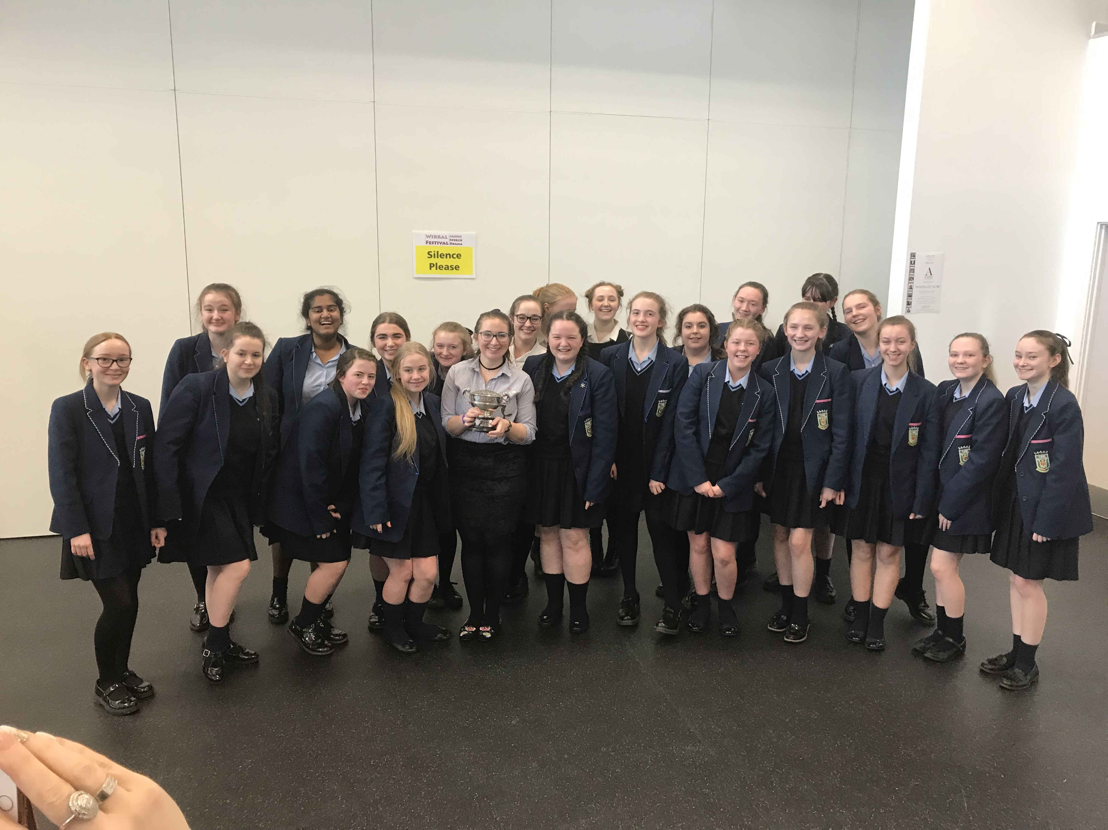
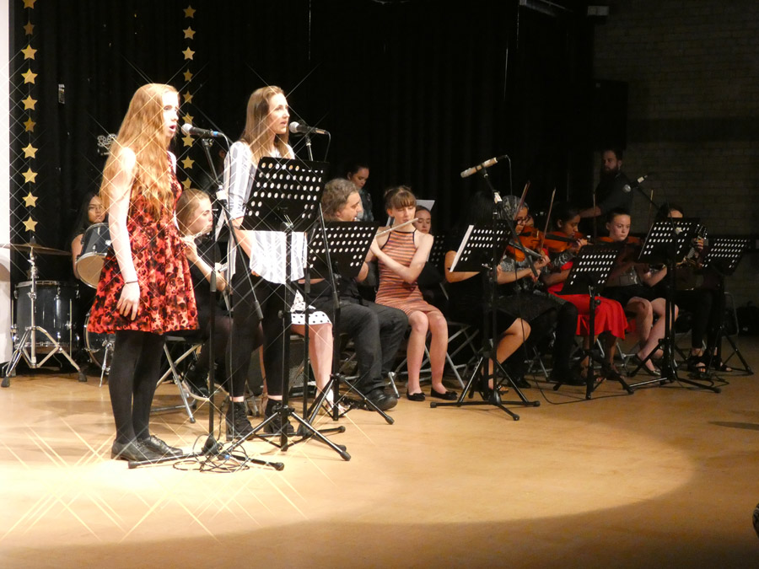
Extra Curricular Activities: Music
- Instrumental Lessons (woodwind, brass, drum kit, guitar, piano, voice)
- Junior Band
- Celebration Group (Senior Band)
- Choir and Vocal Group
Events: Music
- School Production (led by Drama)
- Summer Concert (Summer Term)
- Various festivals/competitions
- Performances at a variety of school events, e.g. Mercy Day Mass, Awards Evening, Year 9 Graduation.

Department Results
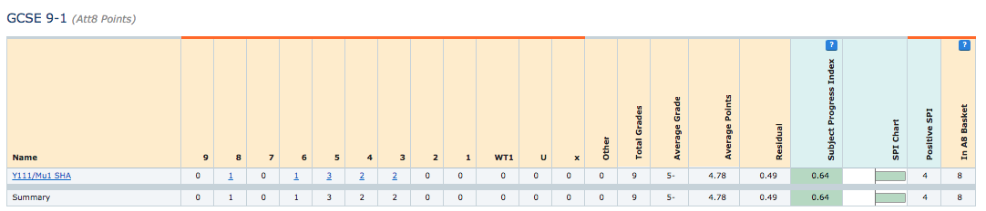
2018

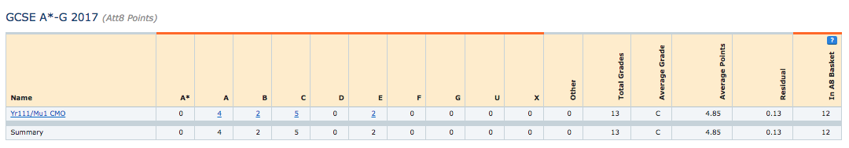
2017

