Head of Maths

Recruitment Pack



CONTENTS

Welcome from the CEO

Four Critical Questions

The E21C Backbone

Our schools

*Improving Outcomes*

*Transforming Lives*

Candidate charter

Welcome from the Head

About the school

About the role

Person Specification

How to apply

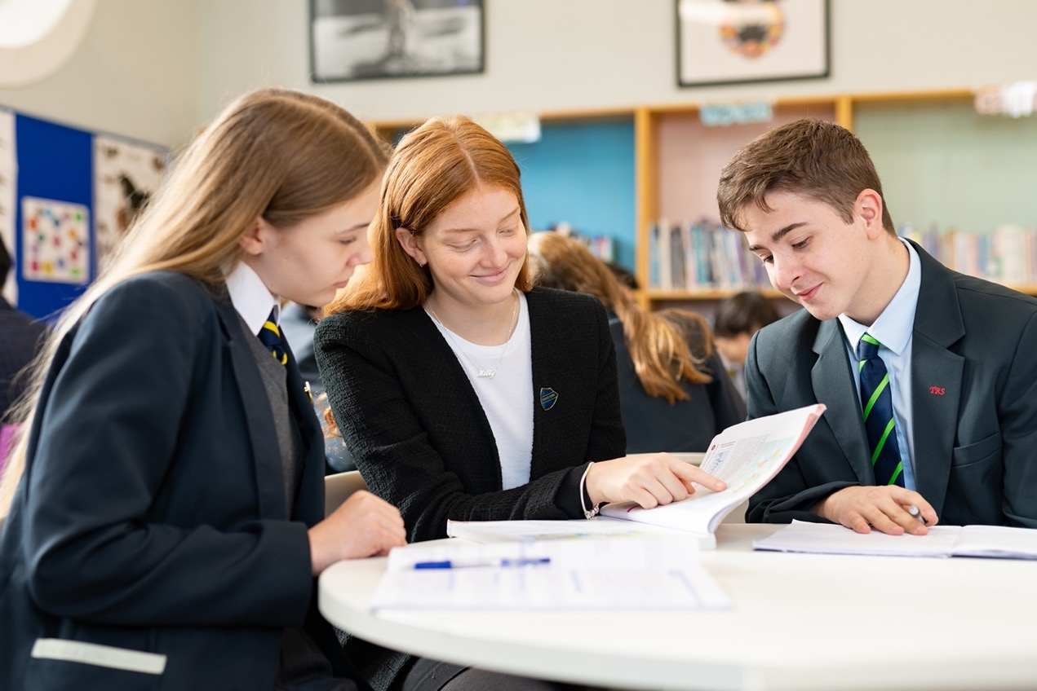

WELCOME FROM THE **CEO**

Thank you for showing an interest in our pupils, our schools and our Trust. This is an exciting time to join Education for the 21st Century. We are a very different organisation in 2023 than we were four years ago. We have understood the need to transform and have developed greater capacity in our leaders at every level. We have developed a shared understanding of what great teaching looks like, developed our curriculum model, developed clear behaviour principles, and landed upon an exciting model of instructional coaching to drive forward teacher efficacy.

Our strategy over the next two years reflects our growing capacity but it also reflects the need to improve quickly. In Year 1 we established the ‘backbone’ of the organisation and to align, where doing so impacts pupils progress, or allows us to influence progress through growing greater capacity in our schools and realising efficiencies. In Year 2, now, we hope to see all schools moving closer to national progress or beyond, as they realise the benefits of collaborative working based upon a common school workflow. In Year 3, as this rapid progress continues, we begin to add capacity for growth so we can support our mission of transforming lives and our aim of becoming one of the highest performing multi academy trusts in London and the South East.

Of course, our strategy is responsive to the needs of those closest to us. The wellbeing of the young people in our care has been significantly impacted by the recent pandemic. Our support will be strategic and comprehensive. Furthermore, the pandemic has had a dramatic impact upon the career prospects of our pupils. Our strategy over the coming years seeks to ensure that our pupils are well placed to move successfully into the next stage of their education or working life, with the right knowledge and skills to make a valuable contribution to society.

The development, wellbeing, and support of staff within the Trust will play a crucial part in our strategy. We adapted quickly to new ways of working and continue to refine and develop our HR processes. One key lever for change over the next three years, will be instructional coaching. The ongoing development of all staff, and in particular, our teachers, is critical if we are to deliver the high-quality teaching that we need to, in order to ‘improve outcomes and transform lives’.

Finally, I am extremely grateful for your interest in our Trust. We are moving forward at a rapid rate and it’s an exciting time to join us.

**Simon Garrill**



**Chief Executive Officer**

|  |  |
| --- | --- |
| **WHY DO WE EXIST?**  Our Mission at E21C is ‘improving outcomes, transforming lives’. We believe in the collective power of schools working together as civic minded leaders to find shared ways of working that improve the lives of our pupils. |  |
| **HOW DO WE BEHAVE?**  Our core values of trust, kindness and endeavour define how we behave. These are the values that we hold most dear, and our schools align their own values to those of the Trust. |  |
| **WHAT DO WE DO?**  We create welcoming and open schools in the local community where every person thrives, makes excellent progress and succeeds. |  |
| **HOW DO WE SUCCEED?**  With aligned autonomy, a clear backbone, a strong culture, academic rigour and smart systems. |  |

THE FOUR CRITICAL QUESTIONS

OUR **SCHOOLS**

There are currently four secondary schools and four primary schools within the Trust. Four of the primary schools and three of the secondary schools are located within Bromley, South East London. A further secondary is close to Canterbury in Kent. These schools include:

**SECONDARY** SCHOOLS

|  |  |
| --- | --- |
|  |  |
| **11-19** | **11-19** |
|  |  |
| **11-19** | **11-16** |

**PRIMARY** SCHOOLS

|  |  |
| --- | --- |
|  |  |
| **4-11** | **4-11** |
|  |  |
| **4-11**  **420 pupils** | **4-7**  **510 pupils** |

CANDIATE **CHARTER**

E21C want every candidate to have an informed, engaging and positive experience, and to support this we’ve created our Candidate Charter which outlines our commitment to you.

OUR **COMMITMENT** TO YOU

* **Transparency** we will treat you with respect, honesty and fairness
* **Protecting** your privacy we’ll ensure your information is secure and handled sensitively
* **Understanding** you’ll be given everything you need to make informed decisions
* **Showcasing talent** we’ll provide a good opportunity for you to share your skills, experience and potential
* **Feedback** we will provide constructive feedback professionally and promptly
* **Listening** we welcome feedback and we’ll act on what you have to share
* **Inclusivity** our hiring decisions align with our commitment to create a high quality, diverse workforce

WE WILL

* Provide you with clear, accurate and timely information
* Give you the opportunity to ask questions ‒ and we’ll ensure you get the answers you need
* Respond to enquiries promptly and usually within 24 hours during the working week
* Adopt a fair and consistent assessment process
* Make sure you have all the documentation and details you need for an interview, well in advance
* Provide you with real insight about what it’s like to be part of our team
* Ensure all offers are fair and equitable
* Seek feedback on your experience at every opportunity, so we can continue to improve

IN RETURN WE ASK THAT YOU

* Be honest and upfront about your experience, aspirations and motivations
* Provide open and accurate information when submitting an application
* Always give yourself the best opportunity to succeed - research who we are and how we work
* Let us know if situations change in relation to your interest - and help us understand why
* Prepare yourself for interview and let us know how we can support you

WELCOME FROM THE **HEAD**

Welcome to The Ravensbourne School – a school with huge ambitions and drive. We are on a journey to become an outstanding provider, where every student is known, nurtured and developed to their full potential.

At The Ravensbourne School we put our staff first as they take centre stage in supporting our students and their education. We are a hard-working team and we work collegiately to transform the learning for all our students.

If you are enthusiastic, student-centred and dedicated to raising standards, we want you to be part of our team. We will ensure you work in a supportive professional environment, with first rate opportunities for development and progression across all key stages.

We are delighted that you are considering a career with us and within E21C, a family of eight infant, primary and secondary schools. Together we provide exceptional opportunities for professional development at all levels and invest in job shares, returnships and part-time working for young parents or carers.

We have a very ambitious, experienced, inclusive and progressive leadership team and a reputation for fostering a fair, dynamic and forward-looking culture. Transformational change is happening at The Ravensbourne School, and we are excited about shaping and supporting your career as we all share the ambition and opportunity to succeed.

Mark Ridley



Head TeacherABOUT THE **SCHOOL**

The Ravensbourne School is a large and truly unique 11-19 school, set in the heart of Bromley. There are 1500 students, with 440 students in Post 16. Some of the buildings are Grade II listed, dating back to 1911 whilst other additions are more recent. The buildings, coupled with the extensive 22-acre grounds, make up elegant and inspiring surroundings.

Our vision is that every student is prepared to be the best they can be in life and able to create their own future. We believe that every student is different and has unique talents. Through developing these talents and knowledge each student can be the best they can be and in control of their own future. We value an inclusive learning environment that accepts no excuses and builds partnerships with all stakeholders.



ABOUT THE **ROLE**

**Head of Maths**

Based at The Ravensbourne School Hayes Kent

Education for the 21st Century is a values-led organisation, driven by a determination to create welcoming and open schools for the local community, where every person thrives, makes excellent progress, and succeeds. We are committed to improving outcomes and transforming lives, realising social mobility, and the transformative power of education. We value the difference in all of our schools while seeking to bring them together around a framework that delivers an enriching experience and a great education for the young people within our care.

We want the very best for all of our young people. Our plan to ensure that we deliver great schools is underpinned by our shared values of trust, kindness, and endeavour. Our schools and our staff are collaborative and we seek to create consistency and quality throughout.

Our leaders create improvement in schools that is robust and sustainable. We are as enthusiastic about developing and nurturing our staff, as we are about developing our young people. Our professional development programs and our approach to school improvement provide quality and rigor while creating a depth of experience and learning for our staff.

In joining The Ravensbourne School and the family of schools within E21C you will gain access to an unparalleled level of support and development in a forward-thinking school and trust.

We are seeking a dynamic, inspirational and experienced classroom practitioner with strong subject knowledge and experience to join our successful Maths Department. We wish to appoint an exceptional individual who has the necessary enthusiasm, skills and motivational attributes to nurture a passion for studying Maths at all levels of ability; an individual committed to the highest expectations of attainment for all and capable of encouraging all students to realise their aspirations.

The ideal candidate will maintain rigorous high expectations for staff and students alike. They will also be similarly passionate about their own learning and engagement with continuous professional development, recognising that meaningful learning is much more than what happens in the classroom alone and the importance of enriching the curriculum through meaningful contributions towards our broad extra-curricular provision.

You will have the opportunity to work with a talented team of like-minded leaders, teachers and a strong central team, all working together to build sustainable excellence in our schools

The successful candidate will:

* Join a forward-looking, high achieving school
* A school that offers a genuine opportunity for meaningful career development.
* A positive and supportive department of enthusiastic and motivated teachers, including TLR holders.
* Contribute to wider improvement of the school and trust
* Excellent career opportunities within the trust
* Be driven and committed to your students
* An excellent practitioner who is willing to challenge and be challenged



JOB DESCRIPTION

JOB TITLE: **Head of Maths**CLOSING DATE:  Wednesday 15th February 2023  
SALARY:  MS/UPS (Plus TLR)  
CONTRACT TYPE: **PERMANENT**

LOCATION:  The Ravensbourne School, Hayes Lane, Bromley BR2 9EH  
REPORTING TO: Deputy Headteacher

# JOB PURPOSE

All teachers at The Ravensbourne School are viewed as both leaders and managers of the academic and pastoral curriculum.

Definition of leadership is defined as: “Identifying and articulating the shared values of the school. Leaders then implement these values and the organisations’ vision for the future through planning. At this school, leadership is not solely located behind one person’s door. It is a shared, collective responsibility to lead the school in the formulation and implementation of its values. The school will seek opinions and canvass for involvement on strategic issues. It is expected that at this level of responsibility, the postholder is aware of the nature of leadership and contributes as much as possible.”

Definition of Management is defined as: “Working with individuals and teams to achieve tasks. It is a means to an end. At the most fundamental level, every time we enter a classroom, we are managers of the learning process. Others have additional management roles. The point is simple: we are all managers of the education process.”

**Head of Department**

* To be accountable for leading, managing and developing the subject area.
* To raise standards of student attainment and achievement within the whole subject/curriculum area and to monitor and support student progress.
* To ensure the provision of an appropriately broad, balanced, relevant and differentiated curriculum for students studying in the department, in accordance with the aims of the school and the curricular policies determined by the Governing Body and Principal.
* To teach the relevant subject across the age and ability range.
* To facilitate and encourage a learning experience which provides students with the opportunity to achieve their individual potential.
* To effectively manage and deploy staff, financial and physical resources within the department
* To share and support the school’s responsibility to provide and monitor opportunities for personal and academic growth.

Key Responsibilities

**Operational/Strategic Planning**

* To formulate, in conjunction with the subject team, an annual subject improvement plan that supports the school improvement plan and is based on rigorous review of subject performance data.
* To lead the development of appropriate syllabuses, resources, schemes of work, marking policies, assessment and teaching strategies in the subject area, within the designated area.
* To contribute to the formulation of and subsequently the monitoring, evaluation and review of the faculty improvement plan.
* To ensure that health and safety policies and practices, including risk assessments are in line with national, local and school requirements.
* Curriculum
* To ensure the delivery off an appropriate, comprehensive, high quality and cost-effective curriculum that has high expectations of achievement for all students.
* To lead development of the subject and its delivery, reviewing it regularly in the light of school and national policies, as well the impact on achievement.
* People Management and Staff Development
* To build and recruit where required an effective team of motivated staff who share the school vision of high achievement for all students.
* To induct, guide and support all staff in the subject area, ensuring training needs are met, in liaison with Senior Leader responsible for CPD.
* To be responsible for the day-to-day management of all teaching and support staff in the subject area, including performance management in line with the school performance management policy.

**Teaching and Learning**

* To be an outstanding role model for teaching, showing evidence that lessons are both planned and prepared.
* Marking, assessing, recording and reporting on student achievement in lessons.
* Using resources to ensure the development of each student in all aspects of the subject(s).
* Teaching in a manner according to students’ educational needs, appropriate to our core values and ensuring the safety of students and others.
* Taking responsibility for a teaching area and providing up-to-date displays of students’ work.
* A commitment to continued professional development.
* To maintain discipline at all times in accordance with the School’s procedures.
* Student Outcomes
* To ensure the effective operation of target setting, monitoring and evaluation systems.
* To ensure the input and maintenance of accurate student data, making use of analysis and evaluating performance data, taking appropriate action to secure improvement.

**Pastoral**

* To act as a Form Tutor and to carry out the duties associated with that role, including contribution to specific pastoral programmes of study, monitoring of attendance and punctuality, liaison with parents, internal and external agencies as appropriate.
* To ensure the behaviour management systems are implemented consistently in the subject area, so that effective learning can take place.
* School Ethos
* To undertake such other duties as may be required, commensurate with the level of responsibility of the post.
* To engage actively in the performance review process, addressing appraisal targets set in conjunction with the line manager each autumn term.
* To participate in training and other professional development learning activities as required.
* To promote equal opportunities and celebrate diversity in all aspects of the school.
* To play a full part in the life of the school community, to support its distinctive aim and ethos and to encourage staff and students to follow this example.
* To support and attend school events such as Open Evening.
* To promote actively the school’s policies.
* To adhere to the school’s Dress Code.
* To comply with the school’s Health and Safety policy and undertake risk assessments as appropriate.
* To be familiar with and promote safeguarding requirements, demonstrating adherence to the DfE Guidance ‘Keeping Children Safe in Education and the school’s Safeguarding/Child Protection policies.
* To be aware of and comply with all school policies and procedures, in particular those relating to conduct, child protection (as above), health, safety and security, confidentiality and data protection, reporting all concerns to an appropriate person.

Employees will be expected to comply with any reasonable request from a manager to undertake work of a similar level that is not specified in this job description. Employees are expected to be courteous to colleagues and provide a welcoming environment to visitors and telephone callers.

The school will endeavour to make any necessary reasonable adjustments to the job and the working environment to enable access to employment opportunities for disabled job applicants or continued employment for any employee who develops a disabling condition (as defined in the Equality Act 2010).

Following consultation with you this job description may be changed by management to reflect or anticipate changes in the job which are commensurate with the salary and job title.

Education for the 21st Century is committed to safeguarding and promoting the welfare of young people and expects all staff and volunteers to share this commitment. All offers of employment are subject to an Enhanced DBS check and where applicable, a prohibition from teaching check will be completed for all applicants. Education for the 21st Century is fully committed to equality and to valuing diversity as an employer and a provider of education.

# PERSONAL SPECIFICATION

|  |  |  |  |
| --- | --- | --- | --- |
|  | **Essential** | **Desirable** | **Method of assessment** |
|  | These are qualities without which the Applicant could not be appointed | These are extra qualities which can be used to choose between applicants who meet all of the essential criteria |  |
| **Qualifications** | *The professional, technical or academic qualifications that the Applicant* ***must have*** *to undertake the role or the training that they* ***must have*** *received*   * Good degree (or equivalent) * QTS (or equivalent) | *The professional, technical or academic qualifications that the Applicant* ***would ideally have*** *to undertake the role or the training that* ***they should ideally have*** *received*   * Management Training | Production of the Applicant’s certificates  Discussion at interview  Independent verification of qualifications |
| **Experience** | *The categories of work or organisations, types of achievements and activities that would be likely* ***to predict*** *success in the role*   * Successful teaching of GCSE at good or better level; * Initiation and effective management of change; * Evidence of raising achievement in present post and showing good value added for groups | *The categories of work or organisations, types of achievements and activities that would be likely to* ***contribute to*** *success in the role* | Contents of the application form  Interview  Professional references |
| **Skills** | *The skills* ***required*** *by the Applicant to perform effectively in the role*  Good communication skills in speech and writing;  Excellent organisational skills  Ability to build and sustain professional standards and relationships with students  Ability to contribute towards creating a safe and protective environment | *The skills that would* ***enable*** *the Applicant to perform effectively in the role* | Contents of the application form  Interview  Professional references |
| **Knowledge** | *The knowledge* ***required*** *by the Applicant to perform effectively in the role*  Knowledge of current curriculum developments in subject and their implications;  Good knowledge and understanding of current educational thinking;  Good understanding of how children learn and how to raise standards of achievement | *The knowledge that would* ***enable*** *the Applicant to perform effectively in the role* | Contents of the application form  Interview  Professional references |
| **Personal competencies and qualities** | *The personal qualities that the Applicant* ***requires*** *to perform effectively in the role and to ensure that the Applicant safeguards and promotes the welfare of children and young people*   * A passion for education and making a difference; * Ability to work under pressure and meet deadlines; * The ability to motivate others to high expectations; * Energy, enthusiasm, good sense of humour * Emotional maturity and resilience in dealing with challenging behaviours * Excellent Interpersonal and Communication Skills – Written and Oral. * Excellent Organisation Skills with a systematic approach to workload management. * Excellent time management, planning and work prioritisation skills. * Ability to relate well to children and adults. * Work constructively as part of a team, understanding school roles and responsibilities and your own position within these. * Ability to self-evaluate learning needs and actively seek learning opportunities. * Confidentiality of information as appropriate. | *The personal qualities that would* ***assist*** *the Applicant to perform effectively in the role*  To be highly motivated and committed.  To maintain confidentiality.  Willingness to participate in ongoing professional development.  Team Player. | Contents of the application form  Interview  Professional references |

HOW TO APPLY

Education for the 21st Century is committed to developing exceptional teams to work with our communities. We invest heavily in talent and aim to provide rewarding careers and clear progression pathways.

To apply please complete the application and equal opportunities monitoring forms [here](https://www.e21c.co.uk/Careers/Current-Vacancies/) and send to Name

# PROCESS TIMELINE

**Closing Date and Time: 12 noon – Wednesday 15th February 2023**

**Interviews: w/c 20th February 2023**

[E21C_benefits_brochure_2022_October.indd](https://www.e21c.co.uk/docs/E21C_benefits_brochure_2022_November.pdf)

[E21C Education for the 21st Century Trust - Working for Us](https://www.e21c.co.uk/Working-for-Us/)

***Completed applications and enquiries should be emailed to:***

***Headteachers PA: Sally Tregidden,*** [***stregidden@trs.e21c.co.uk***](mailto:stregidden@trs.e21c.co.uk)***,***

If you share the school’s vision and ambition to raise standards for our students, then we would be delighted to hear from you.

***Contact us for an informal (confidential) conversation about how you can make a real difference, or to arrange a tour of the school which is highly recommended.***

**Please note, we reserve the right to close the advertisement early if we receive a suitable candidate.**

We look forward to hearing from you.

*.*

**Education for the 21st Century**

Mansion House, Coopers School

Hawkwood Lane, Chislehurst  
Kent, BR7 5PS  
  
020 8290 8505  
enquiries@e21c.co.uk

|  |  |  |  |  |  |  |  |  |
| --- | --- | --- | --- | --- | --- | --- | --- | --- |
|  |  |  |  |  |  |  |  |  |