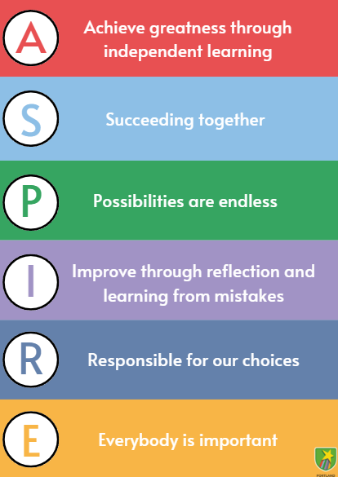
Portland Spencer Academy
Class Teacher (ECTs Welcome) EYFS/KS1/KS2
Start Date: 1st September 2025
Working Pattern: Full-Time
Salary: Main scale – ECTs are welcome
Duration: Fixed Term to August 2026
Closing Date: Friday 16th May 2025 at 9 00 am
Interview Date: Wednesday 21st May 2025
Portland Spencer Academy is an Ofsted ‘Outstanding’ school situated in Bilborough, Nottingham and we are looking for highly effective teachers to join our team.

We are incredibly proud of our aspirational school that believes every child can succeed and ASPIRE in all that they do. If you are looking to work in a school with children who want to achieve greatness, work alongside a team that succeeds together and engage in high quality CPD that shows possibilities are endless… Portland is the place for you.

Click here to read our termly newsletters to get a real sense of life in our wonderful school.

We are looking for someone who:

• Wants to teach children to the highest standard, who believes every child can succeed
• Wants to ensure our children feel happy, safe and loved whilst maintaining high expectations
• Wants to be part of a special team, who put children at the centre of every decision
• Want to continually develop themselves to be the very best version of themselves
If you are thinking ‘THAT’S ME!’ and doing a little dance, then we want to hear from you!
At Portland Spencer Academy we ASPIRE in all that we do, ensuring the very best for every child. Our children expect you to:

Always smile and listen to our ideas

Succeed in teaching and see potential in us

Praise us when we make good choices

Inspire us and include everyone

Respect us and other members of staff

Everyone should have fun!

Applications from ECTs are welcome and visits to school are highly encouraged. Show rounds with the Principal will take place on:
- Thursday 8th May at 15:45
- Monday 12th May at 15:45

If you’re interested in joining us for a show round, please email info@portlandspencer.org.uk or call 0115 9155747 to sign up for a show round. If you’re not able to attend these dates, different appointments could be arranged.

SAT is an educational charity, Multi-Academy Trust and Sponsor of Academies. We have approaching 18000 children and young people in our academies and employ more than 2800 teachers, leaders and educational support professionals across the East Midlands. We aspire to be a leading regional high performing Trust, with a national reputation for excellence.

We currently have 18 primary academies, 8 secondary academies and 1 primary aged special school in our family of schools. All of our schools benefit from the collaboration and added value that being a member of our Trust offers and share our values and beliefs. Spencer Trust academies share an ambition to deliver results that compete with the very highest performing schools in the country and deliver a curriculum for students that is underpinned by breadth, opportunity and quality: one that seeks to give young people the opportunity to develop into well rounded global citizens that believe they can influence positive change in the world.

Mission
Our Mission is to deliver the best possible outcomes for children and young people.

Vision
Spencer Academies Trust is an exceptional Trust, providing an outstanding education for local children.

We Believe:
- All children have a right to a quality education regardless of background or ability, and have an entitlement to the opportunity of a secure progression route in their learning and development.
- Schools are stronger when they work in collaboration with each other, operate within a ‘family’ and are open to a true sense of partnership.
- We grow the effectiveness and sustainability of our schools by developing the people within them, and that through shared and equitable responsibility for quality and outcomes; we achieve more.

Applicants would be expected to share the Trust’s high aspirations and expectations for pupils and staff.

If you would like to discuss the role, or have any queries, please contact Debbie Batterbee info@portlandspencer.org.uk

The Spencer Academies Trust Safer recruitment policy requires applications for this post must be submitted through our recruitment portal. CV’s cannot be accepted. We are also required to request references prior to interview.

Closing date for applications Friday 16th May 2025 at 9 00 am
Interviews will take place on Wednesday 21st May 2025
Early application is strongly encouraged as we reserve the right to interview and close the advert ahead of the closing date.

How to Apply
Applications are submitted through our Every Candidate Portal. If you are a new user to our portal, you can click on ‘Register’ to complete your candidate profile. If you already have a candidate profile with us, click on ‘Sign In’. Both of these routes allow you to feed your candidate information into any of our vacancies and view the status of your application.
If you want to apply directly for this role and not save your data for any future vacancies, you can click on the ‘Apply Now’ button at the bottom of this page.

We have added a video to help guide you through our portal, please visit https://vimeo.com/737845492/c1b8e43656

Spencer Academies Trust is committed to safeguarding and promoting the welfare of all our children and young people. Therefore, we expect everyone to share this commitment. All appointments are subject to satisfactory pre- employment checks, including a satisfactory Enhanced criminal records with Barred List Check through the Disclosure and Barring Service (DBS) and the completion of Level 2 Safeguarding training. It is an offence to apply for the role if an applicant is barred from engaging in regulated activity relevant to children (where the role involves this type of regulated activity).

The Trust and its member academies are committed to promoting equality and diversity in both employment and education provision. We aim to ensure that students, parents, governors, employees, contractors, partners, clients and other stakeholders within the Trust community are treated fairly, and with dignity and respect regardless of Protected Characteristics.
Spencer Academies Trust is a Disability Confident Committed Employer

