

**Todmorden High School**

Come join us! We champion our whole school values which are

**AMBITION, RESPECT, CARE AND HONESTY**



**Recruitment Information**

**January 2020**

**Our Vision**

**‘Enabling individuals to unlock their unique potential’**

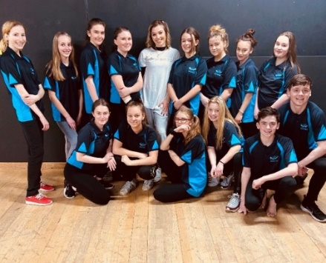



Dear Applicant

Many thanks for your interest in working at Todmorden High School. This covering letter conveys everything we are.

*We are a true community school engaged in a period of significant growth. We are located in the beautiful Todmorden valley. We’re a thriving comprehensive school for 11 to 16-year-olds, with close to 900 pupils and one hundred and twenty-five staff.*

We aim not only to foster a thriving climate for learning and teaching, but to provide the very best career opportunities for everyone; an environment where aspirations can be met and opportunities for personal development and growth remain a constant priority.

We are committed to creating a culture where all staff, at all levels, can feel proud of who we are, of our achievements and feel a sense of pride when they reflect on their individual contribution to our School development. All this in an environment where generosity and kindness can thrive. In keeping with our values, we strive to create a workplace that celebrates difference.

Ambition, Respect, Care and Honesty remain at the forefront everything we do, we are trusted to do the right thing for each other, our students and our wider community.

There are stimulating and rewarding times ahead at Todmorden High School and I very much look forward to sharing them with you.

I do hope you will consider coming with us.



**Gill Shirt**

**Headteacher**

***Workload and Wellbeing*** *is at the forefront of all we do.*

We consider the small things, the big things. We have an On-Site Honesty Shop stocked with every edible you may fancy, we offer a birthday card and present store, tea, coffee and milk for all and filtered water. We offer toast and juice for all students and staff every day (our own version of the magic breakfast) we champion ‘Buttie Friday’ where folk pay for a breakfast sandwich by way of donation, and we encourage bespoke CPD and developmental opportunities at every level and in every team in school - we believe in ‘growing our own’. As such, our staff retention rates are high – colleagues want to stay and develop, right here. There are opportunities for everyone who works hard. We regularly survey staff to understand what time we could give back. What meetings can we reduce? What unnecessary requests can we stop. We have an early closure on Fridays and restrict emails to between 7am-7pm. We have a Wellbeing ‘stay at home’ day in November.

*Staff Voice quote: ‘We encourage working in every formation possible, we know one size does not fit all. We endlessly support working families and champion worklife balance, we’re so much more than ‘just another school’*

*Staff Voice quote: ‘As a parent of a young child I value and appreciate the flexibility and support when I ask to attend sports days, assemblies, and make the time up. It really makes a difference’.*

***Professional Development*** *at THS*

We aim not only to foster a thriving climate for learning, but to provide the very best career opportunities for everyone in an environment where wellbeing for all is respected. It is an environment where aspirations can be met and opportunities for personal development and growth remain a constant priority. We are committed to creating a culture where all staff, at all levels, can feel proud of who we are, of our achievements and feel a sense of pride when they reflect on their individual contribution to our School development. All this in an environment where generosity and kindness can thrive. In keeping with our values of ***Ambition, Respect, Care and Honesty,*** we strive to create a workplace that celebrates difference. Somewhere we all feel responsible, valued, empowered and trusted to do the right thing for each other, our students and our community.

***Benefits*** *of working at THS*

We offer a variety of great benefits in a stunning countryside location.

* A generous auto-enrolment into an excellent pension scheme.
* Great local train links – Close to M65 / M62
* Senior Leader and Middle Leader development programme.
* Associate Assistant Headship opportunities.
* Wellbeing Support, a Wellbeing Committee and Occupational Therapy Inc. physio and counselling.
* Maternity, paternity, adoption and parental leave;
* Discounted membership of Calderdale Council Leisure Centres which allows both employees and their partners to use all the facilities of all 6 Centres and pools;
* Discounted Metro Travel Card for bus and rail travel;
* Cycle to Work Tax free bike scheme offering up to 40% off the cost of a bike and cycling equipment and designed to promote healthy travel to work and reduce environmental pollution;
* Bespoke CPD, access to whole school opportunities and a wide range of mentoring, learning and development.
* Nominations for Awards – Teacher of the Year
* Developing IT responding to Staff Voice
* Annual Garden Party and Community BBQ.

Todmorden High School is a popular and oversubscribed school. We are now looking to appoint an **outstanding Senior Leader** to our team. We seek to appoint colleagues who will inspire our young people in an environment that is supportive and aspirational. The successful candidate will work alongside an ambitious and talented leaders and teachers in a successful school, providing the vision and strategy within a forward looking environment, where wellbeing is championed and staff voice is strong. We are a good school, an oversubscribed school, set in the beautiful Todmorden valley, financially we are strong and we are embracing a period of significant change and growth. This is an excellent time to join our community.

As an outstanding practitioner within your own classroom, with a track record of successful leadership, you will be an applicant who champions our values of Ambition, Respect, Care and Honesty, a colleague who is loyal and is looking to come with us as we progress. We champion flexible working wherever possible and have many individual bespoke arrangements in place. There has never been a more exciting time to join a school which is open, innovative with high expectations for all.  You can have a real impact on the lives of the young people as well as developing your skills to be the best that you can be. Together, we unlock potential.

**Please follow us on Twitter to see more about who we are @todhigh**

***Our Colleagues***

Please see our website for more information regarding our colleagues and our roles. We have a section on our site detailing Senior Leadership, which sets out our team roles and our make-up.

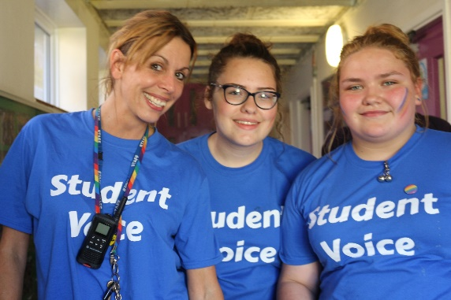 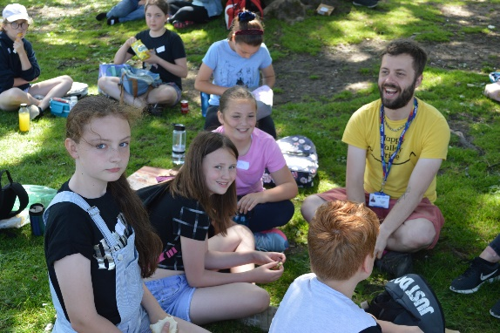

We would warmly welcome you to visit our school and take advantage of a tour. Tour 1 will take place on Wednesday 5 February and Tour 2 will be on Wednesday 12 February both from 12.00 till 1.00pm. Please contact our Office Manager via email; e.crossley@todhigh.co.uk to register for a tour.

Tours do not carry a weighting as regards the selection process, they are offered ahead of you submitting your application to help you understand the school.

**Interviews will take place on Tuesday 25 February and Wednesday 26 February.**

**TODMORDEN HIGH SCHOOL**

**JOB DESCRIPTION**

**Job Title: Assistant Headteacher**

**Raising Attainment in Core**

We particularly welcome applicants from Maths and Science specialists.

**Grade: L12 – L16**

***The Senior Team will evolve to meet the needs of the school. Roles and responsibilities are fluid.***

**Responsible To: Deputy Headteacher (Data and Curriculum)**

**Responsible for:** Heads of Faculty, Line management responsibility for identified middle leaders

**Main purpose of the post**

* To support the Headteacher in the strategic leadership of the school to ensure the continuing improvement, success and high standards of all students.
* To strategically lead the direction and development of the school, in accordance with the ethos and vision of the school, within specific areas of responsibility.
* Taking responsibility and accountability of areas of the School Development Plan, leading on specific areas through innovative strategies and ways of working.
* Establishing systems and protocols for Quality Assurance, evaluation and monitoring.
* Leading a team/teams of people, creating a culture of high expectation, self-review and continuous improvement.
* Developing and enhancing the teaching performance of others.
* Contribute to school improvement plans, strategies for improvement (pace and challenge) whilst reviewing and monitoring systems.

**Key Responsibilities – all School Leaders**

* Lead and contribute to an ethos in the school where every student is valued and given opportunities to maximise their development both educationally and personally.
* Lead and develop outstanding behaviours for learning across all areas of the school so that engagement levels are extremely high and learning experiences are excellent.
* Drive up educational standards, promote lifelong learning and continually improve outcomes for all.
* Strategic responsibility for a whole school initiative or area of learning.
* To ensure full implementation of the school’s Learning and Teaching Policy and play a lead role in modelling, training, communicating and developing this.
* To lead and line manage a team/teams of staff – teaching and associate staff.
* To promote and develop the school curriculum, quality assurance, pastoral and community engagement strategies.
* To be the senior leadership link for a curriculum faculty.
* Be a visible, proactive presence around the school, promoting positive behaviour and ensuring the smooth day-to-day running of the school.
* Reinforce and model the school’s values and behaviours.
* Coach and develop the staff and students for which they are accountable.

**Specific Responsibilities**

*These will be discussed with the post holder and will be relevant to their area(s) of specialism.*

**Leading teaching and learning**

* Be an excellent role model to all teaching and learning staff within the school and reflect a high level of professional teaching standards.
* Demonstrate and articulate high expectations and set stretching targets for the whole school.
* Lead staff development across the school and monitor, evaluate and review the effectiveness of the school professional development programme.
* Lead and coordinate regular staff CPD sessions, designed to provide personalised, faculty/subject-based and whole school staff development.
* Monitor, evaluate and review schemes of learning across the school.
* Monitor, evaluate and review classroom practice and manage improvement strategies, including developing quality assurance systems.
* Monitor, evaluate and review Home Learning across the school.
* Lead on the coaching and mentoring programme in the school.

**Data and Assessment**

* Analyse and interpret school data to inform intervention and improvement strategies across the school.
* Evaluate the performance data provided and take appropriate action on issues arising - setting realistic deadlines where necessary and reviewing progress on the action taken.
* Ensure appropriate schemes of learning are in place and that they meet the academic needs of all students.
* Monitor the quality of achievement through Data Sweeps and assessment moderation.
* Provide all relevant bodies with robust information relating to the school’s performance and development.
* Lead and monitor on the impact of intervention and mentoring strategies.

**Curriculum Development**

* Take a lead role in developing a modern, innovative, balanced and exciting curriculum to raise aspiration and achievement.
* Create structures to ensure that teaching and learning is innovative and of a high quality throughout the school.
* Establish and develop relevant provision to grow successful 14-16 pathways.
* Contribute to the development of a programme of enrichment extending the school experience beyond the limits of the formal school day.

**Developing self and working with others**

* Manage positive working relationships with all staff.
* Motivate and challenge all staff to maintain high expectations of behaviours throughout the school.
* Develop and maintain effective strategies and procedures for staff induction, professional development and performance review.
* Support the school’s ITT, NQT and RQT programmes of staff development.
* Oversee the Performance Management Reviews of school staff.
* Participate in the interview process for teaching posts when required and ensure effective induction of new staff in line with school procedures.
* Support development in learning and teaching within and across curriculum areas through CPD, monitoring and review.
* Support colleagues to be successful in their own leadership role through mentoring, coaching and line management.

**Shaping the future**

* Ensure the vision for the school is clearly articulated, shared, understood and acted upon effectively by all, particularly in the area of teaching and learning, staff development and pastoral systems.
* Motivate and work with others to create a shared culture and positive climate in areas of responsibility.
* Work with individual staff and teams to translate the school vision into agreed objectives and operational plans which will promote and sustain school improvement in areas of teaching and learning, staff development and pastoral systems.

**Managing and promoting the organisation**

* Recruit, retain and deploy staff appropriately.
* Implement evidence-based improvement plans and policies for the school.
* Manage budgets, as appropriate.
* Contribute to the development of effective links with partner schools and the community; attendance where necessary at liaison events in partner schools and the effective promotion of subjects at Open Days/Evenings and other events.
* Ensure effective communication/consultation, as appropriate, with the parents of students and other relevant stakeholders.
* Liaise with partner schools, Higher Education Institutions, industrial links, governors and other relevant external bodies.
* Actively promote the development of effective links with external agencies.
* Act with integrity and a high level of professionalism in all situations.

**Securing accountability**

* Manage staff roles and ensure that responsibilities are clearly defined, understood and agreed.
* Work with the Governing Body or Governing Body sub-committees to enable them to meet their statutory responsibilities.
* Be able to present the school’s performance and other school initiatives to a range of audiences; parents, governors, and other external agencies.

**Strengthening the community**

* Work with other agencies to ensure learning experiences and opportunities for students are integrated into the wider community.
* Build the reputation of the school with the outside community.
* Create and maintain partnerships with parents and carers to support and improve students’ achievement and personal development.

**Child Protection and Safeguarding**

* Ensure that the child protection policies and procedures adopted by the Governing Body are fully implemented and followed by all staff.
* Ensure that sufficient resources and time are allocated to enable staff to discharge their Child Protection related responsibilities effectively.

**Our Policies**

The post holder will fully support and champion, Safeguarding, Child Protection, Equality and Diversity and the Prevent agenda at all times, as appropriate.

**NOTES**

All senior leaders will have generic responsibilities, and a ‘hands-on’ role in the day-to-day leadership and management of the school. This job description allocates duties and responsibilities but does not direct the amount of time to be spent carrying each of them out. Employees will be expected to comply with any reasonable request from the Headteacher to undertake work of a similar level that is not specified in this job description

This job description is current at the date shown. In consultation with you, it may be changed by the Headteacher to reflect or anticipate changes in the job commensurate with the grade and job title.

**Signed: ___________________________________**

**Date: ____________________________________**

**Person Specification**

**Qualification Criteria**

1. Educated to degree level.
2. Qualified Teacher Status.
3. Evidence of relevant and recent CPD.

**General – Experience of:**

1. Working, with evidence of strong impact, at senior/middle leadership level in a secondary setting.
2. Whole School activity (lead role in/experience of)
3. Delivering highly effective staff training and overseeing the professional development of both individuals and teams of staff.
4. Highly effective classroom teaching practice, which has consistently secured excellent student outcomes.
5. SIMS or other equivalent Management Information Systems.
6. Working effectively with external stakeholders.
7. Successfully leading on and being held accountable for whole school initiatives.
8. Dealing with challenging students and parents to help secure excellent outcomes, underpinned by a complete commitment to inclusive education.
9. Implementing highly effective Behaviour for Learning systems.
10. Working successfully with a variety of external agencies / stakeholders

**Leadership and Management – the ability to demonstrate:**

1. An effective leadership style that inspires confidence and collegiality in those they lead, which motivates and encourages others to participate and to ‘go the extra mile’.
2. Versatility and flexibility in own leadership style. To be aware of different leadership styles and in which circumstances it is appropriate to adopt and blend alternative approach.
3. Initiating, leading and managing change programmes.
4. Strong organisational skills and effective time management skills.
5. Delegation, and effectively directing and coordinating the work of others.
6. The ability to prioritise effectively.
7. The emotional resilience and motivation to lead the school through day-to-day challenges whilst maintaining a clear strategic vision, staying positive, and focusing on key priorities.
8. Genuine passion and belief in the potential of every student to make outstanding progress and secure excellent outcomes irrespective of their background and/or prior academic attainment.
9. Strategic thinking and the potential to adopt innovative approaches to the role.
10. Making well informed decisions based on analysis, interpretation and understanding of relevant data and information.
11. An educational vision aligned with the school’s high aspirations and high expectations of themselves and others.
12. Skilful management and maintenance of strong working relationships with parents and other key stakeholders.
13. The skills required to lead, coach and motivate staff within a performance management framework, including professional development and effective leadership and management of underperformance.
14. Up to date knowledge of educational changes at both national and local level.

**Data, Assessment and Evaluation – Experience of:**

1. Using data to inform effective planning, recommendations and intervention.
2. Interpreting data, using it to diagnose weaknesses that need addressing and helping other staff to act on this.
3. Leading intervention programmes at faculty / department / year group / whole school / pastoral level that have had a proven and sustained impact on outcomes.
4. Effective monitoring and evaluation procedures, which highlight key strengths and areas for development.

**Staff Development – Experience of:**

* Understanding what outstanding engagement in learning looks like, identifying areas for improvement and planning training, support and monitoring with staff and students.
* Conducting performance management meetings, lesson observations and providing feedback to staff.
* Contributing to staff development.
* A commitment to an open and collaborative style of leadership and management.
* Dealing sensitively with people, with particular reference to conflict resolution.

**Communication – the ability to demonstrate:**

1. Outstanding interpersonal, written and oral communication skills.
2. Confidence and effective presentational skills during public speaking, including assemblies and addresses at events such as Open Evening.
3. The ability to negotiate and consult fairly and effectively, in a timely manner.
4. Different methods of consulting with variety of stakeholders.

**Personal Qualities**

1. Resilience, emotional intelligence and perspective.
2. Reliability, integrity and stamina.
3. The ability to think creatively and imaginatively to anticipate, identify and solve problems.
4. Intellectual ability and curiosity.
5. Vision, imagination and creativity.
6. Sees working with young people and their families as a vocation.
7. Ability to inspire and maintain confidence in and from others.
8. Ensuring equal opportunities for staff, students and other stakeholders.
9. Adaptability to changing circumstances.

*We are an aware employer, we are committed to safeguarding and protecting the welfare of children and vulnerable adults as its number one priority. This commitment to robust recruitment, selection and induction procedures extends to all organisations and services linked to the school.*

**This post is subject to and enhanced DBS disclosure and associated checks.**

**The post-holder must be committed to safeguarding the welfare of children.**