

Candidate information Pack

Closing date for applications Midnight Sunday 27th July 2025

Early applications are encouraged, and the school reserves the right to close the application process early should a suitable candidate be found.

Apprentice Carpenter



**ABOUT THE WORKS DEPARTMENT**

Winchester College has an exciting opportunity to appoint an Apprentice Carpenter starting in September 2025.

The school has in its care an extraordinary range of buildings from chapels and classrooms to a swimming pool and science laboratories; from the fourteenth century to the twenty-first. The list embraces 11 Boarding Houses and over 100 staff houses.

This built environment is maintained and improved by the Works Department. Under the direction of the Estate Bursar, who also manages the capital projects, The Works Manager has a staff of around 30 operatives and is supported by various office staff.

Members of staff have a great affection for the school and 18 of its number have worked here in excess of 10 years. Combined with this affection, their exemplary skills produce a comprehensive and reliable service to the school community.

The department operates out of a new purpose-built facility in Norman Road.





**ROLE AND RESPONSIBLITIES OF THE APPRENTICE CARPENTER**

**Key Responsibilities**

The main purpose of the role is:

* To develop the practical skills of carpentry, in association with an appropriate apprentice training course.
* To support our existing team in carrying out carpentry work required in the maintenance, improvement and alteration of the College’s varied building stock.
* Be part of a small team of carpenters within a busy Works Department under the supervision of the Lead Carpenter. The mentor and immediate supervisor will be the Lead Carpenter, working under the direction of the Works Manager.
* In order to support the departments wide ranging duties, the apprentice carpenter will require a willingness to work beyond own trade.

The successful applicant must be an enthusiastic and hardworking individual, who is prepared to make the very best of this opportunity to develop the skills of a Carpenter. The successful candidate must fulfil all requirements to attend a relevant plumbing course at a College of Further Education. A clear aptitude for this skill must have been demonstrated.

Candidates should be aware of the physical nature of the position, and the requirement to work under all weather conditions, working at heights will also be required once training has been given.

**PERSON SPECIFICATION AND KEY QUALITIES**

The successful applicant must be an enthusiastic and hardworking individual, who is prepared to make the very best of this opportunity to develop the skills of a Carpenter. The successful candidate must fulfil all requirements to attend a relevant carpentry course at a College of Further Education. A clear aptitude for this skill must have been demonstrated. Candidates should be aware of the physical nature of the position, and the requirement to work under all weather conditions, working at heights will also be required once training has been given.



### **Terms and Conditions**

**Start date**

September 2025.

**Hours of Work**

This position is fixed term, initially for a 42-month period. 40 hours per week, 52 weeks of the year. Monday-Friday with the addition of some evening and weekend requirements.

**Salary**

The salary for this position is £22,900.55 (gross) per annum depending on qualifications and experience. Salary is paid monthly, in arrears, to a nominated back account in 12 equal payments. Salary levels are reviewed on 1 September annually and this appointment will be next reviewed in September 2026.

**Holidays**

The College leave year runs from 1 September to 31 August. This position will be entitled to the statutory holiday requirements. These are presently 28 days, including Bank Holidays. Any Public Bank Holiday occurring during term time is deemed to be a normal working day. All leave must be taken by prior arrangement with the postholder’s line-manager and must be taken outside of the school’s term times.

**Probation and Notice Periods**

The first six working months of employment will be a probationary period. During this time, conduct and performance will be reviewed. The College may extend the probationary period if it is deemed to be required. During the probationary period the notice required to terminate employment will be one month (by either the employee or employer). Once employment is confirmed, the notice period will increase to three months.

**Induction and Continuous Training and Development**

The school is fully committed to the induction, training and development of all our staff, with staff supported to grow and reach their full potential.

We deliver a range of training, run by both our own staff and external providers, varying from highly practical First Aid courses to seminars and learning lunches.

There is an annual cycle of appraisal offering the opportunity to reflect on professional practice and development opportunities.

The school also offers a wide range of apprenticeships supporting staff development and progression.

**Pension and Life Cover**

On employment, employees will be auto-enrolled into the College’s pension scheme according to legislative thresholds. Those who are not eligible for auto-enrolment may still elect to join the College’s pension scheme.

Initially, when joining the College’s pension scheme, employees will become a member of the College’s Group Personal Pension Plan (GPP). For this Plan, known as Tier 1, the employee contributes 5% and the employer 3%.

After 9 month’s membership of the Tier 1 plan, employees may opt to join Tier 2, which is also a GPP, where the employee contributes 5% and the employer 9%.

Employees in Tier 1 automatically qualify for a Life Cover of 2 times salary. On entry to Tier 2, Life Cover changes to 4 times salary.

**Wider Benefits**

* Free staff lunches during term time
* Free use of some sports facilities and discounted hire charges for others
* Tour of the College, with discounted rates available for booking venues within the school’s grounds for hospitality events.
* Cycle to work scheme
* Access to a rich programme of cultural, musical, theatrical and sporting talks and events
* Employee Referral Scheme, with a reward of up to £250 for staff (subject to scheme conditions)
* Free Library membership with access to a range of online journals and magazines.
* Reduced green fee rates for local golf course

**Enhanced Disclosure Check**

As Winchester College is an educational establishment, a condition of employment will be that the successful candidate must consent to the school obtaining an Enhanced Level Disclosure Check through the Disclosure and Barring Service (DBS). This will reveal all spent and unspent convictions, warnings, cautions and bind-overs. A policy on the recruitment of ex-offenders is available on the school’s website.

Safeguarding is one of the primary responsibilities of this role. The jobholder is responsible for promoting and safeguarding the welfare of children and young persons for whom they are responsible, or with whom they come into contact with, and will need to adhere to and ensure compliance with the school’s [Child Protection and Safeguarding Policy](https://www.winchestercollege.org/assets/files/uploads/child-protection-and-safeguarding-policy-september-2024.pdf) at all times. The postholder should be conversant with the responsibilities and procedures detailed in this policy and with the [Department for Education’s Keeping Children Safe in Education](https://assets.publishing.service.gov.uk/media/66d7301b9084b18b95709f75/Keeping_children_safe_in_education_2024.pdf). If, in the course of carrying out the duties of the post, the postholder becomes aware of any actual or potential risks to the safety or welfare of children in the school, they must report any concerns to the school’s Designated Safeguarding Lead, or in their absence, the Deputy Designated Safeguarding Leads.

**References and Other Pre-employment Checks**

The appointment will be dependent upon the receipt of a successful medical check and satisfactory references. The College will usually seek references from shortlisted candidates before interview and may approach previous employers for information to verify particular experience or qualifications. At least one referee must be the current or most recent employer. Where applicants are not currently working with children but have done so in the past, one referee must be the person by whom they were most recently employed when working with children.

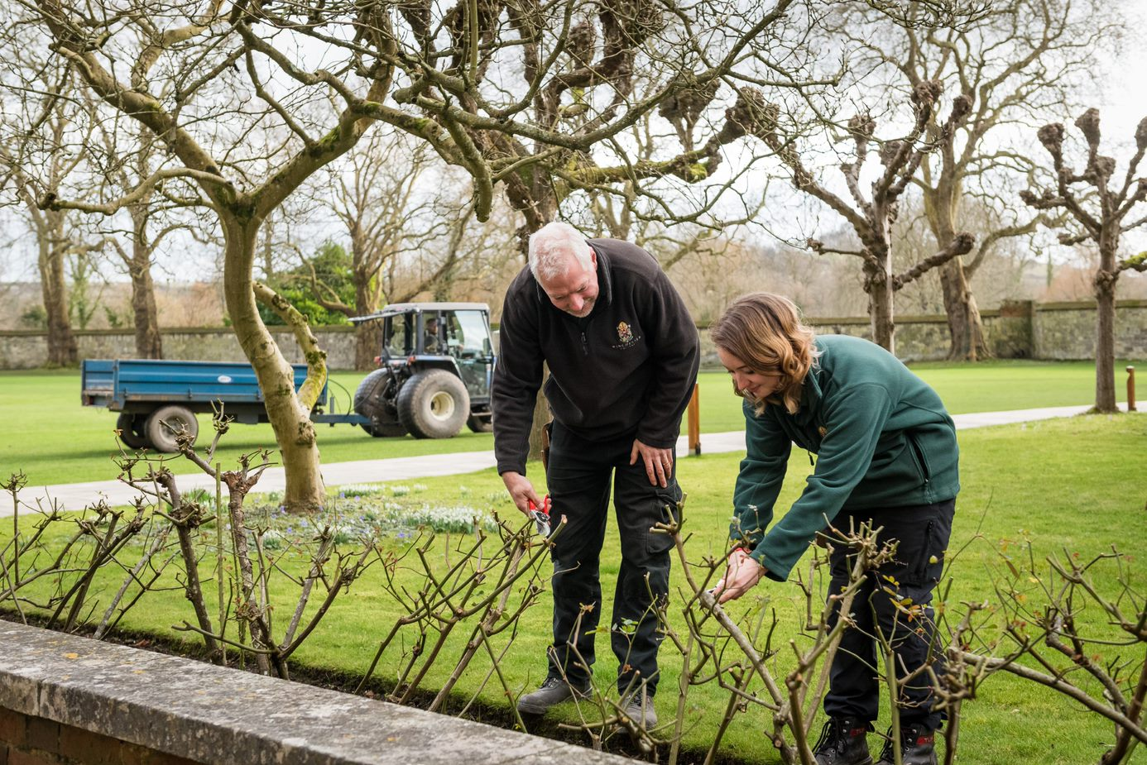

# 

**How to Apply**

If you have any questions about this vacancy or the recruitment process, please email [recruitment@wincoll.ac.uk](mailto:recruitment@wincoll.ac.uk).

Only applications completed on the school website will be accepted.

Closing date for applications: **Midnight Sunday 27th July 2025**

Please note that applications will be dealt with as they arrive. Winchester College reserves the right to appoint prior to the closing date.

Those wishing for an informal conversation about this role are invited to contact Paul Legg, Contracts Manager, [pl@wincoll.ac.uk](mailto:pl@wincoll.ac.uk) .

[**APPLY HERE**](https://www.winchestercollege.org/employment-opportunities/my-application/vacancy/2107613liH)

Further information about the school can be found at [www.winchestercollege.org](http://www.winchestercollege.org).

**Data Protection**

Winchester College collects and processes relevant personal data as part of its everyday operations and is obliged to process it in accordance with the General Data Protection Regulation and Data Act 2018. The school is the Data Controller of this data under the Act and is registered with the Information Commissioner's Office. Its registration number is Z5751669.

If you have any queries or comments about this policy or how personal data is processed by the school, please contact the Bursar and his team by emailing: [dataprotection@wincoll.ac.uk](mailto:dataprotection@wincoll.ac.uk) or by writing to: Data Protection, The Bursary, Winchester College, College Street, Winchester, SO23 9NA.



**About Winchester College**

Winchester College was a pioneering institution when it was founded in 1382 and continues to be a global leader in education today. Renowned for its intellectual excellence and impressive academic record, Winchester is sought after for its combination of superb teaching, outstanding pastoral care, and an exceptional breadth of sports and other activities.

Winchester currently has 735 pupils from Junior Part (Year 9) to Sixth Book (Years 12 and 13). The majority of these pupils are boarders, with around day pupils (boys and girls) in each year in Sixth Book. The first girl boarders will join in 2026.

At all levels Winchester encourages pupils to look beyond the curriculum. We are famous for Div, our unique programme of cultural studies which promotes independence and flexibility of mind and offers an excellent preparation for university study. In these lessons, pupils engage in wide-ranging inquiry across disciplinary lines, from English Literature to Ancient History to the History of Science.

Pupils in the Sixth Form study linear A-level courses and will ordinarily study three A-level subjects and Div, with the option of Extended Project Qualification (EPQ). Linear A-levels are complemented by the flexibility of both Div and the EPQ where pupils are able to explore their cross-curricular research interests more deeply.

Music has been central to life at Winchester ever since its foundation, and the school is unique in having maintained its Choral Foundation to the present day. The Music Department is now one of the leading departments in the country and offers outstanding opportunities to all.

Sport is a major part of Winchester life, supported by the recent opening of a state-of-the-art Sports Centre. There are many fixtures against other schools and excellent facilities allow all pupils to enjoy and participate in a variety of sports and enable the most talented and driven pupils to train and compete at the highest level.

Much energy is also invested in the Combined Cadet Force, the Duke of Edinburgh Award Scheme, Community Service, and in links with local primary and secondary maintained schools. This commitment provides pupils with many opportunities to work for the benefit of others, inside and outside the classroom, developing the knowledge and skills, and the rights and responsibilities, which will enable them to grow into valuable and productive members of society.

Pupils eat all meals in their boarding houses, talking with their Housemaster/mistress, and interacting with friends, visitors and teachers. We believe that conversational ability, developed both inside and outside the community, equips pupils to talk to anyone, about anything, in practically any situation. This unparalleled combination attracts pupils from across the world, making Winchester a truly international and diverse community which celebrates every pupil’s individuality, passions and potential.

Winchester College is committed to maintaining the Founder’s original intention of offering an outstanding education to any pupil who would benefit from it, regardless of their financial circumstances, and many of the pupils in the College are being helped financially through the school with substantial bursaries.

Winchester College is committed to providing a respectful and inclusive workplace and a fair and supportive environment for all. We attract staff with a diverse range of backgrounds, experiences and perspectives, and we work hard to recruit from the widest possible pool of talent, believing that this is for the benefit of our pupils and every member of our community.

**Sustainability**: You can learn more about our goal of creating a more sustainable school [here](https://www.winchestercollege.org/stories/a-more-sustainable-school).

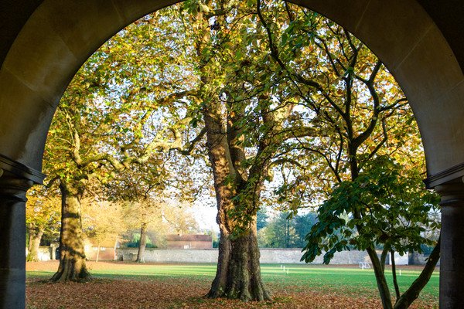





Twitter: [@WinColl](https://twitter.com/WinColl) Winchester College

Instagram: [@winchestercollege](https://www.instagram.com/winchestercollege/?hl=en) College Street

Winchester

SO23 9NA