Teacher of Geography
The Bulwell Academy
September 2019

Welcome
Thank you for showing an interest in becoming part of our team at The Bulwell Academy.
The Bulwell Academy joined The Creative Education Trust, an education charity and multi-academy trust that exists to empower young people with the skills, knowledge and creativity they need to be successful in school and in life, in May 2018, beginning a new era of education for students in Bulwell.
The school serves the families in and around Bulwell, Nottingham and is growing in popularity and is currently oversubscribed in Years 7, 8 and 9.
Expect the Best
“We want only the best for our students and we will go above and beyond to ensure that is the case”
Our vision is based on the belief that everyone can achieve. We want and expect only the best for our students and we will go above and beyond to ensure that is the case. We believe every child is unique and can be successful and we have high expectations of all. The education opportunities provided allow every child to make the best possible progress whilst at The Bulwell Academy, preparing them well for the next stage of their life.
Our staff are determined to demonstrate that there are no barriers to learning and that all young people can be successful in their own way, regardless of their background. We consistently strive to help our students to become better learners; to increase their resilience and to raise their aspirations.
We are looking for ambitious staff who will lead by example. We expect all staff to be leaders, whether within their own classroom or within the leadership structure of the school. We expect staff to show an uncompromisingly high drive to succeed and the focus of all staff must be on the relentless desire to improve Teaching and Learning.
Whether it’s progressing on to a great university, securing an apprenticeship, or entering the workplace, we want every young person who leaves The Bulwell Academy to have real choices in life. Staff from The Bulwell Academy regularly have the opportunity to work together with others across the trust, to share ideas and best practice, to collaborate, seek advice and to learn from each other. Students also get the opportunity to meet, compete, learn and collaborate with students from other schools including on our Days of Performance, Days of Sport and Days of Song.
If you think you have the qualities to help us achieve our vision, we look forward to your application.

Michelle Strong
Principal

- Raise their attainment in exams and tests through outstanding teaching
- Make them intellectually curious with a sense of confidence
- Increase their participation in HE, FE and apprenticeships
- Ensure they have employable skills and attitudes
- Create rounded individuals through a wide choice of co-curricular activities
ABOUT
CREATIVE
EDUCATION
TRUST

Creative Education Trust inspires and enables young people to build successful lives on foundations of learning, resilience and employability. We believe that a rewarding educational experience and the highest possible qualifications are the best way to ensure social mobility for young people.
Creative Education Trust is a growing multi-academy trust educating over 13,000 children in England. It was established in 2010 to work in England’s post-industrial cities and coastal towns: areas of economic disadvantage and with a history of academic underachievement. We transform these schools by integrating a knowledge-rich curriculum with skills and creativity.
Creative Education Trust defines creativity as the ability to find connections between the things we know and turn these connections into new ideas and action. The academic arts and the sciences, practical subjects and life skills all need this creativity, and creativity is valued highly by employers. Our staff and expert advisers use imaginative methods for linking knowledge across subject boundaries, fostering personal development and resilience and developing practical skills that prepare
students for their transition to adult life and employment.
Educational rigour
Organisational effectiveness
Financial efficiency
Partnership & recognition of local identity
Respect for autonomous leadership
Quality not quantity
Promoting practical creativity
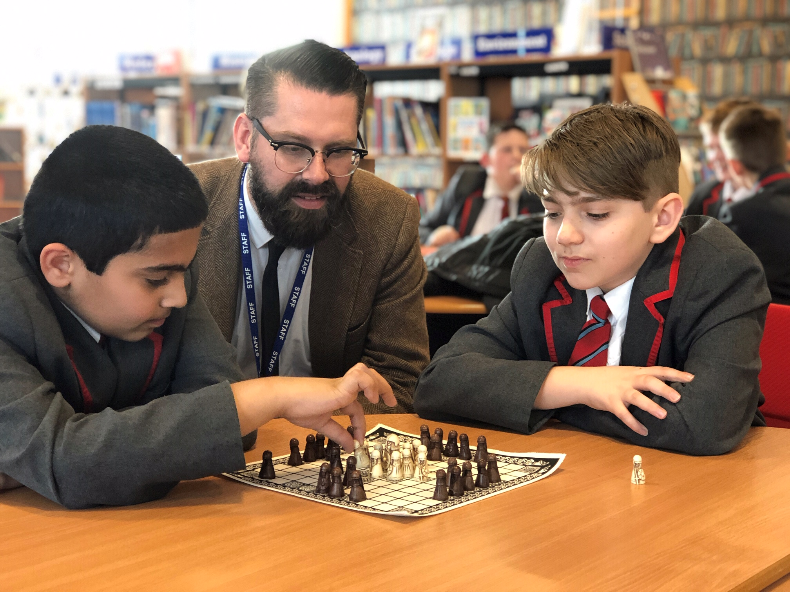

- Improving exam outcomes at KS4

- A small and unique Post 16 provision which is resulting in outstanding outcomes for students at KS5

- In September 2019 we will be oversubscribed in years 7 – 10, with a waiting list in years 7 & 8.

ABOUT
THE BULWELL
ACADEMY

We are a mixed secondary school, catering for children between the ages of 11 and 18 years and located in Bulwell, an area in the north of Nottingham City.

Since May 2018 we have been part of the Creative Education Trust. This is enabling the school to rigorously pursue rapid improvement for the children we teach.

The school boasts many facilities and we strive to provide an inclusive and expansive education for all the children in our care.

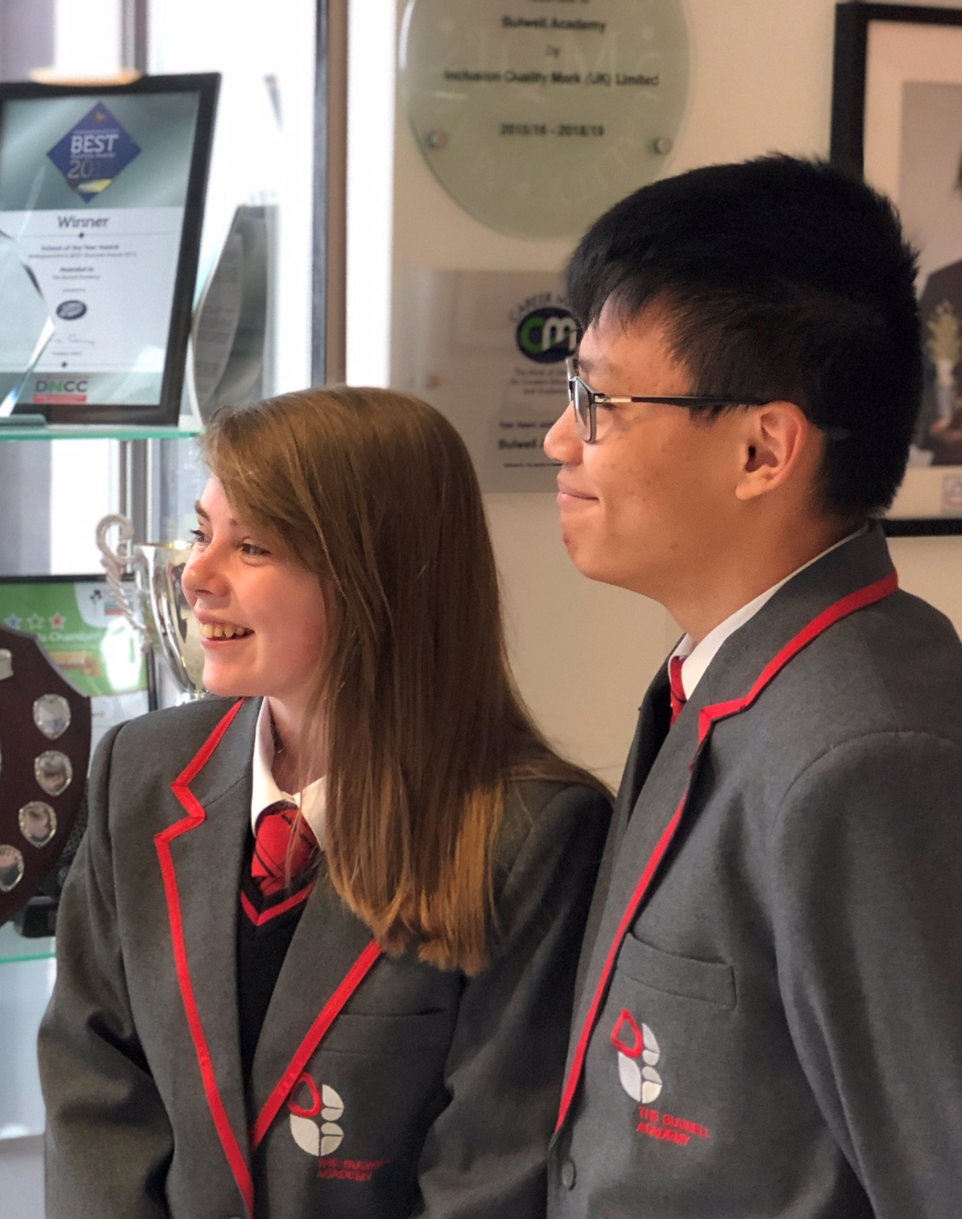
Our on-site facilities include:
- Sports facilities including astro turf pitches;
- Multi-Use Sports Hall;
- Hair dressing salon;
- Dance studio complete with sound system and mirrored wall;
- Hall complete with tiered seating;
- Interactive whiteboards in every classroom;

- Computer suites in most teaching areas;
- Modern library with wide range of reading materials

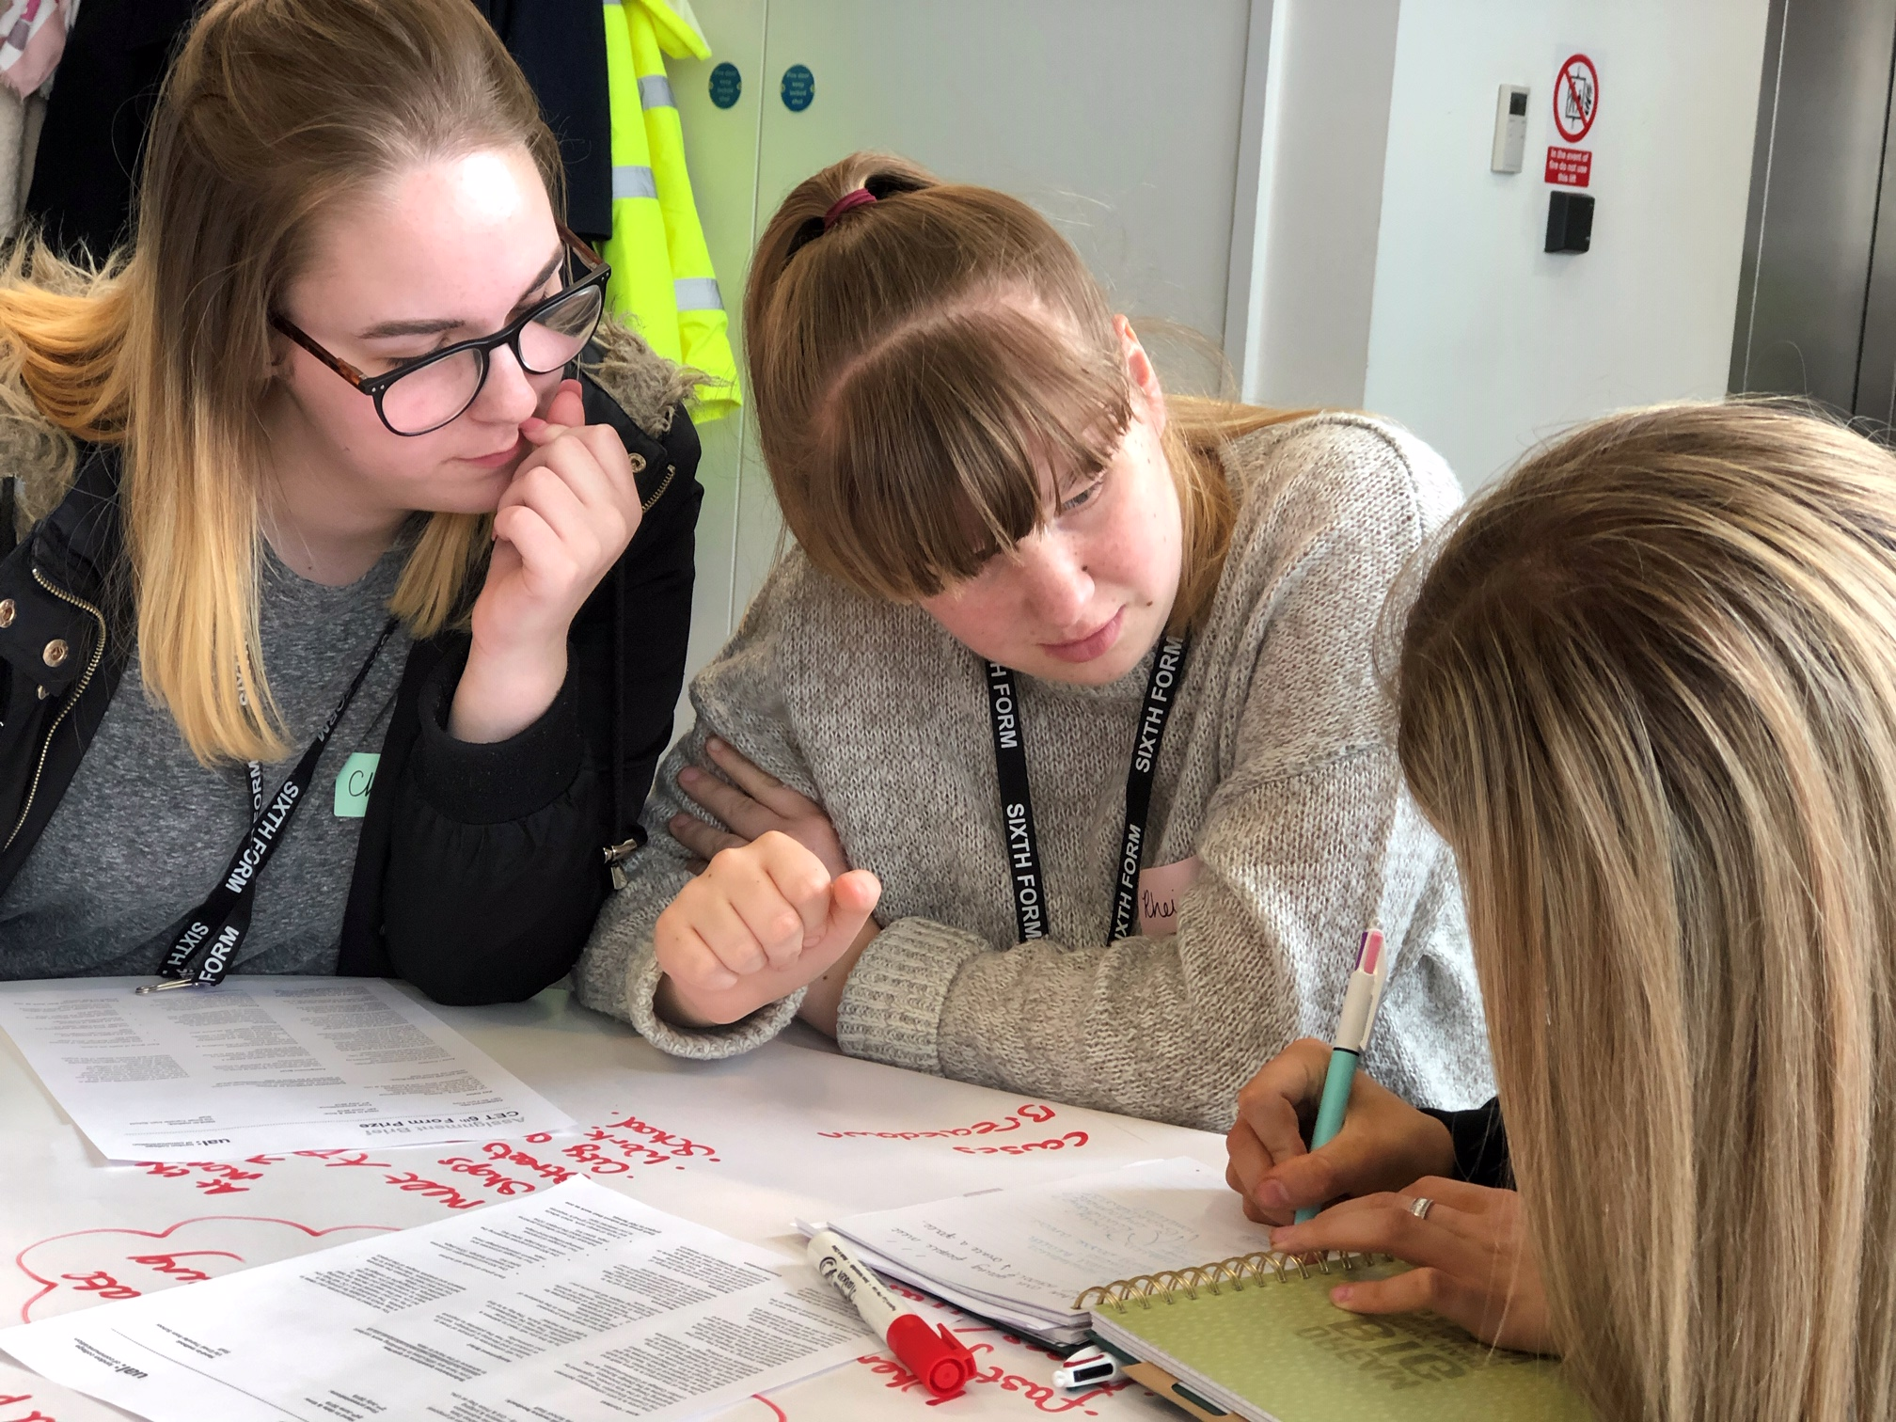

SUPPORT
FOR OUR
STAFF

For our students to achieve their full potential we know that it is essential
that our staff thrive professionally. We value hard work and provide
ample opportunities for all our teachers to work collaboratively with
their colleagues.

As a school, we expect the best and firmly believe that we never stop learning.
We share ideas and good practice regularly and encourage everyone to contribute
to the professional development programme. We are supportive of new ideas
and approaches, and eager for individuals to develop their
professional practice in line with their career goals. All staff are openly
encouraged to take responsibility for furthering their own professional
development and opportunities regularly arise for promotion.

We recognise the value and importance of working with other schools in our trust and beyond and all staff at The Bulwell Academy benefit from visiting other schools and learning from them. Our middle leaders are benefitting from their participation in the Ambition School Leadership Teaching Leaders Programme and some have embarked on NPQ qualifications.

Newly qualified teachers at The Bulwell Academy will benefit from high quality mentoring and access to a customised induction course designed specifically to smooth their progress through the NQT year.

We are keen to welcome teachers at any stage of their career and can offer them a comprehensive programme of support and challenge

TEACHER OF GEOGRAPHY
JOB DESCRIPTION AND PERSON SPECIFICATION

LOCATION
The Bulwell Academy, Bulwell, Nottingham

SALARY
MPS/UPS

THE ROLE
The teacher of Geography will plan and deliver high quality lessons so that all students achieve their potential

REPORTING LINES
The post will report to the Academy Improvement Leader for Humanities

STRATEGIC DIRECTION AND DEVELOPMENT

- Promote and uphold the values and ethos of Creative Education Trust in the school, such that the highest achievements are expected from all members of the school community.

- Contribute to the development of a successful team

TEACHING AND LEARNING

- Plan and prepare effective teaching modules and lessons using the Academy templates.

- Teach engaging and effective lessons that motivate, inspire and improve pupil attainment.

- Use regular and rigorous assessments to set targets for pupils, monitor pupil progress and respond accordingly to the results of such monitoring, ensuring that all students achieve at least national progress.

- Produce and/or contribute to oral and written assessments, reports and references relating to individual and groups of pupils.

- Mark, assess and provide feedback in line with best practice and academy policy at all times, ensuring that assessment for learning is embedded in all teaching so that students understand fully what they need to do to make the best possible progress.

- Monitor, evaluate and review classroom practice; celebrate and promote excellence, challenge under-performance at all levels and ensure
appropriate action is taken in accordance with policies and procedures.

- Maintain regular and productive communication with parents, to report on progress, sanctions and rewards and all other communications.

- Direct and supervise support staff assigned to lessons.

- Actively support and participate in the Academy’s extra-curriculum programme by assisting with a range of enrichment and extension activities, as well as departmental trips and visits.

ACADEMY CULTURE

- Support the Academy’s values and ethos by contributing to the development and implementation of policies practices and procedures.

- Help create a strong academy community, characterised by consistent, orderly behaviour and respectful relationships.

- Help develop a school/department culture and ethos that is committed to ensuring that students achieve.

- Be active in issues of pupil welfare and support.

- Implement and adhere to the Academy’s behaviour management policy, ensuring the health and wellbeing of students is maintained at all times.

OTHER RESPONSIBILITIES

- Be a form tutor, caring for the students’ academic and pastoral development

- Register students, accompany them to assemblies, encourage their full attendance at all lessons and their participation in other aspects of school life.

- Supervise students in accordance with published Academy rotas.

- Attend subject/year team/achievement meetings as relevant

- Support Academy policy in the delivery of some cross-curricular areas of PSHCE and citizenship and enterprise

- To take an equitable part in the cover system of the school according to policy and regulations.

- Undertake, and when required deliver or be part of, appraisals and relevant professional development.

- To undertake as required other duties and responsibilities relevant to the job or the seniority of the post as directed by the Principal.

 | ESSENTIAL | DESIRABLE
QUALIFICATIONS | Appropriate Qualified Teacher Status  Recent and Relevant CPD | Masters level degree
EXPERIENCE | Successful experience of teaching at Key Stage 3 and 4 | Experience of teaching at Key Stage 5
KNOWLEDGE AND  UNDERSTANDING | - Demonstrable experience of improving student progress in a challenging classroom environment.  - Experience of reflecting on an improving teaching practice to increase student achievement  - Evidence of continually improving the teaching and learning of their subject through schemes of work and extra-curricular activities  - Knowledge and experience of a range of successful teaching and learning strategies and interventions to meet the needs of all students  - Understanding of the characteristics of an effective learning environment and the key elements of successful behaviour management  - Up to date subject knowledge
SKILLS AND  PERSONAL  ATTRIBUTES | Excellent classroom teacher with the ability to reflect on lessons and continually improve their own practice  Effective and systematic behaviour management, with clear boundaries, sanctions, praise and rewards  Thinks strategically about classroom practice and tailoring  Understands and interprets complex student data to drive lesson planning and student attainment  Good communication, planning and organisational skills  Demonstrates resilience, motivation and commitment to driving up standards of achievement  Acts as a role model to staff and students
EQUAL  OPPORTUNITIES | A demonstrable commitment to supporting and promoting safeguarding, student welfare, equality and diversity
SAFEGUARDING | A thorough understanding of up-to-date safeguarding requirements and best practice
OTHER  REQUIREMENTS | High expectations for every pupil and a proven track record of making a difference to the learning and experiences of pupils inside and outside the classroom.

Creative Education Trust is committed to safeguarding and promoting the welfare of our children and young people and expects all staff and volunteers to share this commitment. The successful applicant will be required to undertake relevant safeguarding checks in line with Government safer recruitment guideline

