Technology Faculty

The faculty is broken down into a number of departments which include Product Design, Graphics, Electronics, Food & Catering, Child Development, Health & Social Care, Textiles & Fashion & ICT.

Staff are as follows:
Mr C Forbes – Head of Faculty
Mrs M Williams – Subject Leader for ICT
Mr K Brooks – Subject Leader for Product Design and Assistant Head of Year
Mrs G Colby – Subject Leader for Food and Hospitality
Mrs L Hartley – Subject Leader for Child Development and Health & Social Care
Mrs K Lang – Subject Leader for Fashion & Textiles
Mrs C Crowther – Teacher of Child Development and Health & Social Care
Mrs C Fowler – Teacher of ICT
Mr B Tillett – Teacher of ICT
Mrs A Gristwood – Teacher of Food and Hospitality
Mrs D Matthews – Teacher of Fashion & Textiles
Mr D McGuigan – Assistant Head and Teacher of ICT
Mrs K Poxson – Teacher of Art and Graphics
Mr M Schmidt – Teacher of Art and Graphics and Assistant Head of Year
Miss R Swinney – Teacher of Product Design and Graphics
Mrs L Dyson – Technician
Mrs L Fairweather – Curriculum Support Assistant
Mrs J Lee – Curriculum Support Assistant
Mrs J Hewison – Curriculum Support Assistant
Mr P Travis – Technician
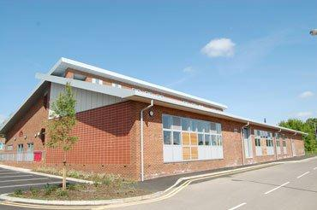
The facilities for Technology are impressive and have benefitted from a multi-million pound refurbishment and replacement of technology facilities. They include 2 materials workshops, 2 food rooms, 2 textiles workshops, 3 computer suites, 1 graphics room, 1 design/systems room, 2 child development rooms and 2 further general classrooms. All classrooms are equipped with up-to-date computers, ceiling mounted projectors and whiteboards. The faculty has over 200 PCs spread across these teaching rooms as well as a number of laptops. The faculty is also well equipped with latest machinery in all areas.

The whole faculty prides itself on a high standard of teaching and results.

In Year 9 students will study ICT and 2 subjects out of Product Design, Graphics, Food and Textiles. These courses are designed to develop on from KS3 teaching in middle schools and prepare students for GCSE options courses.

At GCSE level we currently offer: Product Design; Graphics; Textiles/Fashion; Catering; Food and Nutrition; Hospitality; Computer Science; ICT (CiDA); Child Development

For the sixth form we currently offer: Product Design; Hospitality; Graphic Communication; Fashion and Clothing; ICT; Children’s Care Learning and Development; Health and Social Care (single and double award).

