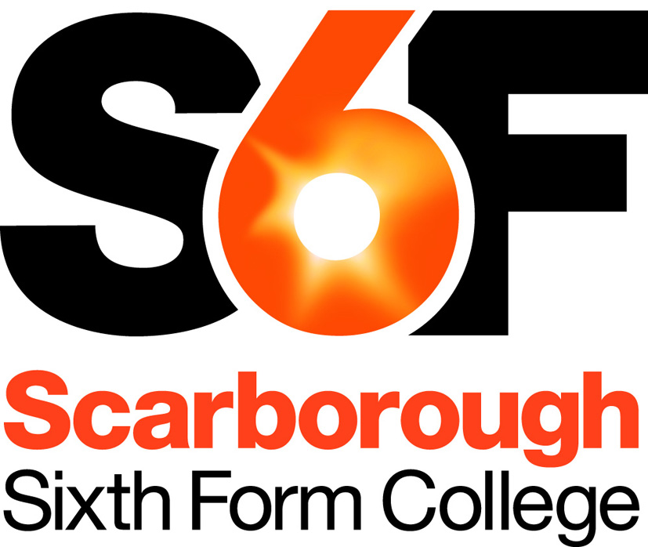
Person Specification
Science Technician (Relief)

Our aim is to recruit highly talented and competent people, fully committed to the College’s aims and values. Below we have identified the qualifications, skills, experience and attributes ideally required for this post. Applicants need to demonstrate how well they meet this profile and/or their potential to develop to meet the requirements of the post. This will initially be assessed based on quality of application, and then, if shortlisted, based on a combination of relevant task(s) and interview(s).
Qualifications
Desirable
- Qualified in a science subject to level 3 (A-level equivalent) or above
- Technician and/or Health & Safety qualification or training

Professional Skills & Experience
- Previous laboratory experience (either as a student or in a work environment)
- Good understanding of safe working practices in a laboratory environment
- Evidence of relevant technical skills and keenness to develop new expertise
- Good communication and interpersonal skills to support a range of staff and student needs
- A pro-active, flexible and user-focussed approach
- Accurate and attentive to detail
- Ability to organise workload to best meet the needs of the service
- Good administrative and IT skills

Desirable:
- Previous work experience as a technician
- Previous experience of working in the education sector

Personal Skills & Attributes
All staff are expected to demonstrate commitment to the college’s aims and values, including:
- Passionate about learning and its importance in life
- Having high expectations of self and others
- Honest, open, reflective and self-critical
- Doing one’s best, adapting well to change and always seeking to do better
- A supportive team worker
- Treating staff and students fairly and with respect, valuing their diverse contributions
- Fully committed to promoting & safeguarding welfare of children & young people

Reviewed: July 2017

