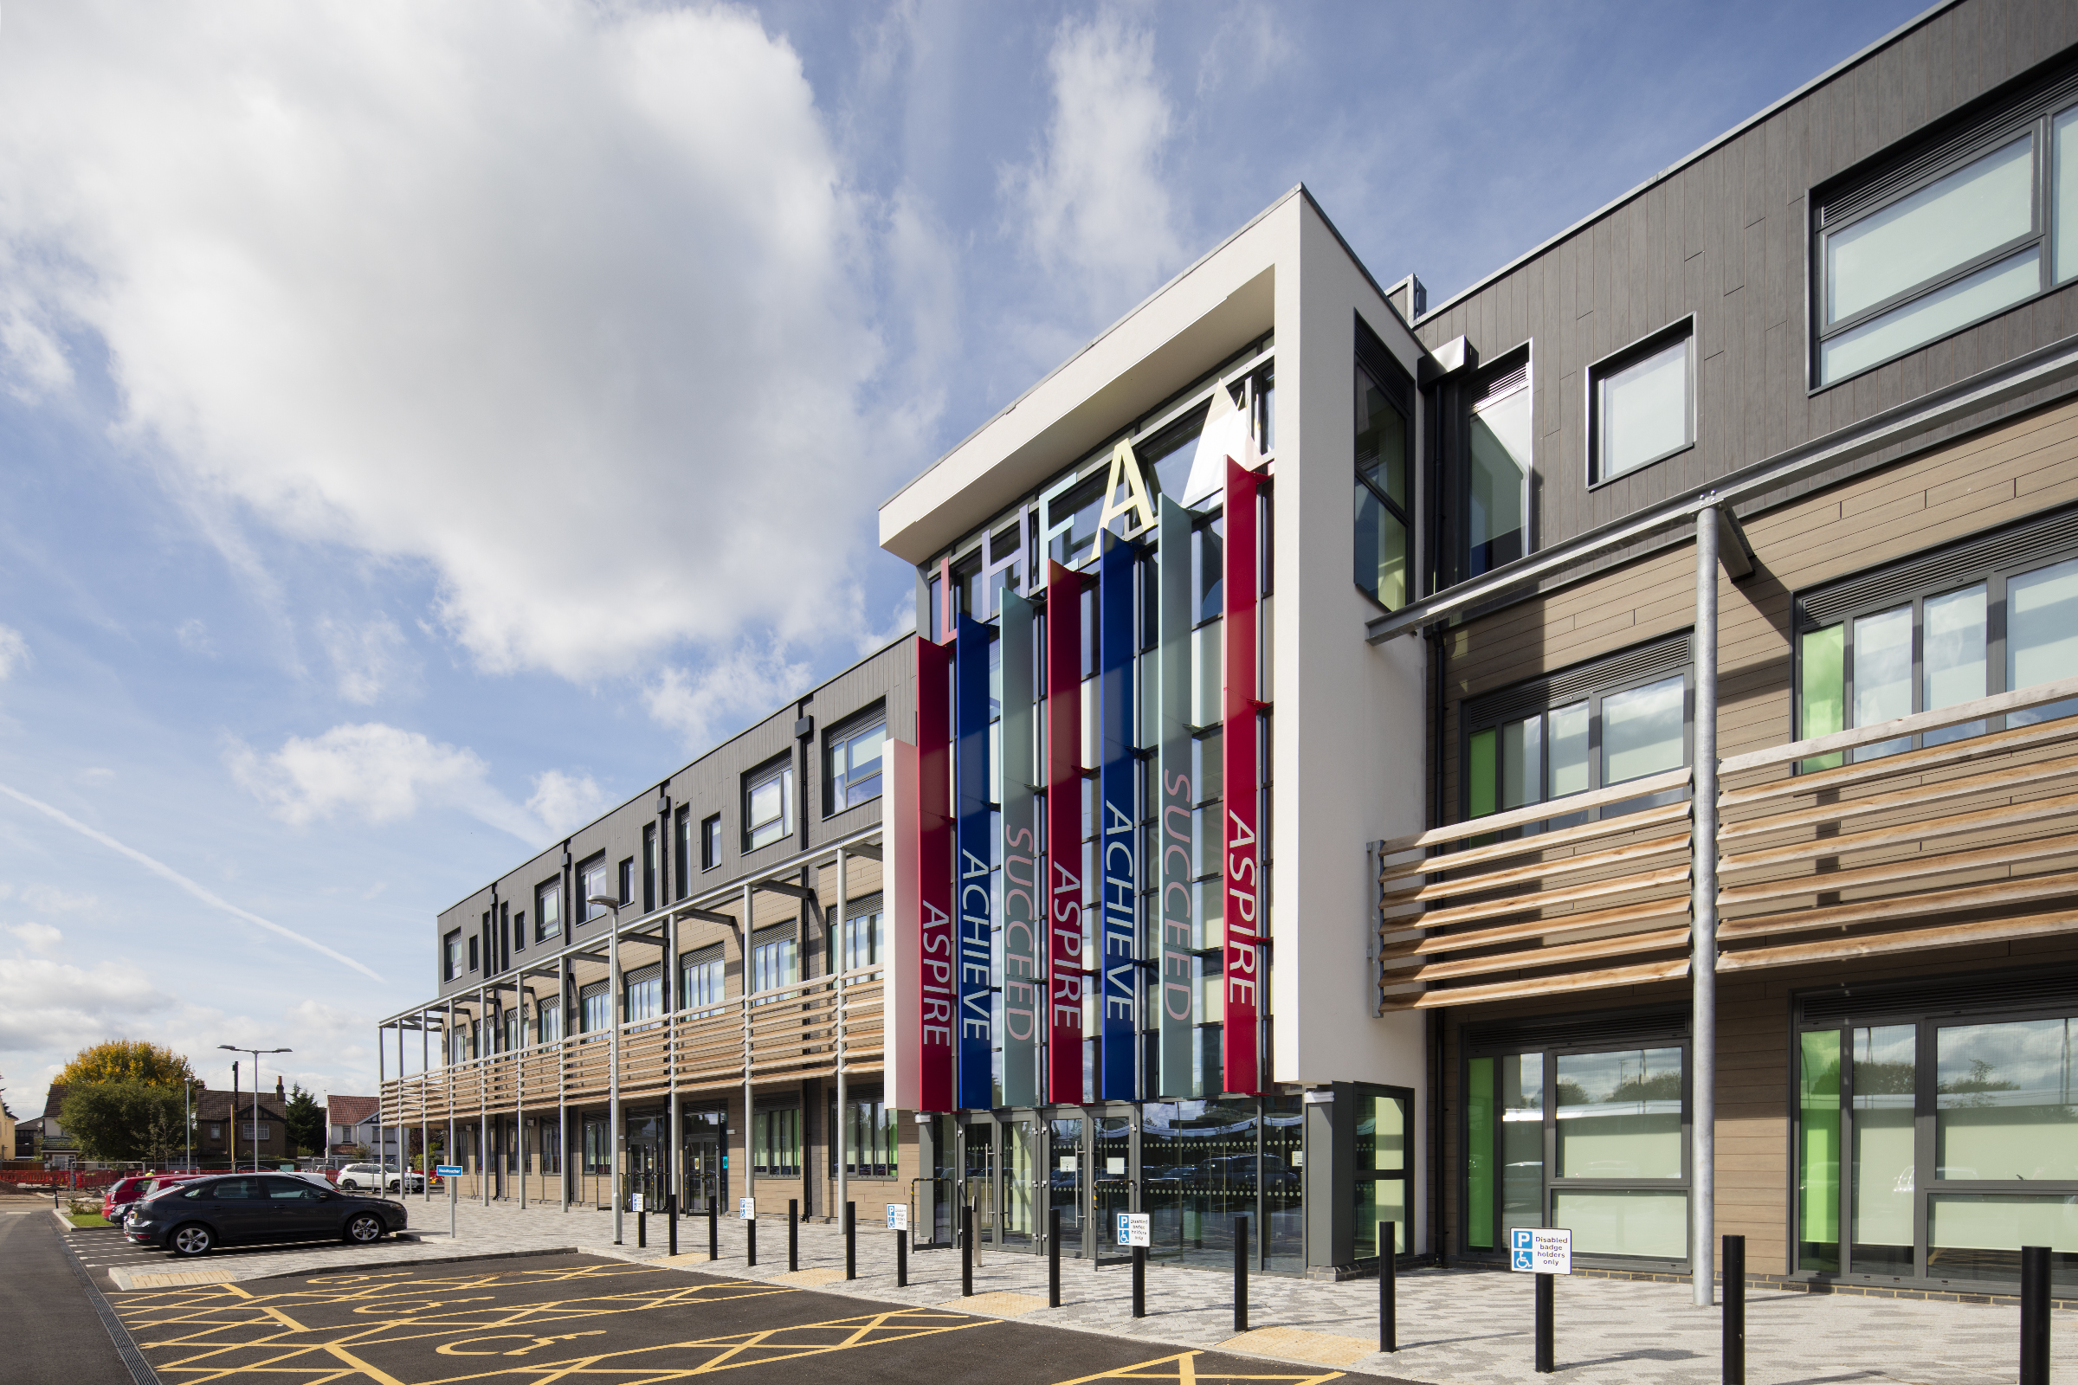

Lynch Hill Enterprise Academy
Deputy Headteacher
Application Pack

Thank you for your interest in the Deputy Headteacher post at Lynch Hill Enterprise Academy
This pack contains:
- Letter to candidates
- Information about Lynch Hill Enterprise Academy
- Details of the Slough and East Berkshire Multi Academy Trust
- The job description and person specification
We hope that you find the pack informative. If you do have any further questions or would like to visit the school, please contact Lynch Hill Enterprise Academy via the details below:
Bobbi Khaira
b.khaira@lhea.org.uk
01753 691583

You can also visit our website at www.lhea.org.uk

Closing date: 20/5/2019
Interview dates: w/b 20/5/2019
We reserve the right to interview promising candidates prior to this date if applications are received early.

If you wish to visit the Academy prior to application then please contact Bobbi Khaira

We are a school that places the safeguarding of all students as our number one priority. Please take the time to review our Child Protection & Safeguarding Policy:
https://www.lhea.org.uk/information/policies/

Contents

Dear Applicant
Thank you for your interest in the post at Lynch Hill Enterprise Academy. This is an exciting opportunity to join our rapidly improving school community. We can offer a supportive setting that will provide further opportunities for development as the school continues to grow and improve. The school has recently joined the Slough and East Berkshire Multi Academy Trust (SEBMAT) and we look forward to developing our working relationships with our Secondary and Primary partners.
A typical Lynch Hill member of staff is someone who is highly committed, motivated and resilient, with a clear focus on improving the life chances of all young people. We firmly believe that high achievement for every student is our shared responsibility. Our school community celebrates excellence and enables students to flourish as happy, successful individuals who achieve their best in all they do. It is a special place to work!
I began at Lynch Hill as interim Head of School in September 2018 and was delighted to be appointed to the substantive role from September. This position of sole Deputy Headteacher is a crucial one for the development of the school overall and the leadership team and how we work together to continue to improve the school. Lynch Hill is a wonderful place to work and has lots of potential and I am now looking for a deputy to work closely with as we shape the future for the school.
If you have enthusiasm and energy and want to be part of our dynamic culture, which aims to ensure that:
• teaching and learning engages and challenges
• our students’ aspirations are raised
• our students are happy, supported and motivated
then I would be pleased to receive your application. Together with your completed application form, I would also request an accompanying letter of no more than two sides of A4 outlining your previous experience and how it makes you a suitable candidate for the role.

Yours faithfully

Chris Thomas
Head of School of Lynch Hill Enterprise Academy

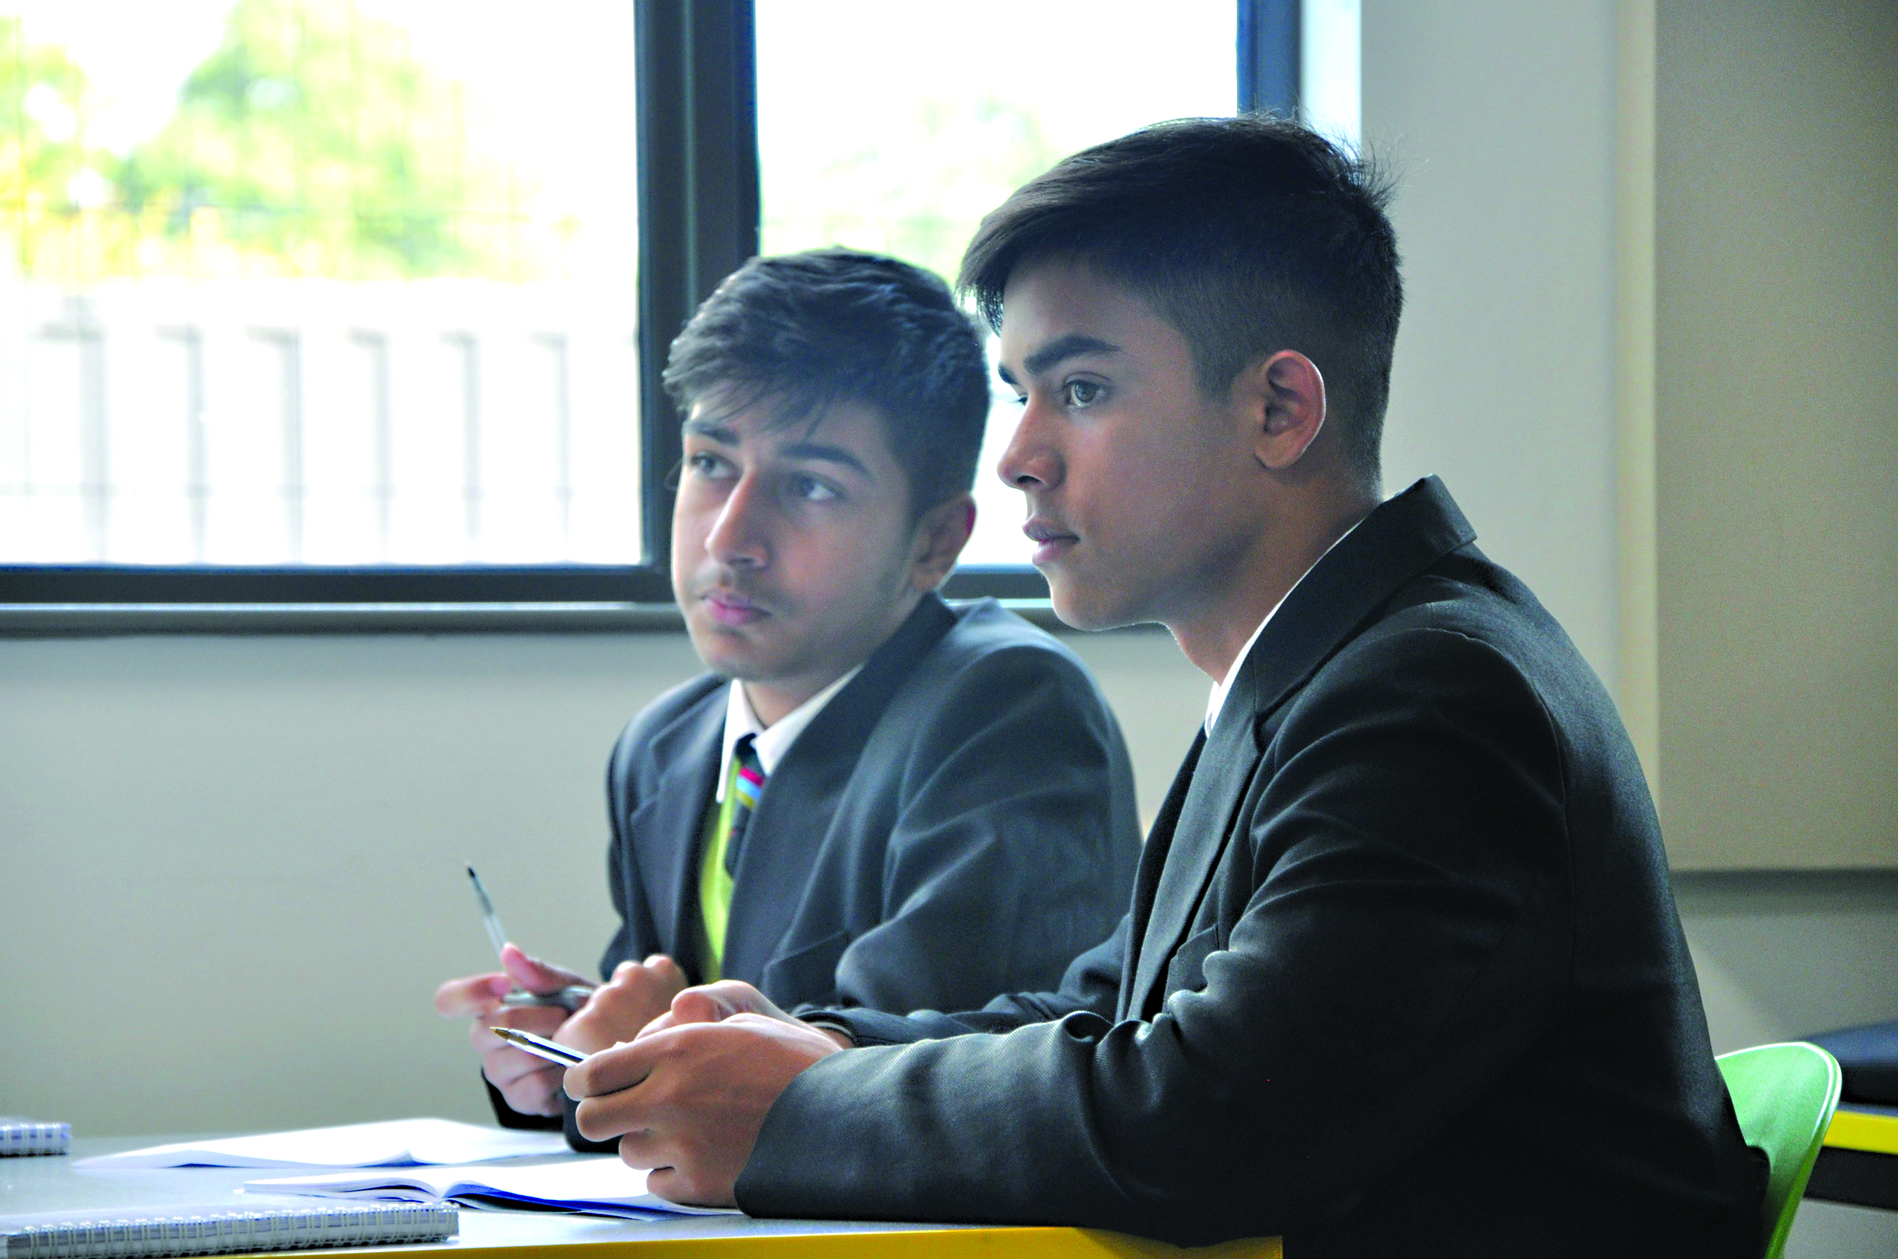

The school
Lynch Hill Enterprise Academy is a free school, which opened in September 2014. We moved into our new building in April 2017 and, in January 2019, Lynch Hill became part of the Slough and East Berkshire Multi Academy Trust. There are approximately 550 students on roll and this will increase by 100 students in September 2019, as a fully subscribed Year 7 replaces a small Year 11 who are the first cohort of students to progress through the school.
We are fortunate to have new state of the art and purpose built facilities, which provide an outstanding learning environment in which to deliver an exciting curriculum and broader learning opportunities. Additional funding has recently been secured to make further developments and improvements and it is fair to say that learning at Lynch Hill is not confined to the four walls of the classroom, as teachers are encouraged to utilise the ‘break-out’ spaces within the building.
The school was first inspected in June 2017 at which it was found to be inadequate. Significant improvements had been made by the first monitoring visit in June 2018, where the inspector noted:
“…teachers’ expectations for pupils’ behaviour and attitudes were consistently high. Pupils conducted themselves well and spoke respectfully both to each other and to the adults around them.”
The school is now much improved and is well placed to build on this; the support provided through the new trust will be invaluable in its continued improvement as well as increasing the range of opportunities for staff career development and CPD.
At Lynch Hill Enterprise Academy our mission is:
Aspire: to be the best you can be.
Achieve: high achievement is the shared responsibility of all.
Succeed: to aim for success in academic, personal and future work life and for this aim to be a personal and collective endeavour.

The Trust
Lynch Hill Enterprise Academy is a member of the Slough and East Berkshire C of E Multi Academy Trust (SEBMAT). SEBMAT includes both primary and secondary schools, which may have a Church of England link, but this does not prevent non Church of England schools from joining the Trust. SEBMAT supports schools to achieve very effective education with high levels of performance through coaching, sharing good practice and helping to secure good value for money.
SEBMAT values
We fully subscribe to the National Society’s determination since 1811 that the education we offer as Church of England schools does not depend on the background of the pupil but on a profound investment in their character and in the sparking of their aspiration. Every pupil will be encouraged to respect and honour their similarities and their differences as well as achieve success and be a positive contributor to the local and wider community.
Schools joining SEBMAT will be expected to commit themselves fully to open, honest and transparent collaboration that aims to help every pupil in the Trust to achieve the highest standards.
SEBMAT aims to provide:
• School improvement and has a track record of success
•Excellence in leadership
• Sustained momentum across the improvement journey
• Curriculum innovation
• Standards monitoring, data analysis and trend information
• Links to local, national and international groups
• Facilitated school-to-school networks, coordinating and brokering expertise
• Excellent staff by attracting the best to the Trust and by providing good development opportunities
• Excellent financial management and value for money

Lynch Hill Enterprise Academy
Deputy Headteacher
Job Description and Person Specification
Job Description
Job title | Deputy Headteacher
Remuneration | L20-24
Line management | The Deputy Headteacher will be accountable to the Headteacher.
Purpose of the role
To work with the Headteacher to contribute to further development of the school, staff and achievement of the students.
Main accountabilities - these will be added to in response to the experience of the successful candidate
To provide strategic leadership and ensure effective operational management of:
- Behaviour & Attitudes across the school
- Staff Wellbeing
- Ensuring that all pupils successfully complete their programmes of study.
- Policies compliance
- Strategic development of ICT across the school
- The school website
- E-Safety and online protection
- Line Management of specific departments
- Deputising for the Headteacher
- Contributing to the day-to-day management and leadership of the school.
General Duties
- Contribute to the development of school policy and to its implementation in the School as a whole.
- Complete the Designated Safeguarding Lead training to support the school’s safeguarding work.
- Take responsibility for knowledge of the school’s safeguarding and child protection policies and procedures, and demonstrate commitment to promoting and safeguarding the welfare of children and young people in line with these.
Specific Duties – these will be added to in response to the full main accountabilities
- Take on-going responsibility for maintaining the LHEA Way approach to standards of behaviour and expectations of relationships within the school.
- Secure and sustain high standards of behaviour to support learning.
- Keep up to date with the development of creative and innovative practices to support
developments in pastoral care and inclusion.

- Work alongside the Assistant Headteachers and Heads of Year to ensure that students from all backgrounds achieve well and that the school’s performance at KS4 continues to improve.
- Oversee the development of ICT across the school and with the promotion of e-safety.
- Attend relevant school and borough meetings
- Ensure that relevant education is offered throughout the school in line with current school policy and national developments, including the use of ICT to support and enhance teaching
- Make the best use of available data and support staff in using this to inform their planning
- Keep abreast of curricular developments and contribute to whole school forward planning
- Support teaching staff on all organisational and disciplinary matters
- Carry out SLT duties/supervision
- Contribute to primary school liaison
- Ensure that staff are fully informed of school policies, understand them and implement them
- Attend whole school functions e.g. parents’ evenings, exam results day etc.
- Contribute to departments you teach in
The duties outlined above are in addition to those covered by the latest School Teachers’ Pay and Conditions Document. They may be modified by the Headteacher, after consultation, to reflect or anticipate changes in the job, commensurate with the salary and job title.
Person Specification - Deputy Headteacher

 | Essential | Desirable
Qualifications  - Qualified teacher status in the UK  - Evidence of further qualifications | √ | √
Knowledge and Skills  - Successful classroom teacher  - Successful Ofsted experience  - Knowledge of strategies to support and improve standards of behaviour  - Knowledge of the National Curriculum and appropriate interventions for pupils to achieve success  - Excellent time management and organisational skills  - Excellent interpersonal and communication skills, both written and spoken  - Knowledge of performance management procedures  - Ability to work independently, take initiative and manage change  - Competent ICT skills | √  √  √  √  √  √ | √  √  √  √
Experience  - Experience of working in a secondary setting  - Experience of successfully managing a team  - Experience of delivering INSET and training  - Experience of managing a budget | √  √  √ | √
Personal Qualities  - High quality communication skills  - A sense of humour  - A flexible and adaptable approach  - A desire to continue to learn and develop within the professional role  - The ability to manage and motivate others to perform and develop  - Resilience and determination to be successful | √  √  √  √  √  √

How to apply

Please complete the attached form to apply for this position responding to the questions and adhering to the word limits for each section.

Applications should be returned to Bobbi Khaira, no later than 12.00 noon on Monday 20th May 2019.

If you would like to discuss the role in more detail or for an informal conversation about the role and your suitability, please contact Bobbi Khaira who will arrange a discussion with the Headteacher.

Equal Opportunities

Lynch Hill Enterprise Academy will not discriminate directly or indirectly through applying conditions or requirements which cannot be shown to be justified. We will not discriminate on the grounds of race, gender, nationality or origin, marital status, disability, economic status, sexual orientation, age, trade union, political or religious belief, or responsibility for dependents.

