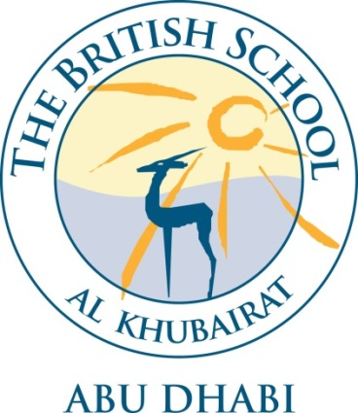

VISION

Building on our unique local heritage, we will provide a world class British education inspiring all our students to exceed expectations.
SAFEGUARDING STATEMENT

The welfare and safety of children who attend the British School Al Khubairat is our paramount concern. We will promote the health, well – being and safety of the pupils in all we do. Our children have the right to protection, regardless of age, gender, ability, race or social background. They have a right to be safe in our school. BSAK expects all its employees and volunteers to share this commitment. The school recognises and understands its responsibilities to work together in partnership with other agencies both here in the UAE and the UK to help children to grow up in a healthy and safe environment. Appointments are subject to satisfactory checks including the enhanced DBS check, Prohibition check and references.

INTRODUCTION

BSAK is committed to safeguarding and promoting the welfare of children, and expects all staff and volunteers to share this commitment. Applicants must be willing to undergo child protection screening appropriate to the post, including DBS checks.
BSAK is an independent British curriculum school for children aged from 3 to 18 years. The school is a member of IAPS, HMC and COBIS.
We recognise that each and every child is unique and we are committed to ensuring that every child develops to their full potential, creating independent, creative, curious, and confident young people, equipped with the values and skills needed for a successful and rewarding life.

JOB DESCRIPTION

Title University and Careers Advisor

Report to Deputy Head Secondary

Collaborates with Staff/Students/Parents

Direct Reports None

OBJECTIVE OF ROLE

The role of the University and Careers Advisor is to manage, oversee and co-ordinate all matters relating to higher education and careers and work experience within the school. This role will include the supporting of staff, students and parents with regards to these areas, in addition to support and advice post exam results.

KEY RESPONSIBILITIES

- To manage, oversee and co-ordinate all higher education applications across the school
- To manage, oversee and co-ordinate all careers and work experience matters across the school
- To ensure all the necessary administration for careers and higher education is in order and to manage these processes: either undertaken directly or to guide staff in a support role on these matters
- To support and provide the necessary guidance to all staff involved in the process of careers and higher education guidance
- To ensure the quality of all applications for higher education and to provide feedback to staff on the quality of their input
- To be the point of contact for the school on all matters relating to careers and higher education
- To organise any visits and guest speakers coming to the school in relation to careers and higher education
- To support students and parents with careers and higher education enquiries and advice
- To communicate effectively with staff, students and parents in a suitable and effective way in relation to all careers and higher education issues and in-line with the school’s communication strategy and outlets
- To review all higher education and careers outcomes providing data and evidence to the school
- To undertake and provide any research in relation to careers and higher education as may be necessary for the school
- To create a development plan for careers and higher education in line with the school’s overall development plan
- To support students and parents post exam results
- Any other reasonable requests as directed by the Line Manager

KEY REQUIREMENTS

Education and Training
- Degree
- Relevant qualification in Careers Guidance
- Relevant experience of advising on universities and careers within a school environment
- Recent Safeguarding training
Experience, Knowledge and Skills
- Work as part of a team
- Warmth, humour and total commitment to young people

