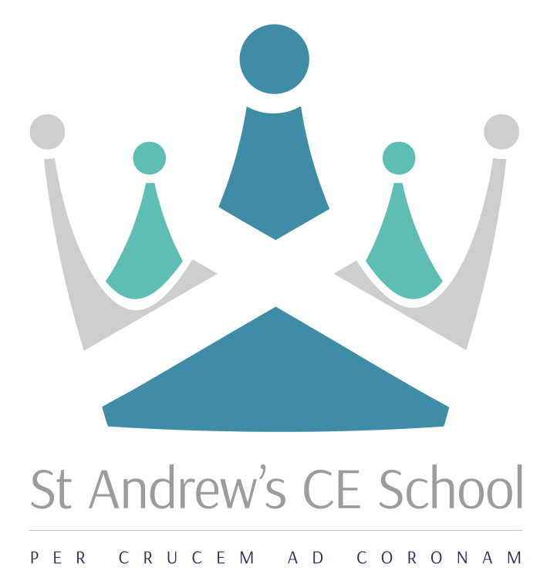

Information for Applicants

Teacher of Modern Foreign Languages
Main Scale
Required for January 2018

Application to be submitted by midday on Monday 13 November 2017
Interviews will take place on Wednesday 15 November 2017

Mission  ‘In God, Through Grace and Guidance,  to Grow and Give’ | Vision  We will ‘StAnd’ together in God’s Grace, to Guide and Grow young people who are motivated, curious and academically successful; who are ready to inspire and aspire to be the very best they can be. Who are ready to give back to their community, work hard and are equipped to embrace life’s many journeys.

Dear Applicant

Thank you for showing an interest in the post of Teacher of MFL. Enclosed in this pack is information about the school and the job that you have enquired about. I hope that you will find this useful in helping you to decide if St Andrew’s would be a school you would be interested in joining.

I am the Headteacher, Kerry Targett and joined the school in September 2015. I believe this is a very exciting time to join the school, as it is in the process of building on the strong foundations of many successful years as a prominent and reputable school in Croydon. Recently however, the school has seen its fair share of challenges, particularly since OFSTED placed it in RI in November 2014 and did not move it on following a recent inspection under the new framework. On my arrival I rebranded the school which included a new staffing structure, with new leadership posts created to enable capacity for leadership at all levels. The Senior Leadership Team includes the Headteacher, four Assistant Headteachers and four Senior Leaders who have responsibility for key curriculum areas.

St Andrew’s is a five form entry, Church of England Voluntary Aided School for boys and girls aged 11 to 16. It is a Christian school, within the Diocese of Southwark, serving the Archdeaconry of Croydon. We welcome all students, whether or not they have an affiliation to Christianity or another Faith. We have a fully comprehensive intake; each Year Group includes a number of students with Education and Health Care Plans but also others capable of achieving top grades across the curriculum at Key Stage 4. The demographic of our student intake has changed greatly over the past few years and our students come to us from a range of areas within Croydon boroughs, many having complex home situations and challenges in their personal lives.

Although there are many challenges to overcome there is a great set of dedicated staff who have embraced the changes and improvements to ensure rapid progress; many of the students want to learn and have been reported by internal and external reviews to demonstrate great attitudes to learning in the classroom. There is a desire from the students to be involved in active lessons with opportunities to be creative and engage in meaningful discussions.

The school buildings were expanded between 1995-2000, with the provision in 2000 of a new technology and administration building. Additional buildings, including a drama and music block, additional ICT and technology rooms and some standard classrooms, were completed in autumn 2005. This year further refurbishment of teaching rooms and the new layout of the administration block to include a new reception area, meeting room and new library facility have been completed, along with a total refurbishment of the science block. All classrooms are equipped with projectors and inter-active whiteboards.

We know how important it is for career opportunities and will be expecting staff to be ambitious in their own development; our commitment to staff is to encourage attendance at PiXL events and recognised conferences, to study for an MA / recognised leadership qualifications, to collaborate with schools in the local area or the Diocese and / or to engage with research around teaching and learning.

I am looking for people to work in the team with great drive and determination, someone who is not afraid of challenge, who is personable and flexible but overall who has a passion for making improvement for students which will enable them to make better lives for themselves.

I would be keen to speak with you further should you be interested in a position within our school. Please do feel free to come and visit us if you want to really get an understanding of the work that we do. You are welcome at any time, please contact me on head@standhigh.net .

Kind Regards



Kerry Targett
Headteacher

Key Information about the school

School: St Andrew’s CE School
Location: Warrington Road, Croydon CR0 4BH
Age Range: 11-16
Type of School: Voluntary Aided School
Denomination: Church of England
Number of Students: 486
Number of teaching staff: 41
Number of non-teaching staff: 36
%students achieving 5xGrade4+ inc EM: 42%

“In God, through Grace and Guidance, to Grow and Give”

Job profile
Title
Teacher of Modern Foreign Languages

Reporting Line
The holder of this post:
- reports to the Subject Leader for Modern Foreign Languages
- liaises closely with other teachers
- liaises closely with teaching assistants and support staff

Primary Purpose
To ensure all students across the age and ability ranges learn to their full potential through:
- the delivery of the curriculum
- effective pedagogy
- precise formative and summative assessment
- addressing students’ diverse learning needs
- addressing students’ spiritual, moral, cultural and social development

Principal Accountabilities
The post-holder is required to:
- plan and deliver lessons and manage the learning environment of one’s teaching area so that teaching is effectively differentiated to enable individual students to achieve their full potential
- feedback, written constructive comment to students on their work no less frequently then every three weeks
- manage students’ behaviour productively
- administer rewards and sanctions for students
- administer the assessment, examination and reporting of one’s subject with due reference to students’ data
- lead a tutor group – see Tutor Job Profile
- be responsible for the effective deployment of books and resources
- contribute to the subject team
- contribute to other teams in response to the school’s development plan
- support the school’s active Christian ethos

Contribute as an effective and collaborative member of the School
The post-holder will:
- attend relevant meetings as required
- participate in training to be able to demonstrate competence
- participate in first-aid training as required
- participate in the on-going development, implementation and monitoring of the School Priorities
- be expected to understand and have sympathy with the school’s Christian ethos and the active expression of this, within the Anglican tradition.

Safeguarding
The school is committed to safeguarding and promoting the welfare of children and young people and therefore expects all staff to share this commitment. All appointments are subject to a satisfactory, enhanced DBS check.

Equalities
The post-holder will:
- be expected, with all employees, to understand, comply with and to promote the school’s policies (having a strong commitment to achieving equality of opportunity in its services to the community and in the employment of people) in their own work, to undertake any appropriate training and to challenge racism, prejudice and discrimination.
Person Specification

Subject Teacher Method of Assessment
 | Application | Interview | Task
Essential Knowledge and Experience
The post-holder will:
- have a second-class or higher honours degree, or equivalent qualification
- have a teaching qualification
- be committed to and understand how to safeguard and promote the welfare of children and young people
- have knowledge of teaching one’s subject to at least GCSE level or the equivalent
- understand how teaching and learning is modified to stretch all students of differing abilities
- understand what constitutes an effectively differentiated curriculum at KS3 and KS4
- understand what constitutes efficient feedback and assessment, and translate these into practical classroom strategies to support progress
- understand how this post and others each contributes to the realisation of a school’s development plan
- understand how a child’s experiences at school and well-being underpin their future opportunities
Essential Skills and Abilities
The post holder needs to demonstrate the ability to:
- manage his or her time effectively, reconciling conflicting priorities
- effect positive relationships with students and colleagues at all levels, exercising a high degree of emotional intelligence
- reward and motivate students, as appropriate, ensuring that due recognition is given to positive behaviour
- discipline students authoritatively, as appropriate, ensuring that sanctions are followed through
- plan and deliver effective lessons within a given time-frame and in accordance with agreed specifications
- ensure accurate records are maintained and data analysed to inform effective teaching and learning
- communicate effectively in different contexts
- take different roles within different teams
- evaluate one’s own learning needs and actively seek learning opportunities for personal and professional development
- be sympathetic to the school’s Christian ethos

Job profile - Tutor
Title
Tutor

Dimensions
This post operates with regard to:
- a tutor group with up to 30 students across the full ability range
- a team of 5 tutors within the same house
- colleagues holding similar posts as tutors throughout the school

Reporting Line
The holder of this post:
- reports to the KS3 or KS4 Coordinator to support the learning and spiritual, moral, cultural and social development of the students in the tutor group
- liaises closely with fellow tutors, teachers and other colleagues
- manages tutor group prefects or monitors

Primary Purpose
To support the academic progress and spiritual, moral, cultural and social development of the students in the tutor group:
- establishing a positive relationship with the members of the tutor group, fostering a cohesive unit
- guiding members of the tutor group through their school career
- celebrating individual students’ achievements
- monitoring and intervening, when appropriate, in matters of discipline
- communicating with parents and carers
- generating reports and references to a high standard and to an agreed format, when and as appropriate

Key Accountabilities
The post-holder is required to:
- manage tutor-time efficiently, as directed by the KS3 or KS4 Coordinator, so that a proper balance is achieved between administrative tasks and activities focussing on the students’ spiritual, moral, cultural and social development
- monitor and guide students in their approach to learning, within and beyond the academic curriculum, so that each achieves his or her full potential
- engage constructively with the rewarding and disciplining of students so that they develop the capacity to make appropriate decisions
- manage the tutor group prefects and monitors so that they develop their own capacity to lead and manage initiatives
- ensure that a Christian Act of Worship occurs during tutor periods, when no other assembly is scheduled, to maintain the school’s distinctive ethos
- communicate effectively with parents, guardians and other professionals to provide full, appropriate support and coherent support and direction for individual students
- contribute to the House’s pastoral agenda to ensure the House runs efficiently on a daily basis, develops effective strategies to address the demands of the present, and anticipate the demands of the future

Safeguarding
The school is committed to safeguarding and promoting the welfare of children and young people and therefore expects all staff to share this commitment. All appointments are subject to a satisfactory, enhanced DBS check.

The post-holder will be expected to understand and have sympathy with the school’s Christian ethos and the active expression of this, with in the Anglican tradition.

Teacher of Modern Foreign Languages
Main Scale
Required January 2018

St Andrew’s is a successful and highly supportive 11 - 16 Church of England school. St Andrew’s is a friendly school which fosters positive relationships between students of all ages and the staff. It is on a journey of rapid progress and high expectations and all staff are required to play a positive role in developing this focus with the students. The school has a strong Christian ethos which underpins the day to day work of students and staff.

We are seeking to appoint an outstanding teacher who:
- has the ability to inspire and engage across KS3 and KS4
- has an absolute commitment to inclusive education
- has high standards and the drive to see these realised
- excellent inter-personal skills

In return we can offer:
- the opportunity to work with energetic, supportive and enthusiastic colleagues
- well-behaved students committed to their community
- scope to make a significant contribution to a school with ambition and vision
- opportunities for professional development

The school runs an established induction programme. St Andrew’s is committed to safeguarding and promoting the welfare of children and young people and therefore expects all staff to share this commitment. All appointments are subject to a satisfactory DBS check.

The application details are available via the school website: www.standhigh.net

Applications to be submitted by midday on Monday 13 November 2017
Interviews will be held on Wednesday 15 November 2017

St Andrew’s CE School, Warrington Road, Croydon, CR0 4BH, www.standhigh.net

General Information

Contact Details:

St Andrew’s CE School
Warrington Road
Croydon
CR0 4BH
t. 020 8686 8306
f: 020 8681 6320
e: office@standhigh.net
w: www.standhigh.net

Location Map:

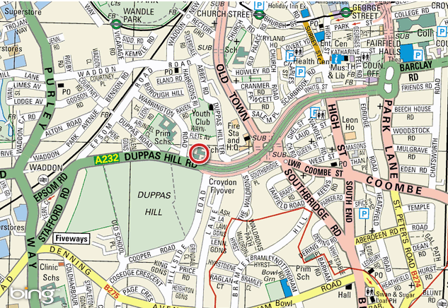

Nearest transport link:

Tube: Morden
Railway: Waddon
Tram: Wandle Park/Church Street

