Collingwood College
Recruitment Information

COVER SUPERVISOR
(Fixed Term 1 Academic year -
September 2021 to July 2022)
________________________________________

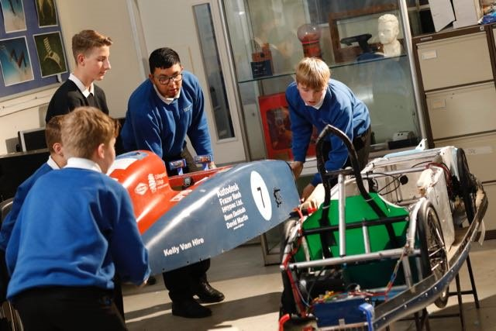

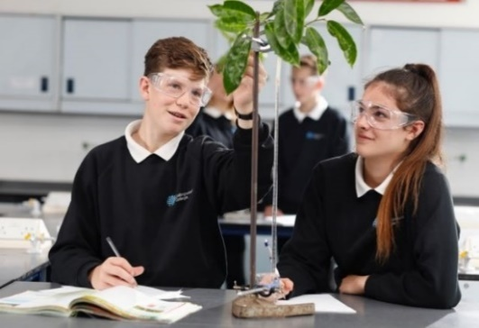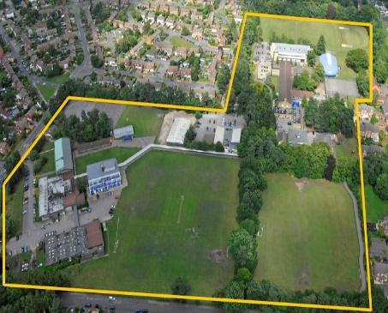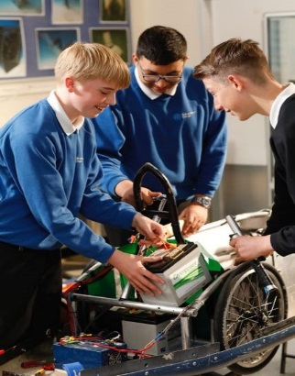

Introduction
Collingwood College is Surrey Heath’s first high-performing Academy. Collingwood is one of Surrey’s largest and most successful secondary schools for students aged 11-19. We have more than 1700 students, including a Sixth Form and 235 teaching and support staff, all of whom are dedicated to ensuring that all our students fulfil their potential and enjoy to the full their secondary education.
As a comprehensive school specialising in Technology and Applied Learning, we welcome students of all abilities. The College offers an outstanding range of educational and extra-curricular opportunities, which few other schools can match. The website provides you with an insight into the many benefits and advantages that a Collingwood education offers.
Technology specialism means that at Collingwood every subject area uses technology to enhance student learning within their curriculum and particularly the STEM subjects (Science, Technology, Engineering and Mathematics). Our wide range of alternative qualifications reflects our second specialism in Applied Learning.
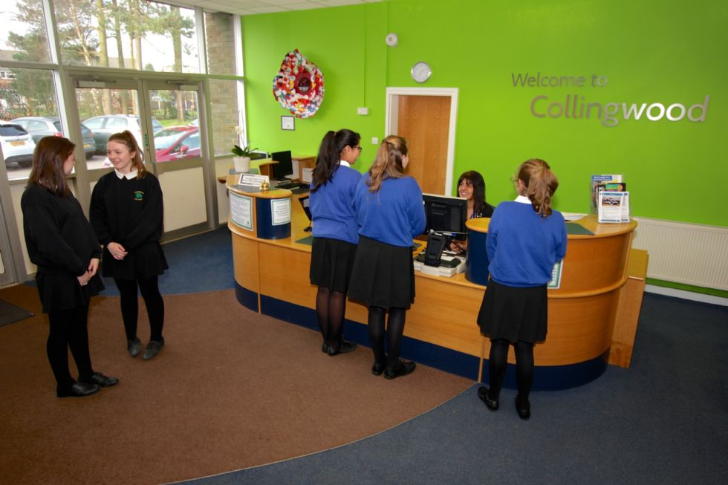

The College’s very successful OFSTED inspection in January 2017 confirmed it to be a good school with outstanding leadership and management. Collingwood’s breadth of curriculum and the quality of the Sixth Form received particular praise. Academic performance at GCSE and A Level is impressive. Our relentless focus on English and Maths ensures results at GCSE are consistently high. Able students are stretched with, on average, 20% of the cohort achieving 5 or more A*/A grades each year.
The diverse talents of our students supported by committed and highly experienced staff are key factors in the success of the College. All Collingwood students are offered a wide range of personal development and leadership opportunities within their curriculum. The contribution of extra-curricular activities such as the College’s Duke of Edinburgh Award Scheme, the wide-ranging educational visits programme, which includes visits to our partner school in Shanghai, ski trips to Europe and the USA, student visits to France and Spain and annual international expeditions are significant.
We have a thriving Sixth Form based in a purpose-built teaching centre. The majority of our students progress into our Sixth Form and from there into higher education. We offer extensive academic and vocational programmes of study.

Dear Applicant,
Our vision for Collingwood is to be the College of first choice for all our parents and we are currently on a journey to move from Ofsted Good to Outstanding!
Collingwood College is committed to developing responsible, aspirational, independent, happy and well-rounded young people with the self-belief to reach their goals.
Our students are the focus of everything we do. We have found that by listening to students’ views and offering them the opportunity to work with each other, staff and governors, they are an integral part of our relentless drive for improvement.
Collingwood College offers all students an inclusive, flexible and stimulating educational experience. With a strong emphasis on personal development and a very wide range of leadership opportunities and extra-curricular activities, we are able to offer challenges that motivate and appeal to all individuals.
Our academic performance is consistently high and in recent years students have achieved excellent results at pre and post 16 level. In 2020, the percentage of students who gained 5+ good passes at GCSE was 81% and in the sixth form 55% of qualifications were at A*-B (or equivalent). This continued level of success is down to the hard work of our students and their teachers.
We believe that our staff are the foundation upon which the success of the College depends and recognise that our employees are the most important asset of the college.
We empower our employees to utilise their talents and skills to make a positive and significant contribution to the quality of teaching, learning and personal development that the College provides for its students.
We look forward to receiving your application for this post.

Yours sincerely

Mr Eden Tanner
Principal

The Role
This role will be as an intervention tutor, however the role will also involve providing cover for absent teachers and supporting/supervising students. We are aiming to appoint a confident, resourceful and creative individual with a passion for supporting young people. The successful candidate will have proven, recent and relevant experience who can demonstrate good communication, organisational and behaviour management skills for a classroom setting.
The role is part time working 30.5 hours per week between the hours of 8:25am and 3:05 pm, plus one day per week to 3:35 to cover coach duty, term time plus inset days (39 weeks per year).
This post is to start in September 2021 and is a fixed term post for 1 year to then of the 2021/2022 Academic Year
The Department
The Cover team at Collingwood College provides a high-quality learning environment that allows our students to continue to make progress during staff absence. The Department has high expectations of all students and is focused on helping them achieve their very best, in classwork, homework, school examinations and public examinations.
Application Process
An application form can be obtained on our website www.collingwoodcollege.com . Completed application forms should be returned to the HR Department hr@collingwood.surrey.sch.uk
Closing Date: 4th June 2021
Interview Date: 10th or 11th June 2021
Suitable candidates may be interviewed before the closing date and Collingwood College reserves the right to withdraw the position if an early appointment is made.
Collingwood College is committed to safeguarding and promoting the welfare of children and young people and expects all staff and volunteers to share this commitment. The successful applicant will be subject to an Enhanced DBS check.
Interviews
The format of the interviews will depend on whether the school is open to students. If this is the case then each short-listed applicant will be invited into to the school and asked to complete a lesson observation, have a tour of the school and if successful following this process be interview by the recruiting manager and the Principal.
Due to Covid-19, Microsoft Teams interviews will be conducted and this will include responses to a pre-released task, relevant to the role i.e. Planning a Lesson or given a presentation of a subject area.
Probationary Periods
All posts are subject are subject to a probationary period. For teachers this is 2 full terms, for support staff this is 6 months. Collingwood College’s Probationary Policy is available upon request.

Remuneration and Benefits
Collingwood College has its own generous pay scale and the financial package offered will be commensurate with the responsibilities of the post and the experience of the person appointed.
The starting range for this post is £15,994 - £17,658 pa (FTE £21,944 to £24,228 pa) for 39 weeks a year. Candidates are normally appointment on point 1 of the relevant scale.
All new staff appointments are subject to verification of fitness to work, receipt of two satisfactory references, qualification verification, clearance from the Disclosure and Barring Service at Enhanced level as well as other checks relevant to the role.
Access to other benefits including:
- Outstanding facilities, including free on-site parking
- All Collingwood College Support staff are eligible to belong to the Local Government Pension Scheme through Surrey and will automatically become members unless they opt out.
- 24/7 Employee Assistant programme for staff and their families
- Exclusive savings, discounts and offers through My Staff Shop including Cycle to Work Scheme
- Flexible leave of absence policy
Training and Development
At Collingwood we are committed to providing a well-structured staff development programme to enhance personal and team development. All new staff received the following training:
- Collingwood College Company Induction
- Safeguarding and Prevent Training
- Mandatory and Compliance Training including Fire Awareness and Health and Safety at Work
- Training linked directly to the job role, which may be delivered by other colleagues or external trainers
In addition, staff can have:
- An opportunity to access other training as detailed in the termly training calendar
- An opportunity to access training outside the college linked directly to your role or career aspirations
- Other on-line training relevant to the role.

JOB DESCRIPTION
Cover Supervisor – Initially Fixed Term to ……
Post: | Cover Supervisor
Reporting to : | Assistant Principal & Cover Manager
Hours | 30.5 Hours per week (8:25 -15:05 4 days per week & 8:25 to 15:35 1 day per week) plus a 40 minute unpaid lunch break per day.
Weeks per year | 38 weeks plus inset days (39 weeks)
Salary Band | C1--6
Job Purpose: | To deliver lessons and provide supervision of students with a range of abilities across the 11-16 age range, facilitating the progression of students learning. Successful candidates will need to respond to questions, generally assist students to undertake set activities and to uphold standards of behaviour in the classroom. In addition to cover needs, there will also be a requirement to work as a Form Tutor and to fulfil the duties and responsibilities of a form tutor. You will work alongside existing staff in specific curriculum areas providing general support for departments. This is a key role in supporting the day-to-day running of the school and the successful applicant must be IT literate and competent in using a variety of software packages.
Involvement with : | Senior Leadership Team, Cover Manager teaching and support staff and students.
Main Duties and Responsibilities
Organisation
Cover Supervisors are expected to carry out the following duties to cover for short-term teacher absence.
- Deliver lessons appropriate to the age and ability of the students so as to facilitate progression in students’ learning; the plans and resources for these lessons to be provided by the Head of Department (or relevant other)
- Manage the classroom and teaching equipment so as to create a positive learning environment which makes effective use of the available resources
- Implement College’s policies with regard to registration, student absence, dress code, behaviour
- Adhere to and enforce Academy rules relating to Health and Safety
- Provide advice and guidance to staff, students and others

In addition, Cover Supervisors are expected to carry out the following duties when providing cover for medium teacher absence:
- In consultation with HoDs / KS coordinators and in accordance with schemes of work, deliver the set cover and review lessons which are appropriate to the age and ability of students, so as to facilitate progression in students’ learning. (HoDs and KS Co-ordinators will set and mark the work)
- Provide classroom assistance and support for individual student needs if necessary.
- With leading support from departmental colleagues assisting in the process of assessment, recording, reporting and completion of marking sheets on the development, progress and attainment of the students assigned to her/him, within the College guidelines where they had been assigned to a class for a 6-8 week period.

When not required to cover classes or groups of students the cover supervisor will provide support for the faculty they are assigned to. This can include:
- Working with individual or small groups of students providing extra support as appropriate
- Helping with admin within the faculty/departments as appropriate

Definition of Short-term cover

Short-term cover involves work for a lesson, a day, or a week. Work is set by absent teacher or departmental colleagues.
Short-term cover does not involve assessment, recording and reporting on the development, progress and attainment of students.

Definition of Medium

Medium-term cover involves a planned sequence of work for a subject for a period of weeks, such as a half-term or term, or for a number of lessons.
Medium-term cover can include identifying learning objectives and outcomes and indicating the activities that will enable these to be achieved. Medium term cover often shows a sequence of activities that will promote progression and some information about the amount of time needed to cover the objectives.
Medium term cover will involve leading support from departmental colleagues assisting in the process of assessment, recording, reporting and completion of marking sheets on the development, progress and attainment of the students assigned to her/him, within the College guidelines where they had been assigned to a class for a 6-8 week period.
Medium term cover will involve leading support from departmental colleagues.

Administration
- Assess, record and report on the development, progress and attainment of the students assigned to her/him, within the Academy guidelines
- Attend relevant meetings and carry out relevant administrative tasks
Other

- To undertake other duties as may reasonably be required in consultation with your line manager, subject to the proviso that normally any changes of a permanent nature shall be incorporated into the job description in specific terms.

PERSON SPECIFICATION
 | Essential | Desirable | Method of Assessment
Knowledge/Qualifications
GCSE or Equivalent in Maths & English at Grade C (4/5) | √ |  | A/C
Knowledge of general office procedures and practices | √ |  | A/C/I
Knowledge of SIMS |  | √ | A/I
A recognised and relevant vocational qualification (NVQ Level 3) and or equivalent practical work experience | √ |  | A/C/I
HLTA Status |  | √ | C
Experience
Communicating and working effectively, confidently and respectfully with senior colleagues whilst maintain confidentiality | √ |  | A/I/R
Working within a school and team environment |  | √ | A/I
Working with a partnership context, including co-ordinating collaborative activities and plans | √ |  | A/I
Skills
Highly organised and self-motivated, with the ability to manage time to ensure that deadlines are met | √ |  | A/I/R
ICT skills to produce quality reports and documents and to create and manage simple databases | √ |  | A/I
Able to communicate effectively both orally and in writing with a wide range of people | √ |  | A/I
Ability to work as part of a team | √ |  | A/I
Ability to work independently with good awareness of when to take initiative and when to check and confirm actions | √ |  | A/I
Ability to be well organised and accurate in all aspects of the role with the ability to prioritise | √ |  | A/I
Ability to work well under pressure and to respect sensitive and confidential work | √ |  | A/I/R
Ability to form strong and effective working relationships with colleagues | √ |  | A/I/R
Ability to use SIMS | √ |  | A/I/R
Ability to use other ICT packages as required | √ |  | A/I/R
Behaviour and other related Characteristics
Diplomacy and discretion and the ability to manage confidential information | √ |  | A/I
Proven ability to work as a team member to achieve goals in effective co-operations | √ |  | A/I
To display responsible and co-operative attitude to working towards achievement of the colleges aims and objectives | √ |  | A/I
Commitment to own personal development and learning | √ |  | I
A commitment to abide by and promote the colleges Equal Opportunities, Health and Safety and Child Protection Policies | √ |  | A/I
The post holder will require and enhanced DBS | √ |  | C

