Bishop Ramsey CE School

Teacher of French and Spanish

The Modern Foreign Languages Faculty

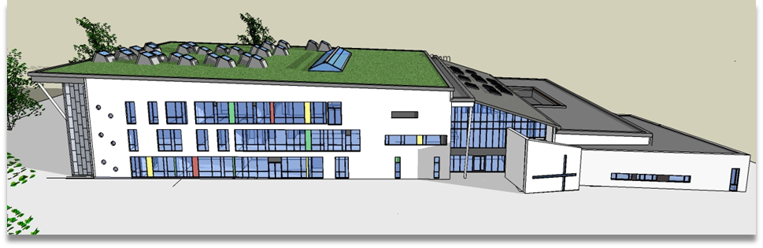

The Modern Foreign Languages Faculty consists of six language specialists who offer both French and Spanish across Key Stages 3, 4 and 5, each teaching in various combinations of both languages according to expertise.
Current members of the Faculty are:
- Miss E Hofmann – Head of Faculty/Head of French/MFL SCITT Lead
- Mrs T Estella – 2nd in Faculty/Head of Spanish
- Mrs A Bishop – Teacher of Spanish/French
- Mrs K Hamilton – Teacher of Spanish/French
- Mrs S Melcarne – Teacher of Spanish/French
- Mrs I Navarro-Bernal – Teacher of Spanish/French.
In Year 7 and 8, French is taught as the foreign language to one half of the year group, and Spanish as the foreign language to the other half. Students then pursue their one language as they go through Bishop Ramsey. Parents are able to nominate which language their child/children studies before they start in Year 7.
All students are expected to continue to study their language until the end of a two-year KS3. They then have the option of continuing a language to GCSE. Languages are not compulsory at Bishop Ramsey; however they are strongly encouraged and they prove very popular with almost 90% of the cohort choosing languages as an option.
We currently follow the AQA specification for both GCSE and A Level.
We are able to offer Spanish and French at A Level which allows staff to pursue their interests in literature and social and political issues. Class sizes at KS5 vary from 4 to 10 depending on the year.
The MFL Faculty also offer Mandarin as an additional language as an after school club which is optional, but very popular, with students.
The MFL Faculty makes every effort to provide an enriching experience for students at Bishop Ramsey in an attempt to bring something of the cultures and life of France and Spain a little closer. We have long running partnerships with Collège Les Ormeaux in Le Havre and Colegio San Buenaventura in Madrid which give rise to classic exchanges where students host a student their age and return the visit by staying with a family in France/Spain. These exchanges are very popular and always oversubscribed. We also run work experience programmes abroad for our Sixth form students which we organise in conjunction with our partner schools. This is in addition to trips to the BFI, French institute, Cervantes Theatre and theatre performances in school as well as House events and competitions throughout the year. We make every effort to make our curriculum as enriching and interesting as possible.
We have an on-going commitment to the development and progression of language teaching, working closely with Hillingdon SCITT to train and develop new teachers. We regularly host trainees in the department and are the “home” school for MFL training in the SCITT scheme.
We hope this brief synopsis will have given you something of the flavour of Modern Foreign Languages at Bishop Ramsey. We extend a warm welcome to new members of a supportive, friendly, lively and hardworking team.

