Castle Donington College

Behaviour Manager
Non- teaching post
Grade 8 (starting at £16,952)
35hrs per week, Term time only (38 weeks)
Commencing: Autumn Term 2019

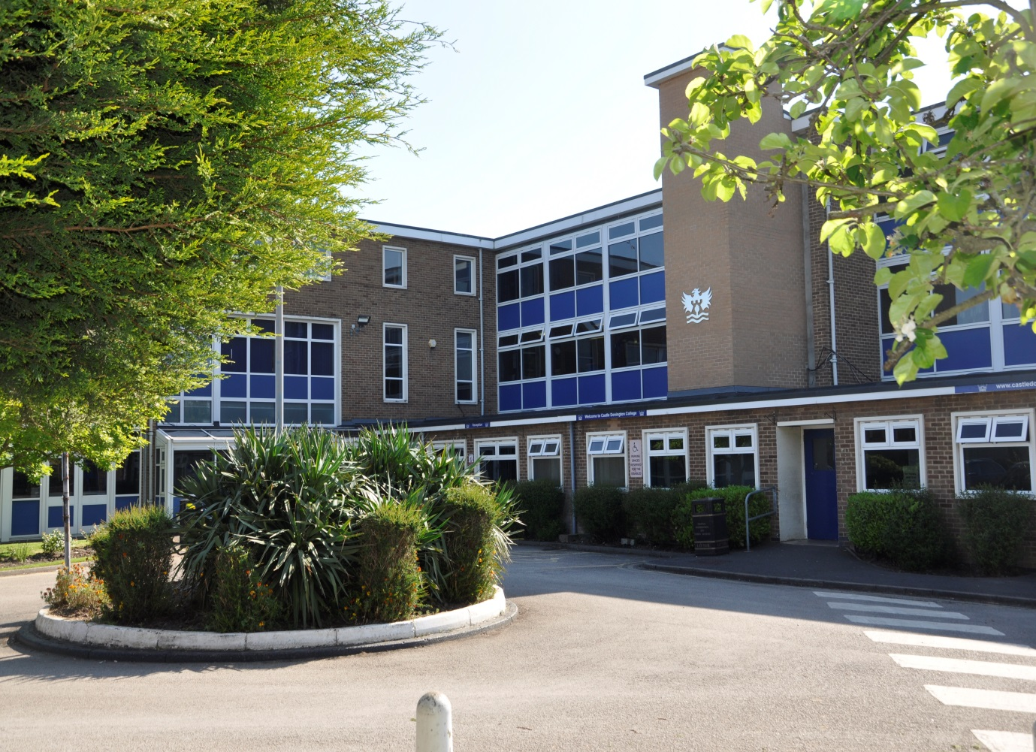

Applicant Information Pack

Behaviour Manager
Dear Applicant,

Thank you for your interest in the post of Behaviour Manager at Castle Donington College. I hope the enclosed pack will be of interest to you and I look forward to receiving your completed application. This is a non-teaching role, based at the College. We welcome submissions from people currently working in pastoral support roles and those aspiring to do so.

Castle Donington College is a small 11-16 school with 540 students on role. The College is situated on the North West edge of Leicestershire on the Leicestershire, Derbyshire, and Nottinghamshire border and within 30 minutes’ drive of Nottingham, Derby, Leicester, Loughborough and Burton, being close to the M1 and A50.

We believe we have the makings of an outstanding school. In January 2019 we received an Ofsted rating of ‘Good’ and continue to strive for excellence in all things. You can be a part of our future.

We are very proud of our community and the students we serve and so are looking for a Behaviour Manager who is an inspirational role model with the highest professional standards to support a team of Year Heads and our students. We are seeking to appoint an outstanding practitioner to join our staff. The successful candidate will to work closely with the Leadership and Pastoral team, teaching and support staff. Their key role will be to ensure that all students are able to learn in the classroom and be successful. The post holder will be responsible for the personal development, behaviour, care and welfare of a number of key students. This may include;
- supporting all students with the basics; respect for others and self, politeness and honesty and helping others in order to become well rounded citizens who are able to contribute positively to society
- coaching and mentoring key students to improve their behaviour and identify barriers to learning
- monitoring and reporting behaviour data
- supporting key students to improve their attendance
- presenting as a positive role model with high expectations and aspirations for students
- communicating and developing positive relationships with parents and carers
- recording and monitoring behaviour data
- organising and managing appropriate sanctions
- ensuring high standards of uniform are maintained
The successful candidate will also play a key role in upholding the highest standards of safeguarding and will be encouraged to train as one of our team of Designated Safeguarding Leaders.
All our staff have high expectations of themselves and the students. They work closely to share best practice and drive school improvement. In a recent staff survey 100% of respondents said that Castle Donington College was a good place to work. We are committed to a happy, purposeful and secure environment that provides the opportunity for all to grow and develop. Our teachers are highly valued, well regarded and fully supported. We can offer a coherent programme of induction and we have a strong commitment to professional development through our Professional Learning Programme. Your development will be a key priority for us, regardless of your experience.

The advertised post comes with challenges and requires someone with resilience, drive and ambition. However, we believe that a candidate with passion for pastoral care and supporting young people will flourish and the rewards will be great.

We welcome and encourage prospective candidates to come and visit, to meet our staff and students and to experience first- hand the ethos and values of the College.

Yours faithfully,

Julie Sheppard
Principal

Our Ethos and Values
At Castle Donington College, we are concerned, first and foremost with people. The staff and Governors are committed to delivering the best possible experience for all of our students. We care passionately about the quality of education we provide.
We consider traditional attitudes and values to be important and so aim to provide individual care and attention for each child and to create a stimulating environment so that effective teaching and learning can take place. Castle Donington College has the highest expectations of its students both academically and socially.
What students can expect from us:

- A challenging inclusive curriculum
- A wide range of curriculum activities
- Good and outstanding teaching everyday
- Targeted and timely support and intervention
- Outstanding pastoral care
- The highest expectations without exception
- Values rooted in respect, kindness, trust and support
- A safe learning environment free from disruption
- To be well prepared for next stage in education, training or employment and for adult life
- A good understanding of individuals’’ strengths and weaknesses

What we expect from students:

- Excellent attitude to learning everyday
- A relentless desire to achieve in all areas
- Excellent attendance
- Impeccable conduct every day
- Curiosity and resilience
- To capitalise on advice and feedback in order to improve
- The highest aspirations for the futures

Qualifications and Knowledge
GCSE or equivalent in English and maths | E
A levels or degree qualification | D
Qualifications relevant to the post and or working with young people | D
Right to work in the UK | E
Be computer literate and have a working knowledge of applications including Microsoft Word and Excel | D
Knowledge of relevant school policies e.g Child Protection, Health & Safety, Equal Opportunities Policy | E
Specific and up to date pastoral care knowledge appropriate to support tutors and other College staff | D
Understanding of role regarding safeguarding and child protection | E
Experience
Experience of working with children and young people | E
Experience of supporting and engaging young people in order to ensure access to the whole curriculum | D
Experience of enabling children and young people to overcome barriers to learning and achievement | D
Excellent health and attendance record | E
Relationships
Able to demonstrate positive relationships and effective outcomes with students | E
Able to demonstrate positive relationships and effective outcomes with staff | E
Able to demonstrate positive relationships and effective outcomes with parents | E
A high degree of emotional literacy | E
Ability to act as a positive role model for students | E
Demonstrate a positive outlook whilst maintaining a consistent, no-nonsense approach | E
Skills
Ability to organise own workload and demonstrate autonomy, initiative and creativity | E
Ability to respond proactively to unexpected problems and situations | E
Ability to run record keeping systems and to produce accurate and up-to-date records and reports as required | E
Ability to communicate with a range of audiences including other staff within the College, Governors, parents | E
Ability to show sensitivity and objectivity in dealing with confidential issues | E
Effective organisational skills including the ability to meet deadlines | E
Ability to work independently and as part of a team | E
Commitment to take a lead in promoting innovations that raise pupils’ levels of attainment and progress | E
Ability to implement imaginative, bespoke and creative solutions to meet the needs of all children | E
Personal Attributes
Commitment to own professional development | E
Work in ways that promote equal opportunities | E
Self-awareness, empathy, ability to manage feelings, motivation and social skills | E
The ability to influence and motivate others | E
Strong communication, planning and organisational skills | E
High expectations for accountability and consistency | E
Belief in the potential of individuals | E

Behaviour Manager – Personal Specification

Castle Donington College
Job Description

Job Title: | Behaviour Manager | Reporting to: | Assistant Principal
Department | Support staff Pastoral Team | Grade | 8
Contract: | 35 hours per week  38 weeks term time | Normal working day: | Mon- Fri 08.30-16.00 (TBC)  30 minutes lunchtime

Safer Recruitment Statement
Castle Donington College is committed to safeguarding and promoting the welfare of pupils and young people and expects all staff and volunteers to share this commitment. This post is designated as a Regulated Activity and the post holder will be subject to an enhanced DBS disclosure check.

Responsibilities of all Support Staff
- To make the education, safety and happiness of the students in the College your primary purpose
- To ensure the need to safeguard students’ well-being is understood and followed in accordance with statutory provisions and in line with College procedures
- To promote the College aims values and ethos and to abide by policies and procedures in all situations
- To maintain high standards of punctuality and attendance
- To act as a role model by demonstrating a professional level of dress, appearance and behaviour
- To treat all members of the College community (staff, students, parents, Governors and visitors) with respect and dignity and at all times observe proper boundaries
- To know and always act within the statutory frameworks which set out your professional duties and responsibilities
- To show a tolerance of and respect for the rights and beliefs of others. To ensure that personal beliefs are not expressed in ways which exploit students’ vulnerability or might lead them to break the law and do not undermine fundamental British values, including democracy, the rule of law, individual liberty and mutual respect and tolerance of those with different faiths and beliefs
- To participate and engage fully in relevant college-based meetings and training activities, within contracted hours, including the appraisal process
- To respond speedily and appropriately to parental concerns, as appropriate to the role

Responsibilities of Behaviour Manager at Castle Donington College
The Behaviour Manager is responsible for the pastoral support for key students in the College. They provide a positive role model in terms of conduct, dress and professionalism and in the way students are treated; this should always be with respect and courtesy.
Key responsibilities
- To assume local responsibility for the well-being and safety of key students
- Maintain an ethos that sets high expectations for academic progress, behaviour, lesson attendance, uniform and punctuality
- To manage appropriate sanctions for key students unable to follow the code of conduct
- To manager internal isolation and detention activities for key students
- To monitor students on behaviour report cards and feedback to relevant staff and parents
- To work with the Pastoral Team to assume responsibility for the welfare and behaviour of key pupils, including; knowing pupils individually following up incidents, maintaining detailed records, meeting with parents as required
- Communicating with parents where appropriate, sharing information with staff
- Take a lead role, in conjunction with other pastoral staff, with the development and implementation of Individual Behaviour Plans (IBPs) for students
- Arranging sanctions as appropriate
- Offer guidance to teachers in planning, evaluating and adjusting teaching & learning approaches to take account of the behavioural needs of key students
- Using specialist knowledge and skills to support positive pupil behaviour choices
- To develop and implement appropriate intervention activities to address behavioural, social and emotional needs of individuals and small groups
- Working with student to identify, set and monitor behavioural targets
- To work with the Pastoral Team to liaise closely with outside agencies to support student educational needs and welfare as directed/ appropriate
- To facilitate discussion and consultation on individual student’s welfare, ensuring all relevant staff are informed and kept up to date, coordinating action and ensuring consistency
- To support the Heads of Year Team and tutors by both counselling and disciplining pupils as and when appropriate
- To work with the pastoral team to monitor and evaluate the standards of behaviour using available and relevant data
- To work closely with Form Tutors and SENCO to identify students who require specialist behavioural intervention
- To work with the pastoral team to provide specialist advice to staff in relation to behaviour targets and the use and effectiveness of individual behaviour plans
- To monitor rewards and celebrate successes of key students
- To respond promptly to parental enquiries by telephone, letter or email as appropriate
- To keep accurate records of all communication with parents, all sanctions issued and any other pertinent pastoral information relating to key students
- Actively seek information regarding, and utilise, the range of activities, courses, organisations and individuals to provide support for students to more effectively manage their behaviour
- To monitor the attendance of key students in liaison with the tutor and report any issues to the AP
- To attend Parents’ Evenings and be available to meet with parents of key students at such events
- To work with the pastoral team to support year group trips and activities
- To work with relevant staff to ensure the smooth running of transition arrangements for key students
- To work with relevant staff as appropriate to ensure key students are prepared for the next phase of their education and longer term careers
- To share relevant information, including pastoral, academic, attendance and medical information with staff about key students as appropriate

This job description sets out the duties and responsibilities of the job at the time when it was drawn up. Such duties and responsibilities may vary from time to time without changing the general character of the duties or the level of responsibility entailed. Such variations are a common occurrence and cannot in themselves justify a reconsideration of the grading of the job. This job description is current at the date shown, but following consultation with you, may be changed by the Principal to reflect or anticipate changes in the job which are commensurate with the salary and job title.
Reviewed May 2019

How to apply

Appointment of | Behaviour Manager
Start date | Autumn Term 2018
Closing date | 09.00 Friday 24th May
Interview date | w/b 3rd June

To apply;
- Complete the application form and attach a letter of application, no more than two sides of A4, which sets out your experience to date and what you feel you can contribute to the post. Ensure that your letter of application presents your philosophy, practice and experience.

- Email the application form and letter to: ldeley@castledonington.leics.sch.uk
Or
Post in an envelope clearly marked ‘Behaviour Manager Vacancy’ to:
Lorraine Deley,
Principal’s PA
Castle Donington College
Mount Pleasant
Castle Donington
Derby
DE74 2LN

If you are shortlisted you will be contacted by email or letter with further details prior to interview.

Castle Donington College is committed to safeguarding and promoting the welfare of pupils and young people and expects all staff and volunteers to share this commitment. This post is designated as a Regulated Activity and the post holder will be subject to an enhanced DBS disclosure check.

Please be aware, as the applicant, you are responsible for ensuring your application reaches us before the deadline/closing date. Late applications will not be accepted.

